Regulatory Committee
Meeting to be held on 25 January 2016

Electoral Division affected:
Lancaster Rural North

Wildlife and Countryside Act 1981
Definitive Map Modification Order Investigation
Addition of a byway from Main Road to Packet Lane, Bolton le Sands, Lancaster District
File No. 804-578
(Annex ‘A’ refers)

Contact for further information:

Jayne Elliott, 07917 836626, Public Rights of Way, Environment and Planning Group, Jayne.elliott@lancashire.gov.uk

Executive Summary

Application for the addition of a public byway open to all traffic from Main Road to Packet Lane, in accordance with file no. 804-578.

Recommendation

That the application for the addition of a byway open to all traffic from Main Road to Packet Lane, Bolton le Sands, in accordance with File No. 804-578, be not accepted but instead a route of a different description be added;

2. That an Order be made pursuant to Section 53 (2)(b) and Section 53 (3)(b) and/or Section 53 (c)(i) of the Wildlife and Countryside Act 1981 to add a restricted byway from Main Road to Packet Lane on the Definitive Map and Statement of Public Rights of Way as shown on Committee Plan between points A – B;

That being satisfied that the higher test for confirmation can be met the Order

be promoted to confirmation.

Background

An application under Schedule 14 of the Wildlife and Countryside Act 1981 has been received for the addition to the Definitive Map and Statement of Public Rights of Way of a byway open to all traffic from Main Road to Packet Lane, Bolton le Sands, across the car park of the former Packet Boat Inn, and shown between points A – B on the Committee plan.

The County Council is required by law to investigate the evidence and make a decision based on that evidence as to whether a public right of way exists, and if so its status. Section 53(3)(b) and (c) of the Wildlife and Countryside Act 1981 set out the tests that need to be met when reaching a decision; also current Case Law needs to be applied.

An order will only be made to add a public right of way to the Definitive Map and Statement if the evidence shows that:
- A right of way “subsists” or is “reasonably alleged to subsist”

An order for adding a way to or upgrading a way shown on the Definitive Map and Statement will be made if the evidence shows that:
- “the expiration… of any period such that the enjoyment by the public…raises a presumption that the way has been dedicated as a public path or restricted byway”

When considering evidence, if it is shown that a highway existed then highway rights continue to exist (“once a highway, always a highway”) even if a route has since become disused or obstructed unless a legal order stopping up or diverting the rights has been made. Section 53 of the Wildlife and Countryside Act 1981 (as explained in Planning Inspectorate’s Advice Note No. 7) makes it clear that considerations such as suitability, the security of properties and the wishes of adjacent landowners cannot be considered. The Planning Inspectorate’s website also gives guidance about the interpretation of evidence.

The County Council’s decision will be based on the interpretation of the evidence discovered by officers and documents and other evidence supplied by the applicant, landowners, consultees and other interested parties produced to the County Council before the date of the decision. Each piece of evidence will be tested and the evidence overall weighed on the balance of probabilities. It is possible that the Council’s decision may be different from the status given in any original application. The decision may be that the routes have public rights as a footpath, bridleway, restricted byway or byway open to all traffic, or that no such right of way exists. The decision may also be that the routes to be added or deleted vary in length or location from those that were originally considered.

Consultations

Lancaster City Council

Lancaster City Council has been consulted and no response has been received, it is assumed they have no comments to make.

Bolton le Sands Parish Council

The parish council are the applicants in this matter.

Applicant/Landowners/Supporters/Objectors

The evidence submitted by the applicant/landowners/supporters/objectors and observations on those comments are included in Advice – Head of Service – Legal and Democratic Services Observations.

Advice

Head of Service – Planning and Environment

Points annotated on the attached Committee plan.

Point | Grid Reference (SD) | Description
A | 4843 6797 | Open junction with Main Road (C486)
B | 4845 6796 | Open junction with Packet Lane (U18784)

Description of Route

A site inspection was carried out on 18 April 2016.

The route is situated across the car park area of the former Packet Boat Inn which has now closed and is a total length of 16 metres.

When the site was inspected in April 2016 it was not possible to see the route or to walk along it due to the fact that temporary fencing had been erected across the boundary of the car park including the former access points at point A and point B. It was not possible to see through the fencing and along the route and notices on the fencing at point A and point B provided details of the proposed renovation of the public house and car park into a residential property and garden.

Google Street View photographs dated June 2009 are available and show the route prior to it being fenced. They show that access was available at point A and point B and that it provided unrestricted access to the car park. Parking bays are marked out but the route is shown as being a clear, unrestricted route into and through the car park area.

Map and Documentary Evidence

Document Title | Date | Brief Description of Document & Nature of Evidence
Yates’ Map  of Lancashire | 1786 | Small scale commercial map. Such maps were on sale to the public and hence to be of use to their customers the routes shown had to be available for the public to use. However, they were privately produced without a known system of consultation or checking. Limitations of scale also limited the routes that could be shown.
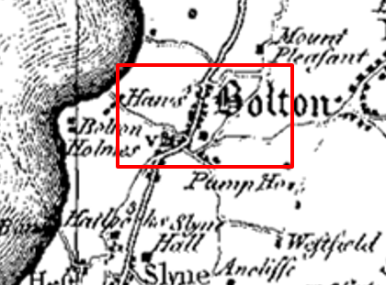
Observations |  | The route is not shown on Yates' Map.
Investigating Officer's Comments |  | The map predates the arrival of the section of canal at Bolton le Sands. The route did not exist as a major route at the time but it may have existed as a minor route which would not have been shown due to the limitations of scale so no inference can be drawn in this respect.
Greenwood’s Map of Lancashire | 1818 | Small scale commercial map. In contrast to other map makers of the era Greenwood stated in the legend that this map showed private as well as public roads.
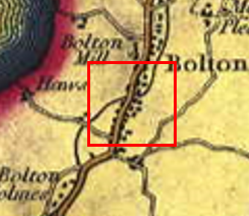
Observations |  | The route is not shown. The canal is shown and the road through Bolton le Sands (Main Road) is shown crossing the canal via Packet Bridge (not named). Packet Lane appears to be shown with properties along either side.
Investigating Officer's Comments |  | The route did not exist as a major route at the time but it may have existed as a minor route which would not have been shown due to the limitations of scale so no inference can be drawn in this respect.
Hennet's Map of Lancashire | 1830 | Small scale commercial map. In 1830 Henry Teesdale of London published George Hennet's Map of Lancashire surveyed in 1828-1829 at a scale of 71/2 inches to 1 mile. Hennet's finer hachuring was no more successful than Greenwood's in portraying Lancashire's hills and valleys but his mapping of the county's communications network was generally considered to be the clearest and most helpful that had yet been achieved.
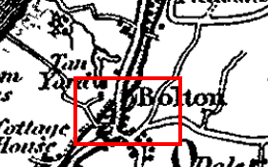
Observations |  | Main Road and Packet Lane are shown but the route is not.
Investigating Officer's Comments |  | The route did not exist as a major route at the time but it may have existed as a minor route which would not have been shown due to the limitations of scale so no inference can be drawn in this respect.
Canal and Railway Acts |  | Canals and railways were the vital infrastructure for a modernising economy and hence, like motorways and high speed rail links today, legislation enabled these to be built by compulsion where agreement couldn't be reached. It was important to get the details right by making provision for any public rights of way to avoid objections but not to provide expensive crossings unless they really were public rights of way. This information is also often available for proposed canals and railways which were never built.
Observations |  | The route is situated to the east of the Lancaster canal and the original Packet Boat Inn was situated directly opposite a landing area used by packet boats transporting goods and passengers along the canal. Plans and records relating to the Lancaster Canal have been examined in the County Records Office but no reference to the route was found.
Investigating Officer's Comments |  | No inference can be drawn.
Tithe Map and Tithe Award or Apportionment | 1846 | Maps and other documents were produced under the Tithe Commutation Act of 1836 to record land capable of producing a crop and what each landowner should pay in lieu of tithes to the church. The maps are usually detailed large scale maps of a parish and while they were not produced specifically to show roads or public rights of way, the maps do show roads quite accurately and can provide useful supporting evidence (in conjunction with the written tithe award) and additional information from which the status of ways may be inferred.
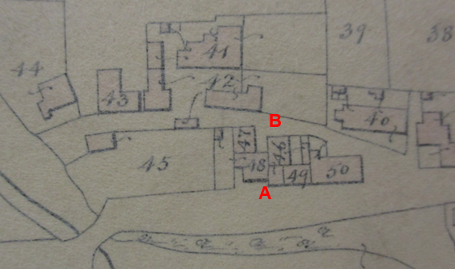
Observations |  | The Tithe Map and Award for Bolton le Sands were inspected in the County Records Office. The Tithe Map includes an insert of a large scale plan of the village. Main Road and Packet Lane are shown but the route is not. Buildings are shown located on and near the route with no access between point A and point B.  The Tithe Schedule records numbered plot 48 as being owned and occupied by George Elwood and is described as consisting of a barn and garden. Plot 47 is also owned by George Elwood but is occupied by William Clapham and is described as a cottage. Plot 46 is owned by George Elwood and occupied by Henry Porter and is described as 'cottage, yard and shop' while plot 49 is also owned by George Elwood and is described as a cottage occupied by Robert Gardner. Plot 50 is described as the Packet Boat Inn, owned by George Elwood. There is no reference to the route within the Award.
Investigating Officer's Comments |  | The route did not exist in 1846.
Inclosure Act Award and Maps |  | Inclosure Awards are legal documents made under private acts of Parliament or general acts (post 1801) for reforming medieval farming practices, and also enabled new rights of way layouts in a parish to be made. They can provide conclusive evidence of status.
Observations |  | There is no Inclosure Award for the area crossed by the route.
Investigating Officer's Comments |  | No inference can be drawn.
6 Inch Ordnance Survey (OS) Map | 1848 | The earliest Ordnance Survey 6 inch map for this area surveyed in 1845 and published in 1848.
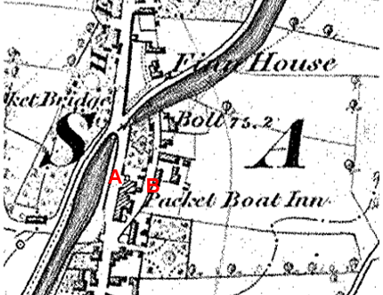
Observations |  | Main Road and Packet Lane are shown and Packet Boat Inn is named on the map. The route is not shown and buildings are shown on the land crossed by the route.
Investigating Officer's Comments |  | The route did not exist in 1848.
25 Inch OS Map | 1891 | The earliest OS map at a scale of 25 inch to the mile. Surveyed in 1889 and published in 1891.
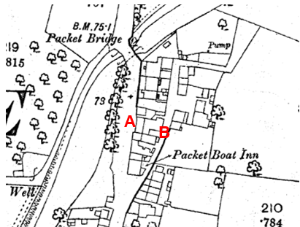
Observations |  | The route is not shown. This large scale map shows in detail the position of buildings and boundaries on land crossed by the route now claimed.
Investigating Officer's Comments |  | The route did not exist in 1889.
25 inch OS Map | 1913 | Further edition of the 25 inch map surveyed in 1889, revised in 1910 and published in 1913.
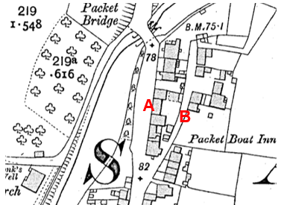
Observations |  | The route is not shown. A building is shown across the route from point A.
Investigating Officer's Comments |  | The route did not exist in 1910.
Finance Act 1910 Map | 1910 | The comprehensive survey carried out for the Finance Act 1910, later repealed, was for the purposes of land valuation not recording public rights of way but can often provide very good evidence. Making a false claim for a deduction was an offence although a deduction did not have to be claimed so although there was a financial incentive a public right of way did not have to be admitted.  Maps, valuation books and field books produced under the requirements of the 1910 Finance Act have been examined. The Act required all land in private ownership to be recorded so that it could be valued and the owner taxed on any incremental value if the land was subsequently sold. The maps show land divided into parcels on which tax was levied, and accompanying valuation books provide details of the value of each parcel of land, along with the name of the owner and tenant (where applicable).  An owner of land could claim a reduction in tax if his land was crossed by a public right of way and this can be found in the relevant valuation book. However, the exact route of the right of way was not recorded in the book or on the accompanying map. Where only one path was shown by the Ordnance Survey through the landholding, it is likely that the path shown is the one referred to, but we cannot be certain. In the case where many paths are shown, it is not possible to know which path or paths the valuation book entry refers to. It should also be noted that if no reduction was claimed this does not necessarily mean that no right of way existed.
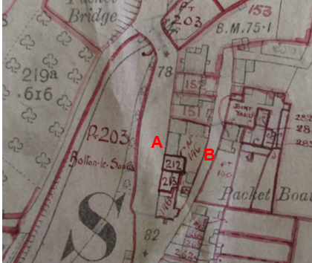
Observations |  | The Valuation Map and Book were inspected in the County Records Office. The route is not shown on the Ordnance Survey base map and is not excluded from the numbered plots. The land crossed by the route is included in plot 146 which was listed in the Valuation Book as being owned by Yates Jackson and occupied by Thomas Fisher. It is described as 'Packet Boat Inn' and there are no deductions listed for public rights of way or user.
Investigating Officer's Comments |  | The Valuation records do not provide any supporting evidence regarding the existence of the route in 1910.
25 Inch OS Map | 1940 | Further edition of 25 inch map (surveyed 1889, revised in 1938 and published in 1940.
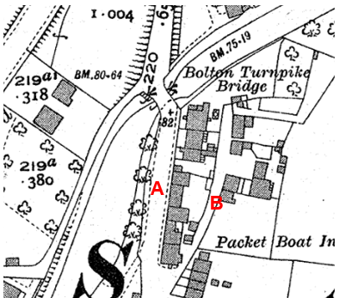
Observations |  | The route is not shown and access does not appear to be possible as a building is shown across the route east of point A.
Investigating Officer's Comments |  | The route did not exist when the map was revised in 1938.
Aerial Photograph | 1940s | The earliest set of aerial photographs available was taken just after the Second World War in the 1940s and can be viewed on GIS. The clarity is generally very variable.
Observations |  | There is no aerial photograph of the area available to view from the 1940s.
Investigating Officer's Comments |  | No inference can be drawn.
6 Inch OS Map | 1956 | The OS base map for the Definitive Map, First Review, was published in 1955 at a scale of 6 inches to 1 mile (1:10,560). This map was revised before 1930 and is probably based on the same survey as the 1930s 25-inch map.
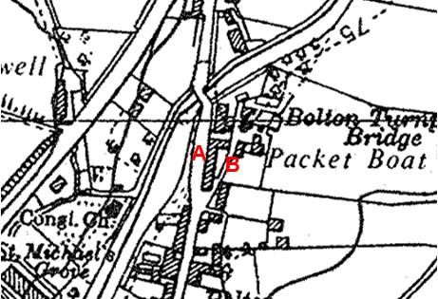
Observations |  | The route is not shown. Buildings are shown across the route east of point A.
Investigating Officer's Comments |  | The route did not exist when the map was revised in the 1930s.
1:2500 OS Map | 1969 | Further edition of 25 inch map reconstituted from former county series and revised in 1967 and published 1969 as national grid series.
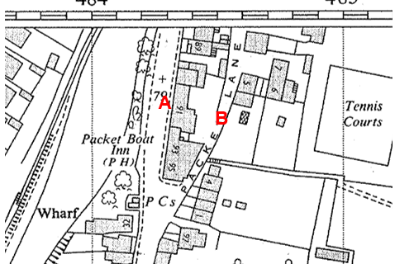
Observations |  | The route is not shown. A building – numbered "91" – is shown across the route east of point A.
Investigating Officer's Comments |  | The route did not exist when the map was revised in 1967.
Aerial photograph | 1960s | The black and white aerial photograph taken in the 1960s and available to view on GIS.
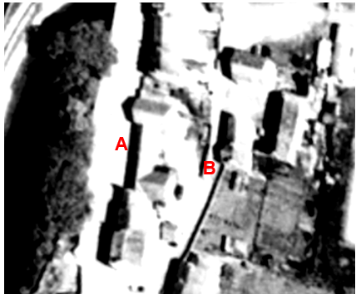
Observations |  | A building can be seen across the route east of point A consistent with the 1:2500 OS map published in 1969. The route is not shown.
Investigating Officer's Comments |  | The route did not exist in the 1960s when the photograph was taken.
OS 1:1250 map enlarged from 1:2500 | 1985 | Extract of OS Sheet SD 4867 from Land Registry plan. Published 1985, survey date unknown.
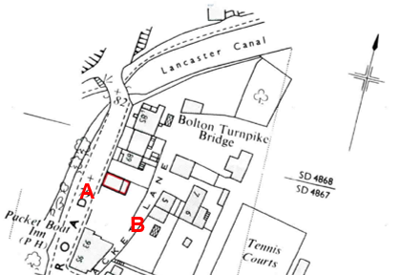
Observations |  | The property shown on earlier maps examined and numbered 91 on the 1969 1:2500 is no longer shown. A gap is shown in the boundary adjacent to Main Road at point A suggesting that access was available from Main Road onto the route at point A. The route is not shown as a defined physical feature but access appears to be available across an open area between point A and point B to exit onto Packet Lane at point B.
Investigating Officer's Comments |  | The route appeared to be accessible and may have been in use in 1985.
Aerial Photograph | 2000 | Aerial photograph available to view on GIS.
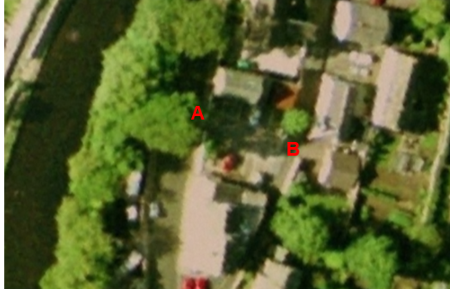
Observations |  | Tree cover and shadows make it difficult to see with any clarity whether the route was accessible in 2000 but the area crossed by the route appears to be a car park with parking bays marked out to the north and south of the route.
Investigating Officer's Comments |  | The route across the car park probably existed in 2000.
Planning Application for alterations to the Packet Boat Inn and car park | 2007 | Details of a planning application submitted in 2007 for land crossed by the route were viewed online (Lancaster City Council online planning applications).
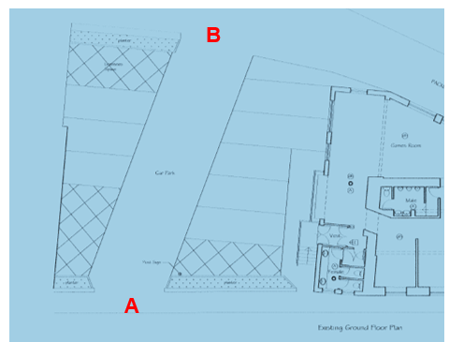
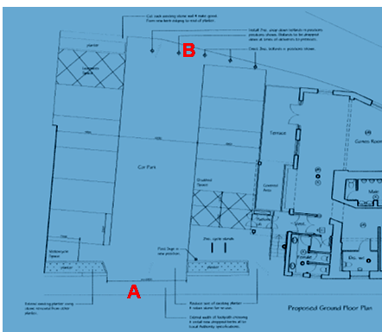
Observations |  | In 2007 listed building consent was sought (and granted) for alterations to the Packet Boat public house and existing car park and access. This included alterations to the car park across which the route runs. A plan was submitted as part of the application and shows access to the car park at point A and point B. Designated car parking spaces are shown on the plan to the north and south of the route – but not across it.  The proposed alterations show that permission was being sought to widen the access at point A to 6 metres and to install dropped kerbs along the entrance from Main Road. It also shows that it was proposed to erect two drop down bollards across the gap at point B and the plan submitted as part of the application stated that these would be dropped down at times of deliveries to the premises.
Investigating Officer's Comments |  | In 2007 it appeared that access along the route was available between point A and point B. Cars would have been using the route to access the car parking spaces marked out and it looks like it may have been possible for cars (and pedestrians) to pass directly along the route from A to point B. The proposed alterations requiring listed building consent included improvements to the vehicular access to the car park from point A but also included the provision of access restrictions at point B (dropped bollards) which would not have prevented pedestrian use but, if subsequently installed, would have limited use by vehicles. No reference to the existence of any public rights across the car park could be found and there was no reference to any public vehicular rights being restricted or prevented by the erection of dropped bollards.
Google Street View | 2009 | Images captured on Google Street View in 2009 and submitted by the applicant.
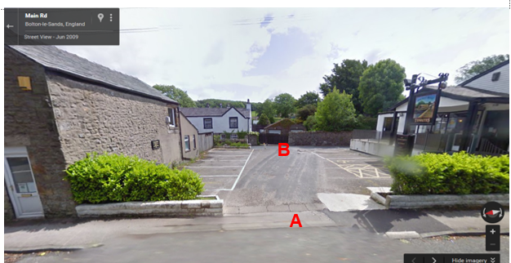
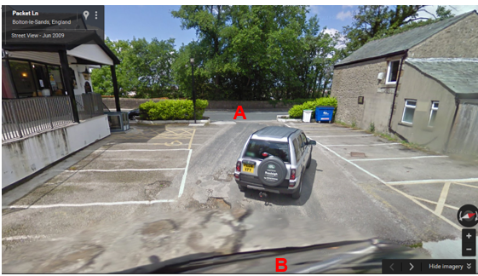
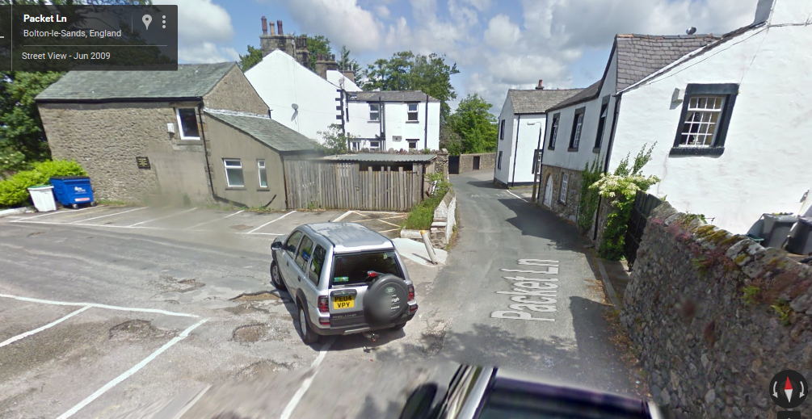
Observations |  | The photographs available to view on Google Street View show the route as being open and accessible across the pub car park. Work appears to have been carried out following the 2007 grant of listed building consent to provide a dropped kerb at point A. The route across the car park was not marked out with parking spaces but appears to be intended to be kept clear of parked cars. A single bollard can be seen at point B although access onto the route at point B appears to be wide and a vehicle is seen entering onto the car park via point B.
Investigating Officer's Comments |  | The route existed in 2009 and appeared to be capable of being used by cars and pedestrians.
Definitive Map Records |  | The National Parks and Access to the Countryside Act 1949 required the County Council to prepare a Definitive Map and Statement of Public Rights of Way.  Records were searched in the Lancashire Records Office to find any correspondence concerning the preparation of the Definitive Map in the early 1950s.
Parish Survey Map | 1950-1952 | The initial survey of public rights of way was carried out by the parish council in those areas formerly comprising a rural district council area and by an urban district or municipal borough council in their respective areas. Following completion of the survey the maps and schedules were submitted to the County Council. In the case of municipal boroughs and urban districts the map and schedule produced, was used, without alteration, as the Draft Map and Statement. In the case of parish council survey maps, the information contained therein was reproduced by the County Council on maps covering the whole of a rural district council area. Survey cards, often containing considerable detail exist for most parishes but not for unparished areas.
Observations |  | The route was not shown on the Parish survey map.
Draft Map |  | The parish survey map and cards for Bolton le Sands were handed to Lancashire County Council who then considered the information and prepared the Draft Map and Statement.  The Draft Maps were given a “relevant date” (1st January 1953) and notice was published that the draft map for Lancashire had been prepared. The draft map was placed on deposit for a minimum period of 4 months on 1st January 1955 for the public, including landowners, to inspect them and report any omissions or other mistakes. Hearings were held into these objections, and recommendations made to accept or reject them on the evidence presented.
Observations |  | The route was not shown on the Draft Map and no representations were made to the County Council.
Provisional Map |  | Once all representations relating to the publication of the draft map were resolved, the amended Draft Map became the Provisional Map which was published in 1960, and was available for 28 days for inspection. At this stage, only landowners, lessees and tenants could apply for amendments to the map, but the public could not. Objections by this stage had to be made to the Crown Court.
Observations |  | The route was not shown on the Provisional Map and no representations were made to the County Council.
The First Definitive Map and Statement |  | The Provisional Map, as amended, was published as the Definitive Map in 1962.
Observations |  | The route was not shown on the First Definitive Map and Statement.
Revised Definitive Map of Public Rights of Way (First Review) |  | Legislation required that the Definitive Map be reviewed, and legal changes such as diversion orders, extinguishment orders and creation orders be incorporated into a Definitive Map First Review. On 25th April 1975 (except in small areas of the County) the Revised Definitive Map of Public Rights of Way (First Review) was published with a relevant date of 1st September 1966. No further reviews of the Definitive Map have been carried out. However, since the coming into operation of the Wildlife and Countryside Act 1981, the Definitive Map has been subject to a continuous review process.
Investigating Officer's Comments |  | From 1953 through to 1975 there is no indication that the route was considered to be public right of way by the Surveying Authority. There were no objections or representations made with regards to the fact that the route was not shown on the map when the maps were placed on deposit for inspection at any stage of the preparation of the Definitive Map.
Highway Adoption Records including maps derived from the '1929 Handover Maps' | 1929 to present day | In 1929 the responsibility for district highways passed from district and borough councils to the County Council. For the purposes of the transfer, public highway 'handover' maps were drawn up to identify all of the public highways within the county. These were based on existing Ordnance Survey maps and edited to mark those routes that were public. However, they suffered from several flaws – most particularly, if a right of way was not surfaced it was often not recorded.  A right of way marked on the map is good evidence but many public highways that existed both before and after the handover are not marked. In addition, the handover maps did not have the benefit of any sort of public consultation or scrutiny which may have picked up mistakes or omissions.  The County Council is now required to maintain, under section 31 of the Highways Act 1980, an up to date List of Streets showing which 'streets' are maintained at the public's expense. Whether a road is maintainable at public expense or not does not determine whether it is a highway or not.
Observations |  | The route is not recorded as being publicly maintainable on the List of Streets by the County Council.
Investigating Officer's Comments |  | No inference can be drawn regarding public rights.
Aerial Photograph | 2010 | Aerial photograph available to view on GIS.
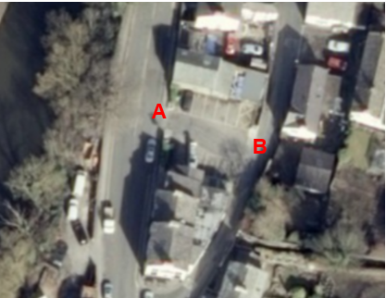
Observations |  | The full length of the route can be seen and appears to be available to use.
Investigating Officer's Comments |  | The route existed and appeared capable of being used in 2010.
Statutory deposit and declaration made under section 31(6) Highways Act 1980 |  | The owner of land may at any time deposit with the County Council a map and statement indicating what (if any) ways over the land he admits to having been dedicated as highways. A statutory declaration may then be made by that landowner or by his successors in title within ten years from the date of the deposit (or within ten years from the date on which any previous declaration was last lodged) affording protection to a landowner against a claim being made for a public right of way on the basis of future use (always provided that there is no other evidence of an intention to dedicate a public right of way).  Depositing a map, statement and declaration does not take away any rights which have already been established through past use. However, depositing the documents will immediately fix a point at which any unacknowledged rights are brought into question. The onus will then be on anyone claiming that a right of way exists to demonstrate that it has already been established. Under deemed statutory dedication the 20 year period would thus be counted back from the date of the declaration (or from any earlier act that effectively brought the status of the route into question).
Observations |  | No Highway Act 1980 Section 31(6) deposits have been lodged with the County council for the area over which the route runs.
Investigating Officer's Comments |  | There is no indication by a landowner under this provision of non-intention to dedicate public rights of way over their land.

The affected land is not designated as access land under the Countryside and Rights of Way Act 2000 and is not registered common land. The former Packet Boat Inn is a Grade II listed building although the listing does not include the car park or later extensions to building.

Landownership

The land crossed by the route is registered as part of 95 Main Road in the freehold ownership of Mr Geoffrey Harris and Mrs Jacqueline Anne Harris.

Summary

The map and documentary evidence examined does not support the existence of the route as an accessible through route from the 1800s through to some point in time between the 1960s and 1985 when the property across the route (and labelled as 91 Main Road on the 1960s 1:2500 OS map) was demolished and the area made into a car park for visitors to the Packet Boat public house.
Access through the car park and along the route appears to have been available from at least 1985 until the public house closed and the property was sold and the car park fenced off, resulting in the submission of this application.

The geography of the area may go some way to explaining why vehicles and pedestrians may have used the route if accessing Packet Lane from travelling south along Main Road as there is a sharp 135 degree turn onto Packet Lane which could be avoided by driving along the route claimed. Packet Lane is a narrow cul de sac vehicular road to several dwellings and the Bolton le Sands Community Centre and the Bolton le Sands Pre-school and also has at a point on its eastern side an access to a pedestrian pathway to the primary school.

The request for listed building consent granted in 2007 includes a request to widen the vehicular access at point A but also to erect bollards which would restrict or limit vehicular access at point B suggesting that the proprietors of the public house at that time were either aware of use of the route as a 'cut through' and wished to control or prevent it or wished to control use of the car park by their customers.

The Natural Environment and Rural Communities Act 2006 (NERC Act)

The claim is that this short claimed route is already a vehicular highway and it is important to consider the effect of the NERC Act on these possible rights. This Act effected a blanket extinguishment of unrecorded public rights for mechanically propelled vehicles (MPVs) with certain exceptions. Prior to this carriageway rights did not discriminate between vehicles which were mechanically propelled, such as cars and motorbikes, and those which were not, such as bicycles, wheelbarrows, horse-drawn carriages, donkey carts, etc.. If Committee concludes that the evidence shows that, on the balance of probability, public vehicular rights exist on the route it is then necessary to consider whether the Natural Environment and Rural Communities Act 2006 has extinguished public rights for MPVs. The route was not, at the time of the Act recorded as a public footpath/bridleway and was not on the List of Streets (maintained at public expense). The application was made for a byway open to all traffic. There is no evidence of historical use of the route by vehicles but evidence submitted by the applicants refers to modern use by the public in MPVs and if Committee accept the application they are advised that it is necessary to consider whether or not public MPV rights have been extinguished by the Natural Environment and Rural Communities Act 2006. One of the exceptions to the blanket removal of MPV rights is if the way was mainly used by MPVs for the 5 years preceding 2 May 2006.

it is suggested that if highway rights in vehicles were found to exist and the MPV rights would have been extinguished because there is insufficient evidence of the main use 201-6 being in vehicles the correct status to record would be restricted byway.

Head of Service – Legal and Democratic Services Observations

Information from the Applicant

In support of their application the Parish Council submitted two google photographs dated 2009 which are considered earlier in the report under the section headed Map and Documentary Evidence.

The Parish Council also submitted a user witness statement, 3 user evidence forms, an e-petition originally submitted to Lancaster City Council and an email. They also stated that a petition of signatures was to be submitted by Mrs Fiona Ryan.

Witness Statement

Statement dated 1st February 2016 whereby a local resident states that he has used the access over the car park to and from Packet Lane on foot and by vehicle without restriction or challenge since 1970. He also makes reference to being a long term customer of the Packet Boat public house.

User evidence forms

User 1: Used the route on foot, bicycle and with a motorised vehicle on an ad hoc basis from 1987 to 2015 (28 years) with more frequent use 2014-2015 as he visited the community centre twice a day. Used route to visit community facilities and to collect children from school. Was never stopped, challenged or given permission to use the route until builder's fence erected in 2015. He refers to the route being through the car park and shows an arrow along main road and along the route and up part of packet lane

User 2: Used the route and refers to passing through on foot or parking 'in one of the spaces' from 1994 to 2015 (21 years). Used the route daily to access the nursery, school, community centre and playing fields. Was never stopped, challenged or given permission to use the route.

User 3: Used the route daily on foot and weekly with vehicles from 1978 – 2015 (37 years). Refers to the route being already in existence and used when she moved to the village in 1978. Use was for pleasure, to collect children from school, to access the playground and to get to work (children's nursery). Was never stopped, challenged or given permission to use the route until 2015 when fence was erected but refers to erection of some removable bollards 'about 5 years ago' at the exit onto Packet Lane 'to deter vehicular use' but states that they were removed within weeks when the difficulty of getting cars down Packet Lane was realised. She refers to the access to the bonfire in november 2015 was made more difficult as they were without the addition of being able to filter through the car park for spectators heading north.

E-Petition

A copy of an e-petition was submitted requesting Lancaster City Council to support 'the Bolton le Sands Community' in registering the application route as a public right of way for both pedestrians and vehicles.

The e-petition appears to have been submitted to the City Council in response to a planning application to close the route and states that the route was an accepted public right of way which had been used on foot and by vehicles since the early 1970s.

32 e-Petition signatures are included on the list as being in agreement with the request but no evidence of use is included.

E-mail

A copy of an email exchange between Bolton le Sands Parish Council and a local resident is also included. The email relates to the resident's concerns about the use of the application route in that it created a dangerous three way traffic situation and is seeking to find out whether, if the route was reopened and accepted as a right of way, whether a crossing control person would be provided at the Packet Boat at the start and end of each school day.
The resident does not support the application.

Letters, additional information and petition of signatures submitted by Mrs Ryan

Mrs Ryan explains that she started the Safer Access Campaign as a result of the closure of the application route in July 2015.

She explains that since the closure of the route the risk to pedestrians has greatly increased and that because only one car can pass at a time through Packet Boat Lane, both cars and pedestrians have used the Packet Boat car park as a right of way for many years. She refers to many people being able to testify to use of the route in excess of 20 years contained in letters and correspondence included with her letter and which are detailed below.

She comments on the high volume of use by pedestrians and vehicles accessing important community amenities including the school, scout hut, playground, bowling and tennis clubs and the community centre and examples of incidents that have occurred regarding the dual use of Packet Lane by pedestrians and vehicles as a result of the closure of the application route. She refers to high volume of cars and pedestrians and that many pupils at the school arrive and are collected by car.

Mrs Ryan also refers to the objections received to the planning application to convert the former public house (Packet Boat) to a residential property and to block the application route and provides details from Lancaster City Councils web site of the 53 comments received in response to the application stating that 50 of those providing comments objected to the closure of the application route. She provides copies of the comments submitted to the City Council regarding the planning application (available to view on the Lancaster City web site) highlighting the frequently repeated comments about the application route being a recognised public right of way, frequent use of the application route by pedestrians and vehicles and concerns about public safety and congestion if the planning application is accepted and the route through the car park blocked off. There is a real sense of concern by a significant number of people and knowledge of how used the route had been but a lack of detail about dates and type of use

The subject of the petition included with Mrs Ryan's letter is stated to be The application for a public right of way to ensure safer access to school/community resources and the action sought by the petitioners is for the Council to support Bolton le Sands community in registering the commonly accepted right of way across the land of the former packet boat inn.

The petition is submitted to the County Council as part of the Definitive Map Modification application in March 2016 and contains 1382 signatures.

In addition to the petition, Mrs Ryan included 24 letters and emails from local people supporting the application, expressing concern about the safety of pedestrians since the closure of the route and referring to their own use, or use by family members over a long period of time (mostly ranging from 30 -50 years).

The majority of letters refer to frequent use to access the school or nursery, to get to the playground, attend scouts, brownies, etc. and to access the tennis or bowling club. None of the letters refer to being given permission to use the route or to being prevented from using it (until 2015). Much of the use appears to have been on foot but this is not clearly specified in some cases. Frequency of use is not specified either although the main points referred to are listed below:

- For many years (40+) parents and children have been able to use the Packet Boat pub car park as a component of their regular walk to and from school as well as visiting the community centre and other local activities and since its closure in summer 2015 it has created very substantial difficulties since.
- The closure of Packet Boat car park has resulted in considerable congestion on Packet Lane because of manoeuvring cars.
- Access to and from the school is now very poor as children and parents are at greater risk than before when the car park afforded safer access to the school via the 'bottom gate'.
- A public right of way across the car park would ensure that parents, children and all the other community users have safer access from the Main Road to Packet Lane then up to the school.
- The car park has been used on thousands of occasions over many years and access across the piece of land has been a feature of life in Bolton-le-Sands for generations.
- The pre-school support a right of way across the land of the former Packet Boat Hotel, to ensure safe access to the pre-school building and other community resources.
- If an accident were to happen at the school the emergency services would have serious problems reaching the school due to the congested lane.
- Drivers now park on both sides of the road opposite the packet Boat and on Packet Hill, this means the village in general is very congested.
- The right of way has been in existence for over 30 years
- Usual route to cut across the car park to access the school rather than through the village towards Mount Pleasant Lane
- Access was never blocked
- The route was used to access other various activities in the village and the community centre grounds.
- Not able to let children walk to school on their own to gain independence anymore due to congested and manoeuvring cars
- Route has been used in different family generations
- Accidents can be avoided if access was still there
- Congestion is also caused from other activities in the community not just from the school
- A small footpath at the back of the former pub whilst not solving the problem for vehicle access would provide a safer route for children of the village and all others accessing the valuable community resources in the area.
- More people use the area due to the development of the community centre
- No notices or signs suggesting the land was private
- The tenants of the pub have never objected to its use
- Witnessed other using the car park on foot bicycle and by vehicle
- Granddaughter knocked down by a car on Bolton Lane, a front entrance to the school

In addition, letters were also submitted from:

Bolton le Sands Church of England Primary School

A letter from the Headmaster of the school states that the school support the application and that for many years (40 plus) parents and children have been able to use the Packet Boat pub car park as part of their regular walk to and from school and that its closure has resulted in serious safety issues and vehicular congestion on Packet Lane. He says that the car park has been used on thousands of occasions over many years and access across the piece of land has been a feature of life in Bolton le Sands for generations.

Bolton le Sands Pre-School

The Pre-School state that they support the application to alleviate current vehicular congestion and safety concerns.

Mrs Ryan also submitted an extract from the village hall bookings register for February 2016 to illustrate how regularly the centre was used (from 9am onwards most days) and the diversity of groups attending the venue, photographs showing vehicular congestion on Packet Lane and the fences erected to obstruct the application route.

Additional User Evidence

Following an initial assessment of the evidence the applicant (Bolton le Sands Parish Council) was contacted explaining the difficulties associated with assessing user evidence on the submission of petitions and suggesting the submission of user evidence forms which could be more thoroughly assessed to determine claimed use of the route.

Co-ordinated by Mrs Ryan 30 user evidence forms were subsequently submitted (at the time of writing).Some were from people who had already submitted an earlier form or responded to the planning application. More precise detail of use and dates are given

Evidence of use was submitted from 1962 through to the closure of the route in 2015.

26 users claimed to have used the route on foot and in a vehicle, with two also referring to use on a bicycle.

1 user refers to use on foot only and another user specifies vehicular use only.

23 users state that they have used the route for between 30 and 53 years.
4 users state that they have used the route for between 20 and 30 years.
3 users state they have used the route for between 7 and 20 years.

Users were going to and from the primary school, community centre, children's nursery and play park/playing fields a number of users explained how they would drive along the application route to get to the community centre car park where they would either park or drop off/collect family members.

Many users described how they were going to the community centre, tennis and bowling clubs, recreation ground, playpark, nursery and school formed the hub of the local community and that they were all located at the end of Packet Lane and accessed both on foot and in vehicles along the application route. There is often reference to use on foot on a daily basis and in a vehicle weekly.

An 'informal' but well established one way system was referred to by a number of users who explained that because of the narrowness of Packet Lane and the fact that there was a sharp turn onto it if driving from the north drivers would drive to the school/community centre/play fields etc. along the application route and then use the route along Packet Lane when departing.

The reasons for using the route included picking up and dropping off children at school and nursery, going to the playground or recreational field, to get to the bowling club, tennis club, to watch or to play football, to attend parties at the community centre, attending the village bonfire and firework display, attending scouts and playgroup, for Women's Institute meetings and coffee mornings, attending keep fit sessions and the Mothers Union, for horticultural shows, after school clubs and coffee mornings.

Use made of the route was frequent in almost every case, often with multiple daily use during the years when users were taking children to nursery or school. Although the reasons for use often changed in time – for example taking own children to school and activities such as scouts, football or dance lessons, then later on use was for visits to community centre, tennis and bowling and more recently taking grandchildren to the park, nursery and school.

The majority of users referred to seeing others using the route.

None of the users refer to being given permission to use the route or having been stopped or prevented until the closure of the route in 2015.

All users completing the forms confirmed that the route had followed the exact same route throughout the time that they had used it and none recalled the existence of any gates, stiles or signs.

Information from Others

Following receipt of the application a letter was received from a local resident who disputed the application and believed that the route was access through the private car park of the Packet Boat Hotel and that use by parents walking through to the school was trespass across a private car park.

Information from the Landowner

Daniel Thwaites PLC responded to the consultation to say that they sold the former Packet Boat Inn on 31 March 2015 and did not provide any information regarding the application.

Assessment of the Evidence

The Law - See Annex 'A'

In Support of Making an Order(s)

user evidence
Route open and available since 1985
No signs or evidence of use being with permission

Against Making an Order(s)

the different forms of user evidence make evaluation complicated both in terms of possible type of dedication and also the application of the Natural Environment and Rural Communities Act

Conclusion

The claim is that this route has already become a vehicular highway and is of such status that it should be recorded as a Byway Open to All Traffic on the Definitive Map and Statement.

There is no evidence that this is a part of the vehicular highway network dating back to the eighteenth and nineteenth centuries. Buildings were at point A until sometime between 1969 and 1985. Upon them disappearing however the route appears then to be available as a route across the carpark linking vehicular highway to vehicular highway.

The user evidence would indicate that the route became used by the public as a way through in vehicles rom highway to highway rather than a car park for the public house. Many users refer to it being "a cut through" a "a right of way for both pedestrians and vehicles across from Main Road to Packet Lane" Its loss "will create a single track access", indicating that this route was another access. "the only way of relieving serious build ups and blockages is cutting through the packet boat car park". "the car park at the Packet Boat takes the weight off the current chaos and allows access to the walk through to the school"

There are those who mentioning going to the car park to park a vehicle and perhaps wait for children to come out of school and it is advised that this use be discounted as it is not use of the route as a highway such as to evidence dedication as a highway. There is also evidence from a significant number of use as a through route on foot.

User can lead to a deemed dedication under S31 Highways Act 1980 if the criteria are satisfied or can be circumstances from which a dedication by the owner can be inferred at common law.

Looking at common law inference it would appear that the owners took no action to challenge use which said use would have been obvious. Given the amount of user it is suggested that on balance a dedication could be inferred at common law. It is suggested that the dedication would be of a vehicular highway. The use on foot was also evident but this is a lesser right.

Looking also at S31 criteria. Use has to be over the twenty years, in this case 1995-2015 up to the clear calling into question in 2015. There is mention of some earlier bollards but only by one of the users and there is reference to them disappearing. They do not appear to have been sufficient to be an earlier calling into question. The use has to be as of right, be sufficient and be by the public and there has not to be any sufficient evidence of the owner's lack of intention to dedicate.

It is suggested that on balance the criteria of S31 could be satisfied in this matter also inference of dedication at common law. A vehicular highway is of higher status and includes footpath rights and it is therefore suggested that the dedication to be deemed would be a vehicular right of way over the route.

There is then a difficulty as mechanically propelled vehicular rights were arguably extinguished by the NERC Act in 2006. Looking at the provisions of the statute it would appear that the only possible exclusion which would save the rights from being extinguished would be to look at whether the rights were over a way whose main lawful use by the public during the period of 5 years ending with May 2006 was use for mechanically propelled vehicles. If the main use by the public 2001-6 was in mechanically propelled vehicles the extinguishment under S67 NERC Act 2006 would not apply.

The evidence has therefore not only to be considered to look at sufficiency of use from which to deem or infer a dedication but also an exercise carried out to see whether the main use 2001-6 was in vehicles or on foot. This has proved somewhat difficult and detail is lacking but from the evidence on file it would appear that there was much daily use on foot 2001-2005 and more weekly use in mechanically propelled vehicles. This does not undermine the sufficiency of use to advise that the dedication would be vehicular. It is suggested that the mechanically propelled vehicular rights are not saved from extinguishment as the main use by the public were on balance on foot and so instead of the route being recorded as a byway open to all traffic it should be more properly recorded as a restricted byway.

Alternative options to be considered - N/A

Local Government (Access to Information) Act 1985

List of Background Papers

Paper | Date | Contact/Directorate/Tel
All documents on File Ref: 804-578 |  | Jayne Elliott, 07917 836626, Public Rights of Way, Environment and Planning Group
Reason for inclusion in Part II, if appropriate

N/A

The Ordnance Survey (OS) has produced topographic maps at different scales (historically one inch to one mile, six inches to one mile and 1:2500 scale which is approximately 25 inches to one mile). Ordnance Survey mapping began in Lancashire in the late 1830s with the 6-inch maps being published in the 1840s. The large scale 25-inch maps which were first published in the 1890s provide good evidence of the position of routes at the time of survey and of the position of buildings and other structures. They generally do not provide evidence of the legal status of routes, and carry a disclaimer that the depiction of a path or track is no evidence of the existence of a public right of way.
Aerial photographs can show the existence of paths and tracks, especially across open areas, and changes to buildings and field boundaries for example. Sometimes it is not possible to enlarge the photos and retain their clarity, and there can also be problems with trees and shadows obscuring relevant features.

