Regulatory Committee
Meeting to be held on 27th September 2017

Electoral Division affected:
Lancaster Central

Wildlife and Countryside Act 1981
Definitive Map Modification Order Investigation
Addition to Definitive Map and Statement of a footpath from Ten Row to Bodie Hill via Fishnet Point, Glasson Dock, Thurnham
File No. 804-562
(Annex ‘A’ refers)

Contact for further information:
Claire Blundell, 01772 533196, Paralegal, Legal and Democratic Services, Claire.blundell@lancashire.gov.uk
Jayne Elliott, 07917 836626, Public Rights of Way Officer, Planning and Environment Group, Jayne.elliott@lancashire.gov.uk

Executive Summary

Application for the addition to the Definitive Map and Statement of a footpath from Ten Row to Bodie Hill via Fishnet Point, Glasson Dock in the parish of Thurnham, Lancaster, in accordance with File No. 804-562.

Recommendation

1. That the application for the addition to the Definitive Map and Statement of a footpath from Ten Row to Bodie Hill via Fishnet Point, Glasson Dock, in accordance with File No. 804-562, be accepted in part and to a higher status.

2. That an Order be made pursuant to Section 53 (2)(b) and Section 53 (3)(b) and/or Section 53 (3)(c)(i) of the Wildlife and Countryside Act 1981 to add to the Definitive Map and Statement a restricted byway from Ten Row to the Customs House as shown on Committee Plan between points A-B-C-D-E.

3. That being satisfied that the higher test for confirmation can be met the Order be promoted to confirmation.

Background

An application under Schedule 14 of the Wildlife and Countryside Act 1981 has been received for the addition to the Definitive Map and Statement of a footpath from Ten Row to Bodie Hill via Fishnet Point, Glasson Dock in the parish of Thurnham as shown between points A-K on the Committee plan.

The County Council previously considered an application to record part of the route under investigation (between points C-D-E on the Committee plan) as part of a byway open to all traffic from a point on Ten Row to the shore (beyond the Customs House), following receipt of an application submitted by Thurnham Parish Council in 1983.

The matter was reported to the Highways and Transportation Public Rights of Way Sub Committee in July 1985 with a further report presented to them on 28 January 1987.

Following receipt of the 1983 application the County Council made an Order to record a route from a point on Ten Row to the Shore (including the application route between points C-D-E) as a byway open to all traffic.

The Order received two objections (one relating to the current use of the route by heavy vehicles meaning that it was unsuitable for public use and the other seeking to ensure that Ten Row remained a cul de sac) and the Parish Council (applicants) withdrew their support for the claim stating that they were content that the area be left as it was because:-

- There was now a new road to the industrial estate, Bodie Hill;
- Ten Row had been blocked by bollards;
- The terminus of Ten Row had been landscaped

A further report was submitted to the Public Rights of Way Sub Committee on 12th June 1996 and Committee resolved in the light of the Parish Council's decision, and also in light of the Officer recommendation, that evidence was of a finely balanced nature and because there were doubts as to the actual use of the route, to withdraw support for the Order.

The Order was submitted to the Planning Inspectorate for determination and the Planning Inspectorate determined not to confirm the Order on the basis that both the claimants and the County Council had withdrawn their support.

Although the public status of part of the application route has been considered before the full length of the route now claimed as a public footpath has not been considered.

Furthermore, additional user and documentary evidence which was not considered when the first application was made has now been made available.

The County Council is required by law to investigate the evidence and make a decision based on that evidence as to whether a public right of way exists, and if so its status. Section 53(3)(b) and (c) of the Wildlife and Countryside Act 1981 set out the tests that need to be met when reaching a decision; also current Case Law needs to be applied.

An order will only be made to add a public right of way to the Definitive Map and Statement if the evidence shows that:

- A right of way “subsists” or is “reasonably alleged to subsist”

An order for adding a way to or upgrading a way shown on the Definitive Map and Statement will be made if the evidence shows that:

- “the expiration… of any period such that the enjoyment by the public…raises a presumption that the way has been dedicated as a public path or restricted byway”

When considering evidence, if it is shown that a highway existed then highway rights continue to exist (“once a highway, always a highway”) even if a route has since become disused or obstructed unless a legal order stopping up or diverting the rights has been made. Section 53 of the Wildlife and Countryside Act 1981 (as explained in Planning Inspectorate’s Advice Note No. 7) makes it clear that considerations such as suitability, the security of properties and the wishes of adjacent landowners cannot be considered. The Planning Inspectorate’s website also gives guidance about the interpretation of evidence.

The County Council’s decision will be based on the interpretation of the evidence discovered by officers and documents and other evidence supplied by the applicant, landowners, consultees and other interested parties produced to the County Council before the date of the decision. Each piece of evidence will be tested and the evidence overall weighed on the balance of probabilities. It is possible that the Council’s decision may be different from the status given in any original application. The decision may be that the routes have public rights as a footpath, bridleway, restricted byway or byway open to all traffic, or that no such right of way exists. The decision may also be that the routes to be added or deleted vary in length or location from those that were originally considered.

Consultations

Lancaster City Council

Lancaster City Council have been consulted but have not provided any comments.

Thurnham Parish Council

Thurnham Parish Council object to the application. They share the concerns of Glasson Grain Limited (detailed the in section of the report providing comments received from landowners) regarding health and safety issues which, they consider would result if the application was approved.

They also share the concerns of the Lancaster Port Commission regarding health and safety issues and note that the port authority has stated that there has been a locked gate across the route for at least the last 25 years.

The Parish Council also submitted concerns raised by members of the public at a Parish Council meeting. These included the protection of livestock as the application route would provide a point of access to the salt marsh; concerns about the public crossing the slipway which was used daily and regulated by strict health and safety procedures; the potential for accidents as part of the route was used for boat storage; concerns about the fact that the route crossed the slipway at the deepest point and would require changes to provide steps; potential financial losses to the owners of the boat park area as the application route would reduce the area available to store boats; public access compromising the safety of children using the privately owned children's play area and the fact that the sailing club's warden's caravan and 4 touring pitches would be affected by the footpath.

Applicant/Landowners/Supporters/Objectors

The evidence submitted by the applicant/landowners/supporters/objectors and observations on those comments are included in Advice – Head of Service – Legal and Democratic Services Observations.

Advice

Head of Service – Planning and Environment

Points annotated on the attached Committee plan.

Point | Grid Reference (SD) | Description
A | 4437 5613 | The north end of the highway known as Ten Row (U3316) adjacent to the Dalton Arms
B | 4436 5614 | The eastern end of the highway known as Bodie Hill (U11194)
C | 4436 5614 | The northern edge of the highway known as Bodie Hill (U11194) adjacent to south east corner of building
D | 4430 5629 | Immediately south of gated access to Glasson Sailing Club
E | 4435 5632 | Boundary wall near corner of buildings
F | 4432 5636 | Between static caravan and boundary of Sailing Club
G | 4431 5636 | Adjacent to north east corner of clubhouse.
H | 4429 5638 | Route crosses slipway
I | 4420 5626 | Metal fencing across route
J | 4419 5616 | Route turns away from floodbank
K | 4425 5609 | North west boundary of Bodie Hill (U11194)

Description of Route

A site inspection was carried out on 15 December 2016.

The application route commences on Ten Row (vehicular highway U3316) adjacent to the Dalton Arms and shown as point A on the Committee plan.

From point A the route crosses a tarmac area which forms part of the turning area at the northern end of Ten Row and on which is written in large letters KEEP CLEAR'. It passes along a short section of tarmac path (approximately 4 metres) to exit onto the eastern end of Bodie Hill (vehicular highway U11194) at point B on the Committee Plan.

The route continues in a north westerly direction across the adopted highway to point C and then for 160 metres in a north north westerly direction along a tarmac and concrete route between large industrial buildings.

Over part of the width a pedestrian walkway was marked on the ground along the eastern side of the road providing direct access to the Port of Lancaster smoke house and offices and on the day that the route was inspected a number of heavy goods vehicles were seen to drive along the route from Bodie Hill, passing over the route between point B and point C and continuing along the route to gain access to factory buildings adjacent to the route between point C and point D.

At point D the route turns to continue in an east north easterly direction immediately before reaching the gated access into land occupied by the Glasson Sailing Club. From point D the application route is crossed by a metal field gate which was locked on the day of inspection. Beyond the gate the route continues bounded on the south side by a factory building and bounded to the north by an old stone retaining wall and hedge. Just before reaching point E the route passes the derelict Customs House and then turns to continue in a north north westerly direction passing through a stone wall into the grounds of the Glasson Sailing Club. Access through the wall is not possible and there is no evidence of a previous gap, gate or stile.

If one was to continue beyond point E (not on the application route) a track exists which turns north north east bounded by a factory wall to the east and the boundary of the Sailing Club to the west to end at a metal security fence which then prevents access down to the shore and a fence and hedge prevent access into the sailing club grounds.

Following completion of the site inspection further clarification of the alignment of the route at point E was sought from the applicant who had previously confirmed that the Committee plan correctly showed the route that they were claiming. The applicant wrote, "historically all routes to the green headland were 'open'. Statements from residents entering the headland (via the Custom House route) indicate that they walked along a path now with trees (at variable distances from one another) and wooden posts and wire fencing (on inside edge of headland) to a crossing point in proximity to the Custom House at the eastern edge of the coast. This route is still closed to the public."

North of point E (on the application route) and within the Sailing Club grounds, the application route continues adjacent to the boundary hedge along a grassed area. There is no visible worn track indicating recent pedestrian use and the route passes to the rear of two trailer tents being stored on the site. Close to point F there is a static caravan inhabited by the Sailing Club warden. The route passes to the rear of the static caravan although access between point F and point G is not available due to the presence of small bushes, a large metal storage container and a collection of wood and building materials.

At point G the route passes to the rear of the club house belonging to the Sailing Club. A grassed strip is available between the club house and a fence on the edge of the headland although a small wooden building and wooden picnic bench restricts access.

Once past the club house the application route continues west and crosses a slipway at point H on the Committee Plan. There is no access across the slipway on the line of the application route and there are steep drops down to the slipway from either side with no access above, over or through it on the line claimed.
A representative of the Sailing Club on site at the time of the inspection reported that the slipway had been constructed by members of the club in the 1990s.

The applicant was again contacted to confirm the alignment of the route claimed at this point and they confirmed that 'the route being claimed is one across the raised slipway'.

Beyond the slipway at point H the application route continues west and then south west around the headland known as Fishnet Point. It follows a line along the top of the sea wall (marked on the map as 'sloping masonry'). There is no visible walked route on the ground and the route crossed rough grass which sloped down to the sea wall. A fence prevented access down onto the marsh with a wooden stile providing access over the fence and down to the marsh west of point H. In several places it was necessary to traverse around boats or boating equipment stored on the site across the line of the application route.

At point I the application route was crossed by a metal security fence on the boundary of the Sailing Club's land. There was no access through or around the fence and the area on either side of the fence was overgrown with brambles.

Access to the route between points I-J-K was not available and was blocked by security fencing at point I and point K. The area appeared to be quite overgrown and unmaintained with parking areas marked out but no longer in use. At point K there was no access onto or from the route onto Bodie Hill (U11194). A metal post was located on the road side close to point K but it was not known why the post had been erected and there was no evidence of the path.

In summary, the application route is approximately 680 metres long. Access was available from point A to point D but no further and there was a locked gate just to the east of point D, a wall across the route at point E, a caravan, storage container and building material across the route between point F and point G. There was no access across the slipway on the route claimed and further fences across the route at point I and point K all indicated that there was no current use of the full length of the route claimed.

The route from point C to point D formed part of the access into the Sailing Club and the gateway into the sailing club was the one shown on a number of photographs submitted with the user evidence and referred to as being used by a number of users. It was not on the application route.

The exact point at which access was available from the route past the Customs House onto the land now leased by the sailing club appears unclear as it passes through a stone wall. However the applicant provided a hand drawn map showing this route and confirmed that the route drawn on the Committee plan was correct.

It would appear that use of the route at point H - across the slipway – could only have been available prior to the construction of the slipway by the Sailing Club in the 1990's.

Map and Documentary Evidence

Document Title | Date | Brief Description of Document & Nature of Evidence
Yates’ Map  of Lancashire | 1786 | Small scale commercial map. Such maps were on sale to the public and hence to be of use to their customers the routes shown had to be available for the public to use. However, they were privately produced without a known system of consultation or checking. Limitations of scale also limited the routes that could be shown.
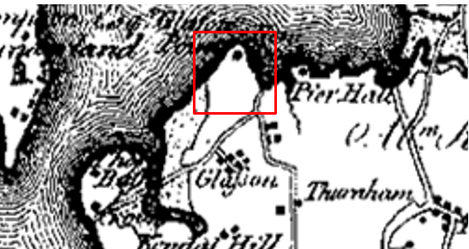
Observations |  | The land crossed by the application route can be seen but the application route is not shown and neither are the port buildings.
Investigating Officer's Comments |  | No inference can be made except that the route under investigation was not a major route in the 1780s.
Greenwood’s Map of Lancashire | 1818 | Small scale commercial map. In contrast to other map makers of the era Greenwood stated in the legend that this map showed private as well as public roads.
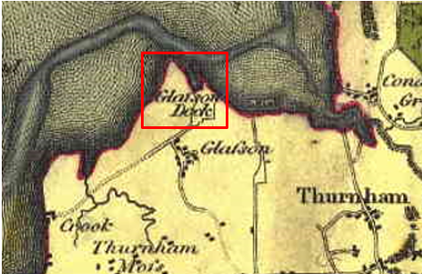
Observations |  | The application route is not shown and neither are the port buildings.
Investigating Officer's Comments |  | No inference can be made except that the route under investigation was not a major route in 1818.
Hennet's Map of Lancashire | 1830 | Small scale commercial map. In 1830 Henry Teesdale of London published George Hennet's Map of Lancashire surveyed in 1828-1829 at a scale of 71/2 inches to 1 mile. Hennet's finer hachuring was no more successful than Greenwood's in portraying Lancashire's hills and valleys but his mapping of the county's communications network was generally considered to be the clearest and most helpful that had yet been achieved.
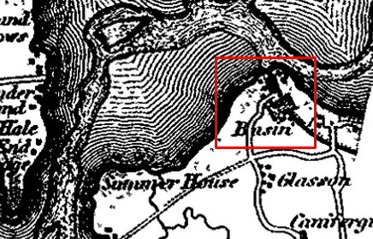
Observations |  | The application route is not shown. The canal basis to the south east of the land crossed by the application route is marked and there appears to be some development shown in proximity of the western side of the application route but the route itself is not shown.
Investigating Officer's Comments |  | No inference can be made except that the route under investigation was not a major route in the 1830s.
Canal and Railway Acts |  | Canals and railways were the vital infrastructure for a modernising economy and hence, like motorways and high speed rail links today, legislation enabled these to be built by compulsion where agreement couldn't be reached. It was important to get the details right by making provision for any public rights of way to avoid objections but not to provide expensive crossings unless they really were public rights of way. This information is also often available for proposed canals and railways which were never built.
Observations |  | Records relating to the Lancaster canal and Glasson canal basin have not been searched as they were located south east of the land crossed by the application route.
Investigating Officer's Comments |  | No inference can be drawn.
Agreement of Sale | 1827 | A copy of an agreement and covenant between the Lancaster Canal Company and John Dalton of Thurnham Hall dated 10 May 1827
Observations |  | A typed copy of an agreement dated 10 May 1827 was found within the papers relating to the original claim for a byway open to all traffic from Ten Row to the shore. The location of the original agreement is unknown and no plan was attached to it.  The agreement details the sale of land the boundaries of which are described within the document. Part of the description has been underlined as it describes land bounded on its north east side by a 'road' adjacent to the Dalton Arms.
Investigating Officer's Comments |  | The agreement appears to describe Ten Row adjacent to the Dalton arms as a road but does not provide details of whether the road was considered to be public or whether it included any part of the application route so no inference can be drawn.
Tithe Map and Tithe Award or Apportionment | 1843 | Maps and other documents were produced under the Tithe Commutation Act of 1836 to record land capable of producing a crop and what each landowner should pay in lieu of tithes to the church. The maps are usually detailed large scale maps of a parish and while they were not produced specifically to show roads or public rights of way, the maps do show roads quite accurately and can provide useful supporting evidence (in conjunction with the written tithe award) and additional information from which the status of ways may be inferred.
Observations |  | The Tithe Map of Thurnham dated 1843 does not cover the area crossed by the route under investigation.
Investigating Officer's Comments |  | No inference can be drawn.
Inclosure Act Award and Maps |  | Inclosure Awards are legal documents made under private acts of Parliament or general acts (post 1801) for reforming medieval farming practices, and also enabled new rights of way layouts in a parish to be made. They can provide conclusive evidence of status.
Observations |  | There is no Inclosure Award for the area crossed by the route under investigation.
Investigating Officer's Comments |  | No inference can be drawn.
6 Inch Ordnance Survey (OS) Map | 1848 | The earliest Ordnance Survey 6 inch map for this area surveyed in 1844-45 and published in 1848.
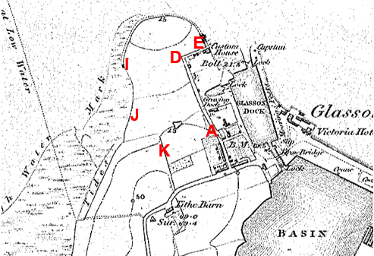
Observations |  | The road now known as Ten Row is shown passing through point A and continuing along the application route. This is clearly shown as a wide bounded route and is the only access to the Custom House (adjacent to point E). Access to the Graving Dock appears to be via a parallel route to the east. From point E (adjacent to the Custom House) a route appears to continue east and then north around the headland (between the solid and broken lines). This route appears to be along the salt marsh and the sea wall and slipway are not marked. The route appears to extend as far as a building at point I but no route is shown between point I to point K and point K. The road known as Bodie Hill does not exist and no route is shown connecting point K to a public highway.
Investigating Officer's Comments |  | A route existed passing through point A and through to point E as a significant route which appeared capable of being used by all traffic at that time. It provided access to a number of buildings including the Customs House. From point E a route may have existed onto and along the salt marsh around the headland as access to a small building at point I. The application route within the field and between points E-F-G-H-I-J-K probably did not exist.
25 Inch OS Map | 1891 | The earliest OS map at a scale of 25 inch to the mile. Surveyed in 1890 and published in 1891.
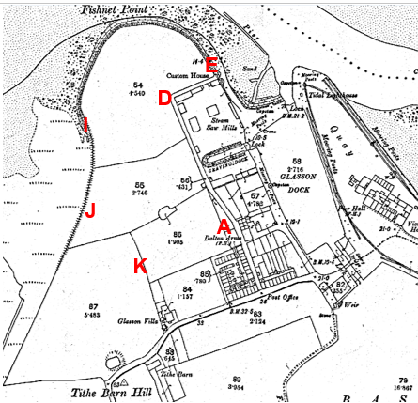
Observations |  | A road is clearly shown as an extension of Ten Row from point A and continuing initially on a different alignment to the application route then through to point D and point E.  From point E there is no route shown through the field boundary and along the route claimed. Continuing east from the Customs House it is not clear whether there was access through the sea wall onto the marsh. The sea wall around Fishnet Point is shown but the application route (which is inland of the sea wall) is not shown. The slipway crossed by the application route at point H is not shown. There is no longer a building shown at point I nor any path leading to it. The application route is not shown between points I-J-K and there does not appear to be any access to point K from Tithe Barn Hill.
Investigating Officer's Comments |  | A route existed in 1891 from point A to point D and then continuing to point E but is not all on the alignment of the application route.  This section of the route existed as a significant track which appeared capable of being used by all traffic and may have provided access to the shore. The application route between point E and point K probably did not exist.
25 inch OS Map | 1913 | Further edition of the 25 inch map surveyed in 1890, revised in 1910 and published in 1913.
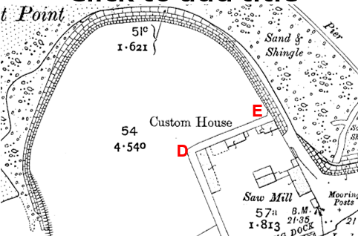
Observations |  | A route is clearly shown from Ten Row passing through point A to point D but is not all on the alignment of the application route.  From point E the application route passes through a boundary and there is no indication that it existed on the ground. Continuing past the Custom House there is no route shown through the sea wall onto the marsh route. The sea wall around Fishnet Point is shown but the application route (which is inland of the sea wall) is not shown. The slipway crossed by the application route at point H is not shown. The route is not shown between points E-H-I-J-K and there is no access to point K from Tithe Barn Hill shown.
Investigating Officer's Comments |  | A route existed from point A to point E (but is not on the exact alignment of the application route) as a significant route which appeared capable of being used by all traffic at that time. The application route between point E and point K probably did not exist.
Finance Act 1910 Map | 1910 | The comprehensive survey carried out for the Finance Act 1910, later repealed, was for the purposes of land valuation not recording public rights of way but can often provide very good evidence. Making a false claim for a deduction was an offence although a deduction did not have to be claimed so although there was a financial incentive a public right of way did not have to be admitted.  Maps, valuation books and field books produced under the requirements of the 1910 Finance Act have been examined. The Act required all land in private ownership to be recorded so that it could be valued and the owner taxed on any incremental value if the land was subsequently sold. The maps show land divided into parcels on which tax was levied, and accompanying valuation books provide details of the value of each parcel of land, along with the name of the owner and tenant (where applicable).  An owner of land could claim a reduction in tax if his land was crossed by a public right of way and this can be found in the relevant valuation book. However, the exact route of the right of way was not recorded in the book or on the accompanying map. Where only one path was shown by the Ordnance Survey through the landholding, it is likely that the path shown is the one referred to, but we cannot be certain. In the case where many paths are shown, it is not possible to know which path or paths the valuation book entry refers to. It should also be noted that if no reduction was claimed this does not necessarily mean that no right of way existed.
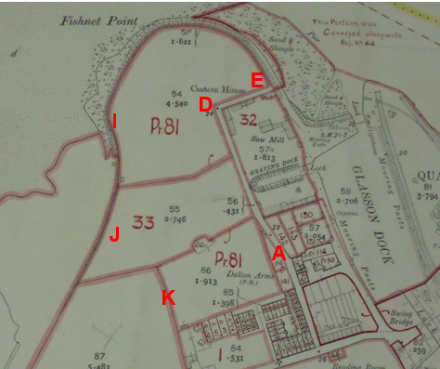
Observations |  | The Finance Act Maps in the County Records Office and The National Archives were inspected and show the land crossed by the application route in the same way.  A route from point A to point E, although not all on the alignment of the application route, was shown excluded from the numbered hereditaments and was shown consistent with the public highway network.  From point E through to point I and midway to point J the route crosses Hereditament 81 which was owned by John Henry Dalton and occupied by George Shaw. It was described in the Field Book as 'land' with no deduction listed for public right of way or user.  The route then passes through Hereditament 33 which was listed as being owned by John Henry Dalton and occupied by Morris Nicholson. It was described as a field at Glasson Dock and there were no deductions listed for public rights of way or user.  The remaining section of the route to point K crossed part of Plot 87 which covers a large area. The land was listed as being owned by John Henry Dalton and occupied by John Lamb and described as 'land' at Glasson farms. A £25 deduction was listed for public rights of way or user but the location of these routes is not known.
Investigating Officer's Comments |  | A route partly consistent with the application route was shown excluded from the adjacent numbered hereditaments between point A and point E which is good evidence of, but not conclusive of, public carriageway rights. This route appeared to stop at the sea wall and it was not clear whether it would have provided access to the shore.  Public footpaths are not normally excluded from numbered plots. The fact that no deductions for Hereditaments 33 or 81 are claimed suggests that either there was no public footpath between points E and J/K – or that the landowners did not wish to claim for and acknowledge its existence at that time. The land crossed by the application route near point K was included in a large plot over which there are a number of recorded public footpaths and the fact that a deduction was claimed for public rights of way within this parcel of land is unlikely to relate to the application route given that there is no apparent access to point K.
Quarter Sessions Diversion Order | 1918 | Before County Councils came into being the only way that a highway (carriageway, bridleway or footpath) could be diverted or stopped up was by application to the Justices of the Peace at the Courts of Quarter Session.
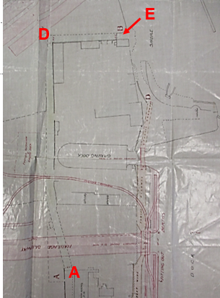
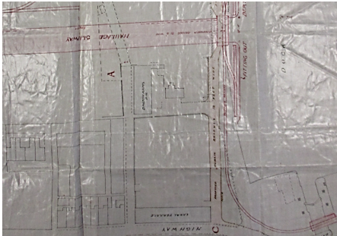
Observations |  | An order was made at Lancaster Quarter Sessions following an application made by Mr John William Nicholson and Mr James Nicholson to facilitate the development of the shipyard.  The Order sought to divert a route shown on the Order plan and described as being between points A and B (i.e. between Committee Plan points A and E) to a route to the east and shown between points C and D (not shown on Committee Plan).  The route to be diverted is described as a 'public highway' leading from Glasson to the foreshore and the new highway to be created was said to be a more commodious route for the public travelling along the highway with or without horses, carts or carriageways. Both the route to be stopped up and the route to be created were described as providing access to the foreshore.  The route to be diverted is largely consistent with the application route between point A and point E although the colouring on the plan appears to show the route to be diverted only extending as far as the south western end of the Custom House rather than through to the shore.  There is no reference to the rest of the application route in the order and the remainder of the application route is not marked on the order plan.  The Quarter Sessions Order stated that the existing route (i.e. part of the application route) would be stopped up on completion of the new highway.
Investigating Officer's Comments |  | A route between point A and point E existed in 1918 and appeared to have been considered a public vehicular highway. There is no evidence that the diversion order was implemented (as illustrated in Parish Council Minutes detailed later in this report) suggesting that the order route remained as the public vehicular access route to the foreshore.
1929 Handover Map | 1929 | In 1929 the responsibility for district highways passed from district and borough councils to the County Council. For the purposes of the transfer, public highway 'handover' maps were drawn up to identify all of the public highways within the county. These were based on existing Ordnance Survey maps and edited to mark those routes that were public. However, they suffered from several flaws – most particularly, if a right of way was not surfaced it was often not recorded.  A right of way marked on the map is good evidence but many public highways that existed both before and after the handover are not marked. In addition, the handover maps did not have the benefit of any sort of public consultation or scrutiny which may have picked up mistakes or omissions.
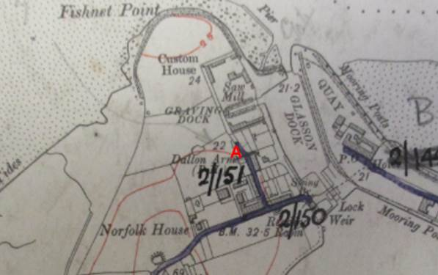
Observations |  | Except for a very short section near point A, and then not exactly the same alignment, the application route is not shown on the 1929 Handover Map including that part of the route between point A and point E which had previously been identified as a highway in the Quarter Sessions records. If the Quarter Session diversion had taken place and the new route to the east constructed it was not shown as a publicly maintainable route.
Investigating Officer's Comments |  | The 1929 Handover Map provided a record of highways considered to be publicly maintainable by the districts. No inference can be drawn with regards to the existence of public rights along a route by the fact that it was not recorded as being publicly maintainable but it appears that the application route was not considered to be a publicly maintainable highway in 1929.
25 Inch OS Map | _{C}1930 | Further edition of 25 inch map published as the third edition in the 1930s.
Observations |  | A copy of the third edition OS map is not held by the County Council and has not been viewed.
Investigating Officer's Comments |  | No inference can be drawn.
Aerial Photograph | 1940s | The earliest set of aerial photographs available was taken just after the Second World War in the 1940s and can be viewed on GIS. The clarity is generally very variable.
Observations |  | The 1940s aerial photograph is of poor quality and it is not possible to determine whether the route under investigation existed on the ground.  It does however appear that between point E and point K the land crossed by the application route was undeveloped and most probably used for agricultural purposes.
Investigating Officer's Comments |  | No inference can be drawn.
6 Inch OS Map | 1955 | The OS base map for the Definitive Map, First Review, was published in 1955 at a scale of 6 inches to 1 mile (1:10,560). This map was revised before 1930 and is probably based on the same survey as the 1930s 25-inch map.
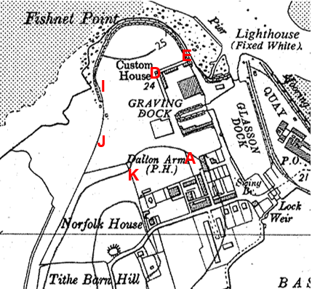
Observations |  | The map does not show Ten Row continuing through to point A or a link between point A and point D. A route is shown between point D and point E but the rest of the route through to point K is not shown.
Investigating Officer's Comments |  | There is uncertainty regarding the route from Ten Row through point A to point E and it may be that the former route to the Customs House, the shore and other buildings had become less significant in the first half of the 20th Century.  The route under investigation probably did not exist from point E to point K at the time.
Aerial photograph | 1960s | The black and white aerial photographs taken in the 1960s.
Observations |  | An aerial photograph of the land crossed by the application route was not available to view.
Investigating Officer's Comments |  | No inference can be drawn.
1:2500 OS Map | 1971 | Further edition of 25 inch map reconstituted from former county series and revised in 1970 and published 1971 as National Grid series.
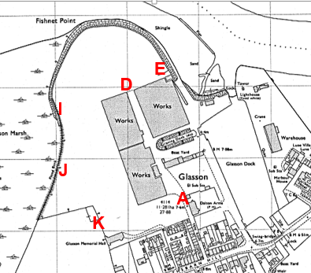
Observations |  | Additional industrial buildings are shown to exist to the west of the application route between point A and point D with access to them shown via Ten Row and through point A. A route between point A and point D appears accessible. At point D a dashed line can be seen across the route which may indicate a change in surface. The route between point D and E appears to be available but is no longer shown as a bounded route and a big industrial works unit has been erected along the southern boundary. The Customs House is shown but is not named on the map. A line is shown across the route at point E suggesting that a boundary still existed along this section. The route between point E and point K is not shown but appeared to cross agricultural land. South east of point K the Memorial Hall is shown.
Investigating Officer's Comments |  | Access may have been available from point A to point D and possibly to point E. The application route between point E and point K probably did not exist.
The Lancashire County Council (Ten Row, Glasson Dock, Lancaster Rural District) (Prohibition of Driving) Order, 1972 | 1972 | Order made on 26th September 1972 to prohibit the driving of vehicles in that length of Ten Row, Glasson Dock at a point 110 yards north of its junction with Tithebarn Hill. The Order came into force on 3rd October 1972.
Observations |  | Linked to the creation of a new access road providing access to the industrial estate (Bodie Hill) in the early 1970s was an order made by the County Council to stop vehicles accessing the industrial area along Ten Row. The order provides that "no person shall cause any motor vehicle to proceed in that length of Ten Row…at a point 110 yards north of its junction with Tithebarn Hill." This ties in with the fact that it was intended to divert traffic, and particularly heavy dock traffic, from Ten Row via Tithebarn Hill and the new access road and to this end it was intended to stop vehicles proceeding along Ten Row beyond a point approximately 10 metres north east of point A. No plan was included with the Order.
Investigating Officer's Comments |  | The Prohibition of Driving Order stops people from exercising the vehicular rights but does not extinguish those rights. It is not quite conclusive proof of public vehicular rights because such an Order can be made in relation to private rights although this would be unusual.
Thurnham Parish Council Minute Books | 1894-1938 and 1950-1979 | Minute books deposited in the County Records Office were inspected.
Observations |  | Thurnham Parish Council Minute books were inspected and the following references to the application route between point A and point E were found:  19 June 1918 – Discussed proposed diversion of 'the road' and adjourned until their next meeting as there was concern about the proposed new access point onto the shore.  25 June 1918 – Council met again to discuss proposed diversion but meeting adjourned again until revised plan was submitted by Mr Nicholson.  31 July 1918 – Revised plan provided and lengthy discussion was noted. The matter was not settled but was adjourned again.  4 September 1918 – Further meeting at which the Parish Council agreed to the diversion as shown on a revised plan. The route to be diverted was described as a 'public highway' and it was agreed that the parish clerk would be instructed to give notice of the resolution as prescribed in the Local Government Act 1894.  3 December 1918 – the Parish Council confirm the resolution agreed on 4 September and again refer to the diversion of a public highway 'to the shore'.  30 May 1922 – The Minutes refer to an 'old highway' through the docks and the fact that it had been closed and no alternative provided as had been agreed on August 23rd 1919. It was agreed that the Parish Council should write to Lancaster Rural District Council to make sure that the old route was retained until the new route was provided.  19 August 1922 – Response from Lancaster Rural District Council read out stating that the access through the ship yard was available night and day to gain access to the shore and that the Rural District Council were not pressing for completion of work at present.  3 February 1926 – It was proposed that a letter be sent to Lancaster Rural District Council asking if the road which led from the Dalton Arms to the Customs House could be reopened.  23 August 1926 – the response from Lancaster Rural District Council was read out as follows: "with reference to the diversion of a road at Glasson Dock. I am directed to inform you that from inquiries made it has been ascertained that it is proposed to complete the slipway as soon as the position is favourable, a road has and is being maintained to the shore as promised and the council is not prepared to take any steps in the matter at present."  25 March 1929 – It was reported that a letter was to be sent to Lancaster Rural District Council about the bad state of the north end of Ten Row.  Further Minutes were checked up until 1938 with no reference to the application route found.  Minute books from 1950 up until 1979 were also checked:  25 May 1964 – Report that Glasson Dock Ltd were to be asked if vehicles arriving and leaving their works could use West Quay and the car park that they had made on the side of the incomplete slipway instead of Ten Row.  27 June 1964 – Glasson Dock Ltd were reported to be prepared to give a stretch of land 20 feet wide from the back of the shipyard offices adjoining Ten Row to the Quayside with the proviso that the road was constructed and maintained by the County Council and that the Court Order of 1919 was not rescinded and that they could close off Ten Row by means of a large gate to be chain fastened and a small gate for the use of pedestrians only, thus precluding vehicles. The Parish Council resolved to pass details of the offer to the County Council.  6 January 1970 – The Parish Council reported that they had been consulted about the closure of Ten Row to vehicular traffic at the northern end of the Dalton Arms. Council in general agreement but stated 'The closure should not restrict pedestrian traffic. The right of way along Ten Row to the Customs House must be maintained.  7 December 1970 – Parish Council agree to request Nicholson's to re-instate road to Customs House to a decent useable condition.  2 August 1970 – Parish Council decide to request Lancashire County Council clean up the 'road' from Ten Row to the Custom House and have it made available for the passage of mechanical vehicles.  4 October 1971 – Complaints about the condition of the 'road to the Customs House' would be noted and that the Parish Council would await a response from the County Council.  8 November 1971 – With reference to the road to the Customs House a letter from Lancashire County Council (Ref F/RAB/A53) was read out. The letter stated that from the evidence available the clerk had formed the view that the road is a public right of way and that "it is not maintainable by the County Council at public expense over its whole length, only from Tithebarn Hill to a point near to the gatepost at the northern end of Dalton Arms Hotel. Beyond that point the public right of way lies over a private occupation road and is privately maintainable. Beyond that point the public right of way may be subject to the private rights of those entitled to use the occupation road as a private road. The position is not however entirely free from doubt.' The Minutes state that the Parish Council decided to request Nicholson's to 'honour promise made'.  17 April 1972 – The minutes again make reference to 'Custom House Road' and state that the Council decided to request Nicholson's (G.D.) Ltd. To fulfil Mr Kenyon's promise to re-instate the road.  8 May 1972 – Again under the title 'Customs House Road' it was reported that Nicholson's Ltd had sent an apology for not answering previous letters and stated that they were having a slight dispute with the Port Commissioners regarding ownership of roads and also in view of the yacht club development it would be inappropriate to reinstate the road at this time. The Parish Council considered that the matter had been going on for too long and decided that a further request should be sent for the route to be reinstated.  12 March 1973 – It was reported that Nicholson's were going to resurface the road to the Customs House but had stopped because the Port Commission were claiming the road.  1 October 1974 – it was reported that the Parish Council were to ask Lancaster City Council to work on 'Custom House Road' to improve its condition.  5 November 1974 – Report that Lancaster City Council had contacted them to ask the location of 'Custom House Road'.  7 January 1975 – A letter from Lancaster City Council stated that the Port Commissioners claimed to own the land and didn’t agree with the Parish Council's claim on its use. They stated that as the road was not a public highway they could not ask Lancashire County Council to carry out repairs and that they were surprised that the road was not on the Definitive Map. It was reported at the meeting that at the time that the footpath survey was carried out in the 1950s the road was an open road, the continuation of Ten Row and so, like Ten Row (and other roads in the parish) was not claimed. The parish council decided to ask the Port Commission to do the work.  4 February 1975 – Receipt of a letter from the Port Commission saying that they would improve the road was discussed.  4 March 1975 – It was reported that the Port Commissioners had carried out improvements.  Minutes of meetings up to 1980 were inspected and no further reference to the route was found.
Investigating Officer's Comments |  | With regards to a route from Ten Row to the shore (including the application route between point A and point E) the Parish Council Minutes confirm the belief that the route from Ten Row to the Shore was a public right of way and that the diversion route agreed was never implemented following the Quarter Sessions Diversion Order. They also confirm the belief that the route was not a publicly maintainable highway and that the landowners accepted this and maintained the route so that it could be used by the public.  No references were found to the application route between point E and point J suggesting that it was probably not considered to be a public right of way during that time.
Agenda Items and Minutes of Reports presented to Lancashire Public Rights of Way Sub Committee | 1985 | Agenda Item and Minutes of report submitted to the County Council's Public Rights of Way Sub Committee in respect of a further application made by Thurnham Parish Council to record routes to the Definitive Map and Statement.
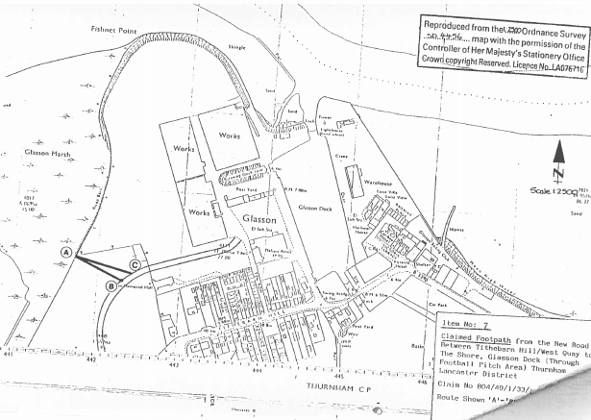
Observations |  | In addition to the application to record a byway open to all traffic from Ten Row to the Shore Thurnham Parish Council also submitted a claim for two other public footpaths across the same land as the application route now under investigation between point I and point J. In July 1985 the County Council's Public Rights of Way Sub Committee considered both the application for the byway open to all traffic and an application for two other routes shown on the plan above.  In the description of the route claimed as a byway the route is described as providing access to the foreshore by the old customs house and it is also noted from the end of the claimed byway there was a path along the road to the sailing club and to the flood bank to link with another claimed route (804-49) but that this route was not the subject of any claimed status.  Claim 804-49 was for two public footpaths extending from two points on the road now known as 'Bodie Hill' to the shore across land to the south west of the application route between point I and point J.  One route is described as descending a set of concrete steps to follow alongside a fence to a stile providing access onto the shore (shown as A-B on the 1985 Committee plan) and it was noted that the landowning company had stated that when Ashley Bending provided the football pitch, the route alongside the fence and the stile were provided for public use. The other route is again described as descending man-made steps and following a surfaced path to the football pitch and continuing to the stile providing access to the salt marsh (shown as A-C on the 1985 Committee plan). Committee accepted the claim for route A-B and rejected A-C and there was no reference to the existence of the current application route between points I-J (on the 2017 Committee plan).  An order was made for the route A-C but it received objections. A local public Inquiry was held on 4 May 1994 at which it was reported that the Parish Council had withdrawn support for order as they now considered that the route was originally provided for access to the football pitch which no longer existed. The County Council, in light of the Parish Council's decision, also decided to withdraw support for the order. The Order was not confirmed.
Investigating Officer's Comments |  | Use of a route through the Sailing Club to link to the two claimed footpaths A-B and A-C was referred to as passing along the road to the Sailing Club but does not appear to be the same route as that now claimed suggesting that the application route may not have existed on the alignment claimed between point E and point J in 1985.
Letter from the Lancaster Port Commission to the Chief Executive/Clerk of Lancashire County Council | 1986 | A search of the County Council's records was made in relation to the application made by Thurnham Parish Council to record a byway open to all traffic along part of the application route.
Observations |  | In response to a letter consulting the Port Commission about the application to record a byway open to all traffic from Ten Row to the Shore the Chairman of the Commission responded in writing on 10th June 1986 stating, 'We have always understood that Ten Row was constructed by the Lancaster Port Commission as an alternative access to the shore when the dry dock was built and that there is a public right of way for all purposes over this unadopted highway. At one time before Glasson Dock Church was built this would be the public road, via ferry or ford, to Overton Church.'
Investigating Officer's Comments |  | The Port Commission believed the application route between Ten Row and point E to be a historical public route in the 1980s and confirmed the view expressed elsewhere that it was privately maintainable.
Aerial Photograph | 2000 | Aerial photograph available to on GIS.
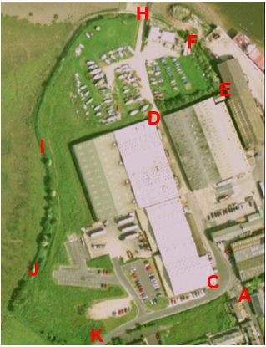
Observations |  | The photograph shows that the link from Ten Row to Bodie Hill existed and that access appeared available from point A to point C.  The route through the industrial area from point C to point D also looked to be open and available with access to the sailing club just beyond point D.  The route between point D and point E cannot be clearly seen but appears to be bounded on the south side by buildings and to the north by a hedge separating it from the sailing club.  Access through the boundary at point E is not visible and the route cannot be seen between point E and point F. A building – possibly the warden's caravan – is visible at point F with further buildings between point G and point H with no clearly visible route.  The slipway at point H can be seen although it is not possible to see whether access was available across it.  Between point H and point I the area is open with what appear to be a few parked cars (or boats) but traces of a walked route can be seen which are consistent with the application route.  Access at point I appears to be open with no fencing and a trodden track is visible to point J. The route is not visible between point J and point K although it crosses open grassland. It is not possible to see whether access is available onto the route at point K.
Investigating Officer's Comments |  | Parts of the route appear to have existed in 2000 but the full length of the application route did not appear to be in existence.
Aerial Photograph | 2010 | Aerial photograph available to view on GIS.
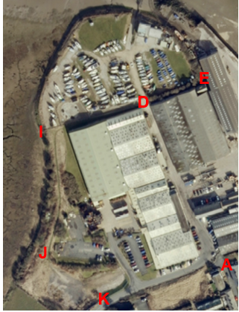
Observations |  | The route from point A to point D can be clearly seen and appeared to be available to use. The route between point D is in shadow and it is not possible to see whether it was available or whether there was a gate at point D or any access at point E. A route around the headland across the sailing club site from point E to point I is not visible on the photograph. Fencing across the route at point I can be seen and there is no worn track visible through it. A worn track can be seen which appears to lead from the track to the pumping station towards point I and then follows a route closely matched to the route of the application route between point I and point J. Access may have been available between point J and point K but it is not possible to see whether access was available through the existing fencing at point K.
Investigating Officer's Comments |  | The application route probably existed between point A and point D and a route close to, but not exactly along the application route may have been in use between points H and point I.
Definitive Map Records |  | The National Parks and Access to the Countryside Act 1949 required the County Council to prepare a Definitive Map and Statement of Public Rights of Way.  Records were searched in the Lancashire Records Office to find any correspondence concerning the preparation of the Definitive Map in the early 1950s.
Parish Survey Map | 1950-1952 | The initial survey of public rights of way was carried out by the parish council in those areas formerly comprising a rural district council area and by an urban district or municipal borough council in their respective areas. Following completion of the survey the maps and schedules were submitted to the County Council. In the case of municipal boroughs and urban districts the map and schedule produced, was used, without alteration, as the Draft Map and Statement. In the case of parish council survey maps, the information contained therein was reproduced by the County Council on maps covering the whole of a rural district council area. Survey cards, often containing considerable detail exist for most parishes but not for unparished areas.
Observations |  | The route under investigation was not shown on the Parish Survey map for Thurnham.
Draft Map |  | The parish survey map and cards for Thurnham were handed to Lancashire County Council who then considered the information and prepared the Draft Map and Statement.  The Draft Maps were given a “relevant date” (1st January 1953) and notice was published that the draft map for Lancashire had been prepared. The draft map was placed on deposit for a minimum period of 4 months on 1st January 1955 for the public, including landowners, to inspect them and report any omissions or other mistakes. Hearings were held into these objections, and recommendations made to accept or reject them on the evidence presented.
Observations |  | The route under investigation was not shown on the Draft Map of Public Rights of Way and there were no representations made to the County Council in relation to it.
Provisional Map |  | Once all representations relating to the publication of the draft map were resolved, the amended Draft Map became the Provisional Map which was published in 1960, and was available for 28 days for inspection. At this stage, only landowners, lessees and tenants could apply for amendments to the map, but the public could not. Objections by this stage had to be made to the Crown Court.
Observations |  | The route under investigation was not shown on the Provisional Map of Public Rights of Way and there were no representations made to the County Council in relation to it.
The First Definitive Map and Statement |  | The Provisional Map, as amended, was published as the Definitive Map in 1962.
Observations |  | The route under investigation was not shown on the First Definitive Map of Public Rights of Way.
Revised Definitive Map of Public Rights of Way (First Review) |  | Legislation required that the Definitive Map be reviewed, and legal changes such as diversion orders, extinguishment orders and creation orders be incorporated into a Definitive Map First Review. On 25th April 1975 (except in small areas of the County) the Revised Definitive Map of Public Rights of Way (First Review) was published with a relevant date of 1st September 1966. No further reviews of the Definitive Map have been carried out. However, since the coming into operation of the Wildlife and Countryside Act 1981, the Definitive Map has been subject to a continuous review process.
Observations |  | The route under investigation is not shown on the Revised Definitive Map (First Review).
Investigating Officer's Comments |  | From 1953 through to 1975 there is no indication that the route under investigation was considered to be a public right of way by the Surveying Authority. There were no objections to the fact that the route was not shown from the public when the maps were placed on deposit for inspection at any stage of the preparation of the Definitive Map.
Lancashire County Council Highway Adoption Records |  | The County Council is now required to maintain, under section 31 of the Highways Act 1980, an up to date List of Streets showing which 'streets' are maintained at the public's expense. Whether a road is maintainable at public expense or not does not determine whether it is a highway or not.
County Council Highway Records (undated)
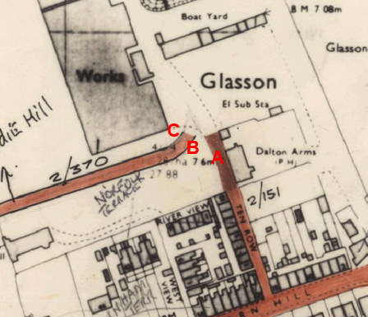
Observations |  | The County Council's records show the publicly maintainable extent of Ten Row. They do not show any part of the application route as being publicly maintainable with the exception of a very short section where the application route crosses Bodie Hill between point B and point C.  The 'adoption' card for a route described as 'un-named road' (Bodie Hill Sept 1994) was found with the reference 2/370. The route is described as "New road from Tithebarn Hill Glasson Dock at 2/150 to Nicholson's Factory and Ten Row." It is noted that the new road does not connect to Ten Row 2/151 but that it connects with "that length of Ten Row extending northwards in front of Ashley Bending Company bldgs and between the buildings on the respective sides of the road & is a 'Public Right of Way' privately maintained by the Ashley Bending Company." It is also noted "see file 2/4 Oct 1971."
Investigating Officer's Comments |  | This information is consistent with information provided to the Parish Council by the County Council in 1971 which referred to a public highway which was not maintainable at public expense. No inference can be drawn regarding the class of public rights.
Statutory deposit and declaration made under section 31(6) Highways Act 1980 |  | The owner of land may at any time deposit with the County Council a map and statement indicating what (if any) ways over the land he admits to having been dedicated as highways. A statutory declaration may then be made by that landowner or by his successors in title within ten years from the date of the deposit (or within ten years from the date on which any previous declaration was last lodged) affording protection to a landowner against a claim being made for a public right of way on the basis of future use (always provided that there is no other evidence of an intention to dedicate a public right of way).  Depositing a map, statement and declaration does not take away any rights which have already been established through past use. However, depositing the documents will immediately fix a point at which any unacknowledged rights are brought into question. The onus will then be on anyone claiming that a right of way exists to demonstrate that it has already been established. Under deemed statutory dedication the 20 year period would thus be counted back from the date of the declaration (or from any earlier act that effectively brought the status of the route into question).
Observations |  | No Highway Act 1980 Section 31(6) deposits have been lodged with the County Council for the area over which the route runs.
Investigating Officer's Comments |  | There is no indication by a landowner under this provision of non-intention to dedicate public rights of way over their land.

The affected land is not designated as access land under the Countryside and Rights of Way Act 2000 and is not registered common land. It is not part of the adjacent Site of Special Scientific Interest (SSSI) but is designated as part of a conservation area.

Summary

A route from point A on Ten Row to the shore beyond point E is consistently shown on OS maps from the 1800s as a substantial route which appeared to be capable of being used by all types of vehicles.

Parish Council records, the Finance Act records of 1910, the fact that it was the subject of a Diversion Order made in the Quarter Sessions in 1918 and subsequent correspondence and records referring to it as a privately maintainable public rights of way which was maintained by landowners – often following requests made by the Parish Council taken together provide good evidence of the existence of a historical vehicular public highway from Ten Row to the foreshore by the Customs House. The 1929 Handover Map supports the existence of vehicular rights although not private maintainability.

The Order made in 1991 to record this part of the route as a byway open to all traffic was not confirmed by the Planning Inspectorate but the decision letter does not appear to take into account the historical evidence but rather does not confirm it following withdrawal of support.

If there were vehicular rights on A-E consideration would need to be given to whether these have been extinguished by the Natural Environment and Rural Communities Act 2006 and if they have not been extinguished whether or not the main use is by mechanically propelled vehicles.

The Natural Environment and Rural Communities Act 2006 extinguished all public rights for mechanically propelled vehicles except for certain exemptions. The most likely exemptions in this case would be if it was on the List of Streets or if it was mostly used by mechanically propelled vehicles in the relevant 5 year period prior to commencement of the 2006 Act. The Highways records in the form of the map on GIS suggests that it was not recorded – whether it should have been (copied from the 1929 map) or not (because of the evidence that it was not publicly maintainable) is not relevant because the legislation only specified whether it was so recorded not whether it should have been. In the absence of evidence with regard the balance of use in the relevant 5 years period the mechanically propelled vehicle rights are taken to be extinguished.

As any mechanically propelled vehicle rights were extinguished by the Natural Environment and Rural Communities Act 2006 it is not necessary to consider the current balance of user.

Despite the amount of information provided there is little map, documentary or photographic evidence to support the existence of the application route from point E through to point K and recent site evidence does not indicate evidence of this route existing beyond point E. There does however appear to be evidence that some access has existed over the site now occupied by the Sailing Club and over the land crossed by the application route between points I-J-K but that there was no consistent use of the application route and that various different routes had been used over and across the land.

Information from the applicant

User evidence submitted by the applicant

Thirteen user evidence forms were submitted with the application and the salient points from each are summarised below.

Use of the route was for 50 years (1960-2010), 30 years (1980-2010), 29 years (1982-2011), 55 years (1953-2008), 44 years (1964-2010), from 1983 onwards (dates not clearly specified), 50 years (dates not specified), 30 years (1940's – 1970's), 30 years (1970-2000), 41 years (1967-2008), 6 years (1964-1970), 5 years (1982-1987) and 3 times in total during the 1990s.

User 1

Used from 1960-2010 (50 years) between 20 and 100 times a year.
Use was to get to Fishnet Point.
Use on foot and also use of part of route with vehicles between 1975-2010.
Recalls stile and adjacent gate not locked until 2009 when a lock requiring a £1 coin to open it was put on gate.
Never asked for or been given permission to use the route but challenged verbally on 31 January 2010.
Provided 7 undated photographs, three of which are included below. The first two photographs show a gate north of point D through which it appears that the user gained access to the Sailing Club and which they appear to have been using as part of the route to which his evidence refers.
The plan attached to the user evidence form indicates use of parts, but not of all of the application route.

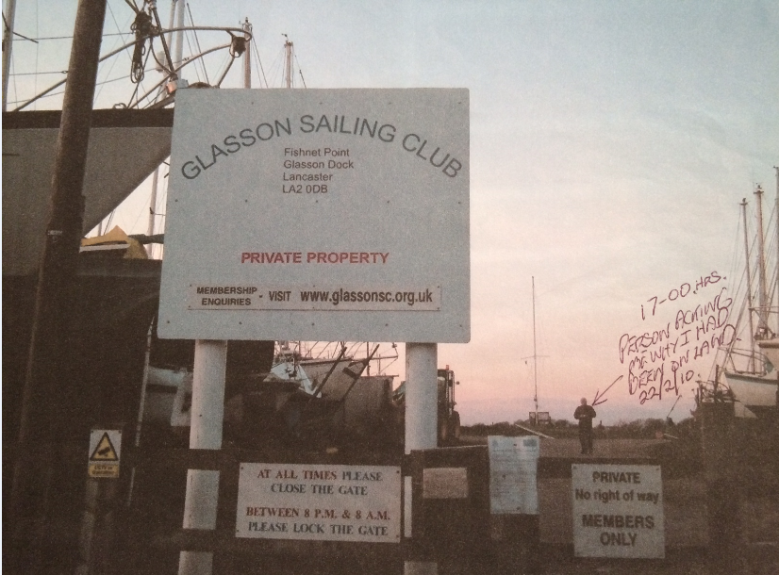
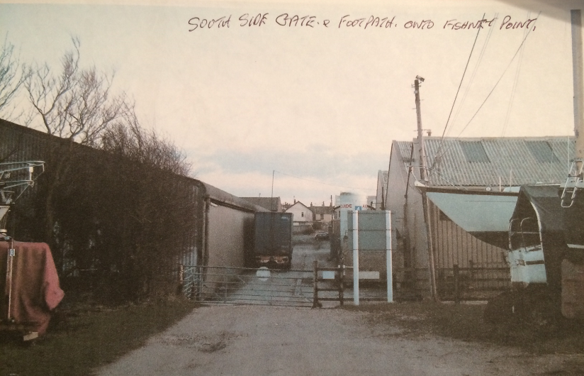
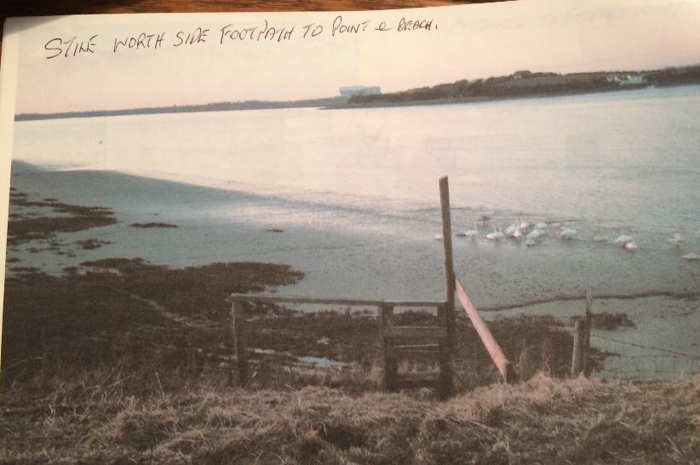

User 2

Used route 1980 'until present (i.e. when closed off)' – sometimes 7 days a week
Use was on foot to gain access to Sailing Club.
Refers to small gate at entrance to Sailing Club which was fenced off in approximately 2008 and a stile at far end of Fishnet Point – neither of which are on the application route.
Refers to a friend being turned back from using route in 2008 and that he was told by Sailing Club Committee member that there was no public right of way in 2010.
Says that there are private signs at the entrance to the Sailing Club and a coin operated gate.
Refers to slipway historically being for public use.
The plan attached to the user evidence form indicates use of parts, but not of all of the application route.

User 3

Used route 1982 – 2011 (29 years), often twice a day to walk dogs. Also refers to occasional use of part of route to ride horse to gain access to the shore.
Refers to route altering as a result of Sailing Club erecting fencing.
When the Sailing Club erected fencing says that she was told 'several years ago' by them that there was no rights of way.
Still walks across part of the land to the east of the factories twice a day to walk dogs but unable to use application route since Sailing Club erected gates and signs.
The plan attached to the user evidence form indicates use of only a short section of the application route.

User 4

Used route on foot between 1953 to 2008 (55 years)
Used frequently in the summer and less often in winter
Never stopped or challenged and never given permission to use the route.
Stopped using the route when a gate was erected and locked behind the Custom House.
No plan was provided showing the route claimed to have been used.

User 5

Used from 1964 onwards (44 years)
Used on foot to walk to Fishnet Point approximately 5 times a year.
Never stopped or challenged and never sought or given permission to use the route but a family member had been stopped at the entrance to the Sailing Club in approximately 2008.
Refers to private signs and gate at entrance to Sailing Club.
The plan attached to the user evidence form indicates use of parts, but not of all of the application route.

User 6

Used part of the route from point A to the slipway from 1983 'onwards' (28 years?). Use was described as 'frequent'
Refers to being challenged but does not provide dates. States that they were told that they couldn't walk there as it was private land.
The plan attached to the user evidence form indicates use of parts, but not of all of the application route.

User 7

Used for 50 years (dates not specified)
Use described as being on foot and every day when children where young.
Refers to the existence of a stile providing access to the beach and taking children to the beach and to play on the football pitch before it was made into a car park.
Never stopped or challenged and never given or sought permission to use the route.
The plan attached to the user evidence form indicates use of all of the application route.

User 8

Used between 1940s and 1970s (30 years plus)
Used every day on foot, in a car or a van.
Refers to a gate near the Customs House (close to point E) always being unlocked.
Never stopped or challenged and never given or sought permission to use the route and states that as a person who had lived from birth (1933) in Glasson, that fishermen, boat owners and villagers had free access to the route. Explains that fishermen historically dried their nets between point D and point E on the Committee plan and that Fishnet Point was used to grow grain by the Lambs during the war years.
The plan attached to the user evidence form indicates use of parts, but not of all of the application route and appears to show access from point D to the sea wall rather than through the wall at point E

User 9

Used route described as being from Nicholson's, Glasson Dock to Blackpool between 1964 and 1970 (6 years)
Employed as lorry driver and would use land now occupied by Glasson Sailing Club to turn lorry round.
Makes no reference to using the application route on foot or seeing other use it.
No plan is attached to the user evidence form indicating which parts of the application route had been used.

User 10

Used route from 1970 – 2000 (30 years)
Used route from Customs house to Bodie Hill on foot for pleasure approximately 20-30 times a year but no reference to using route between point A and point D on the Committee plan.
States that route has always run along the same route with the only change being that the wooden slipway was replaced by concrete.
Refers to a stile near the village hall and one providing access onto the marsh.
Never stopped or challenged and never given or sought permission to use the route.
The plan attached to the user evidence form indicates use of parts, but not of all of the application route.

User 11

Used the route in 1967 and 1968 and 'then occasionally' until c2008. (41 years)
Used on foot for pleasure to walk a circular route.
Refers to existence of stile providing access onto marsh.
Never stopped or challenged and never given or sought permission to use the route but understood that a group of ramblers were challenged in 2010.
Refers to recent fencing and private signs being erected (c. 2008).
The plan attached to the user evidence form indicates use of all of the application route.

User 12

Used a route to access the shore, football pitch and play area from 1982 – 1987 (5 years) but not clear from form whether he used all of the application route.
Used on foot approximately 5-6 times a year.
Never stopped or challenged and never given or sought permission to use the route and refers to land being used for a football pitch and not private.
The plan attached to the user evidence form indicates use of parts, but not of all of the application route.

User 13

Used during the 1990s – possibly on 3 occasions
The plan attached to the user evidence form marks a different route to the application route.

Comments on user evidence submitted

Persons completing the user evidence forms have not been interviewed to clarify the exact route used. However, there are a number of references to the gated access into the Sailing Club (north of point D) through which they gained access to Fishnet Point via a stile which provided access from the Sailing Club land to the foreshore. Whilst the gate and stile could be accessed from the application route neither form part of it.

Comments on historical evidence submitted by the applicant

A substantial body of information was provided by the applicant regarding the history and management of the land crossed by the route claimed.

The applicant submits a significant amount of information about the designation of the land crossed by the route as a conservation area, its proximity to a Site of Scientific interest (SSSI) and internationally important wildlife area and numerous planning policy guidelines and policies associated with the development of such sites. Designation does not generally imply the existence of a public rights of way and in the majority of cases no specific reference could be found to the existence of the application route in the documentation referred to or supplied. The fact that the land was of environmental and historical interest may be a reason why the public may wish to walk on it or had historically used a route across it but without specific reference to the use or existence of the application route much of this information provides no relevance to the existence of public rights.

The Ordnance Survey and early commercial maps submitted have already been examined earlier in the report and all documentation submitted as part of the application has been considered with a summary and comments provided below:

Document Title | Date | Brief Description of Document & Nature of Evidence
Minutes of Lancaster City Planning Committee meeting | 1977 | Extract of Minutes of meeting held on 8 August 1977, Part II, Agenda Item 377 and 378
Observations |  | The Minutes document the approval of the Glasson Village Plan and that the area comprised within the Glasson Village plan be designated as a Conservation Area under the provisions of the Town and Country Planning Act 1971. The Minutes do not refer specifically to the Application route and the approval of the Glasson Village Plan and designation of an area as a Conservation Area does not create, confirm or imply the existence of a public right of way.
Investigating Officer's Comments |  | No inference can be drawn regarding the existence of public rights along the application route. .
Minutes of the Lancaster City Finance and Land Sub-Committee | 1977 | Extract of Minutes of meeting held on 22nd November 1977, Part 1, Agenda Item 752
Observations |  | No reference was made to the application route within the Minutes Committee discussed the possible financial implications to the City Council in the implementation of various (unspecified) proposals contained within the plan.
Investigating Officer's Comments |  | No inference can be drawn regarding the existence of public rights along the application route. .
Digitised plan taken from LCC MARIO maps showing boundary of area designated as a Conservation Area | Undated | Digitised plan available to view on LCC website.
Observations |  | The plan shows the boundary of the conservation area. It does not show the application route but examination of the plan and the alignment of the application route confirms that the route is within the conservation area.
Investigating Officer's Comments |  | No inference can be drawn regarding the existence of public rights along the application route.
Plan showing revised boundary of Glasson Conservation Area | 1998 | Plan submitted by the applicant to show revision of conservation area site boundary in 1988 and is said by the applicant to show the 'open and unobstructed route to and around the headland'.
Observations |  | The digitally created OS base map is undated and there is no key confirming the annotation used to show the boundary revision of the conservation area. The application route is not shown as a physical feature although access appears available between point A and point E. At point E a line is shown across the route and at point H the slipway is shown with no visible route across it.
Investigating Officer's Comments |  | No inference can be drawn regarding the existence of public rights along the application route.
Glasson Village Plan | 1977 according to applicant | Final Draft of plan prepared by Lancaster City Council, believed to be circa 1977
18th Century development
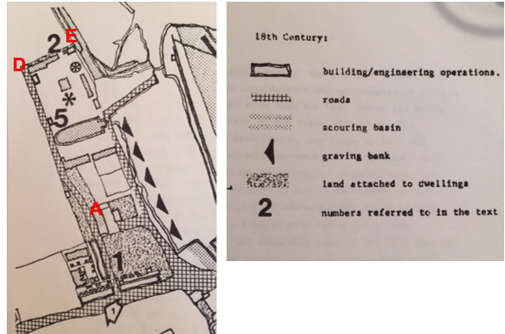
Place Map
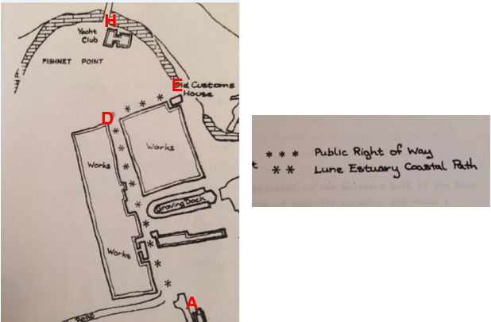
Proposals map
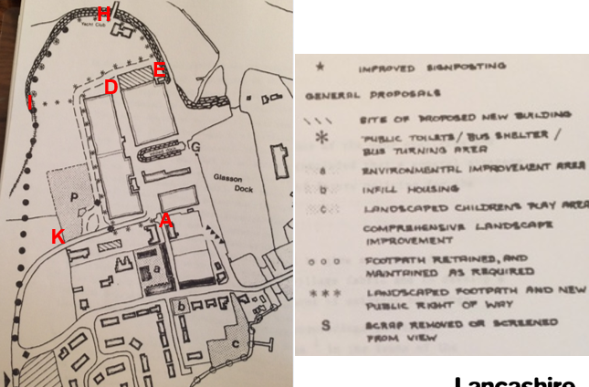
Observations |  | Various undated hand drawn plans are included in the document.  The plan titled 'Historical 18th century view' shows Ten Row and marks the application route through point A to point E, passing the Custom House, as 'road'.  The 'Place map' marks the route between A-D-E as a public right of way but not E-K.  The 'Proposals' plan shows a route described as new public right of way (asterisks) passing west of the buildings then following inside the perimeter of the sailing club to Fishnet Point, plus an east-west link. It also shows a line of asterisks inside circles, not explained in the key (combination of the 2 explained symbols would be contradictory: existing and new public right of way). However, the document states that the existing right of way through Nicholson's' complex, giving access to Fishnet Point, the Customs House and Glasson Sailing Club, should be closed and diverted via the west side of Nicholson's' buildings as shown on the proposal map. Access to the Sailing Club, The Customs House and shore to be obtained from this new right of way.  A new landscaped public footpath to be provided to give access to Fishnet Point.
Investigating Officer's Comments |  | The plans showing 18th century development reflects the view that the route along Ten Row past the Customs House was a road in the 1800s.  The 'Proposals' and 'Place' maps, taken together, suggest that at the time that the Village Plan was prepared the public were using a route to gain access to Fishnet Point through the factory site past the Customs House and either over the Sailing Club land or foreshore some of which (A-E) is consistent with the application route. It also suggests there was no route via I-J-K.
Glasson Conservation Area Appraisal | Undated | Document produced by Lancaster City Council
Observations |  | Refers to the importance of public open spaces and recognition of the marsh as an important area for birds. It notes that the Custom House is a listed building of historical interest which has been completely surrounded by industrial buildings. There is no mention of the existence of the application route.
Investigating Officer's Comments |  | Whilst providing good reasons why people may wish to use, or may have used the land crossed by the application route the document provides no evidence of actual use.  No inference can be drawn regarding public rights.
Various documents including those listed below were submitted by the Applicant in support of the application. These relate to conservation areas, amenity space, play areas, fencing, plans, policies, law, etc. but do not specifically relate to the application route.
Glasson Dock Conservation Area | 1993 | Leaflet produced by Lancaster City Council
Management of Conservation Areas – English Heritage | 2007 | Information captured from English Heritage website on 20 September 2007.
Design Guidance for properties the subject of the Article 4 Direction – Glasson Dock | 1998 | Guidance note prepared by Lancaster City Council.
Conservation Areas: A guide for developers and owners | Undated | Undated guidance note prepared by Lancaster City Council.
Extract from 'Planning Application Validation Guide' | 2007 | Guidance produced by Lancaster City Council.
Thurnham Parish Council Minutes | 1981 | Extract from Minutes of Meeting held on 3rd February 1981.
Thurnham Parish Council Minutes | 1981 | Extract from Minutes of Meeting held on 7th April 1981
Thurnham Parish Council Minutes | 1981 | Extract of Minutes of Meeting held on 7th July 1981.
Thurnham Parish Council Minutes | 1981 | Extract from minutes of meeting held on 4 August 1981, 6th October 1981, 2nd February 1982, 6th April 1982, 8th June 1982, 6th July 1982, 7th September 1982, 5th October 1982, and 9th November 1982.
Local Authority Services and Biodiversity Guidance |  | Guidance on Section 40: Natural Environment and Rural Communities Act 2006 published by the Wildlife Trusts
Planning Application 1/81/252 |  | Change of use of land for Sailing Club purposes, Fishnet Point
Lancaster District Draft Local Plan | 1996 | Extract from Draft plan provided by the applicant.
DEFRA Guidance physical existence or stator Public Authorities on Implementing the Biodiversity Duty | Undated | Extract of guidance note submitted by applicant.
Communities and Local Government Planning Policy Statement 4: Planning for Sustainable Economic Growth | Undated | Planning policy guidance
Extract from Glasson Dock Ecological Survey and Assessment | 2007 | Section of report highlighted by the applicant.
Extract of Lancaster City Development Management report | 2006 | Extract of report considering an application for a caravan to be used as a permanent residential accommodation for the Glasson Sailing Club warden.
House of Lords judgement R v. Oxfordshire County Council and Others ex parte Sunningwell Parish Council | 1999 | A copy of the 'Sunningwell' decision submitted by the applicant.
Extract from Planning (Listed Buildings and Conservation Areas) Act 1990 | 1990 | Extract supplied by applicant refers to the designation of conservation areas and general duties as respects conservation areas in exercise of planning functions.
House of Lords judgement – R v City of Sunderland (Respondents) ex parte Beresford (FC) Appellant | 2003 | Copy of judgement supplied by applicant.
Lancaster City Council (Glasson Village) Article 4 Direction 1981 and associated letters, newspaper notice and plan | 1981 | Details of a direction made by Lancaster City Council to control development to the historic parts of Glasson Dock.
Extract from Minutes of Lancaster City Council | 1965/1966
Office of the Deputy Prime Minister – Planning Policy Statement 9 – Biodiversity and Geological Conservation | Undated | Extracts of policy guidance.
Lancashire County Council Archaeology Service scheduled monument reports |  | Copies of the reports for Glasson Dock and the Custom House.
Supreme Court judgement R (on the application of Lewis) (Appellant) v Redcar and Cleveland Borough Council and another (Respondents) | 2010 | Supreme Court judgement regarding the registration of an area of land as a town or village green and the meaning of 'as of right' under the Commons Act 2006.
DoE Circular No. 15/92 – Publicity for Planning Applications | 1992 | Circular detailing publicity requirements for planning applications
Letter from Thurnham Parish Council to Lancashire County Council | 1970 | Copy of letter sent to Lancashire County Council regarding public rights of way in Thurnham.
Lancaster Local Development Framework, Development Control Policies – Issues and Options Paper | 2004 | The applicant highlighted a number of planning development policies relating to development in villages and rural areas.
Extract from National Planning Policy Framework | Undated | Provided by the applicant with highlighted sections.
Extract from Lancashire Life magazine | Undated | Extract of article about Shore Lighthouse showing a gentleman (Mr Parkinson) fishing in the Lune Estuary (photograph undated).
Investigating Officer's Comments |  | No inference can be drawn from the documents listed above with regards to public rights on the application route.
Thurnham Parish Council Minutes | 1983 | Extracts of Minutes of Meeting held on 7th June 1983 and 6th September 1983.
Observations |  | The Clerk to the parish Council reported that he had drawn up a list of routes to be submitted to the County Council with regards to updating the Definitive Rights of Way. The list included the 'extension of Ten Row between factory buildings to shore at Custom House' and a footpath from Bodie Hill 'to shore alongside boundary of football pitch area'. Minutes from September 1983 indicate that claims had been submitted but that further evidence was required.
Investigating Officer's Comments |  | Details of the claims submitted have already been considered in this report.
Hand-drawn plan of Glasson | 1957 | Hand drawn plan at a scale of 1:2500 titled 'Plan referred to Glasson' submitted by Applicant. Plan is of unknown origin or purpose.
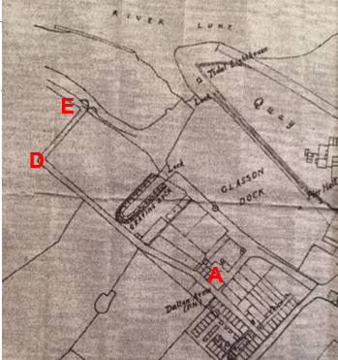
Observations |  | The plan does not show all of the land crossed by the application route but does show a route extending from Ten Row through point A to point D and then turning towards the shore to pass point E and turn north west on the strip above the foreshore. There is no key on the plan.
Investigating Officer's Comments |  | The application route existed as a through route between point A and passed point E but the plan is undated with no key so provides no evidence of public rights.
'Historic' photograph of stile at north side of footpath on Fishnet Point | unknown | Photograph submitted by the applicant. Undated but described as 'Historic'.
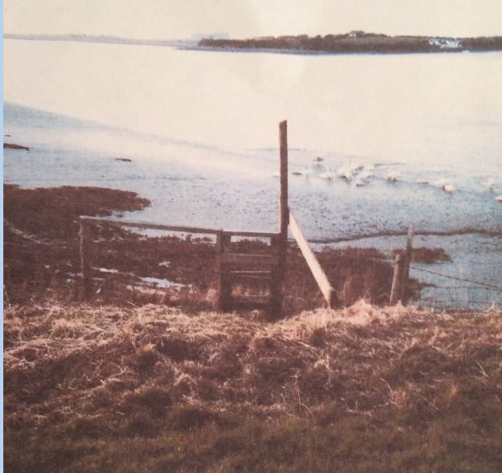
Observations |  | The stile is still in existence today and is located west of point H in the boundary fence separating the land leased by the sailing club and the salt marsh. It is not on the application route but is passed by it and could have been accessed from the route claimed or simply from the sailing club land.
Investigating Officer's Comments |  | The stile provides access to the salt marsh from the Sailing Club. It does not provide access to land open to the public. It could be accessed from the application route and may explain why the application route was used but such use could have been private.
Photograph of caravan on green area of headland | Undated | Undated photograph described as showing 'green area of headland'
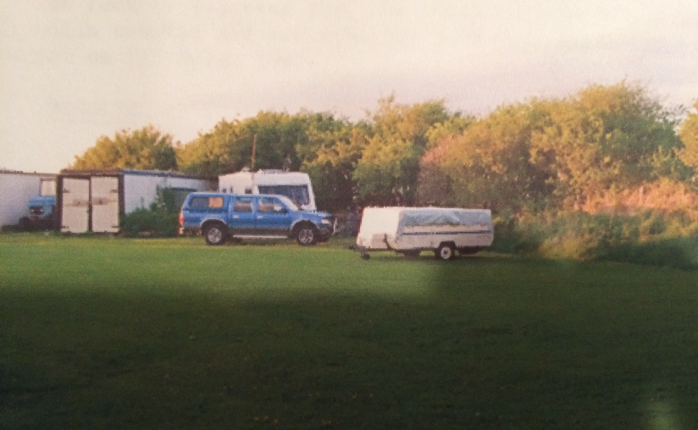
Observations |  | The photograph shows the land crossed by the application route between point E and point F. There is no evidence of a walked route and the caravan and storage units preventing use of the route between point F and G can be seen.
Investigating Officer's Comments |  | This provides no evidence regarding the existence of the application route and it appears that the route could not have been walked at this (unknown) date.
Department of the Environment Decision letter on appeal against refusal of planning permission | 1985 | Determination of an appeal against the decision of Lancaster City Council to refuse planning permission for the change of use of land at Fishnet Point for the siting of 8 mobile caravans for a maximum of 42 days per year.
Observations |  | The decision letter makes reference to a public right of way which according to the council runs along the wall of the factory building adjoining the site'. The decision letter notes that the existence of this right of way is challenged by the Sailing Club.  The location of the disputed public right of way 'along the wall of the factory building' is not known. There is no reference to the land on which the caravans were to be sited being crossed by a public right of way.
Investigating Officer's Comments |  | The reference to the existence of a public right of way may refer to part of the application route – most probably that section between point D and point E.
Aerial Photograph | 1954 | Aerial photograph submitted by the applicant.
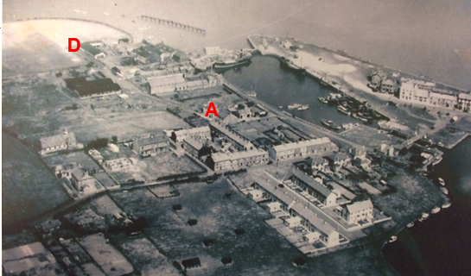
Observations |  | The aerial photograph clearly shows the application route extending from Ten Row to point D but it is not possible to see the route to point E. The headland crossed by the application route from point E to point H is shown as open farmland which may have been accessible but is too far in the distance to see whether a trodden track is visible.
Investigating Officer's Comments |  | The application route existed between point A and point D in 1954.
Aerial photograph | 1972 | Aerial photograph submitted by applicant.
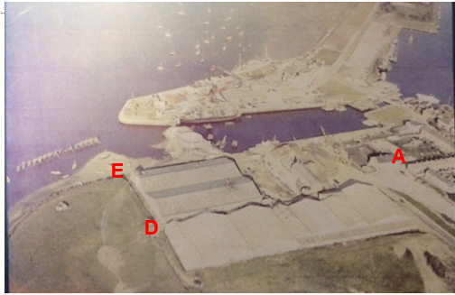
Observations |  | The photograph shows that construction of the new access road (Bodie Hill) was underway (if not complete). The application route can be clearly seen from point D and a route appears to be available past point E to the shore. It is not possible to see whether access onto the field was available at point E although there is no worn track coming from that point which would indicate any form of access. West of point E is a gateway from which a faint track can be seen joining part of the application route towards points F and G and the land crossed by the route within that field as far as point G appears open and available at that time.
Investigating Officer's Comments |  | The application route from point A through to point E appeared to exist in 1972 but appeared to provide access past point E to the shore. Access may have been available through a gateway further west and across the land now leased by the Sailing Club.

Landownership

Ownership of the land crossed by the application route is unregistered between point A and point D on the Committee section with the exception of a length of approximately 5 metres of land extending partway across the route 30 metres north north west of point C. This land – which extends east from the application route is owned by The Lancaster Port Commission, West Quay, Glasson Dock.

However, Glasson Estates Limited have indicated in response to informal consultations that they believe that they own the land crossed by the application route between point C and point D.

From point D to point K the land registry plans appear to show the land crossed by the application route owned by Glasson Estates Limited, West Quay, Glasson Dock although the Lancaster Port Commission have indicated in consultations that they own the land between point D and point E.

Deed plans have not been requested or made available to verify the exact boundaries of landownership but all interested parties have been notified about the application.

Title number LA708560 provides details of the land owned by Glasson Estates Limited. The title plan shows the boundary of the land on the eastern side as thus:

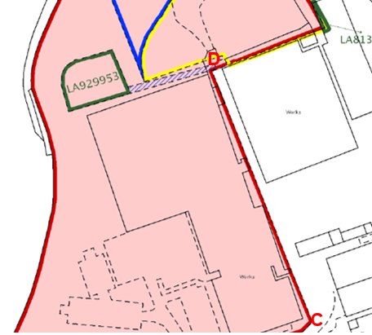

Within the register there is reference to rights preserved by a conveyance dated 1918 regarding land forming 'the road abutting upon the easterly side' of the land 'so far as the same is coextensive therewith subject to all existing rights of way there over and to the liability to bear and pay the expense of repairing the said road'. The title refers to a plan showing the road coloured brown but the current title plan does not indicate any road with colour.

Information from Others

Ramblers Association

The Ramblers Association (Fylde Group) state that they advocate the addition of unrecorded paths to the Definitive Map and Statement and that from experience and from the supporting evidence believe that the application route may have been wrongly excluded in the past.

Open Spaces Society

The Society support the application made by one of their members (the applicant) and believe that there is historical evidence that supports the modification on the basis of public use.

Information from the Landowners

Glasson Estates Limited

Glasson Estates Limited responded by providing a plan showing that they believed that they owned all of the land crossed by the application route with the exception of the land between point A and point B and point D and point E. They also provide details regarding the fact that they lease part of the land to Glasson Grain limited and Glasson Sailing Club.

They state that they are strongly opposed to the application and that with regards to historical public use the area has been fenced for a considerable amount of time, restricting public access.

Lancaster Port Commission

Lancaster Port Commission own a small area of land crossed by the application route 30 metres north north west of point C and state that they own land between point D and point E on the Committee plan and object to the application.

The area between point D and point E on the Committee plan is described as being within the port estate and is secured by a locked gate at point D which they state has been locked for at least 25 years. They also state that there is no access to the shore beyond point E due to the provision of palisade security fencing and the sea defence wall. They explain that under the SOLAS Convention and International Ship and Port Facility Security (ISPS) Code, the Port of Glasson Dock has been assessed by the Department for Transport, Maritime Security, as falling within that code, and subsequently, the Port has carried out an assessment of the port and a (Restricted) Security Plan has been drawn up and approved by the Department of Transport. The Port Commission state that the Assessment and Plan do not allow for public rights of way through the Port Estate.

They also state that they are concerned about the health and safety risks of pedestrians walking the route between point B and point D on the Committee plan due to heavy use of the route by commercial vehicles. They state that a separate marked out pedestrian route has been provided adjacent to the application route to allow access to the Port of Lancaster Smokehouse.

Glasson Grain Limited

An objection has been received from Glasson Grain Limited who operate on land crossed by the application route between point C and point D and point I and point J and then midway to point K on land which is owned by the Lancaster Port Commission and Glasson Estates Limited. They explain that they use a number of commercial vehicles and machinery for loading and unloading across the whole site which regularly travel between point B and point D on the Committee plan. They also refer to use of the area between point B and point D by heavy vehicles accessing work buildings and travelling to the weighbridge area all of which are constantly moving along and crossing the application route.

They explain that in an attempt to protect the public pedestrian traffic to the Port of Lancaster Smoke House they have already, some time ago, marked out a pedestrian walkway from where the footpath finishes at the end of Ten Row to the start of the footpath along the front of their office building and the route is shown on a map attached to their letter as being to the east of the application route. They explain that this was done to reduce the risk to the general public of clashes with industrial/commercial traffic.

Assessment of the Evidence

The Law - See Annex 'A'

In Support of Making an Order(s)

User evidence
Route A-E shown on OS maps since 1800s
Other map and documentary evidence mainly for A-E

Against Making an Order(s)

Inconsistency of the application route in the user evidence forms and the application.

Lack of map and documentary evidence supporting the existence of the route between point E and point K

Conclusion

It is advised there is no express dedication that the Committee should consider, on balance, whether there is sufficient evidence from which to have its dedication inferred at common law from all the circumstances or for the criteria in section 31 Highways Act 1980 for a deemed dedication to be satisfied based on sufficient twenty years “as of right” use to have taken place ending with this use being called into question.

Considering initially the criteria for a deemed dedication under section 31 of the Highways Act 1980, that use needs to be by the public as of right and without interruption over a sufficient 20 year period immediately prior to the route being brought into question, in order to raise a presumption of dedication. This presumption may be rebutted if there is sufficient evidence that there was no intention on the part of the landowner during this period to dedicate the route as a public right of way.

The first consideration is to determine when the route was called into question. In this matter the evidence indicates that access to the route A -E has at some point been denied with a security fence being erected close to point E preventing access down to the shore and a fence and hedge preventing access to the sailing club grounds, it is not clear when the fence/s and hedge came into existence and the applicant has not provided clarity on this matter stating that historically all routes to the headland where open. Therefore it is suggested on balance that the "calling into question" would therefore be the application date itself being November 2014 and that the 20 year period under consideration would be 1994-2014.

Considering first the section A-E; thirteen user evidence forms have been submitted in support of the claimed route, the user evidence forms suggest the route has been used since as early as 1960 as of right on foot but also that the route has been used on horseback and in vehicles. The user evidence forms vary in frequency of use and there are discrepancies by the users as to the exact route in question. In addition a number of users refer to the sailing club erecting a fence and a coin operated gate and 'private' signs preventing and restricting access in approximately 2008/2010, a few users also indicate that they or people they know have been challenged whilst walking the route preventing and restricting access across the sailing club land beyond point D. It should be noted that access through the fence/gate at point D into the sailing club yard is not part of the claimed route. It is therefore suggested that although there does appear to be some evidence to demonstrate a lack of intention to dedicate by the sailing club such actions relate to the area beyond the gate at point D only not the claimed route.

Of the thirteen users only 6 of the users indicate that they use the route A - E with the other users indicating use of a different route or failing to provide any plan with their user form. Use must be more that trivial and sporadic to be sufficient to give rise to a deemed dedication. The 6 users claim to use the route 20-100 times a year, 5 times a year, frequently, weekly, at the weekends and every day and each of those 6 claim they did so without interruption or permission, they did so for pleasure to walk dogs or gain access to the shore and marsh.

Taking all the user evidence information into account it is suggested there does not appear to be any evidence to demonstrate no intention by the land owner to dedicate over the twenty years prior to 2014.

However, deemed dedication under the Highways Act 1980 S31(1) does not apply where the land is such that use by the public could not give rise at common law to a presumption of dedication. The British Transport Commission Act 1949 S57 could have some bearing on this as it prevents rights by user being deemed after 1949 over land owned by the Commission or its successor bodies. The ownership of part of the land, in particular affecting section D-E, is disputed but if that does, or has belonged to the Lancaster Port Commission during all or part of the relevant period such deemed dedication might not have been possible.

User evidence for the remaining section E-K is inconsistent. Some users' descriptions indicate that they did not use the same route, particularly from point D where they went into the sailing club instead of along the application route. The only witnesses using the full application route appear to be users 4 (possibly), 7 & 11 from which it is not reasonable to deem dedication, nor is it possible to piece together other witnesses' use to make significant addition to this.

Considering whether dedication can be inferred on balance at common law it is advised that the Committee has to consider whether evidence from the maps and other documentary evidence coupled with the evidence on site and from witness statements/forms does indicate whether it can be reasonably alleged that the route was dedicated in the past by the owner(s) as a public right of way.

For section A-E, the analysis of the map and documentary evidence shows that a substantial route is shown on the OS maps from the 1800s and that such route appears to be capable of being used by all types of vehicles. There is also the evidence of a privately maintainable public right of way being recognised in the early 1900s which again would indicate that historically there was a vehicular public highway from A to E. Consideration should also be given to the order in 1991 which was submitted to the Planning Inspectorate for determination and the Planning Inspectorate determined not to confirm the Order on the basis that both the claimants and the County Council had withdrawn their support, the decision letter does not appear to take into account the historical evidence.

Therefore, for section A-E, it is suggested that it can be reasonably alleged that the criteria of S31 could be satisfied in this matter with respect to a public footpath and also that on balance inference of dedication at common law of a vehicular highway.

As detailed above (in the summary of the Map and Documentary Evidence) the mechanically propelled vehicle rights are believed to have been extinguished.

Taking all the evidence into account it is suggested to Committee that on a balance of probabilities there is sufficient evidence that the route ought to be added to the Definitive Map and Statement as a restricted byway between points A-E. A restricted byway means a highway over which the public have a right of way on foot, on horseback or leading a horse and a right of way for vehicles other than mechanically propelled vehicles, with or without a right to drive animals along the highway.

The historical mapping does not show that there was a path on the ground along the section E-K and the user and other documentary evidence is insufficient to reasonably allege that a right of way subsists.

Local Government (Access to Information) Act 1985

List of Background Papers

Paper | Date | Contact/Directorate/Tel
All documents on File Ref: 804-562
Reason for inclusion in Part II, if appropriate

N/A

The Ordnance Survey (OS) has produced topographic maps at different scales (historically one inch to one mile, six inches to one mile and 1:2500 scale which is approximately 25 inches to one mile). Ordnance Survey mapping began in Lancashire in the late 1830s with the 6-inch maps being published in the 1840s. The large scale 25-inch maps which were first published in the 1890s provide good evidence of the position of routes at the time of survey and of the position of buildings and other structures. They generally do not provide evidence of the legal status of routes, and carry a disclaimer that the depiction of a path or track is no evidence of the existence of a public right of way.
Aerial photographs can show the existence of paths and tracks, especially across open areas, and changes to buildings and field boundaries for example. Sometimes it is not possible to enlarge the photos and retain their clarity, and there can also be problems with trees and shadows obscuring relevant features.

