Regulatory Committee
Meeting to be held on 15 November 2017

Electoral Division affected:
Chorley Rural West

Wildlife and Countryside Act 1981
Definitive Map Modification Order Investigation
Upgrading to Bridleway of Parts of Footpaths Charnock Richard 14 and 15, Chorley known as Delph Lane
File No. 804-586
(Annex ‘A’ refers)

Contact for further information:
Claire Blundell, 01772 533196, County Secretary and Solicitors Group, Claire.blundell@lancashire.gov.uk
Jayne Elliott, 01772 537663, Public Rights of Way Definitive Map Officer, Environment and Planning, jayne.elliott@lancashire.gov.uk

Executive Summary

Application to upgrade to public bridleway parts of Footpaths Charnock Richard 14 and 15, Chorley Borough, on the Definitive Map and Statement in accordance with File No. 804-586.

Recommendation

That the application to upgrade parts of Footpaths Charnock Richard 14 and 15 to bridleway, on the Definitive Map and Statement of Public Rights of Way for Lancashire, in accordance with File No. 804-586, be not accepted

Background

An application under Schedule 14 of the Wildlife and Countryside Act 1981 has been received to upgrade to bridleway of parts of Footpaths Charnock Richard 14 and 15, known locally as Delph Lane and shown between points A-B-C-D-E-F-G on the Committee plan, on the Definitive Map and Statement of Public Rights of Way.

The County Council is required by law to investigate the evidence and make a decision based on that evidence as to whether a public right of way exists, and if so its status. Section 53(3)(b) and (c) of the Wildlife and Countryside Act 1981 set out the tests that need to be met when reaching a decision; also current Case Law needs to be applied.

An order will only be made to add a public right of way to the Definitive Map and Statement if the evidence shows that:

- A right of way “subsists” or is “reasonably alleged to subsist”

An order for upgrading or downgrading a way shown on the Definitive Map and Statement will only be made if the evidence shows that:

- "it ought to be there shown as a highway of a different description"

An order for adding a way to or upgrading a way shown on the Definitive Map and Statement will be made if the evidence shows that:

- “the expiration… of any period such that the enjoyment by the public…raises a presumption that the way has been dedicated as a public path or restricted byway”

When considering evidence, if it is shown that a highway existed then highway rights continue to exist (“once a highway, always a highway”) even if a route has since become disused or obstructed unless a legal order stopping up or diverting the rights has been made. Section 53 of the Wildlife and Countryside Act 1981 (as explained in Planning Inspectorate’s Advice Note No. 7) makes it clear that considerations such as suitability, the security of properties and the wishes of adjacent landowners cannot be considered. The Planning Inspectorate’s website also gives guidance about the interpretation of evidence.

The County Council’s decision will be based on the interpretation of the evidence discovered by officers, and documents and other evidence supplied by the applicant, landowners, consultees and other interested parties produced to the County Council before the date of the decision. Each piece of evidence will be tested and the evidence overall weighed on the balance of probabilities. It is possible that the Council’s decision may be different from the status given in any original application. The decision may be that the routes have public rights as a footpath, bridleway, restricted byway or byway open to all traffic, or that no such right of way exists. The decision may also be that the routes to be added or deleted vary in length or location from those that were originally considered.

Consultations

Chorley Borough Council

A response from the Coppull Ward District Councillor was received. He strongly supported the application and reported that he had ridden the route on a mountain bike on a regular basis for more than 20 years, always believing it to be a public bridleway.

Charnock Richard Parish Council

Following detailed discussions with residents attending the Parish Council Meeting, and the significant concerns and objections raised to the proposal, the Parish Council have stated that they strongly object to the proposed upgrading.

The comments from the Parish Council do not relate to the evidence of the status but to important potential management issues including the unsuitability of the narrow single track road for horse riders and cyclists, as well as the large number of walkers and the private vehicular and agricultural traffic to Roscoe House Farm and Roscoe House Boarding Kennels. They also refer to a significant drop into a four foot ditch adjacent to the route.

The Parish Council are extremely concerned that the safety of walkers using the route would be significantly compromised if the route is upgraded to a bridleway, and therefore maintain their strong objections to the proposals.
Applicant/Landowners/Supporters/Objectors

The evidence submitted by the applicant/landowners/supporters/objectors and observations on those comments are included in Advice – Head of Service – Legal and Democratic Services Observations.

Advice

Head of Service – Planning and Environment

Points annotated on the attached Committee plan.

Point | Grid Reference (SD) | Description
A | 5533 1679 | Open junction with adopted spur leading off A49 Preston Road
B | 5540 1675 | Junction of Footpaths 14 and 15 Charnock Richard
C | 5541 1675 | Application route passes through gate posts (no gate)
D | 5574 1663 | 3 way split in Footpath 15 Charnock Richard at Roscoe House Farm
E | 5574 1663 | Gate/metal barrier with adjacent gap across application route
F | 5591 1623 | Route meets access road to Lower House
G | 5595 1613 | Gateposts on either side of route at junction with Delph Lane (U8885).

Description of Route

A site inspection was carried out on 7th June 2017.

The application route commences at the junction with Preston Road (A49), point A, and runs south east along a rough tarmac access road past Tan House Farm, for approximately 85 metres to the access to Hamlets Retreat where Footpath 16 leaves the application route (point B).

The application route continues from point B along a tarmac access road in a south easterly direction, passing almost immediately through gateposts (no gate) at point C and continues (along part of FP 15) as a tarmac access road with mown grass verges and bounded by open ditches and fences/hedges on either side, for approximately 365 metres in a south easterly and then east north easterly direction, past Roscoe Cottage and Roscoe Farm to the entrance to Roscoe House (point D).

Footpath 15 splits with one part turning north through Roscoe House and the application route turning south east, leaving the tarmac roadway via a gap adjacent to a metal gate (point E). Adjacent to the gap is a public footpath signpost pointing along the route which continues along a tree lined path. There is a worn trod and although quite overgrown, the route is passable on foot but there is no evidence of the track being recently used by vehicles, and no hoof prints or tyre tracks indicating recent equestrian or cycle use. In places, stone resembling broken sections of cobbles was evident suggesting that the route may have been surfaced in the past.

The route descends gently downhill passing Lower House Delph (a flooded quarry) between two stone walls, with the Delph on one side and Lower House on the other, to the entrance to Lower House (point F) from where it continues as an unenclosed access road, leading from Lower House gradually uphill south east through an area of woodland to pass through gateposts where it meets the adopted highway of Delph Lane (point G).

In summary, the whole of the application route is currently recorded as a public footpath and is accessible as such. The route also provides vehicular access to properties from the A49 (Preston Road) between points A and D and also from Church Lane to properties between points G to F. The middle section of the route – between point D and point F does not appear to be used by vehicles, and although overgrowth now restricts the available width, it does appear to have been wider in the past and may have been surfaced with stone and/or cobbles.

The route would be accessible on horseback or on a bicycle – although the gap adjacent to the gate at point D is quite narrow – but there is no physical evidence of recent use by either.

The total length of the route is 1.02 kilometres.

Map and Documentary Evidence

Document Title | Date | Brief Description of Document & Nature of Evidence
Roman origins of the route |  | The applicant has asserted that part of the application route was originally a Roman road and makes reference to a study carried out by historian Ivan Margary and information contained on a website detailing research carried out by David Ratledge.  http://www.romanroads.org/gazetteer/roman1.htm
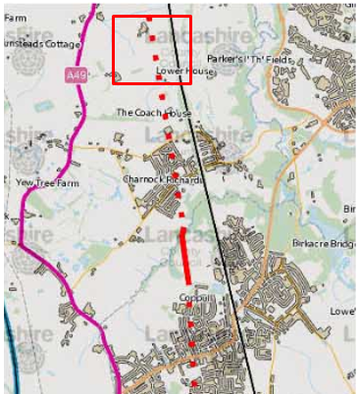
Observations |  | The information provided by the applicant refers to work undertaken to try to locate the route(s) of roman roads through Lancashire. The applicant refers to research undertaken using aerial photography, light detection and ranging and includes a map of the projected route of what was believed to be part of a roman road between Wigan and Preston. The projected route appears to correspond to the alignment of the application route between points E-F.
Investigating Officer's Comments |  | On the basis of the evidence provided by the applicant no inference can be drawn with regards to the existence of public bridleway rights.  Roman road evidence is very difficult to assess because often it involves an assertion of a conjectural line, e.g. we may know from research that a route went from Wigan to Preston for certain but cannot be sure of its exact alignment because there is no evidence on the ground after all this time. Even where tracks exist today we do not have more than a probability that a modern track follows a 17th Century road and whether that road was built over a medieval road and whether that was built on top of a Roman one or whether at any stage for unknown reasons the alignment of the route altered a bit.  Neither do we know which Roman roads were used by the public and which were used strictly for military purposes. Or whether public use was tolerated on foot but not on horse.
Yates’ Map  of Lancashire | 1786 | Small scale commercial map. Such maps were on sale to the public and hence to be of use to their customers the routes shown had to be available for the public to use. However, they were privately produced without a known system of consultation or checking. Limitations of scale also limited the routes that could be shown.
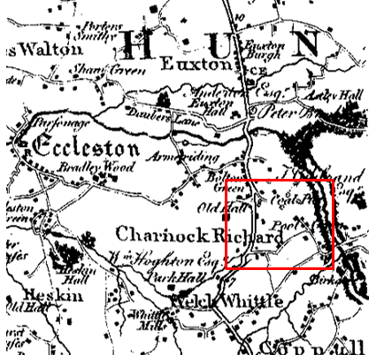
Observations |  | The start of the route at point A is shown extending east from the main route north-south (now known as the A49 Preston Road) with buildings shown on either side. The application route is not shown as continuing further than the approximate position of point B although buildings and a coal pit are marked on the map further east. The southern end of the route (from point G) is also shown as are buildings named 'poel'. The application route is not, however shown as a through route.
Investigating Officer's Comments |  | The fact that the two ends of the application route are shown suggest that the route – or part of it – may have existed in 1786. It is not known why the rest of the route was not shown on the map. It may have been that Yates did not consider the route to be a public highway or that it was unenclosed or that the hedges/fences/walls were in disrepair or possibly that this section was not surveyed, as surveys were expensive.
Greenwood’s Map of Lancashire | 1818 | Small scale commercial map. In contrast to other map makers of the era Greenwood stated in the legend that this map showed private as well as public roads and the two were not differentiated between within the key panel.
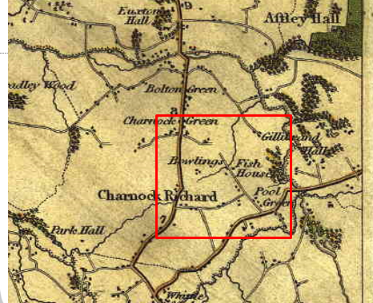
Observations |  | Most of the application route is shown but a short section is not shown from approximately point D extending south towards point F. Properties are shown along the route.
Investigating Officer's Comments |  | Most of the application route appears to have existed in 1818 but it was not shown as a through route for reasons that we do not know. Its omission does not necessarily mean that it did not exist since there are examples of other similar gaps being shown on the map on routes which did exist at the time and which were shown on other maps both earlier and later. However it could suggest that the route was not considered to be a public vehicular through route at that time or was unenclosed for that section.
Hennet's Map of Lancashire | 1830 | Small scale commercial map. In 1830 Henry Teesdale of London published George Hennet's Map of Lancashire surveyed in 1828-1829 at a scale of 71/2 inches to 1 mile. Hennet's finer hachuring was no more successful than Greenwood's in portraying Lancashire's hills and valleys but his mapping of the county's communications network was generally considered to be the clearest and most helpful that had yet been achieved.
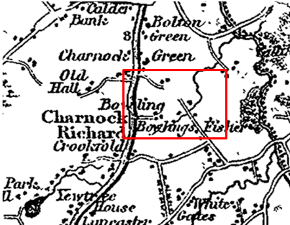
Observations |  | The application route is shown in a similar way to how it is shown on Greenwoods Map with a gap in the middle. Properties are shown along the route.
Investigating Officer's Comments |  | At least part of the application route existed in 1830. It is not known why the rest of the route was not shown on the map. It may have been that Hennet did not consider the route to be a public highway or that it was unenclosed or that the hedges/fences/walls were in disrepair or possibly that this section was not surveyed, as surveys were expensive.
Canal and Railway Acts |  | Canals and railways were the vital infrastructure for a modernising economy and hence, like motorways and high speed rail links today, legislation enabled these to be built by compulsion where agreement couldn't be reached. It was important to get the details right by making provision for any public rights of way to avoid objections but not to provide expensive crossings unless they really were public rights of way. This information is also often available for proposed canals and railways which were never built.
Observations |  | The application route is not directly affected by any proposed or constructed canal or railway. However, Delph Lane, recorded as a public vehicular highway at its southern end, meets the application route at point G. Delph Road appears to have been diverted from its original alignment when the railway between Wigan and Preston was constructed in the 1830's. A search of records held by the County Records Office in Preston was made but no reference was found to the application route.
Investigating Officer's Comments |  | No inference can be drawn.
Tithe Map and Tithe Award or Apportionment | 1842 | Maps and other documents were produced under the Tithe Commutation Act of 1836 to record land capable of producing a crop and what each landowner should pay in lieu of tithes to the church. The maps are usually detailed large scale maps of a parish and while they were not produced specifically to show roads or public rights of way, the maps do show roads quite accurately and can provide useful supporting evidence (in conjunction with the written tithe award) and additional information from which the status of ways may be inferred.
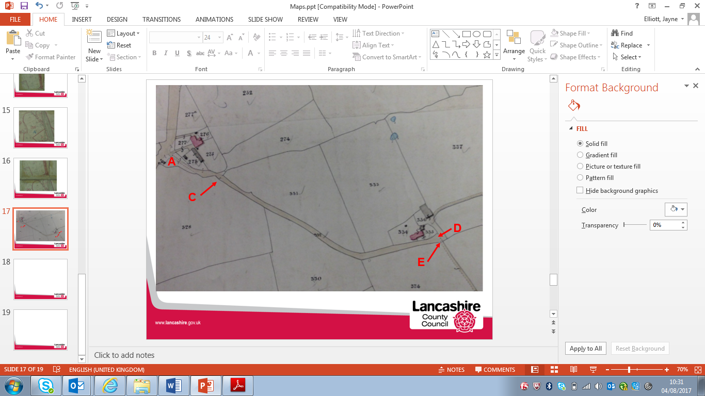
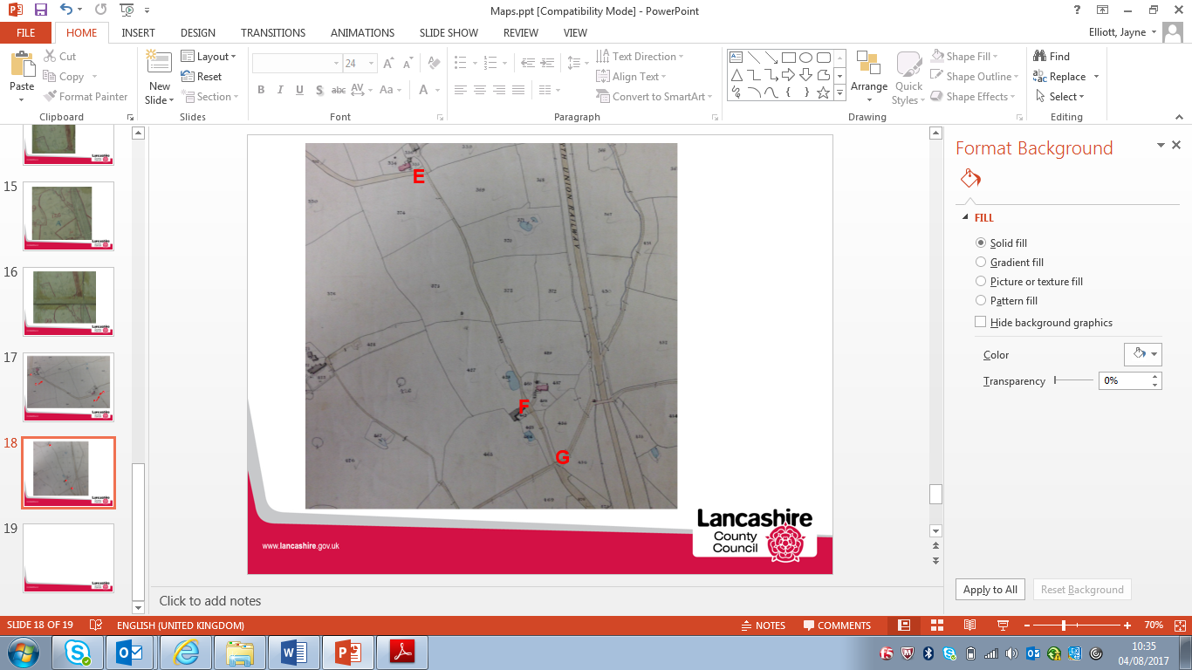
Observations |  | The copy of the Tithe Map and Schedule for Charnock Richard have been examined in the County Records Office.  The full length of the application route is shown as a bounded route and is shaded on the map in the same way as other bounded routes.  The route is numbered 332 between point A and point E and in the Tithe Schedule landownership details state Coward and Thomas's (Trustees), Edward Silvester's with the land occupied by Sarah Charnock. The land is described as 'Occupation road and waste' and a tithe of 2s 1d is listed as being payable.  Between point E and point F the application route is numbered on the Tithe Map as plot 461 and listed as being owned by Lady Catherine Susannah Hoghton and occupied by Frank Ryding. It is described as a 'Lane' and a tithe of 1s 2d is listed as being payable.  The remaining section of the route between point F and point G is numbered as plot 463; owned by Lady Catherine Susannah Hoghton, occupied by Frank Ryding and described as being a 'track and waste' with a tithe of 1s 5d listed as being payable.  Beyond point F Delph Lane (not named in the Tithe Schedule) is numbered 476 and is listed at the end of the schedule under a separate section titled Roads and is described as a 'Highway'. No tithe is payable and those listed are all stated to be kept in repair by the Township.  It can be seen elsewhere on this Tithe Map that apparent private roads, currently recorded footpaths, tram roads and railway are shown shaded in the same manner as public carriageways.
Investigating Officer's Comments |  | All three separately numbered sections of the route are described as being in private ownership and as being occupied with tithes payable.  From consideration of the information available in the Tithe Award and Map it does not preclude the route existing as a public bridleway or public carriageway in 1842 but it does not provide any evidence to support it.  The shading of the route is not considered to be significant other than suggesting that it existed as a substantial physical feature that could be identified as tracks on the ground.  The Award lists a number of roads at the end of the Schedule all of which are labelled on the map and which correspond to ways now recorded as public vehicular highways through the former township. No part of the route is listed in such a way: this suggests that it was not considered to be a public vehicular highway at that time.
Inclosure Act Award and Maps |  | Inclosure Awards are legal documents made under private acts of Parliament or general acts (post 1801) for reforming medieval farming practices, and also enabled new rights of way layouts in a parish to be made. They can provide conclusive evidence of status.
Observations |  | There is no Inclosure Award for the land crossed by the application route.
Investigating Officer's Comments |  | No inference can be drawn.
6 Inch Ordnance Survey (OS) Map | 1849 | The earliest Ordnance Survey 6 inch map for this area surveyed in 1844-47 and published in 1849.
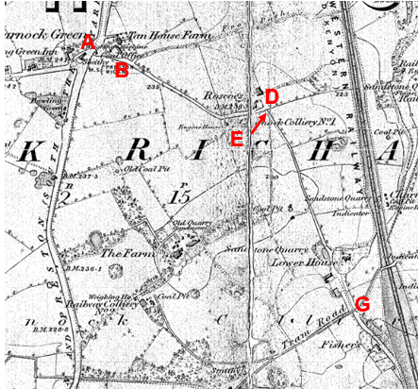
Observations |  | The full length of the application route is shown. Access appears to be open and unrestricted from the Turnpike Road (A49) at Charnock Green (point A) and provides access to a weighing machine and coal office. A footpath is marked on the map leaving the application route at point B and the full length of the application route from point A to point D is shown as a bounded route providing access to a property named as Roscoe's at point D.  At point E a line is shown across the route and then the route is shown continuing – as a bounded but narrower route passing a sandstone quarry and Lower House from where it continues as an unbounded track to point G. At point G the application route is crossed by a tram road.
25 Inch OS Map | 1894 | The earliest OS map at a scale of 25 inch to the mile. Surveyed in 1893 and published in 1894.
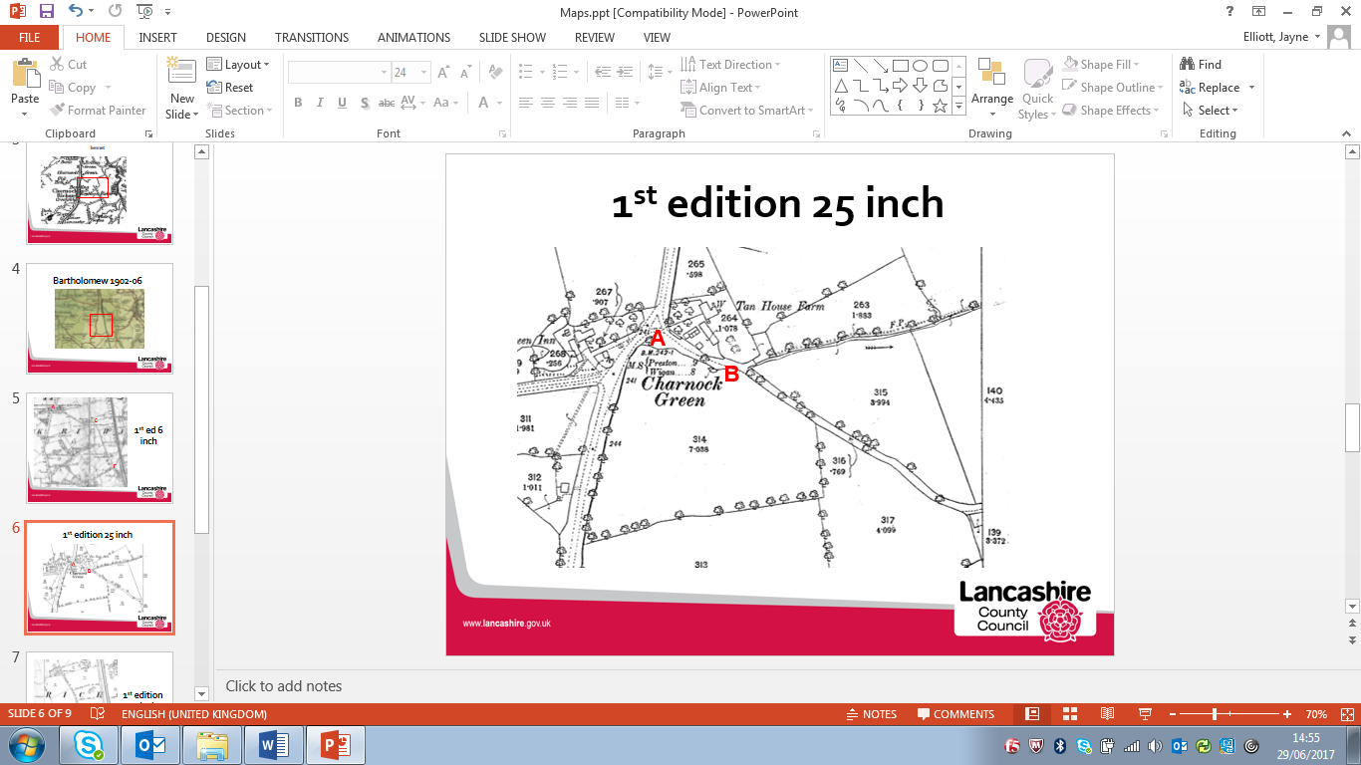
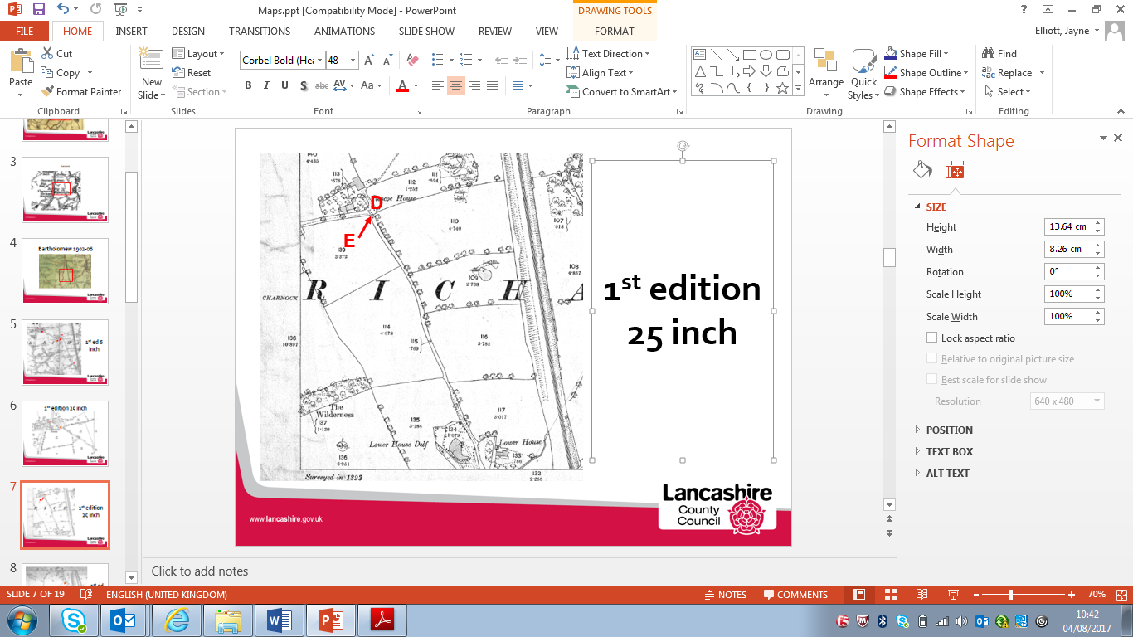
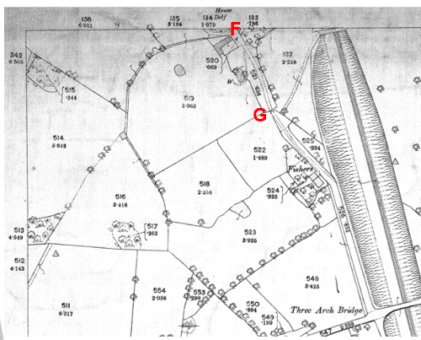
Observations |  | The application route is clearly shown as a bounded access road between point A and point D providing access to Tan House Farm and Roscoe House.  From Roscoe House at point E the application route appears to have been gated but then continues as a bounded route to Lower House Delf and continuing past Lower House to point G. The tram road marked on the earlier 6 inch map is not shown.  The route is not shown in any way that indicates public status.
Investigating Officer's Comments |  | The route under investigation existed in 1894 and provided access to a number of properties.  Metalled public roads for wheeled traffic kept in good repair by the highway authority were to be shaded or shown with thickened lines on the south and east sides of the road. The application route is not shown in such a way suggesting that it was not such a road. Whilst this does not preclude it being a public bridleway or carriageway it does not provide evidence to support it.  Gates are marked across the route which may have restricted but not necessarily prevented access. The existence of gates along a public route would not have been considered unusual in the 1800s particularly in the proximity of farms or in rural locations. Gateways, if they were found to exist, were shown by the surveyor in their closed position although this is not necessarily a true reflection of what may have been the position on the ground.
6 inch OS Map | 1893-1895 | Extract of second edition OS 6 inch map submitted by the applicant.
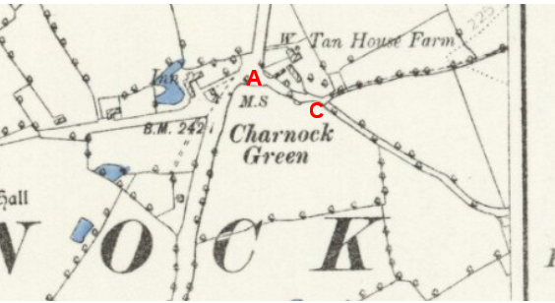
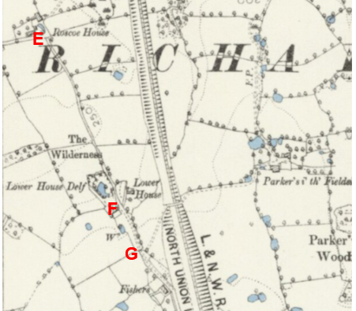
Observations |  | The application route is shown and appears to be gated at point C and point E.
Investigating Officer's Comments |  | The application route existed as a through route in the late 1800s. It provides no information regarding its public status.
Bartholomew half inch Mapping | 1902-1906 | The publication of Bartholomew's half inch maps for England and Wales began in 1897 and continued with periodic revisions until 1975. The maps were very popular with the public and sold in their millions, due largely to their accurate road classification and the use of layer colouring to depict contours. The maps were produced primarily for the purpose of driving and cycling and the firm was in competition with the Ordnance Survey, from whose maps Bartholomew's were reduced. An unpublished Ordnance Survey report dated 1914 acknowledged that the road classification on the OS small scale map was inferior to Bartholomew at that time for the use of motorists.
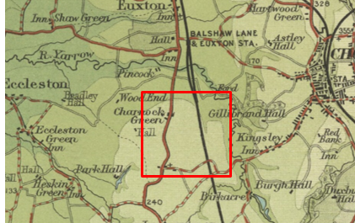
Observations |  | The application route is not shown.
Investigating Officer's Comments |  | Ordnance Survey maps produced both before and after the publication of Bartholomew's Map show the application route so it can be inferred that the route did physically exist at the time but that it did not appear to be considered to be a public vehicular highway or a route passable for cyclists at that time. No inference can be drawn with regards to whether the route was used by horses.
25 inch OS Map | 1911 | Further edition of the 25 inch map surveyed in 1892, revised in 1908-9 and published in 1911.
Observations |  | The whole of the application route is shown. Lines are shown across the route at points B, C and F indicating the probable existence of gates at those points.
Investigating Officer's Comments |  | The route existed on the ground and appeared to be capable of being used on horseback. The existence of gates across a route – especially in a rural setting – is not uncommon and would not necessarily prevent equestrian use.
6 inch OS Map | 1912 | Further edition of the 6 inch map provided by the applicant.
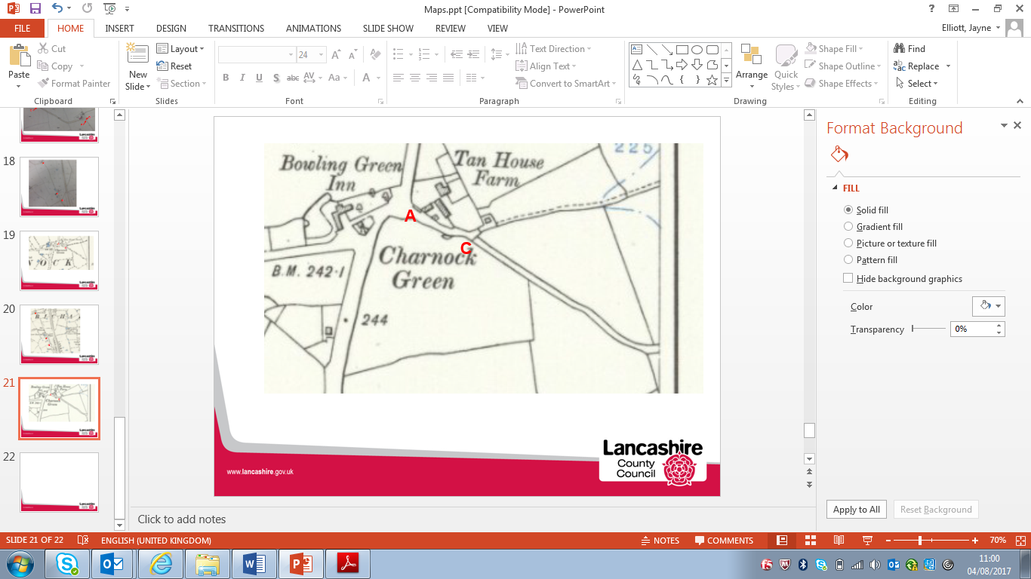
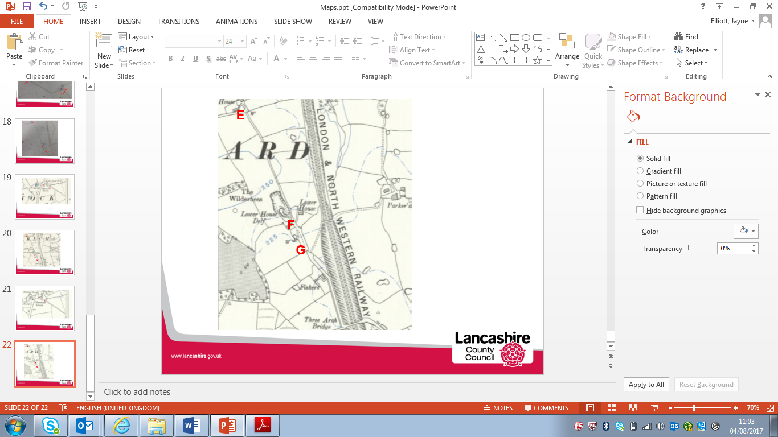
Observations |  | The whole of the application route is shown. Lines are shown across the route at points C, E and G indicating the probable existence of gates at those points.
Investigating Officer's Comments |  | The route existed on the ground and appeared to be capable of being used on horseback. The existence of gates across a route – especially in a rural setting – is not uncommon and would not necessarily prevent equestrian use.
Finance Act 1910 Map | 1910 | The comprehensive survey carried out for the Finance Act 1910, later repealed, was for the purposes of land valuation not recording public rights of way but can often provide very good evidence. Making a false claim for a deduction was an offence although a deduction did not have to be claimed so although there was a financial incentive a public right of way did not have to be admitted.  Maps, valuation books and field books produced under the requirements of the 1910 Finance Act have been examined. The Act required all land in private ownership to be recorded so that it could be valued and the owner taxed on any incremental value if the land was subsequently sold. The maps show land divided into parcels on which tax was levied, and accompanying valuation books provide details of the value of each parcel of land, along with the name of the owner and tenant (where applicable).  An owner of land could claim a reduction in tax if his land was crossed by a public right of way and this can be found in the relevant valuation book. However, the exact route of the right of way was not recorded in the book or on the accompanying map. Where only one path was shown by the Ordnance Survey through the landholding, it is likely that the path shown is the one referred to, but we cannot be certain. In the case where many paths are shown, it is not possible to know which path or paths the valuation book entry refers to. It should also be noted that if no reduction was claimed this does not necessarily mean that no right of way existed.
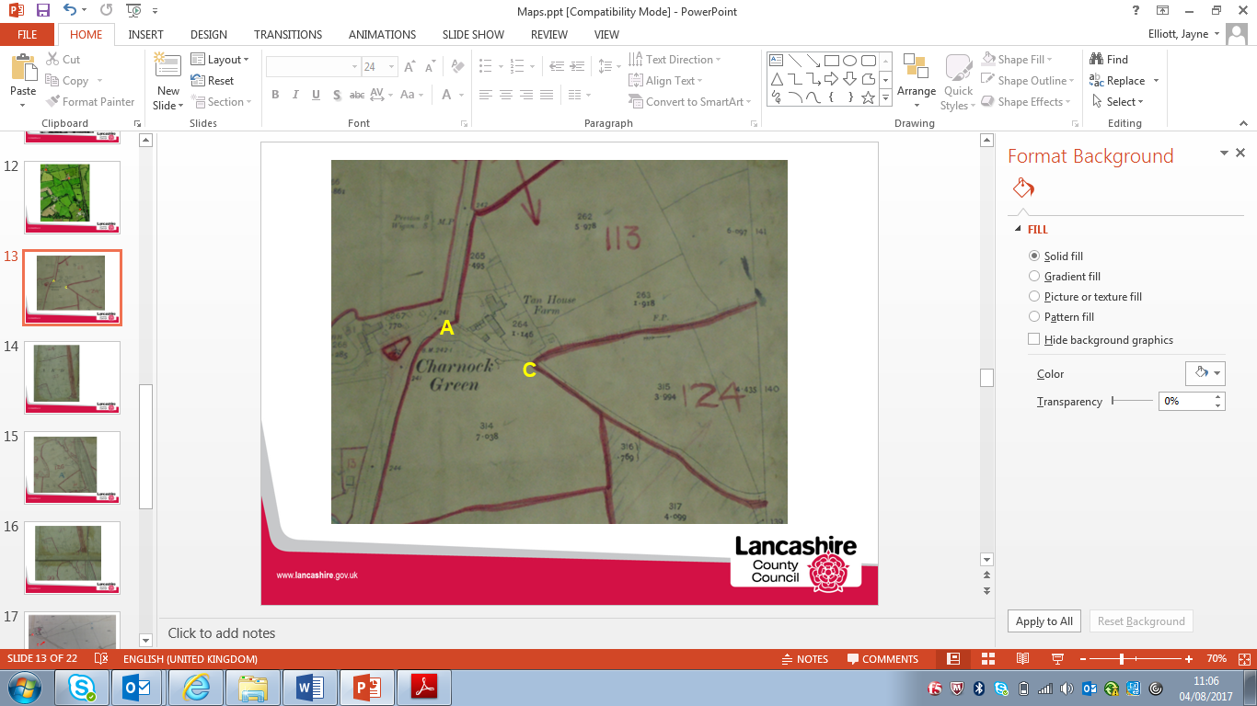
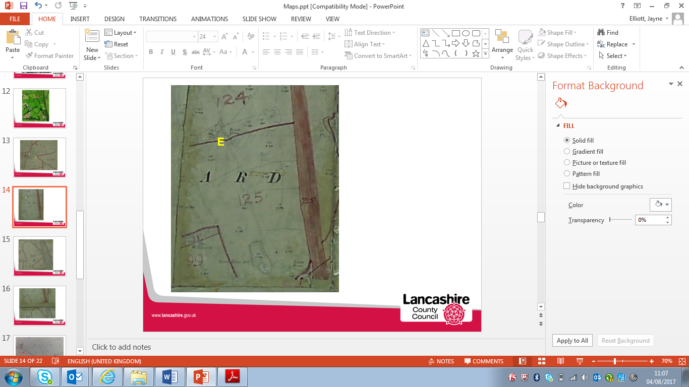
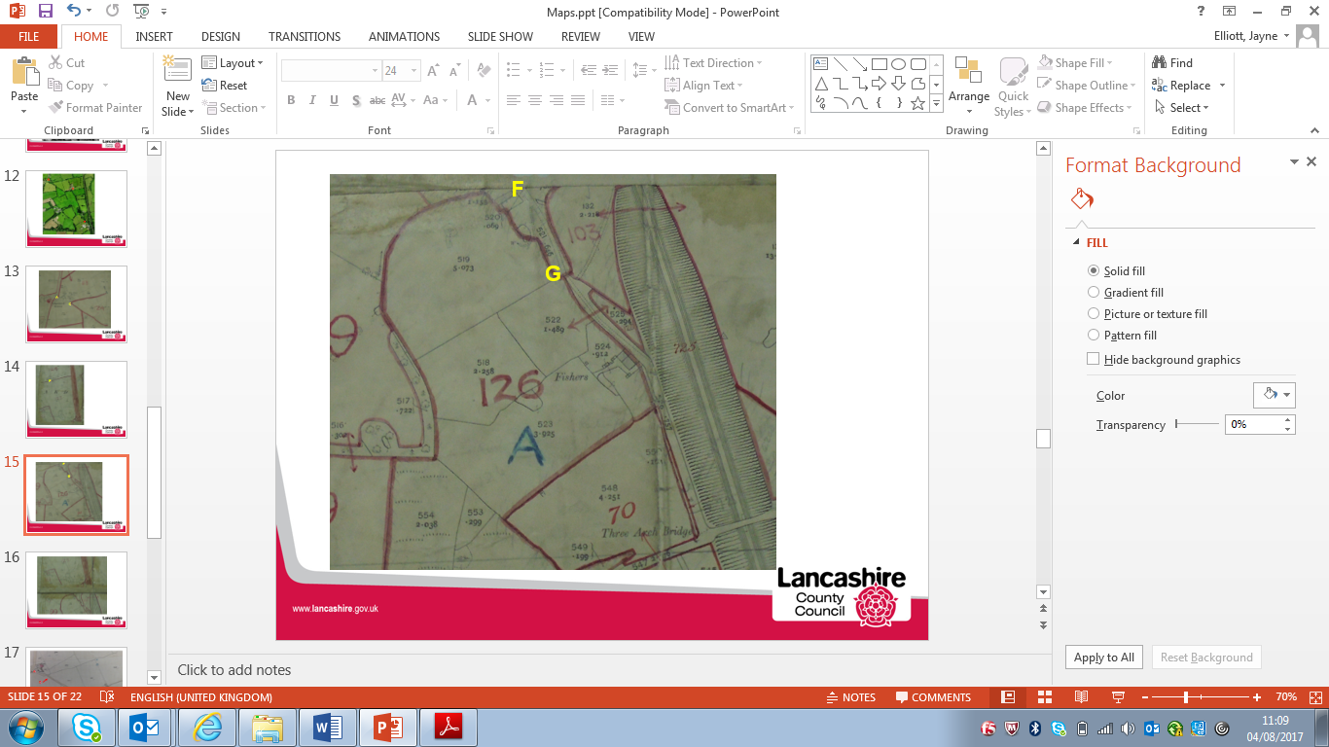
Observations |  | None of the application route is excluded from the numbered plots.  Between point A and point C the route is included within plot 113 which is described in the Field Book as a tenanted property known as Tan House Farm. The landowner is not listed but there is a note referring to hereditament 110 suggesting that landownership details are detailed there. A search of the Valuation Book held at the County Records Office confirmed ownership of the three plots covering the application route including plot 110 as being Reginald A Tatton Esquire.  Under the heading for restrictions for hereditament 110 it is written 'footpaths' and a £2 deduction is claimed for 'Public Rights of Way or User'. The specific route or routes referred to are not listed.  Between point C and point E the application route is included in plot 124. The Field Book describes this as Roscoe House Farm, another tenanted property owned by Reginald A Tatton Esq. A deduction of £5 is listed for 'public footpaths' but again (as is normal) the specific route or routes referred to are not listed. An easement to Lower House Farm 'over road' is also listed and a deduction of £5 recorded. In the list of calculations included in the Field Book Ordnance Survey parcel number 115 – which is the number allocated by the Ordnance Survey to the application route from point E to point F is described as the 'road' for which a £5 deduction was made.  The remaining section of the application route (from point E-point G) is included in plot 125 and is described in the Field Book as Lower House Farm, a tenanted property owned by Reginald A Tatton Esq.  In the details relating to the property it is written that 'the cart road is private but there is a public footpath along it' and a £7 deduction has been listed for footpaths although the specific route or routes for which the deductions are claimed are not listed.  Delph Lane south of point G is excluded from the numbered hereditaments.
Investigating Officer's Comments |  | On balance it is considered that the Finance Act information does not support the existence of a public bridleway in 1910.  It is normal to see an acknowledged public vehicular highway excluded from the numbered hereditaments as part of the process of compiling the taxation records and for ways considered to be public footpaths or bridleways at that time to be included in the numbered hereditaments for which a deduction is claimed.  The whole of the application route was listed in the ownership of one person but appeared to be split into three separate listings according to the fact that the land was tenanted by three different people/farms. No part of the route is excluded from the numbered plots suggesting that it was not considered to be a public vehicular carriageway and deductions are made within each of the numbered plots specifically for public footpaths which, although not specifically detailed as being the application route, are likely to be in reference to it – and possibly other cross field paths linking to it.  References to the fact that the cart road was private but that footpath rights existed along it, and the fact that a deduction was made for a private easement along part of the application route are also consistent with the view that he route, at that time was considered by the landowners and occupiers to be a public footpath.
25 Inch OS Map | 1928 | Further edition of 25 inch map, re-surveyed 1893, revised in 1927 and published in 1928.
Observations |  | The whole of the application route is shown as it was on the earlier (1911) edition of the 25 inch map. Gates are shown across the route at points B,C and F.
Investigating Officer's Comments |  | The route existed on the ground and appeared to be capable of being used on horseback. The existence of gates across a route – especially in a rural setting – is not uncommon and would not necessarily prevent equestrian use.
6 inch OS Map | 1929 | Further addition of OS 6 inch map submitted by the applicant.
Observations |  | The whole of the application route is shown as it was on the earlier editions of the 6 inch and 25 inch maps. Gates are shown across the route at points B,C and F.
Investigating Officer's Comments |  | The route existed on the ground and appeared to be capable of being used on horseback. The existence of gates across a route – especially in a rural setting – is not uncommon and would not necessarily prevent equestrian use.
Highway Adoption Records including maps derived from the '1929 Handover Maps' | 1929 to present day | In 1929 the responsibility for district highways passed from district and borough councils to the County Council. For the purposes of the transfer, public highway 'handover' maps were drawn up to identify all of the roads within the county which had been maintained by the districts. These were based on existing Ordnance Survey maps and edited to mark those routes that were public. However, they suffered from several flaws – most particularly, if a right of way was not surfaced it was often not recorded.  A right of way marked on the map is good evidence but many public highways that existed both before and after the handover are not marked. In addition, the handover maps did not have the benefit of any sort of public consultation or scrutiny which may have picked up mistakes or omissions.  The County Council is now required to maintain, under section 31 of the Highways Act 1980, an up to date List of Streets showing which 'streets' are maintained at the public's expense. Whether a road is maintainable at public expense or not does not determine whether it is a highway or not.
Extract from Handover Map
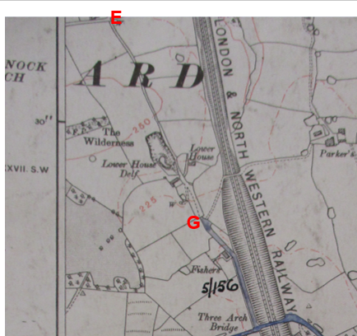
Adoption layer on LCC GIS
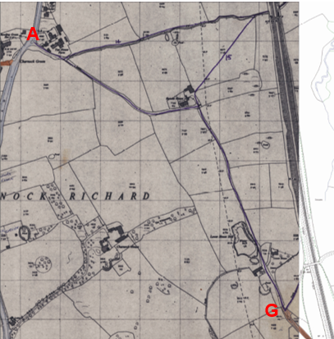
Observations |  | The application route is not shown as a publicly maintainable highway on the 1929 Handover Maps available to view in the County Records Office but it is recorded as being publicly maintainable (as a remote footway) on the List of Streets.
Investigating Officer's Comments |  | The route was not recorded as publicly maintained highway on the 1929 handover map although this does not mean that it wasn't one and many public rights of way with public vehicular rights have subsequently been found not to have been recorded on these maps.  Later highway records maintained by the County Council include the fact that the route under investigation had been recorded as a public footpath and was publicly maintainable as such.
Authentic Map Directory of South Lancashire by Geographia | Circa 1934 | An independently produced A-Z atlas of Central and South Lancashire published to meet the demand for such a large-scale, detailed street map in the area. The Atlas consisted of a large scale coloured street plan of South Lancashire and included a complete index to streets which includes every 'thoroughfare' named on the map.  The introduction to the atlas states that the publishers gratefully acknowledge the assistance of the various municipal and district surveyors who helped incorporate all new street and trunk roads. The scale selected had enabled them to name 'all but the small, less-important thoroughfares'.
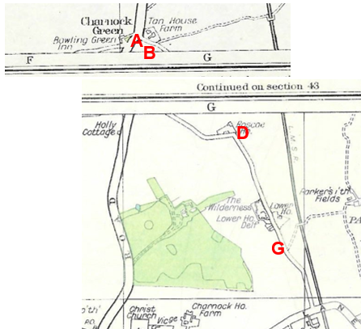
Observations |  | The full length of the route is shown providing access to properties and appearing to form part of a longer route between the A49 (from point A) and Church Lane. The route is not shown as being named.
Investigating Officer's Comments |  | The route is shown in a street atlas consistent with other ways proven or suspected to carry public vehicular rights. It may have been shown in this way because of its substantial physical nature (a bounded route providing vehicular access to properties) as other routes which are private access tracks – or which carry lesser public rights are shown.  The fact that the route is shown does, however, add weight to the fact that the route physically existed as a substantial route at that time which was probably capable of being used by horses.
Aerial Photograph | 1940s | The earliest set of aerial photographs available was taken just after the Second World War in the 1940s and can be viewed on GIS. The clarity is generally very variable.
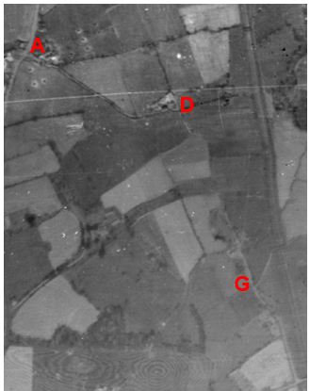
Observations |  | The application route can be quite clearly seen between point A and point D and seen as a fainter line between point D and point G.
Investigating Officer's Comments |  | The application route existed in the 1940s and its appearance between points A to point D appeared to be consistent with regular vehicular use – consistent with a route providing access to a farm. Use of the route from point D to point F at Lower House with vehicles may have been less frequent.  No inference can be drawn regarding public rights.
6 Inch OS Map | 1955 | The OS base map for the Definitive Map, First Review, was published in 1955 at a scale of 6 inches to 1 mile (1:10,560). This map was revised before 1930 and is probably based on the same survey as the 1930s 25-inch map.
Observations |  | The whole of the application route is shown on the map but not named. Gates are shown across the route at points C, E and G.
Investigating Officer's Comments |  | The route existed on the ground and appeared to be capable of being used on horseback.
1:2500 OS Map | 1960 | Further edition of 25 inch map reconstituted from former county series and revised in 1959 and published 1960 as national grid series.
Observations |  | The whole of the application route is shown on the map but not named. Gates are shown across the route at points C, E and G.
Investigating Officer's Comments |  | The route existed on the ground and appeared to be capable of being used on horseback.
Aerial photograph | 1960s | The black and white aerial photograph taken in the 1960s and available to view on GIS.
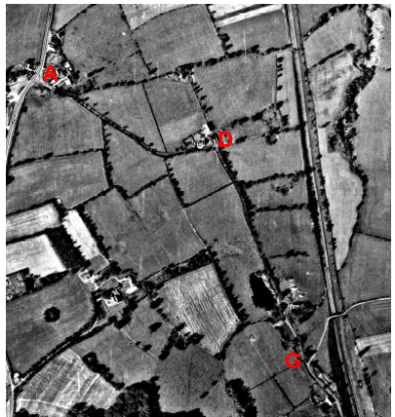
Observations |  | The full length of the application route is visible – although partly obscured by trees although it is not possible to see from the photograph whether the route would have been accessible to horse riders or cyclists at that time.
Investigating Officer's Comments |  | The application route existed in the 1960s but no inference can be drawn with regards to public rights.
Aerial Photograph | 2000 | Aerial photograph available to view on GIS.
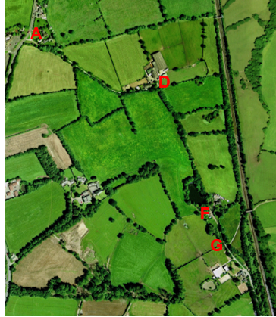
Observations |  | Although partly obscured by tree cover, the route is shown as a substantial track between point A and point D providing access to properties. Between point D and point F the route cannot be seen as it follows a route bounded by trees and the fact that a track cannot be seen suggest use more akin to pedestrian and possibly on horseback rather than a wider worn track used by vehicles. Between point F and point G the route can be seen – consistent with a track providing access to properties.
Investigating Officer's Comments |  | The application route existed in 2000 but no inference can be drawn with regards to public rights.
Definitive Map Records |  | The National Parks and Access to the Countryside Act 1949 required the County Council to prepare a Definitive Map and Statement of Public Rights of Way.  Records were searched in the Lancashire Records Office to find any correspondence concerning the preparation of the Definitive Map in the early 1950s.
Parish Survey Map | 1950-1952 | The initial survey of public rights of way was carried out by the parish council in those areas formerly comprising a rural district council area and by an urban district or municipal borough council in their respective areas. Following completion of the survey the maps and schedules were submitted to the County Council. In the case of municipal boroughs and urban districts the map and schedule produced, was used, without alteration, as the Draft Map and Statement. In the case of parish council survey maps, the information contained therein was reproduced by the County Council on maps covering the whole of a rural district council area. Survey cards, often containing considerable detail exist for most parishes but not for unparished areas.
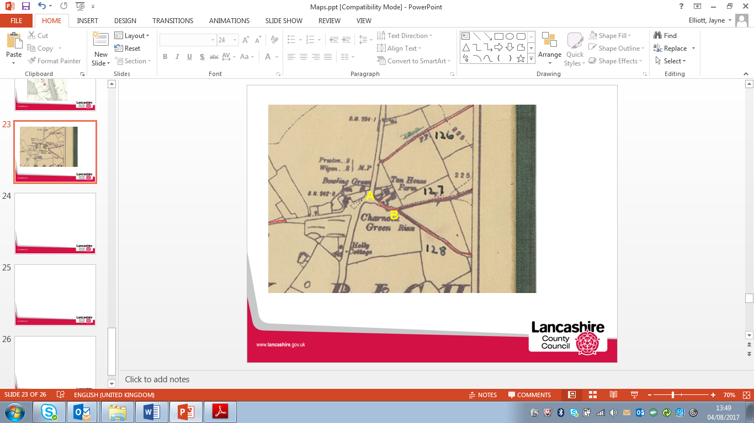
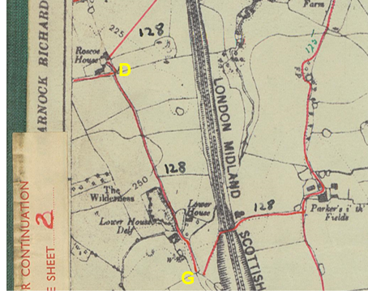
Observations |  | Between point A and point B the route was shown as part of Footpath 127. The footpath was described in the parish survey card as being 'From Charnock Green Rises, across Railway to join Footpath No. 126'. It was also stated 'General condition good. Stiles in good repair and well defined walk'. The survey card was dated 1951. The rest of the application route formed part of the route shown numbered as 128. The parish survey card (also dated 1951) stated that the route was a 'Footpath along private road'. The route was described as being 'From Charnock Green rises, branching at Roscoe House, northwards to join footpath No 127 and Southwards past Lower House, across Railway to join Footpath no 125 at Parker I' th' Fields.' A further handwritten note states 'Private Road metalled. All stiles and gates in fair condition.'  Footpath 128 was shown to end at point G with a break so as not to include Delph Lane before continuing as the same numbered path east across the railway from Delph Lane.
Draft Map |  | The parish survey map and cards for Charnock Richard were handed to Lancashire County Council who then considered the information and prepared the Draft Map and Statement.  The Draft Maps were given a “relevant date” (1st January 1953) and notice was published that the draft map for Lancashire had been prepared. The draft map was placed on deposit for a minimum period of 4 months on 1st January 1955 for the public, including landowners, to inspect them and report any omissions or other mistakes. Hearings were held into these objections, and recommendations made to accept or reject them on the evidence presented.
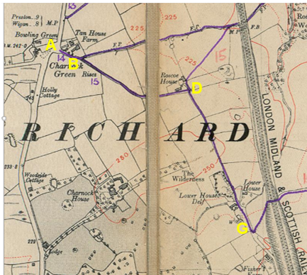
Observations |  | The application route is shown in the same way as it is on the Parish Survey with the exception that the numbering has altered and the route now recorded as part of Footpath 14 and 15 Charnock Richard and Footpath 15 is shown without a break crossing Delph Lane just south of point G.
Provisional Map |  | Once all representations relating to the publication of the draft map were resolved, the amended Draft Map became the Provisional Map which was published in 1960, and was available for 28 days for inspection. At this stage, only landowners, lessees and tenants could apply for amendments to the map, but the public could not. Objections by this stage had to be made to the Crown Court.
Observations |  | The route was shown in the same way on the Provisional Map as on the Draft Map and no representations were made to the County Council.
The First Definitive Map and Statement |  | The Provisional Map, as amended, was published as the Definitive Map in 1962.
Observations |  | The route was shown in the same way on the First Definitive Map as on the Provisional Map.
Revised Definitive Map of Public Rights of Way (First Review) |  | Legislation required that the Definitive Map be reviewed, and legal changes such as diversion orders, extinguishment orders and creation orders be incorporated into a Definitive Map First Review. On 25th April 1975 (except in small areas of the County) the Revised Definitive Map of Public Rights of Way (First Review) was published with a relevant date of 1st September 1966. No further reviews of the Definitive Map have been carried out. However, since the coming into operation of the Wildlife and Countryside Act 1981, the Definitive Map has been subject to a continuous review process.
Observations |  | When the Map and Statement were reviewed the route was shown in the same way as it had been on all earlier maps produced.
Investigating Officer's Comments |  | From 1953 through to 1975 there is no indication that the route was considered to be of any higher status than public footpath by the Surveying Authority. There were no objections to the depiction of the status of the route from the public when the maps were placed on deposit for inspection at any stage of the preparation of the Definitive Map.
Highway Stopping Up Orders | 1835 - 2014 | Details of diversion and stopping up orders made by the Justices of the Peace and later by the Magistrates Court are held at the County Records Office from 1835 through to the 1960s. Further records held at the County Records Office contain highway orders made by Districts and the County Council since that date.
Observations |  | No Orders relating to the application route were found.
Investigating Officer's Comments |  | There is nothing to indicate that the route, currently recorded as a public footpath was ever considered to be any other public status.
Statutory deposit and declaration made under section 31(6) Highways Act 1980 |  | The owner of land may at any time deposit with the County Council a map and statement indicating what (if any) ways over the land he admits to having been dedicated as highways. A statutory declaration may then be made by that landowner or by his successors in title within ten years from the date of the deposit (or within ten years from the date on which any previous declaration was last lodged) affording protection to a landowner against a claim being made for a public right of way on the basis of future use (always provided that there is no other evidence of an intention to dedicate a public right of way).  Depositing a map, statement and declaration does not take away any rights which have already been established through past use. However, depositing the documents will immediately fix a point at which any unacknowledged rights are brought into question. The onus will then be on anyone claiming that a right of way exists to demonstrate that it has already been established. Under deemed statutory dedication the 20 year period would thus be counted back from the date of the declaration (or from any earlier act that effectively brought the status of the route into question).
Observations |  | No Highways Act 1980 Section 31(6) deposits have been lodged with the County Council for the area over which the route runs.
Investigating Officer's Comments |  | There is no indication by a landowner under this provision of non-intention to dedicate public rights of way over their land.

The affected land is not designated as access land under the Countryside and Rights of Way Act 2000 and is not registered common land.

Landownership

The list below indicates the landowners affected by this application:

Hamlets Retreat
Delph Lane
Charnock Richard
Chorley
PR7 5LD

Roscoe House Farm
Delph Lane
Charnock Richard
Chorley
Lancashire
PR7 5LD

Parkers i'the Field
Delph Lane
Charnock Richard
Lancashire
PR7 3RA

Summary

The application is for the route to be recorded as a public bridleway.

The map and documentary evidence submitted by the applicant, together with a range of additional map and documentary evidence identified by the County Council, has been examined by officers who have looked at the history of the route to see whether there is evidence to suggest that the route, or part of the route, may already be a public bridleway or carriageway by virtue of historical dedication and use.

With regards to the physical characteristics of the route, it is currently possible to ride the full length of the route on horseback or bicycle although access is restricted to a narrow gap at point E and the route quite overgrown from point E south to Lower House Delf – which could make riding it on horseback quite difficult. When inspected in June 2017 there was no physical evidence of hoof prints or tyre tracks.

Whilst the route has physically existed on the ground as a through route since at least the mid-1800s and appeared to be capable and wide enough) to be used by horses (and bicycles), there appears to be no map and documentary evidence to conclude that the route was considered to be anything other than a private access road carrying public footpath rights.

Head of Service – Legal and Democratic Services Observations

Information from the Applicant

The applicant provided two user evidence forms.

The first was completed by the applicant. He states that he used the application route on foot from 1965 to 2017 (52 years) and on a bicycle from 1970 to 2017 (47 years). He states that he used the route 3-4 times a year but that there could have been one year (not specified) during the period when he did not use it. He always used the same route and saw others using it on foot and on bicycles. He had never been stopped or challenged when using the route and had never been given permission to use it. He didn’t recall any signs other than public footpath signs but stated that the route always had the 'feel' of a bridleway. Use was as part of a longer journey and there was reference to use for a cross country run.

One further evidence of use statement was submitted. Use was stated as being 4 or 5 times a year from 2014-2017 (4 years) on a bicycle. Use was for pleasure; always along the same route and was part of a longer journey. He stated that he had seen others using the route on foot and on bicycles. He had never been stopped or challenged when using the route and had never been given permission to use it.

In addition to the user evidence detailed above, the applicant provided a written document, including extracts of the following maps and documents, which he asserts support the claim for the route to be recorded as a public bridleway:

- Maps asserting that the projected line of a roman road is on the same alignment as part of the application route.
- Yates Map 1786 asserting that the route is not shown on the map because cross roads were shown as 'stumps' because they were not maintained as public roads.
- Greenwoods Map 1818
- Hennets Map 1829
- 1st edition 6 inch Ordnance Survey map published 1849
- 6 inch OS maps published 1893 and 1895
- 6 inch OS map published 1912
- 6 inch OS map published 1929
- 6 inch OS map published 1947
- Tithe Map and Schedule for Charnock Richard 1842
- Finance Act Map and Schedule obtained from County Records Office
- Image captured from Chorley BC web portal which the applicants claims shows the application route as an adopted road (no key provided).

The maps and documents listed above have already been considered earlier in this report.

Information from the Landowners

The owners of Hamlets Retreat responded to confirm their landownership but provided no comments.

The owners of Roscoe House have also objected to the application explaining that they have owned the property since 1962 and that it has never been a bridleway. They state that the road to their property is maintained by them and that they would have serious concerns if the route were to become bridleway. They refer to the fact that they may be able to provide further evidence but despite being asked for it have not submitted anything further.

The owner of Roscoe House Cottage has commented that he has lived at the property for 27 years and that Delph Lane is a very popular public footpath used by many locals (particularly dog walkers) and rambler groups.

He states that the north western end of the route is privately owned by the neighbouring farm and is heavily used by farm/agricultural vehicles and members of the public visiting the kennels. He notes that during the past year there has been an increase in the number of mountain bikers and motorcyclists using the lane with the likelihood of presenting problems for others using the lane, due to its narrowness and open ditches.

Information from Others

The owners of Lower House Farm do not own land crossed by the application route but access their property along part of it.

They have responded to consultations stating that they object to the application. They explain that they have lived at the property for 10 years but that it has been in the family for over 80 years and in that time it has not been used or classed as a bridleway. They state that the 'old farm track' was used as a connection between the two farms only.

They also state that they object to the route being a bridleway on health and safety grounds as it is not wide enough for pushchairs, and walkers with young children with them to meet horses or cyclists on the route. They refer to use of the route by cyclists and the fact that they have shouted at them to slow down but that they take no notice or become abusive.

Assessment of the Evidence

The Law - See Annex 'A'

In Support of Making an Order(s)

Present line available since mid 1800's
Some user evidence on pedal cycle

Against Making an Order(s)

Weak user evidence
No evidence of use on horseback
Lack of historical evidence

Conclusion

The route under consideration is currently recorded as a public footpath. The application is to upgrade the sections of the footpath from points A-B-C-D-E-F-G to a bridleway, as it is suggested the public footpath carries higher public rights. Committee should note that as the route already appears on the definitive map as a public footpath, it is not sufficient to satisfy the lesser test of reasonably alleging the existence of higher rights, neither is it necessary for there to be conclusive evidence of the existence of a higher public right than a public footpath, instead the standard of proof required is the balance of probability.

It is advised that as there is no express dedication in this matter that the Committee should consider, on balance, whether there is sufficient evidence from which to have its dedication inferred at common law from all the circumstances or for the criteria in S31 Highways Act 1980 for a deemed dedication to be satisfied based on sufficient twenty years "as of right" use to have taken place ending with this use being called into question.

Looking firstly at whether dedication can be inferred on balance at common law it is advised that the Committee has to consider whether evidence from the maps and other documentary evidence coupled with the evidence on site does on balance indicate how the route should be recorded. The analysis of the map and documentary evidence presented in this report would seem to suggest that there is insufficient historic or documentary evidence of the claimed route. Landowners of the route have commented that the route is private for access to their respective properties and is currently enjoyed as a popular public footpath. There is also no equestrian user evidence presented. It is suggested that it is difficult to see sufficient circumstances from which to infer the owners dedicated this route as a bridleway.

Looking secondly at deemed dedication under S31 Highways Act 1980. S31 requires there to be sufficient use of a route for twenty years before the route was called into question. In this matter the date the route was called into question for bridleway use would be the application itself which is dated 2017. To deem dedication of bridleway it would be usual to see use being on horseback, which use has not be demonstrated in this matter.

In the Whitworth case it was suggested that subsequent use by cyclists of an accepted, but unrecorded, bridleway, where use of the bridleway would have been permitted by virtue of section 30 of the Countryside Act 1968, could not give rise to anything other than a bridleway. The use on pedal cycle would have to show earlier acceptance of the route as bridleway for the cycle use to be supporting use to evidence bridleway.

It is suggested that the limited pedal cycle use evidenced in this matter is not sufficient evidence of use from which dedication of a bridleway could be deemed just from that use and no other evidence of a historical or long-standing bridleway that subsequently becomes used by cyclists.

Section 31, Highways Act 1980, as amended by section 68 of NERC 2006, provides that use of a way by non-mechanically propelled vehicles (such as a pedal cycle) can give rise to a restricted byway. Committee is therefore asked to also look at whether the use by two users on pedal cycles, one using it 2 to 4 times a year since 1965 and one 4 to 5 times a year since 2014 would be sufficient to deem dedication by the owner as a route for non mechanically propelled vehicles. It is suggested that such use is insufficient in this matter.

Taking all the evidence into account it is suggested that the evidence is insufficient to satisfy the criteria of S31 nor sufficient from which to infer landowners' intention to dedicate a bridleway in this matter. Committee may therefore feel that the application be not accepted and no Order be made.

Local Government (Access to Information) Act 1985

List of Background Papers

Paper | Date | Contact/Directorate/Tel
All documents on File Ref: 804-586 |  | Paralegal, 01772 535604, County Secretary and Solicitors Group
Reason for inclusion in Part II, if appropriate

N/A

The Ordnance Survey (OS) has produced topographic maps at different scales (historically one inch to one mile, six inches to one mile and 1:2500 scale which is approximately 25 inches to one mile). Ordnance Survey mapping began in Lancashire in the late 1830s with the 6-inch maps being published in the 1840s. The large scale 25-inch maps which were first published in the 1890s provide good evidence of the position of routes at the time of survey and of the position of buildings and other structures. They generally do not provide evidence of the legal status of routes, and carry a disclaimer that the depiction of a path or track is no evidence of the existence of a public right of way.
Aerial photographs can show the existence of paths and tracks, especially across open areas, and changes to buildings and field boundaries for example. Sometimes it is not possible to enlarge the photos and retain their clarity, and there can also be problems with trees and shadows obscuring relevant features.

