|  |
| --- |
| Electoral Division affected:  (All Divisions); |

**Health Scrutiny Committee**

Meeting to be held on Monday, 5 March 2018

**Life Expectancy and Health in All Policies**

(Appendix 'A' refers)

Contact for further information:

Aidan Kirkpatrick, Public Health Consultant Andrea Smith, Public Health Specialist

[aidan.kirkpatrick@lancashire.gov.uk](mailto:aidan.kirkpatrick@lancashire.gov.uk) andrea.smith@lancashire.gov.uk

|  |
| --- |
| Executive Summary This report outlines the most up to date estimated position on life expectancy and healthy life expectancy across Lancashire's districts and in particular its impact at ward level. Between 2005-2007 and 2014-2016 male and female life expectancy in the twelve districts has increased in line with the national trend. Across Lancashire the rate of these increases appears to be slowing down and there is a variation in life expectancy between the wards in the districts.  The report provides an overview of current activity at a Lancashire population level and at district level and how elected member engagement would further support this approach. Recommendation The Health Scrutiny Committee is asked to:   1. Note the information contained in the report, in particular in respect of healthy life expectancy and the degree of variation in our life expectancy figures across the districts and wards in Lancashire. 2. Formulate recommendations on how to support current Lancashire and South Cumbria (STP) level activity (points a. to f. in the report) to address and improve life expectancy at population level across Lancashire. 3. Formulate recommendations on how to engage with district councils and partners in improving life expectancy and implementing health in all policies at a local level in respect of the social determinants of health, in particular, spatial planning and the economic determinant. |

**Background and Advice**

# This report follows on from the Health Scrutiny Committee Workshop and the Prevention Matters session, provided by Public Health and Wellbeing in conjunction with the Local Government Association. Both of these events raised awareness with elected members as to the importance of a Health in All Policies approach to improve life expectancy and the associated health inequalities across Lancashire.

# It further outlines the most up to date estimated position on life expectancy and healthy life expectancy across Lancashire's districts and in particular its impact at ward level. It gives an overview of current activity at a Lancashire population level and at district level and how this could be supported by elected member engagement in the approach.

# Life Expectancy and Healthy Life Expectancy:

# Figure 1: Life expectancy and Healthy Life Expectancy in Females and Males in Lancashire for the three year period 2014-2016 [Source: ONS]

# 

# Life expectancy and healthy life expectancy are important summary measures of mortality and morbidity. Life Expectancy is the average number of years a person would expect to live based on contemporary mortality rates. Healthy life expectancy is the average number of years a person would expect to live in good health based on contemporary mortality rates and prevalence of self-reported good health. In figure 1 above, female life expectancy in Lancashire is shown to be 82.2 years. However, approximately 23% of these 82.2 years are spent 'not in good health'. For a male living in Lancashire, life expectancy is lower, at 78.7 years and again, approximately 21% of those 78.7 years are spent 'not in good health'.

# Between 2005-2007 and 2014-2016 male and female life expectancy in the twelve districts that make up Lancashire has increased in line with the national trend. Across Lancashire the rate of these increases appears to be slowing down. This is a trend that is observed nationally and is subject to some debate, slowing down in some parts of the country and, in some cases, even reversing.

# There is a degree of variation in our life expectancy figures across the districts. In respect of female life expectancy, eight districts in Lancashire (Burnley, Hyndburn, Pendle, Preston, Lancaster, Rossendale, Chorley and West Lancashire) have a female life expectancy that is significantly lower than England [83.1years]. The Lancashire figure for females is 82.2 years. There is also a variation in male life expectancy across the twelve Lancashire districts with six districts in Lancashire (Burnley, Hyndburn, Pendle, Preston, Lancaster and Rossendale) with a male life expectancy that is significantly lower than England [79.5 years]. The Lancashire figure for males is 78.7 years.

# Crucially however, the variation in life expectancy between the wards in each district across Lancashire is even more significant. Female life expectancy ranges from 72.1 years in Queensgate ward in Burnley to 91.2 years in Broad Oak ward in South Ribble. Male life expectancy ranges from 70.8 years in Central ward in Hyndburn to 87.6 years in Buckshaw and Worden ward in South Ribble. This wide variance in life expectancy is displayed in figure 2 below.

**Figure 2:** Spread of estimated female life expectancy at birth (2011-2015) in Burnley and South Ribble by ward. The data in yellow (noted as Queensgate and Broad Oak) shows the range in variance between wards.

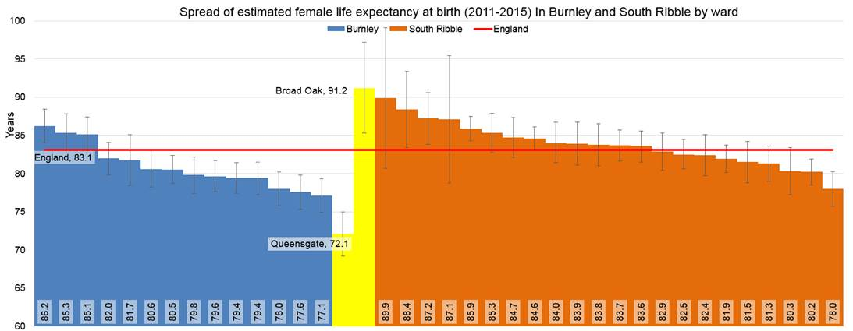

# Socio, economic and environmental determinants of health and wellbeing:

# This life expectancy information is one of the drivers for the health in all policies approach across Lancashire, underlined by the evidence base of what the social, economic and environmental determinants of health, often referred to as the SEED's of health and wellbeing, are for broader health and wellbeing.

# The SEED's of health are the key factors that affect the health and wellbeing of individuals, families and communities, the range of good health promoting factors including the conditions in which residents in Lancashire are born, live and work. They are the root causes of our health. They have a significant impact on inequalities in health and wellbeing and it is here that action is needed to improve our health and wellbeing. Action can be taken on the majority of these determinants, they are modifiable either at an individual or population level. Some determinants are not modifiable and these include age, sex and hereditary factors. Incorporating health into policy is an effective way of taking action.

# Figure 3: The Determinants of Health (1992) Dahlgren and Whitehead

# 

# Evidence has consistently shown that improving health and services contributes to about 25-40% of population health. Improving population health requires action across communities, public, private and VCF sectors, national government. The following figure presents an estimate of the impact that a range of determinants have on health outcomes. It estimates that only 20% of an individual's health can be attributed to 'Clinical Care'. The other determinants of health are categorised as 'behaviours', socio-economic factors' and the 'built environment'.

# Figure 4: Relative contribution of the determinants of health

# 

# The most effective way to maximise the beneficial impact on the social determinants of health is to take a Health in All Policies approach. This is an organisational approach to policies that systematically and explicitly takes into account the health implications of the decisions made; targets the key social determinants of health; looks for synergies between health and other core objectives and the work the council does with partners; and tries to avoid causing harm with the aim of improving the health of the population and reducing inequity.

# All policies have the potential to impact on the health and wellbeing of individuals, communities and populations. Health in All Policies aims to ensure that decision-makers are informed about the health, equity and sustainability consequences of various policy options during the policy development process. Approaches to improving life expectancy and healthy life expectancy need to give consideration to the social determinants of health. This means people have poor quality of life and are living in poor health and disability, often needing high cost NHS and care services. However, health and wellbeing is not just a social issue. Not only does it have a financial and cost impact on the health and social care system but it also has an impact on the local economy and the productivity of the Lancashire workforce. We also know much of this can be avoided or delayed if we act on the various determinants of population health.

# Health inequalities are systematic, avoidable and unjust differences in health and wellbeing between groups of people. Population level interventions that are multifaceted and complementary are most likely to be successful at addressing them.

# Current Lancashire and South Cumbria (STP) Level activity:

# Members are asked to support action to improve health inequalities and population health measures across Lancashire by:

# Supporting the Improving Health and Care at Scale [iHAC's] work – a single overarching population health framework that connects actions across our Lancashire and South Cumbria Sustainability Transformation Partnership [STP] which includes five Integrated Care Partnership's [ICPs] to enable improvements in health outcomes. The framework identifies short, medium and longer term priorities to improve population health.

# Supporting, championing and improving access to equitable, high quality health care is still important to prevent ill health and restore good health when people need it wherever they live in Lancashire.

# Supporting work multi-sectoral and whole system approaches to reduce the inequity and unwarranted variation in access, quality of care, and the health outcomes across the STP.

# Supporting and engaging in the development of preventions frameworks at local delivery plan level in the five integrated care systems, to reflect this health in all policies approach.

# Achieving and sustaining a fully engaged scenario with communities and people mobilised for improving their health and wellbeing.

# Acknowledging that, with declining resources, that is, the nation Public Health grant, as well as wider local authority resources, that short term demand management initiatives are likely to be prioritised over strategies to address inequalities. Therefore, inequality impact assessment should be promoted across the public sector to ensure that inequalities are not widened as a result of this short term prioritising.

These actions will also address the priorities set by the Health and Wellbeing Board.

# Update on Health in All Policies:

# There are more specific areas that Public Health and Wellbeing is developing to embed Health in All Policies and improve the wider determinants including policies on housing, employment, planning and licensing, transport, and advocating for national healthy public policies. These include areas where elected members could provide influence at a district level to embed locally and work to remove barriers. In particular, the Scrutiny Steering Group determined that the following be outlined further:

# Spatial Planning: Elected member support and engagement in the embedding of Public Health Advisory Note advice and guidance into local district spatial planning policy and built environment approaches. Specifically, the recently drafted Fast Food Take-away Advisory Note, the Home for Life-Long Living (Assisted Design) Advisory Note for new housing developments and also, the development of the good place-making healthy high streets advisory note which is currently being drafted and intended for use by colleagues and elected members to mobilise communities.

# Economic Determinant: Elected member support to encourage discussion with local partnerships, for example, the Lancashire Economic Partnership, to raise awareness of the connection of population wellbeing with economic development for inclusive growth, including,

# Supporting and promoting interventions in the workplace to improve workplace health and wellbeing, connecting health and productivity of the workforce and how it contributes to sustaining a workforce that can support an improving Lancashire economy, as employment and socio-economic status are the main drivers of social gradients in health.

# Consultations

N/A

**Implications**:

This item has the following implications, as indicated:

**Risk management**

This report has no significant risk implications.

##### Local Government (Access to Information) Act 1985

##### List of Background Papers

|  |  |  |
| --- | --- | --- |
| Paper | Date | Contact/Tel |
| N/A |  |  |
| Reason for inclusion in Part II, if appropriate  N/A | | |