Regulatory Committee
Meeting to be held on 19 September 2018

Electoral Division affected:
Lancaster Rural North

Wildlife and Countryside Act 1981
Definitive Map Modification Order Investigation
Addition of Footpath from the junction of Dunkirk Avenue and Windermere Road to Footpath 12 Carnforth
File Number 804-597
(Annex ‘A’ refers)

Contact for further information:
Claire Blundell, 01772 535604, Paralegal Officer, Legal and Democratic Services, Claire.blundell@lancashire.gov.uk
Jayne Elliott, 01772 537663, Public Rights of Way Officer, Planning and Environment Group, jayne.elliott@lancashire.gov.uk

Executive Summary

Application for the addition to the Definitive Map and Statement of Public Rights of Way of a footpath from the junction of Dunkirk Avenue and Windermere Road to Footpath 12 Carnforth in accordance with File Number 804-597.

Recommendation

That the application for the addition to the Definitive Map and Statement of a

Public Footpath from the junction of Dunkirk Avenue and Windermere Road to Footpath 12, Carnforth, in accordance with File Number 804-597, be accepted.

That an Order be made pursuant to Section 53 (2)(b) and Section 53 (3)(b)

and/ Section 53 (3)(c)(i) of the Wildlife and Countryside Act 1981 to add a Public Footpath from Dunkirk Avenue to Footpath 12 Carnforth to the Definitive Map and Statement of Public Rights of Way as shown on Committee Plan between points A-B-C-D-E-F-G-H.

That being satisfied that the higher test for confirmation can be met the Order

be promoted to confirmation.

Background

An application under Schedule 14 of the Wildlife and Countryside Act 1981 has been received for a public footpath to be recorded on the Definitive Map and Statement of Public Rights of Way from Dunkirk Avenue to Footpath 12, Carnforth and shown by a thick dashed line between points A-B-C-D-E-F-G-H on the Committee plan.

An earlier application (File Ref: 804-593 also included the section of the route between point A-B) and a report on that application is also being considered by the Regulatory Committee at this meeting.

The county council is required by law to investigate the evidence and make a decision based on that evidence as to whether a public right of way exists, and if so its status. Section 53(3)(b) and (c) of the Wildlife and Countryside Act 1981 set out the tests that need to be met when reaching a decision; also current Case Law needs to be applied.

An order will only be made to add a public right of way to the Definitive Map and Statement if the evidence shows that:
- A right of way “subsists” or is “reasonably alleged to subsist”

An order for adding a way to or upgrading a way shown on the Definitive Map and Statement will be made if the evidence shows that:
- “the expiration… of any period such that the enjoyment by the public…raises a presumption that the way has been dedicated as a public path or restricted byway”

When considering evidence, if it is shown that a highway existed then highway rights continue to exist (“once a highway, always a highway”) even if a route has since become disused or obstructed unless a legal order stopping up or diverting the rights has been made. Section 53 of the Wildlife and Countryside Act 1981 makes it clear that considerations such as suitability, the security of properties and the wishes of adjacent landowners cannot be considered. The Planning Inspectorate’s website also gives guidance about the interpretation of evidence.

The county council’s decision will be based on the interpretation of the evidence discovered by officers and documents and other evidence supplied by the applicant, landowners, consultees and other interested parties produced to the county council before the date of the decision. Each piece of evidence will be tested and the evidence overall weighed on the balance of probabilities. It is possible that the council’s decision may be different from the status given in any original application. The decision may be that the routes have public rights as a footpath, bridleway, restricted byway or byway open to all traffic, or that no such right of way exists. The decision may also be that the routes to be added or deleted vary in length or location from those that were originally considered.

Consultations

Lancaster City Council

The Lancaster City Council responded to consultations. They had nothing to substantiate an objection to the application but provided that the site was previously used as a garage site by local residents on the Highfield housing estate and the garages were demolished and removed some years ago leaving the site vacant and unsecured. They advised the county council that the city council has proposals for a small new development to provide affordable housing to the local people of Carnforth. The city council is of the opinion that the claimed footpath route is important for providing pedestrian flow within the local neighbourhood from the Highfield housing estate to and from the proposed housing developments on Lundsfield.

Carnforth Town Council

The town council did not provide any comments in objection or support therefore it is presumed they have no comments to make.

Applicant/Landowners/Supporters/Objectors

The evidence submitted by the applicant/landowners/supporters/objectors and observations on those comments are included in Advice – Head of Service – Legal and Democratic Services Observations.

Advice

Head of Service – Planning and Environment

Points annotated on the attached Committee plan.

Point | Grid Reference (SD) | Description
A | 5000 6971 | Open junction with Dunkirk Avenue and Windermere Road
B | 4996 6972 | Field gate and metal ladder stile
C | 4995 6966 | Field gate
D | 4989 6952 | Route met by access track from Thwaite Gate Farm
E | 4985 6940 | Metal gate across part of route
F | 4986 6931 | Junction of three access tracks
G | 4976 6920 | Field gate and stile
H | 4973 6917 | Junction with Footpath 12

Description of Route

A site inspection was carried out on 27 June 2018.

The application route commences at the right angled junction of Dunkirk Avenue and Windermere Road and extends in a westerly direction along the first part of a wide surfaced track providing access to some garages to the south of a playing field. The route passes to the north of the garages across the corner of the playing field (overgrown with grass and nettles) to a metal field gate and metal ladder stile at point B. On the day of inspection the field gate was overgrown and did not appear to have been recently used. It was padlocked shut with large concrete blocks positioned on the west side of it which prevented it being opened.

The adjacent metal ladder stile was overgrown but useable.

Immediately beyond gate and stile the application route turns south along a bounded grass and stone track with further pedestrian access available (a narrow worn track) from the garages (not part of the application route).

The application route follows the track for approximately 55 metres to a metal gate and fencing across the track (point C). The gate was padlocked shut with a sign attached to it which explains a planning proposal submitted by Homes and Communities for housing. The area around the wooden fencing west of the gate is worn and it appears that people have been climbing over the fence to gain access along the route and dogs have worn a track under the fence.

From point C the route continues in a south south westerly direction along a bounded track to a junction with an access track (which appears to be used by vehicles) to Thwaite Gate Farm (point D). An old wooden field gate was located at the side of the route at point D which looked to have closed across at least part of the route at some time in the past but which was no longer used/operational.

From point D it appears that the application route is used by vehicles (going to and from Thwaite Gate Farm). It continues as a bounded track past an area of woodland to where a small metal pedestrian gate swings free, hanging into the track and without latch-post but leaving a gap wide enough for vehicles (point E). There is also an overgrown field gate at the side of the track possibly leading onto an adjacent wooded area.

From point E the application route continues along the bounded track in a south south easterly direction to a junction of three tracks (point F).

A Lancashire County Council sign (referred to by the applicant in their application) is positioned on a fencepost at the junction stating that dogs should be kept on the footpath and under close control.

From point F a bounded track (with evidence of use by vehicles) continues south east to Back Lane. This route is not a recorded public right of way and is not part of the application route.

The application route turns in a generally south westerly direction along a grass and stone track bounded by a hedge and fence, past another track to Thwaite House Farm and continues to a metal field gate (open on the day the route was inspected) and an adjacent wooden stile (point G). The ground around the stile was well worn indicating recent and significant levels of use and suggesting the gate was often closed across part of the application route.

The route continues a further 30 metres along the track to where it meets Footpath 12 Carnforth which crosses the track in a generally east – west direction at this point (H).

The total length of the route is 675 metres.

Map and Documentary Evidence

Document Title | Date | Brief Description of Document & Nature of Evidence
Yates’ Map  of Lancashire | 1786 | Small scale commercial map. Such maps were on sale to the public and hence to be of use to their customers the routes shown had to be available for the public to use. However, they were privately produced without a known system of consultation or checking. Limitations of scale also limited the routes that could be shown.
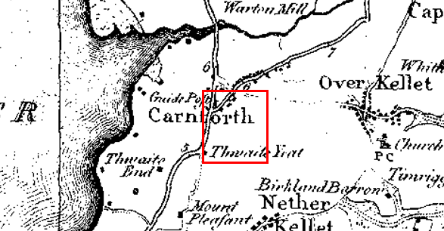
Observations |  | The route is not shown on Yate's Map.
Investigating Officer's Comments |  | The route is unlikely to have existed in 1786 and if it did exist as a minor route (even in part) was not shown due to limitations of scale so no inference can be drawn in this respect.
Greenwood’s Map of Lancashire | 1818 | Small scale commercial map. In contrast to other map makers of the era Greenwood stated in the legend that this map showed private as well as public roads and the two were not differentiated between within the key panel.
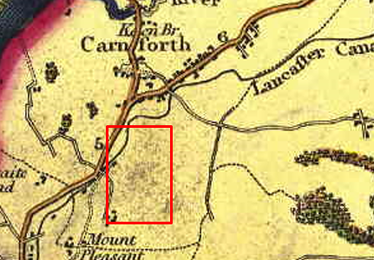
Observations |  | The route is not shown on Greenwood's Map.
Investigating Officer's Comments |  | The route did not exist as a major route at the time but it may have existed as a minor route which would not have been shown due to the limitations of scale so no inference can be drawn in this respect.
Hennet's Map of Lancashire | 1830 | Small scale commercial map. In 1830 Henry Teesdale of London published George Hennet's Map of Lancashire surveyed in 1828-1829 at a scale of 71/2 inches to 1 mile. Hennet's finer hachuring was no more successful than Greenwood's in portraying Lancashire's hills and valleys but his mapping of the county's communications network was generally considered to be the clearest and most helpful that had yet been achieved.
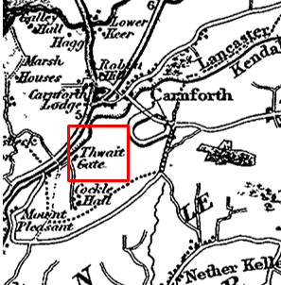
Observations |  | The application route is not shown.
Investigating Officer's Comments |  | The route did not exist as a major route at the time but it may have existed as a minor route which would not have been shown due to the limitations of scale so no inference can be drawn in this respect.
Canal and Railway Acts |  | Canals and railways were the vital infrastructure for a modernising economy and hence, like motorways and high speed rail links today, legislation enabled these to be built by compulsion where agreement couldn't be reached. It was important to get the details right by making provision for any public rights of way to avoid objections but not to provide expensive crossings unless they really were public rights of way. This information is also often available for proposed canals and railways which were never built.
Observations |  | The route is not crossed by any canals or railways and there were no proposed canal or railways affecting the site.
Investigating Officer's Comments |  | No inference can be drawn.
Tithe Map and Tithe Award or Apportionment | 1846 | Maps and other documents were produced under the Tithe Commutation Act of 1836 to record land capable of producing a crop and what each landowner should pay in lieu of tithes to the church. The maps are usually detailed large scale maps of a parish and while they were not produced specifically to show roads or public rights of way, the maps do show roads quite accurately and can provide useful supporting evidence (in conjunction with the written tithe award) and additional information from which the status of ways may be inferred.
Observations |  | Early maps and further research indicates that the route did not come into existence until much later, probably when quarrying started here. For these reasons the 1846 Tithe Map and Award has not been examined.
Investigating Officer's Comments |  | No inference can be drawn.
Inclosure Act Award and Maps |  | Inclosure Awards are legal documents made under private acts of Parliament or general acts (post 1801) for reforming medieval farming practices, and also enabled new rights of way layouts in a parish to be made. They can provide conclusive evidence of status.
Observations |  | There is no Inclosure Award in the County or National Archives for the land crossed by the application route.
Investigating Officer's Comments |  | No inference can be drawn.
6 Inch Ordnance Survey (OS) Map | 1848 | The earliest Ordnance Survey 6 inch map for this area surveyed in 1845 and published in 1848.
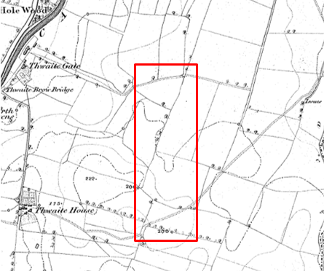
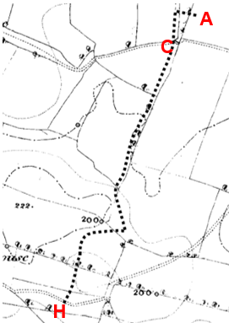
6 inch OS with digital overlay of application route
Observations |  | The application route is not shown and the route (as identified by a digital overlay) can be seen crossing a number of field boundaries.  A route consistent with the route now recorded as Footpath 12 can be seen (as a double pecked line) passing through point H but there is no indication that the application route joined it.
Investigating Officer's Comments |  | The application route did not exist on the ground in 1848.
25 Inch OS Map | 1891 | The earliest OS map at a scale of 25 inch to the mile. Surveyed in 1890 and published in 1891.
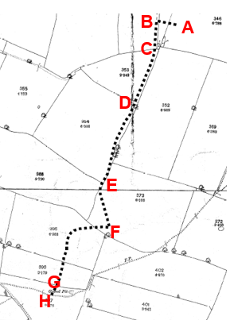
25 inch OS with digital overlay
Observations |  | The application route is not shown.  The map, which provides greater detail than the earlier 6 inch map, shows 9 field boundaries across the route but there is no indication that the route existed.
Investigating Officer's Comments |  | The route did not exist on the ground in 1891.
25 inch OS Map | 1913 | Further edition of the 25 inch map surveyed in 1890, revised in 1910 and published in 1913.
Observations |  | The route is not shown.  The land crossed by the application route appears unaltered from how it is shown on the first edition 6 and 25 inch maps.
Investigating Officer's Comments |  | The route did not exist on the ground in 1913.
Finance Act 1910 Map | 1910 | The comprehensive survey carried out for the Finance Act 1910, later repealed, was for the purposes of land valuation not recording public rights of way but can often provide very good evidence. Making a false claim for a deduction was an offence although a deduction did not have to be claimed so although there was a financial incentive a public right of way did not have to be admitted.  Maps, valuation books and field books produced under the requirements of the 1910 Finance Act have been examined. The Act required all land in private ownership to be recorded so that it could be valued and the owner taxed on any incremental value if the land was subsequently sold. The maps show land divided into parcels on which tax was levied, and accompanying valuation books provide details of the value of each parcel of land, along with the name of the owner and tenant (where applicable).  An owner of land could claim a reduction in tax if his land was crossed by a public right of way and this can be found in the relevant valuation book. However, the exact route of the right of way was not recorded in the book or on the accompanying map. Where only one path was shown by the Ordnance Survey through the landholding, it is likely that the path shown is the one referred to, but we cannot be certain. In the case where many paths are shown, it is not possible to know which path or paths the valuation book entry refers to. It should also be noted that if no reduction was claimed this does not necessarily mean that no right of way existed.
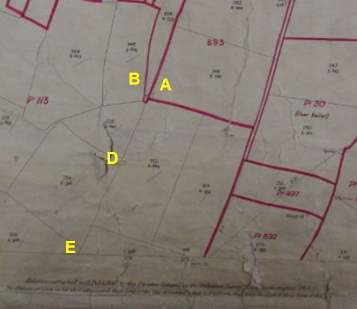
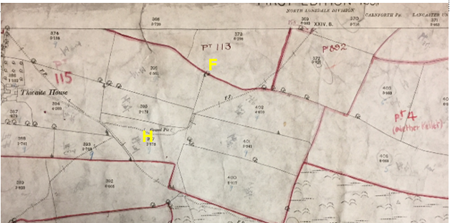
Observations |  | The application route passes through plots numbered 893, 311, 113 and 115 which were all owned and occupied by different people. No deduction was claimed for public rights of way or user in any of the numbered plots through which the application route runs.
Investigating Officer's Comments |  | The Valuation records do not provide any supporting evidence regarding the existence of the route in 1910.
25 Inch OS Map | 1932 | The 'third' edition of the 25 inch OS map was revised in 1930 and published in 1932. The county council does not have a copy of the map sheet covering point A to point E of the application route and it could not be found online.  The map sheet covering the second part of the application route (from point E to point H) is available to view in the county council records.
Observations |  | The land crossed by the application route between point E and point H remained unaltered from earlier editions of the 6 inch and 25 inch maps and the application route is not shown.
Investigating Officer's Comments |  | No inference can be drawn with respect to the route between point A and point E.  The application route between point E and point H did not exist on the ground in 1932.
Aerial Photograph | 1940s | The earliest set of aerial photographs available was taken just after the Second World War in the 1940s and can be viewed on GIS. The clarity is generally very variable.
Observations |  | No copy of the 1940s aerial map was available.
Investigating Officer's Comments |  | No inference can be drawn.
6 Inch OS Map | 1956 | The OS base map for the Definitive Map, First Review, was revised before 1930, with major revisions in 1951 and published in 1956 at a scale of 6 inches to 1 mile (1:10,560).
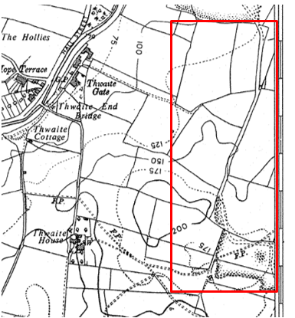
Observations |  | Changes had occurred since the 1930s and it appears that quarrying had commenced in the vicinity during that time. As these were not shown on the 1932 edition, which is likely to have used the same revision information as the 1956 edition which stated it was revised before 1930, the differences between the 2 editions must have resulted from the 1951 revision for major changes.  Dunkirk/Windermere Avenue are not shown and the route is not shown between point A and point B. From point B the route is consistent with a bounded route running generally north to south linking two quarry areas passing through point C, point D and point E to approximately point F. The route between point F and point H is not shown.
Investigating Officer's Comments |  | Part of the route existed from before 1951 (point B to point F) as a substantial track connecting two quarries. It did not create a through route from point A to point H and appears to have been constructed for the specific purpose of a quarry access route.
Aerial photograph | 1960s | The black and white aerial photograph taken in the 1960s and available to view on GIS.
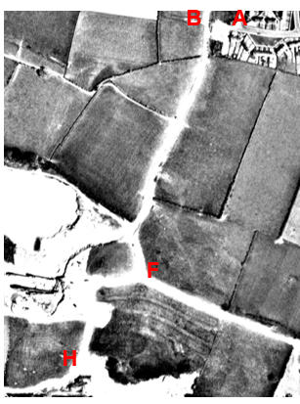
Observations |  | The application route from point B to point H can be clearly seen as a substantial quarry access road. It is not clear whether access was available at point B to gain access to the rest of the application route.
Investigating Officer's Comments |  | The application route from point B to point H appears to have formed part of a quarry access road.
1:2500 OS Map | 1972 | Further edition of 25 inch map reconstituted from former county series and revised in 1969-70 and published 1972 as national grid series.
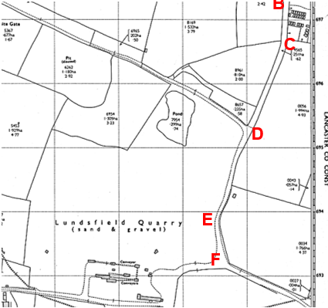
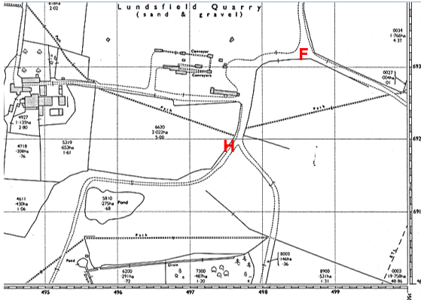
Observations |  | Dunkirk Avenue and Windermere Road are shown, together with the garages. The application route between point A and point B appears to be available although a line can be seen across the route at point B with no indication as to whether access was available through it.  Between point B and point D the application route is shown as a substantial bounded track and from D to F it is a similar width track but enclosed only on the east. The track splits at point F from where the application route through to point H is shown as a broader open area providing access to (and past) the sand and gravel quarry. A 'path' (double pecked lines) is shown crossing the application route in the proximity of point H but is not on the exact alignment of the route later recorded as Footpath Carnforth 12 (or the route shown as a footpath on the earlier OS maps).  North of point B (and not shown on the map extract inserted into the report) the route continues to link to a further quarried area.
Investigating Officer's Comments |  | The application route from point B to point H appeared to form part of a network of substantial routes providing access to and between the quarries in 1969-70. It is unclear whether access was available onto the route from Dunkirk Avenue/Windermere Road (at point B).  The route from B to point H is consistent with a quarry access road.
Aerial Photograph | 1988 | Aerial photograph available to view at the County Records Office.
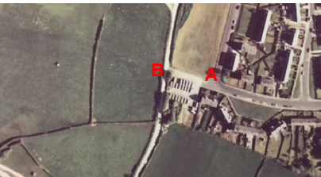
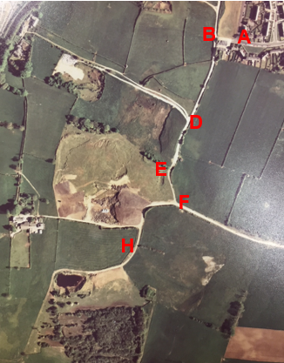
Observations |  | The quarry no longer appears to be in operation and much of the surrounding land had been landscaped. The tracks clearly visible and not grassed over, suggesting vehicular use.  A-B appears accessible and no overgrown area is visible around B; this suggests it did connect to the former quarry track.
Investigating Officer's Comments |  | The application route existed in 1988 and appeared to be capable of being used.
Aerial Photograph | 2000 | Aerial photograph available to view on GIS.
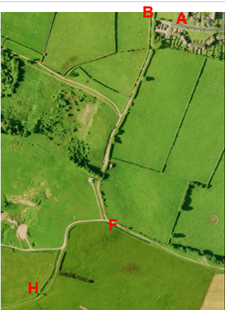
Observations |  | Access along the route appears to be available between point A and point B From point B the application route is clearly visible through to point H.
Investigating Officer's Comments |  | The application route existed in 2000 and appeared to be capable of being used.
Aerial photograph | 2016 | Aerial photograph available to view on GIS.
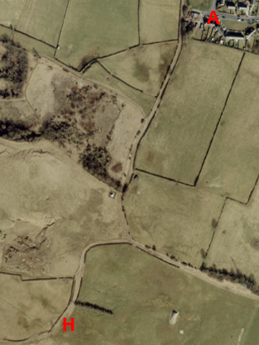
Observations |  | The full length of the application route can be seen although it is not possible to see what access was available at point B.
Investigating Officer's Comments |  | The application route existed in 2016 and appeared to be capable of being used.
Definitive Map Records |  | The National Parks and Access to the Countryside Act 1949 required the county council to prepare a Definitive Map and Statement of Public Rights of Way.  Records were searched in the Lancashire Records Office to find any correspondence concerning the preparation of the Definitive Map in the early 1950s.
Parish Survey Map | 1950-1952 | The initial survey of public rights of way was carried out by the parish council in those areas formerly comprising a rural district council area and by an urban district or municipal borough council in their respective areas. Following completion of the survey the maps and schedules were submitted to the county council. In the case of municipal boroughs and urban districts the map and schedule produced, was used, without alteration, as the Draft Map and Statement. In the case of parish council survey maps, the information contained therein was reproduced by the county council on maps covering the whole of a rural district council area. Survey cards, often containing considerable detail exist for most parishes but not for unparished areas.  Carnforth was an Urban District Council for which no parish survey map was prepared.
Draft Map |  | The Draft Maps were given a “relevant date” (1st January 1953) and notice was published that the draft map for Lancashire had been prepared. The draft map was placed on deposit for a minimum period of 4 months on 1st January 1955 for the public, including landowners, to inspect them and report any omissions or other mistakes. Hearings were held into these objections, and recommendations made to accept or reject them on the evidence presented.
Observations |  | The route was not shown on the Draft Map and no representations were made to the county council.
Provisional Map |  | Once all representations relating to the publication of the draft map were resolved, the amended Draft Map became the Provisional Map which was published in 1960, and was available for 28 days for inspection. At this stage, only landowners, lessees and tenants could apply for amendments to the map, but the public could not. Objections by this stage had to be made to the Crown Court.
Observations |  | The route was not shown on the Provisional Map and no representations were made to the county council.
The First Definitive Map and Statement |  | The Provisional Map, as amended, was published as the Definitive Map in 1962.
Observations |  | The route was not shown on the First Definitive Map and Statement.
Revised Definitive Map of Public Rights of Way (First Review) |  | Legislation required that the Definitive Map be reviewed, and legal changes such as diversion orders, extinguishment orders and creation orders be incorporated into a Definitive Map First Review. On 25th April 1975 (except in small areas of the County) the Revised Definitive Map of Public Rights of Way (First Review) was published with a relevant date of 1st September 1966. No further reviews of the Definitive Map have been carried out. However, since the coming into operation of the Wildlife and Countryside Act 1981, the Definitive Map has been subject to a continuous review process.
Investigating Officer's Comments |  | From 1953 through to 1975 there is no indication that the route was considered to be public right of way by the Surveying Authority. There were no objections or representations made with regards to the fact that the route was not shown on the map when the maps were placed on deposit for inspection at any stage of the preparation of the Definitive Map.
Highway Adoption Records including maps derived from the '1929 Handover Maps' | 1929 to present day | In 1929 the responsibility for district highways passed from district and borough councils to the county council. For the purposes of the transfer, public highway 'handover' maps were drawn up to identify all of the public highways within the county. These were based on existing Ordnance Survey maps and edited to mark those routes that were public. However, they suffered from several flaws – most particularly, if a right of way was not surfaced it was often not recorded.  A right of way marked on the map is good evidence but many public highways that existed both before and after the handover are not marked. In addition, the handover maps did not have the benefit of any sort of public consultation or scrutiny which may have picked up mistakes or omissions.  The county council is now required to maintain, under section 31 of the Highways Act 1980, an up to date List of Streets showing which 'streets' are maintained at the public's expense. Whether a road is maintainable at public expense or not does not determine whether it is a highway or not.
Observations |  | The route is not recorded as being publicly maintainable on the List of Streets by the county council.
Investigating Officer's Comments |  | No inference can be drawn regarding public rights.
Statutory deposit and declaration made under section 31(6) Highways Act 1980 |  | The owner of land may at any time deposit with the county council a map and statement indicating what (if any) ways over the land he admits to having been dedicated as highways. A statutory declaration may then be made by that landowner or by his successors in title within ten years from the date of the deposit (or within ten years from the date on which any previous declaration was last lodged) affording protection to a landowner against a claim being made for a public right of way on the basis of future use (always provided that there is no other evidence of an intention to dedicate a public right of way).  Depositing a map, statement and declaration does not take away any rights which have already been established through past use. However, depositing the documents will immediately fix a point at which any unacknowledged rights are brought into question. The onus will then be on anyone claiming that a right of way exists to demonstrate that it has already been established. Under deemed statutory dedication the 20 year period would thus be counted back from the date of the declaration (or from any earlier act that effectively brought the status of the route into question).
Observations |  | No Highway Act 1980 Section 31(6) deposits have been lodged with the county council for the area over which the route runs.
Investigating Officer's Comments |  | There is no indication by a landowner under this provision of non-intention to dedicate public rights of way over their land.
Google Street View | 2009 | Google images taken in 2009.
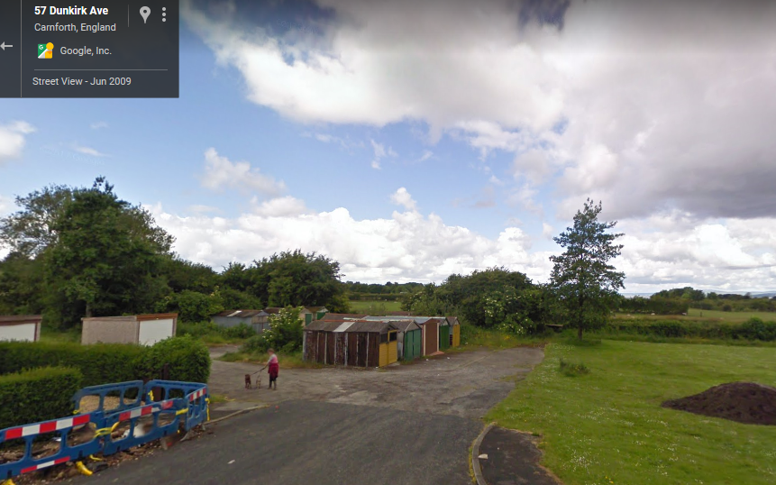
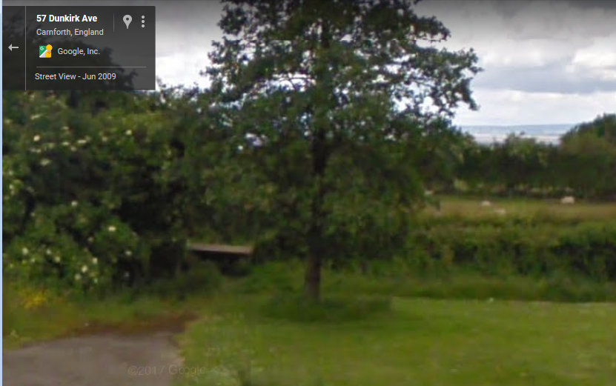
Point A
Observations |  | Access onto the application route at point A is open and accessible with no signage apparent indicating whether or not the route was considered to be public or private. The track appears to be used by vehicles gaining access to the garages (indicated by its width and pot holed surface).
Investigating Officer's Comments |  | Access onto the application route appears available at point A in 2009.
20 Barriers Race |  | Details of a local running race held annually in Carnforth.
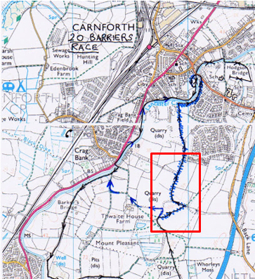
Observations |  | An online search found a dedicated web page to 'the 20 barriers race'. The race appears to be an annual event supported by a running shop (the Runners Centre) in Lancaster with part of the proceeds from the event being donated to charity.  The event is described as following a 5.5 mile scenic route on the field paths, trails and canal towpath in the countryside to the south of Carnforth.  The website explains that the race gets its name from the number of stiles and other field boundaries crossed along the route but it is stated that none of the ‘20 barriers’ should present any unusual hazards or difficulties.  In relation to the 2018 event (held on 3rd July) it is stated that following the closure of the Lundsfield track to the public in early 2017 the race now finds its way back to Carnforth via Thwaite End Bridge number 127 and an annotated extract of an Ordnance Survey map is provided (see map insert above) showing the revised route with the former route – which followed the application route between point B and point F – scribbled out with a blue pen.  The Investigating Officer made contact with the current race organiser who explained that he had taken over organising the event in 2004 from a former Carnforth High School teacher who started it off in the mid-1990s and that the event had been run every year since (with the exception of 2001 when it wasn't run due to the foot and mouth out outbreak).  He explained that the race had included use of the application route between point B and point F and that as organisers they never sought permission to stage the race over this land with the landowner as it was an unused post-industrial site which for all intent and purposes appeared to be open to the public.
Investigating Officer's Comments |  | The route appeared to have been capable of being used (at least between points B and point F) since the mid-1990s and had a local reputation of being open to the public.

The affected land/specified parts of the land is not designated as access land under the Countryside and Rights of Way Act 2000 and is not registered common land. The route crosses a biological heritage site between points D to H.

Landownership

The section of the route between points A and B is registered to Lancaster City Council of Town Hall, Dalton Square, Lancaster, LA1 1PJ.

The section of the route between points B and C is registered to the Homes and Communities Agency (now Homes England) of Arpley House, 110 Birchwood Boulevard, Birchwood, Warrington, WA3 7QH.

The section of the route between points C and F is registered to John W. Hartley Limited of Station Road, Stoney Stanton, Leicestershire, LE9 4LX.

The section of the route between points F and H is registered to Rodney and Jean Thompson of Thwaite House, Carnforth, Lancaster, LA5 9EL.

Summary

The application is for the route to be recorded as a public footpath.

To summarise, the Investigating Officer was of the opinion that there was insufficient historical map and documentary evidence from which public rights could be inferred.

It appears that the route applied for did not physically exist until the development of the sand and gravel quarries located to the north of point B and to the west of point F and that part of the route existed by at least 1951 as a substantial track connecting the two quarries.

However, no information could be found about when the quarry ceased to operate and whether public access was available during the time the quarries were in use.

By the 1970s the whole length of the application route appears to have existed and may have been capable of being used although it is unclear whether access was available through point B and at that time the route appeared to be primarily for the purpose of quarry access.

From the 1970s onwards map and photographic evidence supports the user evidence in regards to the fact that the route existed and appeared to be capable of being used and current site evidence suggests that the route is still being used.

Head of Service – Legal and Democratic Services Observations

Information from the Applicant
The application was supported by maps, photos and evidence forms.

User Evidence
There were 40 User Evidence forms provided with the application.

The application route use varies between the years 1955 and 2018.

No. Users over continuous period of years
70 Years | 60 Years | 50 Years | 40 Years | 30 Years | 20 Years | 10 Years
2 | 4 | 7 | 9 | 6 | 3 | 4

5 Users did not provide any clear dates of their continuous usage of the route.

Usage per year up until 2018:
 | Everyday | 300 | 250 | 200 | 150 | 100 | 50 | Other
Foot | 10 | 1 | 1 | 4 | 7 | 6 | 4 | 7
Bicycle | 0 | 0 | 0 | 1 | 1 | 1 | 0 | 0
Horse | 0 | 0 | 0 | 0 | 0 | 0 | 0 | 1

7 foot users provided the following comments with regards to how often they use the route: "regularly for many years"; "1000's of times over the years"; "all year around"; "regularly"; "hundreds"; "20/30 times per year"; and "2/3 times per year".

37 users confirmed that the application route has always followed the same course. 2 users did not provide an answer and 1 user provided that giant gates were put in place in 2017.

The main reasons for the use of the route were for dog walking, playing as a youth, pleasure, social, walking to the canal or Nether Kellet, walking to school, shopping, access to Carnforth Rangers FC, keeping fit, playing in the quarry as a child, bike rides, horse riding and bird watching.

33 users confirmed that they have never seen any signs or notices suggesting that the route was not a public right of way. 2 users provided that they have seen notices 'just recently' and 1 user provided that there is a sign saying "no motorcycles".

30 users provided that there are stiles or gates on the route:

Of the 30 users, 8 users described or marked there being a stile on the route close to the garages at the end of Windermere Road (point B on the committee plan);
7 of the 30 users describe there being a small swing gate near to the mast on the path (point E); 3 users marked the same point on the plan but described it as a stile and 3 other users marked the same point but did not provide whether it was a stile or gate;
1 user marked the plan as there being a gate at point F;
5 users marked there being a gate at point D, 4 users marked a gate at point C;
12 of the 30 users that answered provided that there were gates or stiles on the route but did not describe or mark on the map where these were; 6 users answered "no" to there being any stiles or gates and 4 provided no answer to the question.

1 user provided that there are steps at point B.

1 user provided that the stile has been there for 30+ years; 2 were not sure; 3 provided that it has always been there; and another provided that it has been there as long as they could remember.

36 users answered "no" to having ever been stopped or turned back whilst using the route or having heard of others having been stopped or turned back; 4 users did not provide an answer.

37 users answered "no" to having worked for the landowner whilst using the application route; 3 users did not provide an answer.

35 users answered "no" to having ever been told by any owner or tenant of the land that the route was not public, 1 user provided that they have had polite conversations with 2 land owners; 3 users did not answer the question and 2 users provided the answer "just recently".

None of the users have heard or been told of anyone being prevented or turned back whilst using the route.

37 users answered "no" when asked if they had been given permission to use the route; 3 users provided no answer to the question.

Comments referring to locked gates and any other obstructions are as follows:
- "From November 2017 a locked gate with a fence on both sides has blocked the track near to point A" (point B on the committee plan)
- "When the fence has been put up by Homes England"
- "Only obstruction to appear were last year by the Quarry Site Developers (locked gates and palisade fencing)"
- "Last year when the lane got blocked behind the garages on Dunkirk Ave" (point B on the committee plan)
- "There is now a gate at the bottom of the track near the garages (point B) which stops me from walking up there with my little girl and dog as he is a big dog"
- "Just recently"

Additional comments made by users are as follows:
- "It's been used for that long my dad used to play up there as a child"
- "Since the gates have blocked the route people have to use Back Lane Road to access public footpaths. I believe by doing this people's lives are at risk as cars and wagons come down too quick. Families with children are especially at risk"
- "For as long as I can remember the lane has been open to the public. People of all ages have used the lane for dog walking or for walking round the countryside using the public rights of way"
- "My grandfather was on the committee for Rangers when it opened in 1953 and the paths were used then"
- "The track will spoil my enjoyment of the area"
- Myself, brothers and friends used to go up the lane for many years as children and to present day. My children have done the same and my grandchildren have walked up there may a time with myself and our dogs"
- "I have seen many a visitor on walks up there"
- "The two local farmers, Mr Thompson and Mr Longton have always allowed us to use all of the footpaths on their land with no trouble"

Information from Landowners

Trowers & Hamlins LLP acting on behalf of one of the landowners, Homes England object to the application.

They requested a copy of the application which was sent 17th April to them. We are yet to receive any comments on these documents.

Their client is currently developing the site and has taken exhaustive steps to give notice (by signage on site) that the land is privately property, potentially unsafe and unsuitable for public access.

Information from others

Neil Herbert on behalf of the Lancaster Group of the Ramblers Association have no objections to the application. They provided the following comments:
1. There is a similar route in their potential list ways claims, L.1-13.02, Tipping Lane.
2. A second claim, L.1-03.03 Carnforth 29 could be linked in with this application since 1-3-FP29 does not end on a PRoW.
3. The route is well used by the local community. Currently the route has closed steel gates at both the Kellet Road and near the Dunkirk Avenue end. In the past the path would have been used for access to the quarry but more recently for the football ground, marina and Carnforth centre as well as for general exercise.
4. Since the area appears to be subject to an imminent planning application, maybe best to await this application and then develop the most suitable route to suit all parties.

Assessment of the Evidence

The Law - See Annex 'A'

In Support of Making an Order(s)

- User evidence
- Absence of action taken by the landowners to discourage use of the route until recently
- Absence of signs and notices along the route suggesting that the route was not public until recently
- Map and photographic evidence from the 1970's onwards supporting the user evidence that the route existed and was capable of being used.
Map provided as part of the 20 Barriers Race suggesting that the route (at least between points B and F) was capable of being used from the mid 1990's and had a local reputation of being open to the public.

Against Making an Order(s)

- Insufficient historical map and documentary evidence from which public rights could be inferred.

- Recent locking of gates and barriers along the route.

Conclusion

The claim is that the route A-B-C-D-E-F-G-H has already become a footpath in law and should be recorded on the Definitive Map and Statement of Public Rights of Way.

Committee will note that an earlier application, a report in respect of which is also being considered by Committee at this meeting, also includes the section of the route A-B.

It is advised that as there is no express dedication that Committee should consider, on balance whether there is sufficient evidence from which to have its dedication inferred at common law from all the circumstances or for the criteria in section 31 Highways Act 1980 for a deemed dedication to be satisfied based on sufficient twenty years "as of right" use to have taken place ending with this use being called into question.

Considering initially whether there are circumstances from which dedication could be inferred at common law. It is advised that Committee has to consider whether evidence from the maps and other documentary evidence coupled with user evidence indicates that it can be reasonably inferred that in the past the landowner(s) intended to dedicate the route as a public right of way. Considering the historical map evidence it is suggested that there is insufficient historical map evidence from which public rights could be inferred. Whilst it would appear that part of the route existed by at least 1951 as a substantial track connecting two quarries and that the whole length of the application route existed and may have been capable of use by the 1970's, it is not clear whether the route was primarily for access to the quarries. However, whilst it is suggested that the way this route is recorded on documentary evidence is not itself sufficient circumstances from which dedication could be inferred, sufficient as of right use acquiesced in by the owners may also be circumstances from which dedication can be inferred. From looking at the user evidence it would appear that until 2017 no clear actions were taken by owners and use by the public continued over several years prior to 2017 such that on balance there may be sufficient evidence from which to infer dedication at common law.

Looking secondly at the criteria for a deemed dedication under section 31 of the Highways Act 1980; use of the route needs to be by the public 'as of right' (without force, secrecy or permission) and without interruption over a sufficient 20 year period immediately prior to the route being called into question. In this matter the evidence indicates that access to the route was denied in or around 2017 by the presence of locked gates and fencing. Accordingly, the 20 year period under consideration for the purposes of establishing deemed dedication would be 1997-2017.

The applicant has provided 40 user evidence forms which show use of the route from as early as 1955. With the exception of 5 of the users who did not provide any clear dates of their continuous usage of the route, all other users have provided evidence of use during the period under consideration with one user having witnessed other users whilst using the route and 4 of the other users making reference to family members and others having used the route for many years. Other than for one user who claims to have used the route on horseback, all users claim to have known and used the route on foot on a regular basis 'as of right' with 3 users also having used the route on pedal cycle. 2 users refer to having seen signs 'just recently' and one user provided that there is a sign saying 'no motorcycles'. However, 33 of the users have never seen signs or notices along the route suggesting that the route was not a public right of way. None of the users, other than 2 who state that they had been told 'just recently' refer to having ever been told that the route was not a public right of way nor do any users refer to having been turned back, having heard of others being turned back or having asked for permission to use the route. It is therefore suggested that the user forms indicate that on balance, the route has been used as of right and without force, secrecy or interruption during the period under consideration.

An objection has been received from one of the landowners, Homes England. However, whilst this objection is acknowledged, it is submitted that the concerns raised are not relevant considerations under either section 31 Highways Act 1980 or under Common Law.

On balance and after careful consideration, it is suggested that the criteria under section 31 Highways Act 1980 can be satisfied. Taking all of the information into account Committee may consider that a dedication of a footpath can be deemed or inferred and that it is appropriate that an Order be made and promoted to confirmation.

Risk management

Consideration has been given to the risk management implications associated with this claim. The Committee is advised that the decision taken must be based solely on the evidence contained within the report, and on the guidance contained both in the report and within Annex 'A' included in the Agenda Papers. Provided any decision is taken strictly in accordance with the above then there is no significant risks associated with the decision making process.

Local Government (Access to Information) Act 1985

List of Background Papers

Paper | Date | Contact/Directorate/Tel
All documents on File Ref: 804-589 |  | Claire Blundell, 01772 535604, Legal and Democratic Services
Reason for inclusion in Part II, if appropriate

N/A

The Ordnance Survey (OS) has produced topographic maps at different scales (historically one inch to one mile, six inches to one mile and 1:2500 scale which is approximately 25 inches to one mile). Ordnance Survey mapping began in Lancashire in the late 1830s with the 6-inch maps being published in the 1840s. The large scale 25-inch maps which were first published in the 1890s provide good evidence of the position of routes at the time of survey and of the position of buildings and other structures. They generally do not provide evidence of the legal status of routes, and carry a disclaimer that the depiction of a path or track is no evidence of the existence of a public right of way.
Aerial photographs can show the existence of paths and tracks, especially across open areas, and changes to buildings and field boundaries for example. Sometimes it is not possible to enlarge the photos and retain their clarity, and there can also be problems with trees and shadows obscuring relevant features.

