LEP – Sub Committee

LEP - Lancashire Skills and Employment Board

Private and Confidential: NO

Date: Wednesday, 21 November 2018

Lancashire Skills and Employment Hub Update

Report Author: Dr M Lawty-Jones, Director of the Lancashire Skills and Employment Hub, Tel: 07825996446, michele.lawty-jones@lancashirelep.co.uk

Executive Summary

This paper provides an overview of activity since the last committee meeting in October 2018.

Recommendation

The Lancashire Skills and Employment Board are asked to note the update.

Background and Advice

1. Careers Education, Information, Advice and Guidance (CEIAG)
  - The Lancashire Enterprise Adviser Network has grown from 127 (as of the end of September) to 129 schools and colleges at the end of October. 111 have been matched with at least one volunteer business leader (Enterprise Adviser) – this has reduced by 3 due to churn in Enterprise Advisers. Plans are in place to match all schools and colleges by the end of the year.

  - Stuart Graham commenced employment with the LEP's delivery partner, Inspira, mid-October as Senior Enterprise Coordinator. Stuart will have a caseload of schools and colleges, and line manage the Enterprise Coordinators outside of the Careers Hub.

  - Following the briefing event for the schools and colleges within the Careers Hub at the end of September, the Careers Hub Lead, Kay Vaughan, has been undertaking individual visits to the institutions to support the development of an implementation plan. Kay also attended the 5 day Careers and Enterprise Company training programme for the 20 Careers Hub Leads from pilots from across the Country.

  - The Careers and Enterprise Company have announced the activity fund providers for the Careers Hub areas of Burnley and Pendle. An event has been arranged to enable the providers to pitch their offer to the schools and colleges in the area. Each school and college will have a 'virtual wallet' to purchase activities from the providers as per the model in the Blackpool Opportunity Area. In terms of Blackpool, contracts have been extended by the Company with providers who delivered activity in the last academic year, and schools and colleges are currently in the process of 'purchasing' activities using their virtual wallets. The Enterprise Coordinators and Advisers are supporting schools and colleges with their choices, mapping offers to their most recent Careers Compass assessments.

  - Following a meeting with the Greater Manchester Growth Company, who have secured the contract for the National Careers Service for a further 3 years across the Northwest and Staffordshire, priorities have been shared for the Lancashire area based on the refreshed labour market intelligence. This includes a focus on priority wards with higher levels of unemployed and inactive residents (including the Blackpool Opportunity Area), a focus on 18-24 NEETs, 50+ and SEN/disabled.

  - To note national priorities are driving provision towards adults who have been unemployed for over 12 months, and those that have Level 1 or less skills levels (previously Level 2). The service is more targeted than previously, and as such, there is less flexibility for providers.

2. European Structural Investment Funds (ESIF)
2.1 It was reported at the October Committee that Lancashire's ESIF funds would be up-rated to reflect fluctuations in the exchange rates. As a result the sterling value of the ESIF programme has been increased.

2.2 For ESF an exchange rate of €1=£0.87 has been applied which equates to an up-rated total of £89,144,685 without the performance reserve (94%) and £94,834,771 with the performance reserve (100%).
2.3 DWP has requested that all LEP areas indicate how they are looking to commit additional funds. Further information is in the ESF paper on the agenda, for consideration by committee members.
2.4 The Escalate on-line referral tool to support people on their journey into work was launched in April: https://www.lancashireskillshub.co.uk/escalate/ with seven launch events and over 400 people attending. Initially Escalate included all of the ESF projects targeting unemployed and inactive adults. This is now being expanded to include other offers aimed at re-engaging adults into the labour market, for example, the Work and Health Programme and the National Careers Service.
2.5 Following on from the positive feedback from the marketplace attendees at the Escalate launch events, the Lancashire Adult Skills Forum decided to hold a further 7 regional events to support cross project working. The first two events have taken place in Preston and Pendle. Additional events are planned for West Lancashire, the Fylde Coast and Blackburn. The aim of the events is to bring together front line workers across the ESF projects and other providers to enable them to start some positive conversations and to facilitate the increase of cross project referrals and progressions.
2.6 From April 2018 until 31st September 2018 there have been 914 searches made on the Escalate system. The top 3 sectors searched for are Retail, Customer Service and Hospitality & Catering. The highest support requests have been for confidence, mental health support and support with IT and the use of IT.
2.7 The Lancashire Adult Skills Forum are supporting the development of Escalate, with a number of updates including improved reporting. The Forum will review the data obtained from Escalate and will use this data to inform current provision and influence future activity.
3. City Deal

3.1 As outlined in the last update at the October meeting, data against the skills and employment metrics for the mid-year report has now been compiled and collated by the City Deal Skills and Employment Steering Group and submitted for the broader report which will go to the City Deal Executive at the end of November. The report is provided under a separate agenda item for review by committee members.
4. Apprenticeship Update
4.1 As reported previously, the LEP secured £5,000 of ESFA funding in January 2018 to support Apprenticeship intermediary training and to purchase Blue Sheep data to support analysis of data from the ESFA Data Cube. Analysis could not be undertaken due to GDPR issues and access to the Data Cube. This has now been resolved and, as a result, purchase of the Blue Sheep data will now be progressed using end of year data, which is due to be made available by the ESFA at the end of November.
4.2 The Lancashire Ambassador Network continues to grow and is linking to both the North West Network and the National Network. There are currently 37 active Apprentice Ambassadors and 46 Employer Ambassadors in Lancashire. Ambassadors are presenting at a wider range of events, including business forums, and in schools and colleges. The network is currently supported through ESFA Opt-in capacity building funds until the end of March 2019. Future sustainability is currently being discussed with partners. The Lancashire Work Based learning forum is working closely with the NW network looking at how they can link into the wider NW activities. The most recent newsletter can be accessed via the website:
http://www.lancsforum.co.uk/apprentice-ambassadors/apprentice-ambassador/

5. Technical Education
5.1 The first meeting of the Technical Education Steering Group, chaired by Bev Robinson, Blackpool and The Fylde College, took place on 22nd November. Terms of Reference, reporting, governance and ways of working were agreed.
5.2 The Technical Education Vision for Lancashire is being launched on 30th November at Brockholes, Preston. All committee members have been invited to this through Eventbrite. The launch will be supported by a 16 page summary of the Vision document.
5.3 Three T Level Routeway Networks have now been established with support from the Skills & Employment Hub, with membership from those Lancashire colleges who are planning to deliver the routes: Digital, Construction and Engineering & Manufacturing. The Industry Placement working group has now met twice with input from a range of partners, most recently, Myerscough College discussing their work on the pilot last year. Over £2 million in capacity and development funding (CDF) has been allocated to Lancashire colleges for use in 2018/19 to grow their Industry Placement offer with employers.

5.4 The Teach Too project with The Lancashire Colleges, focussing on the Digital Sector, is starting to have some traction, with three activities which take teaching staff into employer environments in planning. Seven more need to take place before the end of March.

5.5 Several requests for presentations continue to be fulfilled by the Skills & Employment Hub. These have been for staff at colleges, Information, Advice and Guidance services and mixed provider and employer groups.

5.6 There is also a presentation to the committee on the agenda, outlining the Technical Education Vision to 2030, the two year rolling action plan and the agenda for the launch event.
6. Skills Advisory Panels (Skills and Employment Boards)
6.1 As per the update at the last meeting, the DfE have issued two draft documents to LEPs and Mayoral Combined Authorities (MCAs) for comment: 'Guidance on the Development of Skills Advisory Panels Boards' and 'SAPs: Proposed Analytical Toolkit'. The former sets out expectations relating to remit, governance and composition and the latter expectations regarding high quality analysis of skills-related data.
6.2 The Skills Hub has attended the LEP Network's Skill and Data Leads meetings and fed in views, alongside a written response. Following the events, a survey regarding 'data analyst' capacity was issued by DfE in response to the concerns raised by a number of LEPs regarding capacity to collate data, as per the proposed Data Toolkit, and to undertake analysis.
6.3 The DfE have indicated that they will provide feedback on responses from LEPs and MCAs shortly, with view to aligning SAPs with the broader LEP Review.
7. Marketing and Communications
7.1 It has been another positive month on Twitter, with an additional 51 followers since the last report, bringing the total to 1,475 as of 05/11/18. A twitter campaign is being prepared for the run up to the festive season, promoting ESF projects and partnerships. Some additional information includes:-
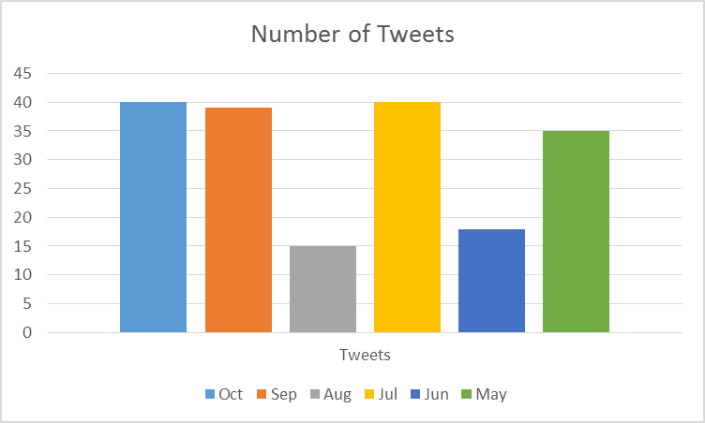

Number of times users saw the tweet on twitter

Our most popular tweets: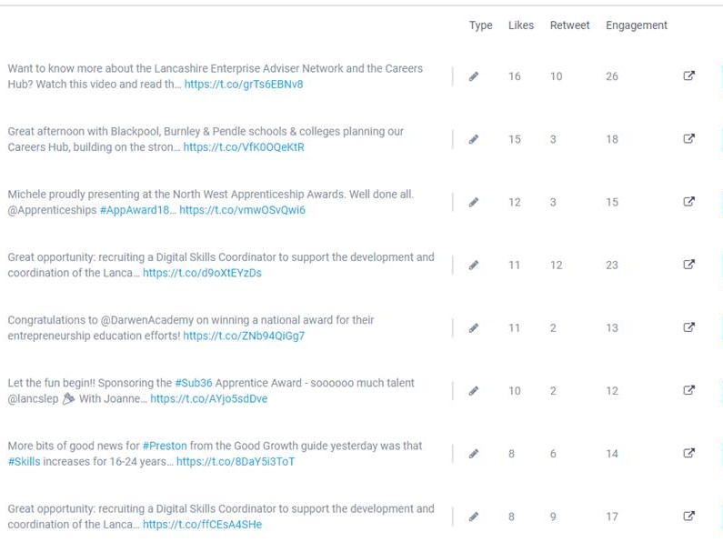

7.2 Joanne Pickering, Vice Chair of the committee, presented the Apprentice Award at the Sub36 awards to Lucas Benson of BAE Systems. A number of the shortlisted Apprentices will be joining the Young Apprenticeship Ambassador Network as result of the Skills Hub's involvement in judging.
7.3 Following attendance of the Local Democracy Reporter at the last meeting, a piece and video on the Careers Hub discussion was published on the Lancashire Post website: https://www.lep.co.uk/news/careers-advice-will-every-lancashire-school-pupil-get-the-gold-standard-1-9410468

8. Digital Skills Partnership
8.1 The Lancashire Digital Skills Partnership (LDSP) was the first pilot Local Digital Skills Partnership working with the Department for Culture, Media and Sport and was launched at the Lancashire Digital Skills Summit held on Wednesday 18th April 2018. The innovative approach will help identify gaps in digital skills provision in Lancashire, encourage partners to work strategically together to address them and attract investment from outside bodies. The aim is to have greater impact and be more effective and sustainable over the long term.
8.2 Since the launch of the partnership a steering group has been established to steer the activity of the partnership. The steering group is chaired by the LEP director Mike Blackburn. The steering group has met 3 times with a focus on developing the plans for the 3 themes of Inclusive Workforce, Future Workforce and Skilled and Productive Workforce.
8.3 Funding has been made available from DCMS for the recruitment of a Digital Skills Coordinator who will lead on the coordination of the LDSP and will also work with DCMS to share the learning and best practice to support the role out of Digital Skills Partnership with other Local Enterprise Partnerships. Recruitment has taken place and Kerry Harrison will commence in post on 12th November.
8.4 Activities driven by the LDSP have already commenced including training provision by Google. In addition a bid has been made to DCMS for the Digital Skills Innovation fund for 4 project ideas that are focused on the 3 key themes and in particular on the skills required to move into digital jobs.
8.5 In terms of next steps the focus will be on establishing the network groups for the 3 strategic themes and also refreshing the baseline date to inform the future development of plans.

List of Background Papers

Paper | Date | Contact/Tel
None
Reason for inclusion in Part II, if appropriate

N/A

