Regulatory Committee
Meeting to be held on 30 January 2019

Electoral Division affected:
Morecambe North

Wildlife and Countryside Act 1981
Definitive Map Modification Order Investigation
Addition of Bridleway from Coastal Road to Lancaster Canal towpath, Bolton-le-Sands, Lancaster
File No. 804-602
(Annex ‘A’ refers)

Contact for further information:
Claire Blundell, 01772 535604, Paralegal Officer, County Secretary and Solicitors Group, Claire.blundell@lancashire.gov.uk
Jayne Elliott, 01772 537663, Public Rights of Way Officer, Planning and Environment, jayne.elliott@lancashire.gov.uk

Executive Summary

Application for the addition to the Definitive Map and Statement of Public Rights of Way of a footpath from Coastal Road to the Lancaster Canal, Bolton-le-Sands, to be recorded in accordance with File Number 804-602.

Recommendation

(i) That the application for the addition to the Definitive Map and Statement of Public Rights of Way of a Footpath from Coastal Road to the Lancaster Canal, Bolton-le-Sands, in accordance with File Number 804-602, be accepted subject to the recording of additional rights discovered.

(ii) That an Order be made pursuant to Section 53 (2)(b) and Section 53 (3)(b) and/or Section 53 (3)(c)(i) of the Wildlife and Countryside Act 1981 to record a Bridleway from Coastal Road to the Lancaster Canal on the Definitive Map and Statement of Public Rights of Way as shown on Committee Plan between points A and B.

(iii) That being satisfied that the higher test for confirmation can be met the Order be promoted to confirmation.

Background

An application under Schedule 14 of the Wildlife and Countryside Act 1981 has been received for a footpath to be recorded on the Definitive Map and Statement of Public Rights of Way from Coastal Road to the Lancaster Canal, Bolton-le-Sands and shown by a thick dashed line between points A-B on the Committee plan.

The county council is required by law to investigate the evidence and make a decision based on that evidence as to whether a public right of way exists, and if so its status. Section 53(3)(b) and (c) of the Wildlife and Countryside Act 1981 set out the tests that need to be met when reaching a decision; also current Case Law needs to be applied.

An order will only be made to add a public right of way to the Definitive Map and Statement if the evidence shows that a right of way “subsists” or is “reasonably alleged to subsist”.

An order for adding a way to or upgrading a way shown on the Definitive Map and Statement will be made if the evidence shows that “the expiration… of any period such that the enjoyment by the public…raises a presumption that the way has been dedicated as a public path or restricted byway”.

When considering evidence, if it is shown that a highway existed then highway rights continue to exist (“once a highway, always a highway”) even if a route has since become disused or obstructed unless a legal order stopping up or diverting the rights has been made. Section 53 of the Wildlife and Countryside Act 1981 (as explained in Planning Inspectorate’s Advice Note No. 7) makes it clear that considerations such as suitability, the security of properties and the wishes of adjacent landowners cannot be considered. The Planning Inspectorate’s website also gives guidance about the interpretation of evidence.

The county council’s decision will be based on the interpretation of the evidence discovered by officers and documents and other evidence supplied by the applicant, landowners, consultees and other interested parties produced to the county council before the date of the decision. Each piece of evidence will be tested and the evidence overall weighed on the balance of probabilities. It is possible that the council’s decision may be different from the status given in any original application. The decision may be that the routes have public rights as a footpath, bridleway, restricted byway or byway open to all traffic, or that no such right of way exists. The decision may also be that the routes to be added or deleted vary in length or location from those that were originally considered.

Consultations

Lancaster City Council

Lancaster City Council have not responded to consultations therefore it is assumed they have no objection to the application.

Bolton-le-Sands Parish Council

Bolton-le-Sands Parish Council have not responded to consultations therefore it is assumed they have no objection to the application.

Applicant/Landowners/Supporters/Objectors

The evidence submitted by the applicant/landowners/supporters/objectors and observations on those comments are included in Advice – Head of Service – Legal and Democratic Services Observations.

Advice

Head of Service – Planning and Environment

Points annotated on the attached Committee plan.

Point | Grid Reference (SD) | Description
A | 4756 6695 | Open junction with Coastal Road (A5105)
B | 4769 6696 | Open junction with the Lancaster Canal towpath immediately west of Hatlex swivel bridge

Description of Route

The total length of the application route is 130 metres.

Commencing on Coastal Road (A5105) between 53 Coastal Road and 1 Easdale Close (point A) the application route leaves Coastal Road at an open junction to follow a stone surfaced access road with a grass strip along the middle and bounded on either side by mature hedges in a generally easterly direction for a distance of approximately 130 metres to an open junction with the towpath of the Lancaster Canal (point B).

The full length of the application route is wide enough for a single vehicle to drive along it and there is evidence of regular use by vehicles. Along the south side of the route the properties on Easdale Close all have pedestrian gates opening onto the route and after about 90 metres there is also pedestrian access onto it from the northern end of Whitendale Drive although this appeared to have been recently fenced off in a manner consistent with preventing cyclists but allowing pedestrian to step over, albeit not conveniently for many.

Just before reaching the towpath on the south side off the route adjacent to the boundary of 40 Whitendale Drive is a triangular shaped area of mown grass with a wooden bench located on it.

From the end of the application route (point B) access is available north and south along the canal towpath. In addition vehicular access is available across the towpath to Hatlex swing (swivel) bridge to Thortindale Cottage.

It was noted that parallel to the application route (to the north) was a pedestrian route leading from Coastal Road to the canal towpath. This appeared to have been constructed fairly recently and was not evident on the maps and plans examined as part of this investigation. It was signed as a private right of way at both ends of the route and is reported to be closed off sometimes at the eastern end.

Map and Documentary Evidence

Document Title | Date | Brief Description of Document & Nature of Evidence
Yates’ Map  of Lancashire | 1786 | Small scale commercial map. Such maps were on sale to the public and hence to be of use to their customers the routes shown had to be available for the public to use. However, they were privately produced without a known system of consultation or checking. Limitations of scale also limited the routes that could be shown.
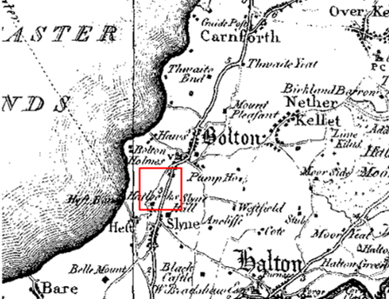
Observations |  | Neither the application route nor the Lancaster Canal are shown.
Investigating Officer's Comments |  | The application route is unlikely to have existed in 1786.
Greenwood’s Map of Lancashire | 1818 | Small scale commercial map. In contrast to other map makers of the era Greenwood stated in the legend that this map showed private as well as public roads and the two were not differentiated between within the key panel.
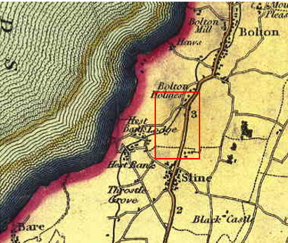
Observations |  | The application route is not shown. The Lancaster Canal and Coastal Road are shown.
Investigating Officer's Comments |  | The application route did not exist as a major route at the time but it may have existed as a minor route which would not have been shown due to the limitations of scale so no inference can be drawn in this respect.
Hennet's Map of Lancashire | 1830 | Small scale commercial map. In 1830 Henry Teesdale of London published George Hennet's Map of Lancashire surveyed in 1828-1829 at a scale of 71/2 inches to 1 mile. Hennet's finer hachuring was no more successful than Greenwood's in portraying Lancashire's hills and valleys but his mapping of the county's communications network was generally considered to be the clearest and most helpful that had yet been achieved.
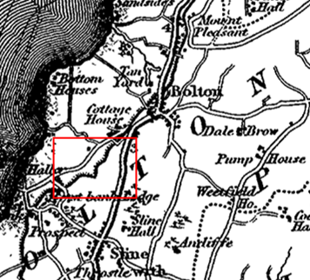
Observations |  | The application route is not shown.
Investigating Officer's Comments |  | The application route did not exist as a major route at the time but it may have existed as a minor route which would not have been shown due to the limitations of scale so no inference can be drawn in this respect.
Canal and Railway Acts |  | Canals and railways were the vital infrastructure for a modernising economy and hence, like motorways and high speed rail links today, legislation enabled these to be built by compulsion where agreement couldn't be reached. It was important to get the details right by making provision for any public rights of way to avoid objections but not to provide expensive crossings unless they really were public rights of way. This information is also often available for proposed canals and railways which were never built.
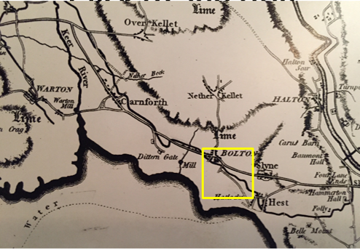
John Rennie plan of proposed canal 1791-1792
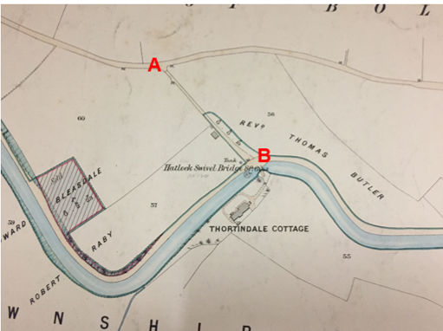
Map in the possession of the railway company _{c}1880 before they purchased the canal
Observations |  | No railway plans or information examined which had been deposited in the County Records Office provided any information about the application route.  The line of the canal was first surveyed in 1772. In 1791 the proposed line was resurveyed and a final survey was carried out later the same year by John Rennie.  A small scale plan surveyed in 1791 and 1792 by John Rennie is available to view at the maritime museum in Lancaster. The plan shows the full length of the proposed Lancaster Canal from Kendal to West Houghton. The plan shows the canal and coastal road but does not show the application route.  In 1792 the promoters of the canal sought an Act of Parliament to allow its construction. It received the Royal Assent on 11 June 1792, and was entitled The Westmoreland Canals Act 1792 - 'An Act for making and maintaining a navigable canal, from Kirkby Kendal in the county of Westmorland, to West Houghton in the county palatine of Lancaster, and also a navigable branch from the said intended canal at or near Barwick, to or near Warton Cragg, and also another navigable branch, from, at or near, Galemoss, by Chorley, to or near Duxbury in the said county palatine of Lancaster. (Ref:32 Geo.111c. 101). A copy of the Act has been deposited in the County Records Office (CRO Ref: CBP 11804/59) but makes no specific reference to the application route or to the swivel bridge.  The canal through Bolton-le-Sands appears to have been constructed and become operational by the end of the 1700s.  A further set of 1:2500 scale plans in the ownership of the maritime museum shows the full length of the Lancaster Canal and provides details of landownership along the route. The origins of the set of plans is unknown but they were purchased by the museum a number of years ago and are referenced as London and North Western Railway Company plans dated 1880. The railway company leased the canal from the 1860s before purchasing it in 1885 so the plans appear to predate the purchase of the canal by the company.  The plan clearly shows the application route. A line is shown across the route at point A and a line and drawing of a gate is shown at B. Further gates are shown providing access to the fields to the south of the route and elsewhere on the plan.  The route is shown leading to the canal towpath and to the Hatlock Swivel Bridge which provided the only access to Thortindale Cottage.  A thick line is shown along either side of the canal and includes the towpath and approximately half of the application route (from point B). There is no key on the map indicating what the line is marking but it appears to be the extent of the canal suggesting that it indicated land forming part of the canal company ownership.
Investigating Officer's Comments |  | It is not surprising that the scale of the John Rennie plan did not show the application route (if it did exist) so no inference can be drawn.  The 1880 plan shows the route under investigation existed at that time and that it provided access to the canal towpath and to Thortindale Cottage. The route is shown gated, at least at point B, could have been to restrict some types of access since there are no apparent stock control reasons.  Part of the application route appeared to be considered to be in the ownership of the canal company at that time. It is possible that this implies that the canal company as well as Thortindale Cottage used it for access.
Thorntindale Cottage  Online Research | 1830 | Online research into the history of Thortindale Cottage  https://www.greenlanearchaeology.co.uk/?projects=thortindale-cottage-bolton-le-sands
Observations |  | Details of some research carried out by a private research company was found on the internet. The article explained that Thortindale Cottage was built in the early part of the 19th century, probably 1830, for a John Pearson and that the architect was probably George Webster of Kendal (1797-1864) who is recorded as building Hawksheads House, also in Bolton-le-Sands, for John Coulston, who had previously lived at Thortindale.  The details of the residents is documented to be of some interest, with initially a local banker, John Coulston, and family, followed by the Fisher family, indicating that it was occupied by and perhaps built for professional people who wanted a home in the most fashionable current style. A William Webster is also believed to have lived at the house but by the early 20th century it was said to have come into the possession of a local clergyman.
Investigating Officer's comments |  | If the research into the history of the house is correct it appears that the construction of the property post-dated the building of the canal and that the application route and access to the property via the swivel bridge were originally constructed specifically to access Thortindale Cottage.
Tithe Map and Tithe Award or Apportionment | 1846 | Maps and other documents were produced under the Tithe Commutation Act of 1836 to record land capable of producing a crop and what each landowner should pay in lieu of tithes to the church. The maps are usually detailed large scale maps of a parish and while they were not produced specifically to show roads or public rights of way, the maps do show roads quite accurately and can provide useful supporting evidence (in conjunction with the written tithe award) and additional information from which the status of ways may be inferred.
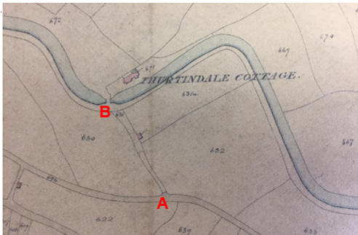
Observations |  | The application route is clearly shown and this is the earliest map examined to show it. There is a line across the way at point A and it is shown as an enclosed route to point B where a further line is shown across the route. The route is numbered 631 and the Tithe Award lists it being owned by John Pearson and tenanted by John Coulston. It is described as a 'road' for which no tithe was payable and the same landowner and occupier were listed for Thortindale Cottage.  The canal towpath is shown and a bridge is shown across the canal providing access from the towpath over the canal to a field numbered 672 and to Thortindale Cottage.  The application route is not coloured (shaded) as are public roads listed in the Award. Routes acknowledged as public highways or waste, although not listed separately at the end of the Award, were generally given the same number (696) and were listed as being in the ownership of the Township.
Investigating Officer's Comments |  | The application route existed in 1846 and appeared to provide gated access to the canal towpath and across the canal to Thortindale Cottage. It appears to have been recorded as a private road.
Inclosure Act Award and Maps |  | Inclosure Awards are legal documents made under private acts of Parliament or general acts (post 1801) for reforming medieval farming practices, and also enabled new rights of way layouts in a parish to be made. They can provide conclusive evidence of status.
Observations |  | No Inclosure Award was found for the area under investigation.
Investigating Officer's Comments |  | No inference can be drawn with regards to the existence of public rights.
6" Ordnance Survey (OS) Map Sheet 24 | 1848 | The earliest Ordnance Survey 6 inch map for this area surveyed in 1845 and published in 1848.
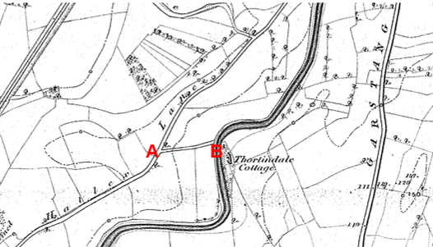
Observations |  | The application route is shown as a substantial bounded track from Hatlex Lane (now known as Coastal Road) and the Lancaster Canal from where it crosses the canal to provide access to Thortindale Cottage. There is an open junction with Hatlex Lane and the swivel bridge is not shown.
Investigating Officer's Comments |  | The application route existed and appeared capable of being used. No other access is shown to Thortindale Cottage suggesting that the application route provided access to the property.
25 Inch OS Map Sheet 24/15 | 1892 | The earliest OS map at a scale of 25 inch to the mile. Surveyed in 1889 and published in 1891 and reprinted in 1892.
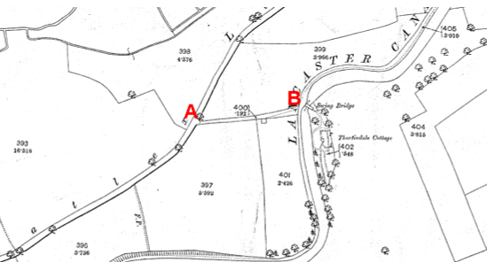
Observations |  | The application route existed and provided access to the canal towpath and to Thortindale Cottage via a swivel bridge.  A line is shown across the route at point A suggesting that a gate existed across the route at this point. The route is shown with a parcel number and acreage. It is not shown shaded down one side (like Hatlex Road).  A small building is shown on the south side of the route in Field 401.
Investigating Officer's Comments |  | The application route existed and appeared capable of being used providing access to the canal towpath and to Thortindale Cottage via the swivel bridge.  The route was gated at point A. The existence of gates along a public route would not have been considered unusual in the 1800s particularly in the proximity of farms or in rural locations. Gateways, if they were found to exist, were shown by the surveyor in their closed position although this is not necessarily a true reflection of what may have been the position on the ground.  The Planning Inspectorate Consistency Guide states "Public roads depicted on 1:2500 maps will invariably have a dedicated parcel number and acreage." However, it goes on to say that this is far from conclusive evidence of highway status. An enclosed lane in different ownership from the adjacent land would also be expected to be shown as a separate parcel.
Sale of the Hatlex Estate by public auction | 1894 | Sale particulars detailing the sale by public auction of land comprising the Hatlex Estate including Thortindale and available to view at the County Records Office Ref: DDT/111
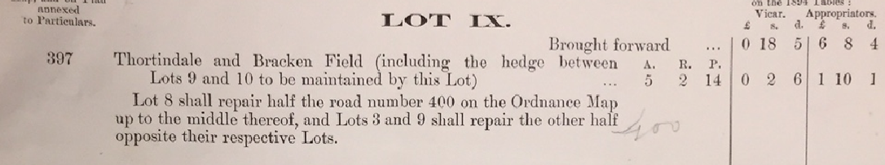
Observations |  | No plan was included with the sale brochure included but land to be sold is referenced by Ordnance survey parcel numbers on the first edition 1:2500 map detailed above.  The sale brochure describes the extent of the property to be sold at public auction on 3rd October 1894. It describes the property as being a freehold estate known as the Hatlex Estate which comprised of 3 dwelling houses, extensive farm buildings and over 103 acres of land.  Lot 3 is Thortindale (referenced as OS parcel numbers 401 and 402) which covers the plot on which the house is built to the east of the canal and also a field to the west of the canal which was accessed from the application route. The sales document describes the property as being for sale 'together with the right of way to the same usually occupied therewith' but does not clearly specify where the right of way is.  The application route is not included as part of the sale although land on either side of it was to be sold. Details for Lot 9 specify that the purchaser of lot 8 will be responsible for repairing half the road number 400 on the Ordnance Map up to the middle thereof, and Lots 3 and 9 shall repair the other half opposite their respective Lots.
Investigating Officer's Comments |  | Land on either side of the application route was sold as part of the Hatlex Estate but not the route itself. There is no indication in the documentation as to who owned the route but the maintenance obligation implies that a right existed along it to access Thortindale Cottage and whilst not owning it, purchasers of adjacent fields would also be required to maintain it. The route is described as a road but there is no indication whether it carried any public rights.  There is no information given about the name of the vendor (owner of the Estate prior to the Sale) or the purchasers.
25 inch OS Map Sheet 24/15 | 1913 | Further edition of the 25 inch map surveyed in 1889, revised in 1910 and published in 1913.
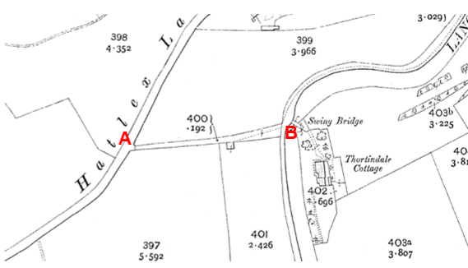
Observations |  | The application route is shown in the same way as it was on the earlier addition of the 25 inch map. The route provided access to the canal towpath and still provided the only access to Thortindale Cottage (via the swing bridge).
Investigating Officer's Comments |  | The application route existed and appeared to be capable of being used in 1913 but it is not known whether there was use by the public.
Bartholomew half inch Mapping | 1902-1906 | The publication of Bartholomew's half inch maps for England and Wales began in 1897 and continued with periodic revisions until 1975. The maps were very popular with the public and sold in their millions, due largely to their accurate road classification and the use of layer colouring to depict contours. The maps were produced primarily for the purpose of driving and cycling and the firm was in competition with the Ordnance Survey, from whose maps Bartholomew's were reduced. An unpublished Ordnance Survey report dated 1914 acknowledged that the road classification on the Ordnance Survey small scale map was inferior to Bartholomew at that time for the use of motorists.
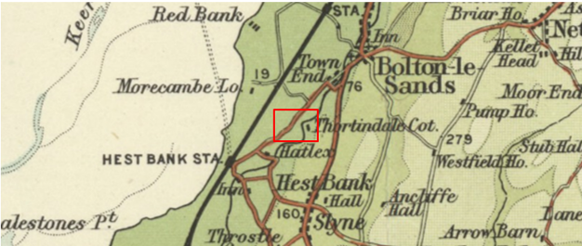
Observations |  | Thortindale Cottage is named on the map but the application route is not shown.
Investigating Officer's Comments |  | The application route was not considered to be a public vehicular highway which would be shown on a map of this scale. It was likely to have provided private vehicular access to Thortindale. Public footpaths linking to canal would not be shown on a map of this scale so no inference can be drawn in this respect.
Finance Act 1910 Map | 1910 | The comprehensive survey carried out for the Finance Act 1910, later repealed, was for the purposes of land valuation not recording public rights of way but can often provide very good evidence. Making a false claim for a deduction was an offence although a deduction did not have to be claimed so although there was a financial incentive a public right of way did not have to be admitted.  Maps, valuation books and field books produced under the requirements of the 1910 Finance Act have been examined. The Act required all land in private ownership to be recorded so that it could be valued and the owner taxed on any incremental value if the land was subsequently sold. The maps show land divided into parcels on which tax was levied, and accompanying valuation books provide details of the value of each parcel of land, along with the name of the owner and tenant (where applicable).  An owner of land could claim a reduction in tax if his land was crossed by a public right of way and this can be found in the relevant valuation book. However, the exact route of the right of way was not recorded in the book or on the accompanying map. Where only one path was shown by the Ordnance Survey through the landholding, it is likely that the path shown is the one referred to, but we cannot be certain. In the case where many paths are shown, it is not possible to know which path or paths the valuation book entry refers to. It should also be noted that if no reduction was claimed this does not necessarily mean that no right of way existed.
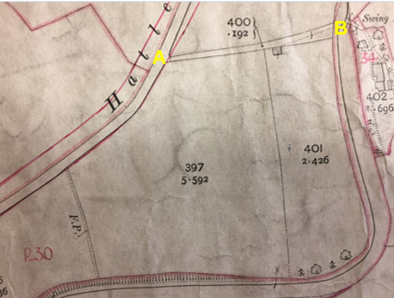
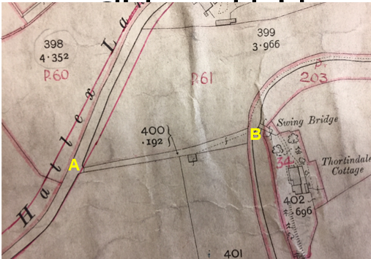
Observations |  | The application route is not shown excluded from the numbered hereditaments but it is unclear whether it formed part of the plot numbered 30 (numbered south of the route) or 61 (numbered north of the route) as there is no boundary shown between the two.  Plot 30 is described as being owned by JW Pickard and occupied by Thomas Cook. It is described as 'land and buildings' and a £10 deduction is listed for public rights of way or user. The most obvious boundary between plot 30 and 61 would be the application route but as this has not been indicated as being the case on the map there is no certainty. The full extent of plot 30 is not known and there is no explanation as to which route or routes the £10 deduction was claimed for. A route as a footpath (F.P.) is however shown on the Ordnance Survey base map close to the number '30' and is now recorded as a public footpath on the Definitive Map.  There is a note in the Valuation Book that the valuation details for plot 30 also 'includes' a plot numbered 157 in Slyne with Hest. Plot 157 Slyne with Hest is listed in the Valuation book for that parish as being owned and occupied by the same people as plot 30 and is described as being 'Land at Hatlex'. No further deductions are listed for public rights of way or user but there is a note cross-referencing the fact that details are included in 'Bolton-le-Sands 30'.  Online research indicated that William Pickard purchased Thortindale Cottage at public auction in 1894. If this is the case then the auction details (detailed earlier in the report) suggest that the sale at that time did not include the application route but that a right of access to Thortindale Cottage existed along it and that Mr Pickard was responsible for maintenance of part of the route.  Plot 61 is listed as being in the ownership of a Mr Tomlinson and occupied by Messrs Bowther. It is described as 'land and buildings' located on Slyne Road with no deductions listed for public rights of way or user.
Investigating Officer's Comments |  | The District Valuation Map and records available to view in the County Records Office are insufficiently clear to conclude whether or not the land crossed by the route was included in either plot or whether a deduction was claimed for public rights of way or user and it is considered that no inference can be drawn to the existence of public rights.
Sales plan and documentation | 1922 | Copy of a Sales pamphlet for the sale at public auction of land known as 'Hatlex' provided by the applicant.
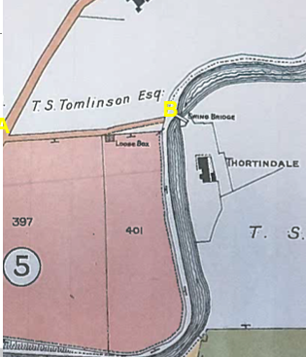
Observations |  | The land for sale does not include the application route and there is no reference with regards to any public or private rights along it. It is coloured brown and contiguous with Hatlex Lane.  Conditions of sale refer to indentures dated 1895 regarding field 401 (south of the application route) between John James Harris and William Pickard adding weight to the belief that Mr Pickard purchased Thortindale Cottage in 1894.
Investigating Officer's Comments |  | No inference can be drawn with regards to the existence of public rights although the depiction being the same as the public road suggests it was similarly accessible as far as potential purchasers were concerned.
25 Inch OS Map  Sheet 24/15 | 1932 | Further edition of 25 inch map (surveyed 1889, revised in 1930 and published 1932.
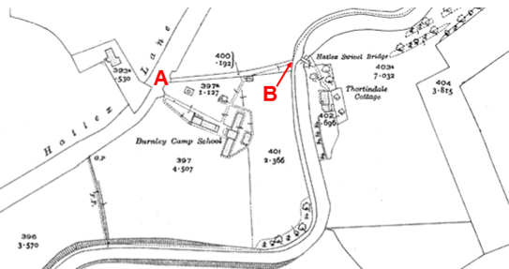
Observations |  | The application route is shown. It is gated at point A and provided the only access to Thortindale Cottage and the canal towpath. Burnley Camp School is shown to the south of the route with the main access to the school being from Hatlex Road but with additional access available from midway along the route.
Investigating Officer's Comments |  | The application route existed and appeared to be capable of being used to access the canal towpath (as well as Thortindale Cottage).
1932 Rights of Way Map |  | The Rights of Way Act 1932 set out the mechanism by which public rights of way could be established by user and under which landowners could deposit maps to show highways already in existence and to indicate that they didn't intend to dedicate further rights of way. The Commons, Open Spaces and Footpath Preservation Society (which became the Open Spaces Society) who were the prime instigators of this Act and the later 1949 Act, called for local authorities to draw up maps of the public rights of way in existence (a quasi-pre-cursor of the Definitive Map). This is set out in 'The Rights of Way Act, 1932. Its History and meaning' by Sir Lawrence Chubb [M]. The process for consultation and scrutiny followed in Lancashire is not recorded but some of the maps exist including maps for the following areas are available for inspection at County Hall: Lunesdale Rural District (RD), Lancaster RD, Burnley RD, Garstang RD and West Lancashire RD.  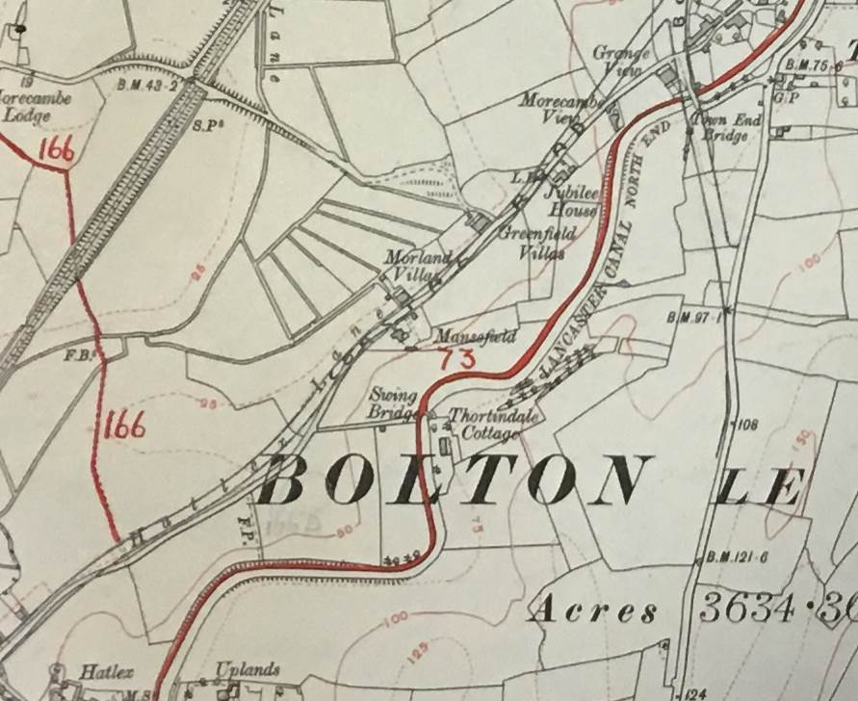
Observations |  | The application route is not shown marked up on the map.
Investigating Officer's Comments |  | The route was either regarded as part of the road network or not considered to have any public rights by those drawing up that map, whose purpose was to record public paths.
6 Inch OS Map Sheet 46NE | 1956 | The OS base map for the Definitive Map, First Review, was published in 1955 at a scale of 6 inches to 1 mile (1:10,560). This map was revised before 1930 and is probably based on the same survey as the 1930s 25-inch map.
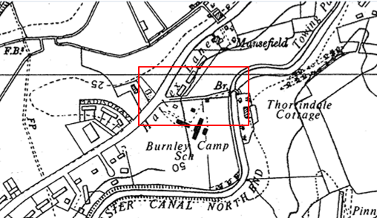
Observations |  | The application route is shown on the map in the same way as it is shown on earlier editions of Ordnance Survey Mapping.
Investigating Officer's Comments |  | The application route existed and appeared to be capable of being used to access the canal towpath (as well as Thortindale Cottage).
1:2500 OS Map Sheet SD 4666-4766 | 1968 | Further edition of 25 inch map reconstituted from former county series and revised and published in 1968 as national grid series.
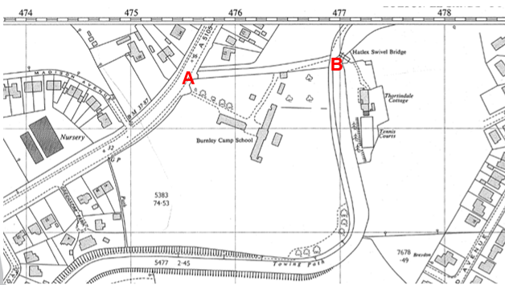
Observations |  | The application route is shown gated at point A and point B. the route still provides the only access to Thortindale Cottage (via the swing bridge) with access directly onto the route from Burnley Camp School and the towpath.
Investigating Officer's Comments |  | The application route existed in 1968 and appeared to be capable of being used.
Aerial photograph | 1960s | The black and white aerial photograph taken in the 1960s and available to view on GIS.
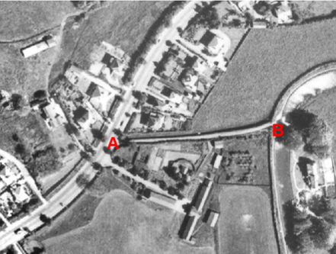
Observations |  | The application route can be clearly seen as a substantial track leading to the canal towpath and swing bridge. It is not possible to see from the photograph whether access onto or along the route was gated or restricted in any way.
Investigating Officer's Comments |  | The application route existed in the 1960s as a substantial track and appeared to be capable of being used to access the canal towpath.
Aerial Photograph | 2016 | Aerial photograph available to view on GIS.
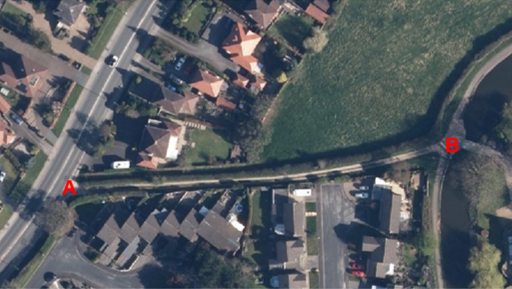
Observations |  | The application route can be clearly seen as a substantial route used by vehicles to access Thortindale Cottage via the swing bridge. It also appears to be available for people to access the canal towpath.
Investigating Officer's Comments |  | The application route existed in 2016 and appeared to be capable of being used.
Google Street View | 2017 | Google Street View image captured in 2016.
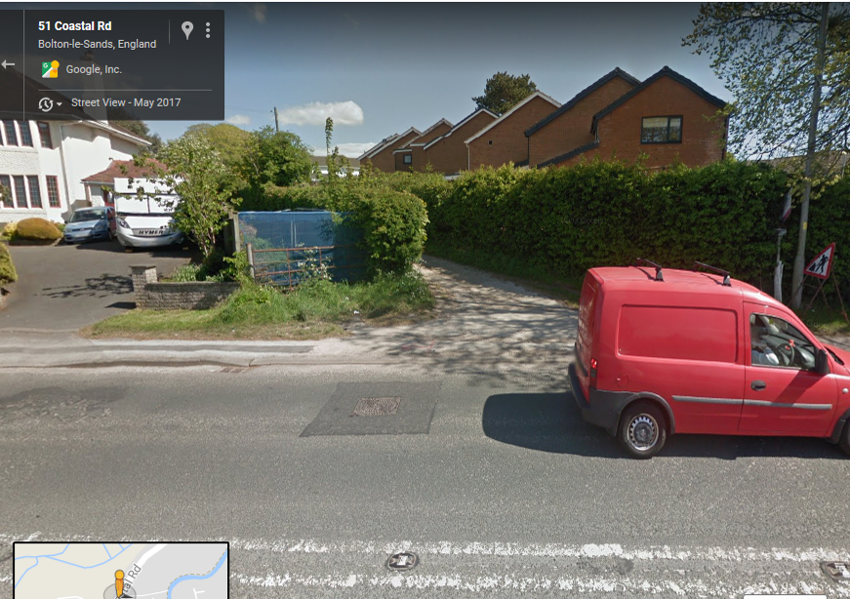

Observations |  | The application route existed and access onto it at point A was open and available. No signs can be seen indicating whether the route was considered to be public or private.
Investigating Officer's Comments |  | Access onto the application route was available in 2017.
The Lancaster Canal Trust | 2017 | Photocopy of document submitted by the Applicant and titled simply as 'The Lancaster Canal Trust' 2017
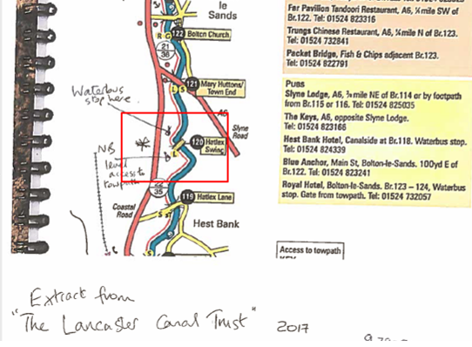
Observations |  | An online search confirmed that the extract provided by the applicant was from a book published by the Lancaster Canal Trust titled 'The Complete Guide to the Lancaster Canal'. The Canal Trust was formed in 1963 with the primary aim of restoring the canal from Carnforth north to Kendal but also to promote the use and interest in the whole canal.  The book shows various points of interest along the canal and the location of various services, bridges, road crossings etc. The plan shows the location of Hatlex swing bridge but does not show the application route.  The applicant has annotated the plan showing the location of a waterbus stop close to the route and stating that the application route would provide flat access to the canal towpath.
Investigating Officer's Comments |  | The book extract provides no information about the application route so no inference can be drawn with regards to public rights.  The applicant has provided information about a stopping off point for the waterbus possibly suggesting that people would access the canal towpath and/or waterbus along the application route due to the fact that it has a flat gradient and is in close proximity to the water bus stop. These points will need to be considered as part of an analysis of the user evidence submitted as part of this application.
Definitive Map Records |  | The National Parks and Access to the Countryside Act 1949 required the County Council to prepare a Definitive Map and Statement of Public Rights of Way.  Records were searched in the Lancashire Records Office to find any correspondence concerning the preparation of the Definitive Map in the early 1950s.
Parish Survey Map | 1950-1952 | The initial survey of public rights of way was carried out by the parish council in those areas formerly comprising a rural district council area and by an urban district or municipal borough council in their respective areas. Following completion of the survey the maps and schedules were submitted to the County Council. In the case of municipal boroughs and urban districts the map and schedule produced, was used, without alteration, as the Draft Map and Statement. In the case of parish council survey maps, the information contained therein was reproduced by the County Council on maps covering the whole of a rural district council area. Survey cards, often containing considerable detail exist for most parishes but not for unparished areas.
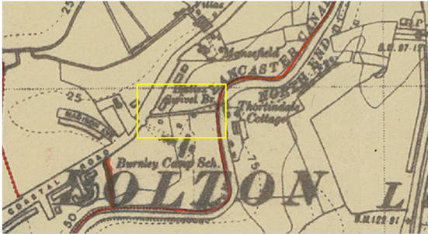
Observations |  | The application route is not shown on the parish survey and no representations were made to the county council about it. The canal towpath has been coloured red indicating that the parish council believed it to be a public footpath.
Draft Map |  | The parish survey map and cards for Bolton-le-Sands were handed to Lancashire county council who then considered the information and prepared the Draft Map and Statement.  The Draft Maps were given a “relevant date” (1st January 1953) and notice was published that the draft map for Lancashire had been prepared. The draft map was placed on deposit for a minimum period of 4 months on 1st January 1955 for the public, including landowners, to inspect them and report any omissions or other mistakes. Hearings were held into these objections, and recommendations made to accept or reject them on the evidence presented.
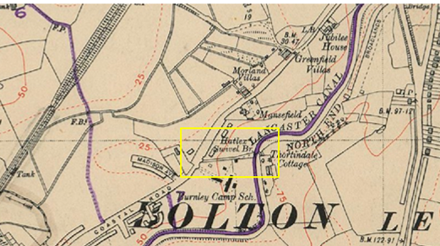
Observations |  | The application route is not shown on the Draft Map and no representations were made to the county council about it. The canal towpath is shown as a footpath
Provisional Map |  | Once all representations relating to the publication of the draft map were resolved, the amended Draft Map became the Provisional Map which was published in 1960, and was available for 28 days for inspection. At this stage, only landowners, lessees and tenants could apply for amendments to the map, but the public could not. Objections by this stage had to be made to the Crown Court.
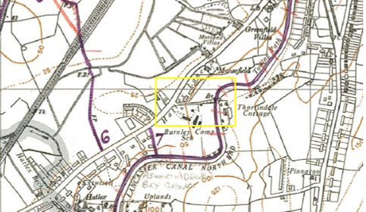
Observations |  | The route was not shown on the Provisional Map and no representations were made to the county council about it. The canal towpath is shown as a footpath (purple line) with red lines across it indicating that an appeal had been successfully made to remove it from the map.
The First Definitive Map and Statement |  | The Provisional Map, as amended, was published as the Definitive Map in 1962.
Observations |  | The route was not shown on the First Definitive Map and Statement (and neither was the canal towpath).
Revised Definitive Map of Public Rights of Way (First Review) |  | Legislation required that the Definitive Map be reviewed, and legal changes such as diversion orders, extinguishment orders and creation orders be incorporated into a Definitive Map First Review. On 25th April 1975 (except in small areas of the County) the Revised Definitive Map of Public Rights of Way (First Review) was published with a relevant date of 1st September 1966. No further reviews of the Definitive Map have been carried out. However, since the coming into operation of the Wildlife and Countryside Act 1981, the Definitive Map has been subject to a continuous review process.
Investigating Officer's Comments |  | From 1953 through to 1975 there is no indication that the route was considered to be a public right of way by the Surveying Authority. There were no objections or representations made with regards to the fact that the route was not shown on the map when the maps were placed on deposit for inspection at any stage of the preparation of the Definitive Map.
Highway Adoption Records including maps derived from the '1929 Handover Maps' | 1929 to present day | In 1929 the responsibility for district highways passed from district and borough councils to the county council. For the purposes of the transfer, public highway 'handover' maps were drawn up to identify all of the public highways within the county. These were based on existing Ordnance Survey maps and edited to mark those routes that were public. However, they suffered from several flaws – most particularly, if a right of way was not surfaced it was often not recorded.  A right of way marked on the map is good evidence but many public highways that existed both before and after the handover are not marked. In addition, the handover maps did not have the benefit of any sort of public consultation or scrutiny which may have picked up mistakes or omissions.  The county council is now required to maintain, under section 31 of the Highways Act 1980, an up to date List of Streets showing which 'streets' are maintained at the public's expense. Whether a road is maintainable at public expense or not does not determine whether it is a highway or not.
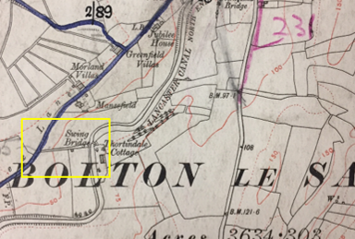
Road Transfer Map 1929
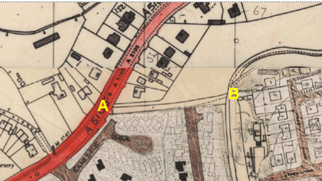
LCC Adoption records
Observations |  | The route is not recorded on the 1929 Handover Map and is not recorded on the List of Streets or shown as an adopted highway on highway records retained by the county council.
Investigating Officer's Comments |  | No inference can be drawn with regards to the existence of non-vehicular public rights.
Statutory deposit and declaration made under section 31(6) Highways Act 1980 |  | The owner of land may at any time deposit with the County Council a map and statement indicating what (if any) ways over the land he admits to having been dedicated as highways. A statutory declaration may then be made by that landowner or by his successors in title within ten years from the date of the deposit (or within ten years from the date on which any previous declaration was last lodged) affording protection to a landowner against a claim being made for a public right of way on the basis of future use (always provided that there is no other evidence of an intention to dedicate a public right of way).  Depositing a map, statement and declaration does not take away any rights which have already been established through past use. However, depositing the documents will immediately fix a point at which any unacknowledged rights are brought into question. The onus will then be on anyone claiming that a right of way exists to demonstrate that it has already been established. Under deemed statutory dedication the 20 year period would thus be counted back from the date of the declaration (or from any earlier act that effectively brought the status of the route into question).
Observations |  | No Highways Act 1980 Section 31(6) deposits have been lodged with the county council for the area over which the routes under investigation run.
Investigating Officer's Comments |  | There is no indication by the landowners under this provision of non-intention to dedicate public rights over this land.
Notice of Planning Permission  Ref: 18/00491/CU | 2018 | Details of planning permission granted for a change of use from dwelling home to children's care home – Thortindale Cottage.
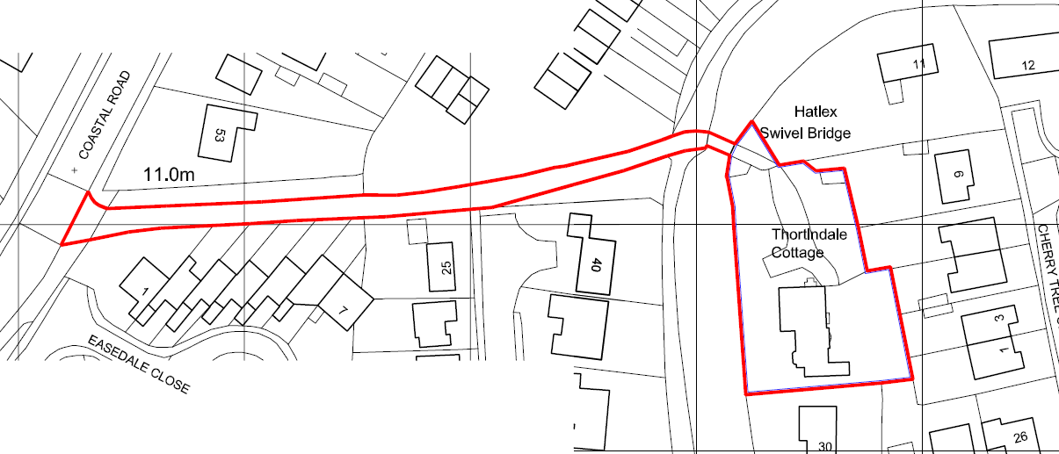
Observations |  | Planning permission has recently been granted to the current owners of Thortindale Cottage for change of use from a residential property to a children's care home. As part of the permission granted it has been stipulated that the access road which includes the application route A-B must be resurfaced to an agreed standard to a width of 4.1 metres and that 2 passing places were to be provided for cars. It was also specified that signage needed to be provided to warn users of the towpath (which crosses the access road) of vehicles.  The planning consultations and a report to Lancaster City Council Planning Committee on 25 June 2018 refer to the fact that ownership of the access road from Coastal Road to the canal towpath is unknown but that the owners of Thortindale Cottage had access rights along it. It also makes reference to the fact that there is occasional use of the route by pedestrians but that there is now a parallel footpath immediately north of the route which is owned and maintained by The Orchards Management Company Ltd but 'available' for public use.
Investigating Officer's Comments |  | Ownership of the application route is not known and no one has provided evidence of ownership as part of the planning process. The access road was not recorded as a public right of way at the time the planning permission was requested and although there is some suggestion that public use was made of the track it is not dealt with by the Planning Authority as an application affecting a public right of way.

The affected land is not designated as access land under the Countryside and Rights of Way Act 2000 and is not registered common land. Lancaster canal and the towpath are classified as a biological heritage site.

Landownership

The land crossed by the application route is unregistered and landownership unknown.

Summary

The application route appears to have come into existence to provide access to Thortindale Cottage which is believed to have been built in 1830 (after the construction of the Lancaster Canal) and possibly to the canal towpath itself.

In 1846 (Tithe Map and Award) it is recorded as being owned by John Pearson and tenanted by John Coulston. It is described as a 'road' for which no tithe was payable and the same landowner and occupier (John Pearson) were listed as being the owner of Thortindale Cottage.
Ownership of the route from that point on is unclear although private rights of access to Thortindale Cottage are frequently referred to.
From 1846 to the current day all map and documentary evidence examined suggests that the route has remained unaltered and, although gated at point A and point B for at least some of its existence, the route appears to have been capable of being used, subject to being able to get through, round or over any gates, and supports the user evidence submitted as part of the application, to gain access to and from the canal towpath.

Head of Service – Legal and Democratic Services Observations

Information from the Applicant

The applicant provided the following documents in support of the application:
Maps showing the route over the passage of time
Bills of sale for the Hatlex Estate
Copy of Deeds from Thortindale Cottage
57 User Evidence forms

User Evidence Summary:

There were 57 User evidence for received with the application.
The application route use varies from the 1960 through to 2018.

Table of years users known and used route:
No. of years known and used | No. of users | No. of years known and used | No. of users
Over 60 years | 1 | Over 35 years | 6
Over 55 years | 4 | Over 30 years | 8
Over 50 years | 3 | Over 25 years | 8
Over 45 years | 6 | Over 20 years | 5
Over 40 years | 12 | Over 15 years | 1
No dates provided | 3

Types of use of the route until 2018:
 | Daily | Weekly | Monthly | Every few months | Yearly | Other
Foot | 19 | 24 | 3 | 4 | 2 | 3-'frequently', 1-'regularly'
Bicycle | 4 | 9 | 5 | 3 |  | 1–daily 1954-56  3-'frequently'  1-'regularly'  2-no frequency provided
Vehicle |  |  |  |  | 2 | 1-daily 1954-1956
Wheelchair | 1

- Reasons provided for use of the route by users were: pleasure/ walking to shops/ dog walking / cycle route/ accessing the canal for fishing and canoeing/ part of a circular route along canal to Hest Bank and the beach/ going to feed the ducks/ playing by the canal/ walking and cycling to Bolton-le-sands and Lancaster/ jogging/ going to school/ walking with wheelchair/ walking to the library/ accessing the canal towpath
- Whilst using the route: 47 users have seen others on foot; 39 users have seen others on bicycles; 5 people have seen people on horses; 12 people have seen others using a wheelchair, 2 have seen people on mobility scooters; and 14 people have seen vehicles on the route (Canal and River Trust vehicles, land owners vehicles for access to property and fishermen accessing the canal), all using the same route as them.
- 50 users provided that the route has always followed the same course.
- 1 user provided that there is a stile at the end of Whitendale Drive to allow access onto the lane which has been there since the 1970's when they moved to the area. Another user provided that the only gates along the route are those at the back gardens of Easedale giving them access to the route. No other users mention there being any stiles, gates or barriers along the route. No users mention anything preventing them from accessing the route at any time.
- 1 user mentions there being a 'private road' sign on a wooden board at the Coastal Road end of the lane which disappeared roughly when the private owner left Thortindale a few years ago, they provide that the sign did not look official. No other users mention seeing any signs on the route.
- None of the users have ever been given permission from an owner to use the route. The route is on unregistered land.
- 47 users provided that they have never been prevented from using, stopped, turned back or challenged by anyone whilst using the route. 1 user mentions that there was a restriction of use during the foot and mouth outbreak.
- Of the 14 users mentioning having seen vehicles on the route 10 users provided that the vehicles were from the Canal and River Trust, 2 users provided that they were vehicles of people from Thortindale Cottage and 1 was a fisherman. 6 users provided that they either walked back to the top or bottom to allow safe passage or alternatively step into the tall grassed embankment for safety.
- 45 users provided that they have never being told that the route was not public.
- Other comments made by the users include the following:

A waterbus stop is near Swing Bridge 120 and top of the lane (when running).
The pathway is an ancient pathway used for over 100 years.
One user provides that they are wary of using the route at night as there are no street lights down the lane.
It serves as an invaluable route for access to the canal for all users.
The pathway has been the same since the canal was built in 1887. It has always been an unmade road with potholes being filled by those who had vehicle access over it.
This green lane has been part of a historical route from manor Farm at Slyne to Thortingdale House to Morecambe Lodge on the shore dating back several hundred years before the construction of either the canal or the railway. The development of the housing on the east side of the canal adjacent to the swing bridge diverted the original route of the path although access between the houses still permits walkers to cross the swing bridge. It is a green lane and the hedges are protected under the Hedgerow Regulation as they date back to the original access construction as shown on the first series Ordnance Survey maps.
It is a safe access to the canal as there are no steep steps to negotiate or narrow entrances.
One user lived in Thortindale Cottage from 1954 until 1965 and their parents lived in it until 1968. They used the route on bike, foot and in a car. They provide that fishermen would drive and cycle up the lane, parking on the canal bank. The lane was definitely in public use during this time. They go on to provide that the lane serviced fields and land of Hatlex Lane prior to the cutting of the Lancaster Canal in 1797.
Information from Others

40 Whitendale Drive
Mr and Mrs Boardman support the application and provided that they have lived at 40 Whitendale Drive for over 36 years, during which time the lane has been extremely well used all year round by a variety of people including walkers, many with dogs, joggers, rambling groups, people with children and pushchairs, fishermen, cyclists, people in wheelchairs, horse riders and boat owners using the lane to access the Spar shop on the main road. The lane is the only public access to the canal bank for wheelchairs, cycles and horses between Station Road in Hest Bank and Bolton Le Sands Village. They have always assumed that the lane was a public footpath. The lane borders their property along with No 25 Whitendale Drive and the rears of 7 properties on Easedale Close, which each have rear access gates opening onto the lane.
They provide that the northern side of the Lane is mature hedge behind which there is a private footpath and that this is owned and maintained by the Orchard Estate Management Company for the sole use of residents on their estate.

25 Whitendale Drive
Mr and Mrs Midgley have lived at 25 Whitendale Drive for 38 years and have no objection to the application. They have always been lead to believe that the lane was a public footpath. They provide that the lane runs from the canal towpath to Coastal Road and borders the side of their property along with No 40 Whitendale Drive and 7 properties down Easedale Close, with each having rear access gates openings and steps. The lane is well used by joggers, walkers, cyclists, dog walkers, families with children, walking groups, horse riders and fisherman. The lane is really the only easy access to the canal tow path for wheelchair users. They, along with the owners of No 40 Whitendale Drive keep the grass verge on their side of the lane well-kept and keep the grass cut back.

4 Easedale Close
Ms Patricia Roberts has lived at 4 Easedale Close since the property was built in 1978. She provides that she and her neighbours installed fencing/walling, gates and steps down to the footpath for access as the rear gardens were not landscaped by the builders at the time. Mrs Roberts claims that banking and steps form part of her property. Checked LR and doesn’t appear so. The properties in Easedale Close are linked and have no side access therefore the access to the footpath was needed for refuse collections, which at that time (no dates provided) was collected from the rear of the properties.
Ms Roberts provides that she believes the footpath was a public right of way for people to access the canal tow path and has been told that years ago there was a church on the other side of the canal which was accessible only via the swing bridge.
The footpath is used regularly by walkers, cyclists and families accessing the canal towpath. The footpath is not a straight line so you cannot see one end from the other. If a vehicle comes down, pedestrians have to climb the banks in order for them to pass. The footpath has extensive hedgerows along the length.

Bay View Child Care, Thortindale Cottage
Paul Johnson, owner of Thortindale Cottage objects to the application to record a public footpath. He provides that their established right of way from Coastal Road to Thortindale Cottage is for all purposes their established legal right of way which allows vehicles to use the narrow access lane.
Should a public right of way be granted, they are concerned for public safety as the access lane is not sufficiently wide to allow pedestrians and vehicles to pass safely, to allow use by both pedestrians and vehicles.
They suggest an alternative that the newly established footpath, to the immediate north of the access lane should be confirmed as a definitive public right of way because it offers a much safer route, that is dedicated to pedestrian use without the potentially dangerous vehicle/pedestrian conflict that will result from the proposal.
The registered title LA793077 provides that the land has the benefit of a right of way along the lane in an easterly direction towards the canal and across the swing bridge.

Oakmere Homes (Northwest) Ltd
Oakmere Homes initially objected to the application believing the application to be for the private footpath to the north of the route. They are now aware of this and provided the council with a copy of a letter their legal representatives have sent to Bay View Child Care in relation to the removal of part of the boundary hedge separating the track leading to Thortindale Cottage and the private path owned by The Orchards which has been replaced by a fence.

Assessment of the Evidence

The Law - See Annex 'A'

In Support of Making an Order(s)

- A substantially high amount of user evidence of the route being used as a footpath or bridleway on a regular basis
- Users claim to have seen others using the route on foot, bicycle and horse.
- The route is shown on some of the older Ordnance Survey Maps, first appearing in 1880 indicating that it existed and was capable of being used.
- The route is shown on a range of other (but not all) maps
- The route provides access to the canal towpath which is a permissive path for use on foot, cycle and horseback, as well as being a place of public resort.

Against Making an Order(s)

- The Map and Documentary evidence alone is insufficient evidence for the existence of a public right of way.
- There are no deduction for public rights of way in the Finance (1909-1910) Act 1910 Maps

Conclusion

The Committee will recall that this matter relates to an application for a footpath to be added the Definitive Map and Statement. The said footpath is described under the "Description of Route" section above and shown on the Committee Plan with a dashed line. The application includes over 50 user evidence forms, various maps, bills of sale for the Hatlex Estate and the title deeds for Thortindale Cottage in support of the application.

From the Map and Documentary evidence alone, it is difficult to infer that this route carried public rights of way. While the route is depicted on the majority of maps shown within the report and is mentioned within the Hatlex public auction sale documents, the maps do not determine if the route carried a public right of way. The route was first depicted on the OS map of 1848 and has since been depicted consistently on the subsequent OS maps. Evidence from the Finance (1909-1910) Act 1910 map is inconclusive, and in any event primarily relates to vehicular public rights.

Evidence of use of the route over a period of time and the owner's acquiescence can be circumstances from which to infer dedication at Common Law.

We can see from the mapping evidence that the route existed consistently on maps from as early as 1846 and therefore was capable of being used. The land on which the route falls is unregistered and there is no evidence of any apparent owner making an objection or otherwise preventing use.

The comments from users who have used the route for over 25 years is important evidence showing extensive use exceeding 20 years without users being stopped or otherwise prevented from using the route. The route links in and provides access to the canal towpath, which itself is a permissive path for cycle and horseback use and is considered a place of public resort. The route does not lead to a cul-de-sac.

Deemed dedication under Highways Act 1980

Considering the provisions of section 31 Highways Act 1980 for deemed dedication of a public right of way, it is a requirement that the route is used for a continuous 20 year period without interruption, and without any sufficient overt acts demonstrating an intention not to dedicate by the owners. The first step is to determine the 20 year period, which starts from the date the use of the route was first brought into question. It could not be properly determined whether the route was ever called into question prior to the date of application and since there is no evidence stating otherwise, the 20 year period runs retrospectively from the date the application was submitted. The relevant 20 year period therefore runs from 08 October 1998 to 08 October 2018.

The other parts of section 31 require the use to be "without interruption" and there being "no sufficiently overt" acts to demonstrate that there is no intention to dedicate by the owners.

These are both matters to be considered by reviewing the user evidence and any other evidence, such as objector evidence or landowner evidence to determine if the use was ever interrupted or if there was a sufficient enough act from the landowner to negate intention to dedicate. The user evidence clearly shows the use of the route on foot and on bicycle for an extensive period without any apparent interruption. No user claims to have been stopped or turned back from using the route, nor has any signage been erected to deter users. The owner cannot be identified and the land is unregistered.

The volume of user evidence in this matter is reasonably high and sufficiently detailed. The majority of user evidence confirm they have used the route on foot. Others have also used the route on bicycle and have seen others on cycles on the route. From a total of 57 users, 48 have confirmed use of the route for over 25 years and of those 48, 12 users have used the route for more than 40 years. Collectively, the majority of the use has been on foot, with use on bicycle being significantly less, but still enough for that use to be taken into account. None of the users have ever stated that they were stopped or turned back from using the route and only one user found the route to be closed via a notice during the foot and mouth outbreak.

The Committee may consider that there has been as of right use for the twenty year period without any interruption and without any sufficient overt acts demonstrating an intention not to dedicate by the owners during that period. Taking all the evidence into account on balance the Committee may consider that there is sufficient evidence from which a dedication of this route as a bridleway can be deemed under section 31 of the Highways Act 1980 or inferred under Common Law, and that the application be accepted with the modification that the route is recorded as a bridleway.

Risk management

Consideration has been given to the risk management implications associated with this claim. The Committee is advised that the decision taken must be based solely on the evidence contained within the report, and on the guidance contained both in the report and within Annex 'A' included in the Agenda Papers. Provided any decision is taken strictly in accordance with the above then there is no significant risks associated with the decision making process.

Local Government (Access to Information) Act 1985

List of Background Papers

Paper | Date | Contact/Directorate/Tel
All documents on File Ref: 804-602 |  | Claire Blundell, 01772 535604, County Secretary and Solicitors Group
Reason for inclusion in Part II, if appropriate

N/A

The Ordnance Survey (OS) has produced topographic maps at different scales (historically one inch to one mile, six inches to one mile and 1:2500 scale which is approximately 25 inches to one mile). Ordnance Survey mapping began in Lancashire in the late 1830s with the 6-inch maps being published in the 1840s. The large scale 25-inch maps which were first published in the 1890s provide good evidence of the position of routes at the time of survey and of the position of buildings and other structures. They generally do not provide evidence of the legal status of routes, and carry a disclaimer that the depiction of a path or track is no evidence of the existence of a public right of way.

