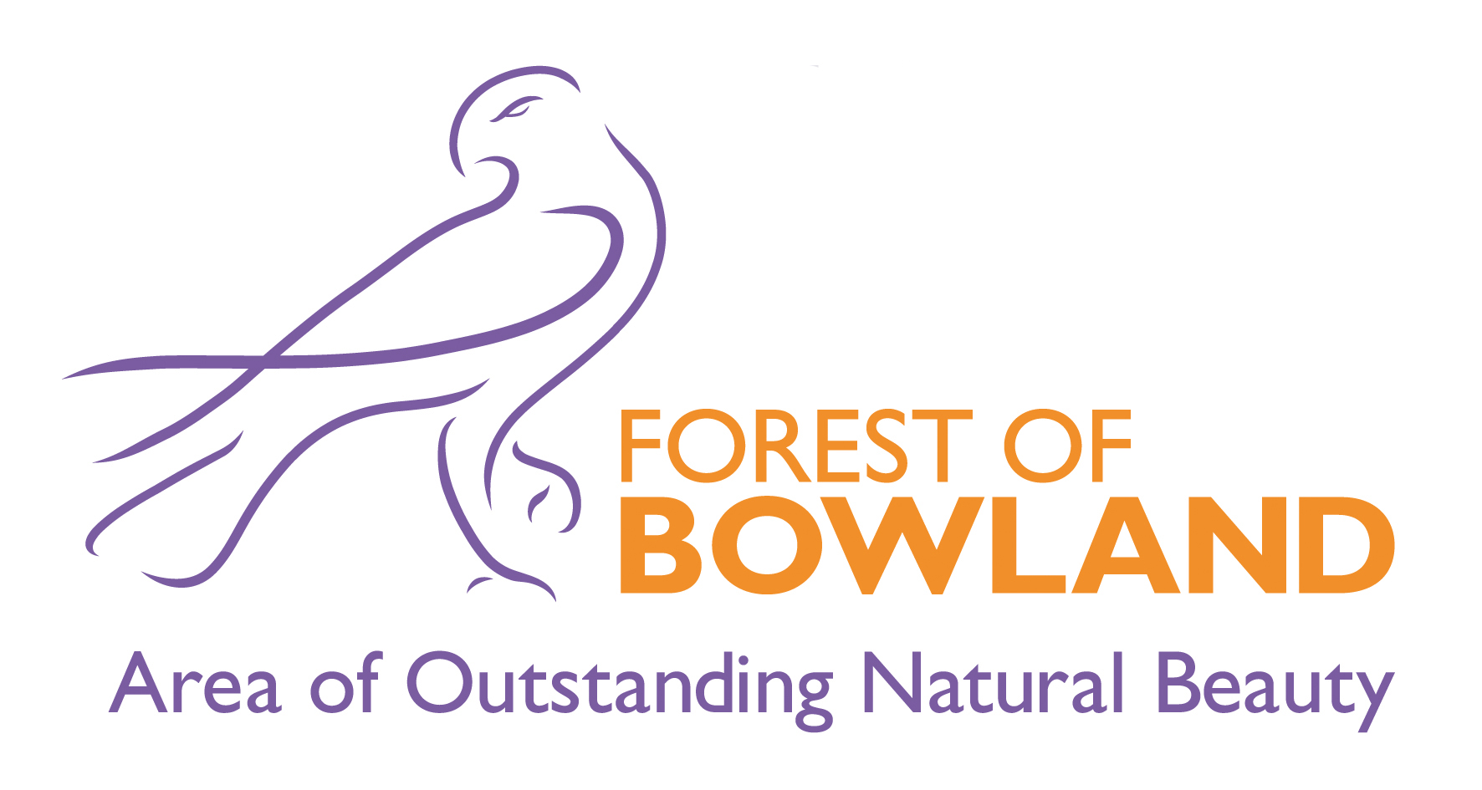

Forest of Bowland Area of Outstanding Natural Beauty Joint Advisory Committee

Minutes of the Meeting held on Thursday, 18th April, 2019 at 2.00 pm in Calder Vale Social Club Building, Calder Vale Country Club, Vale Terrace, Calder Vale, Preston PR3 1SH

Present

Chair
Elliott Lorimer, Forest of Bowland AONB Unit, Lancashire County Council
Committee Members
Councillor Ian Thompson, Craven District Council
Councillor Mrs Rosemary Elms, Ribble Valley Borough Council
Councillor John Browne, Preston City Council
Councillor John Ibison, Wyre Borough Council
Matthew Upton, United Utilities
Mr Andrew Taylor, Bowland Land Managers Forum
David Kelly, Ramblers Association
Chris Kynch, Lancashire Association of Local Councils (Parish Councils)

Officers
Alison Boden, Wyre Council
Hetty Byrne, Forest of Bowland AONB Unit
David Porter, Lancaster City Council
Sandra Silk, Forest of Bowland AONB Unit
Sam Gorton, Legal and Democratic Services, LCC
Graham Nuttall, Wyre Ranger Service
Lucy Brookfield, Wyre Rivers Trust

Apologies
County Councillor Albert Atkinson, Lancashire County Council
County Councillor Mrs Susie Charles, Lancashire County Council
County Councillor Shaun Turner, Lancashire County Council
Councillor Jane Parkinson, Lancaster City Council
Councillor James Starkie, Pendle Borough Council
Colin Price, Yorkshire Local Councils Association
Helen Dix, Environment Agency
Rosemary Budd, Natural England
Blanaid Denman, Royal Society for the Protection of Birds
David Hewitt, Ribble Valley Borough Council
Cathy Hopley, Forest of Bowland AONB Unit
Neil Kilgour, Grosvenor Estate
Andrew Laycock, Craven District Council
Liz Small, North Yorkshire County Council
Sarah Robinson, Forest of Bowland AONB Unit

Welcome, Introductions and Apologies

In the absence of the Chair (who was unable to attend to unforeseen circumstances) and Deputy Chair, Elliott Lorimer, AONB Manager, Lancashire County Council, chaired the meeting.

Apologies were presented on behalf of the Committee members and officers as detailed above.

Presentation from United Utilities on Haweswater Aqueduct

Jemma Parkinson and James Cullen from United Utilities gave a presentation to the Committee on 'Keeping the North West Flowing' which includes the replacement of sections of the Haweswater Aqueduct.

Previous repair work that had been carried out in 2016 had rectified some issues with the tunnel lining however the quality of the concrete used when the tunnels were first constructed meant that there remained a risk to water quality and disruption of supplies if further improvements were not made.

United Utilities confirmed that work could not take place inside the existing tunnels. Technology does not exist to repair the issue, and that is why United Utilities were having to replace the tunnels.

United Utilities will be carrying out investigation work during Summer 2019 as it prepares to embark on a project to replace six tunnel sections of the Haweswater Aqueduct. This will involve geological and ecological surveys. Two sections of the Forest of Bowland AONB would be affected at Bowland Fells (south of Wray) and Marl Hill, Waddington and Newton (Ribble Valley). Refurbishment work was also planned at Hodder Treatment Works as well and this scheme was likely to occur earlier than expected. Further information on this was requested to be brought to a future meeting.

Timescales for the investigation work was that it is likely to last for around two weeks in each location and water supplies would be unaffected during the investigation.

The stretch of the tunnel due to be replaced at Marl Hill runs for four miles and the section beneath the Bowland Fells extends for 11 miles.

Following the investigation work, formal public engagement was likely to take place between 2020 and 2022, with the project itself beginning the following year and continuing until 2028.

Concern was raised with regards security lighting and plant equipment on-site of the project and United Utilities confirmed that talks were already taking place with landowners and that they would ensure that security lighting at night was kept to a minimum.

Discussions were also taking place with Natural England and leaflets explaining the investigations work had been shared with Landowners. It was also requested that these leaflets be shared with Parish Councils in the affected areas also.

The Committee requested that it be kept up to date with the works which would help with queries they may receive from the public.

Resolved: i) That further information be brought to a future meeting on the planned work scheduled for Hodder Treatment Works.
ii) That the Committee be kept informed on the progress of the investigation and planning works at the Haweswater Aqueduct affecting the Forest of Bowland AONB.

Disclosure of Pecuniary Interests

There were no disclosures of pecuniary and non-pecuniary interests.

Minutes of the Meeting held on 1 March 2019

Resolved: That the Minutes of the meeting held on 1 March 2019 were agreed as a correct record.

Matters Arising

Elliott Lorimer, Area of Outstanding Natural Beauty Manager, updated the Committee that following approval at the last Joint Advisory Committee meeting on 1 March 2019, the Area of Outstanding Natural Beauty Management Plan was now in the process of being adopted within District Councils as well as the two County Councils. Timings for adoption would be impacted due to the local elections and possibly the European elections. Elliott expected that Defra would be understanding of these slight delays in adoption of the AONB Management Plan by local authorities.

Area of Outstanding Natural Beauty Partner Updates

Matt Upton, United Utilities, updated the Committee on work that had been ongoing in partnership with the RSPB. It was looking to be a promising year with hen harriers peregrines and other birds of prey having been seen returning to United Utilities' Bowland estate.

Repairs had been carried out on Salter Fell Track and some further work was proposed. Comments were raised with regards the filling of the track when it was not a public road and only accessible by motorbikes and that United Utilities should let people know who keyholders were in case of emergencies.

Resolved: That Matt Upton, United Utilities would look into the possibilities of keyholder details being shared.

Matt also reported that there was lots of planning taking place around wildfire prevention following last year's heatwave and moorland fires and people were proactively involved alongside the Fire Service.

Nicky Nook had been very busy and Matt was looking for connections between United Utilities and the Council. There were some useful contacts and these needed to be shared.

Resolved: That Alison Boden, Wyre Borough Council and Matt Upton, United Utilities, would discuss the sharing of useful contacts.

Alison Boden, Wyre Borough Council reported on work that the River Wyre Partnership had been doing on the river works to protect the river embankment and that they were currently working on an Integrated Catchment Draft Plan. Defra and the Environment Agency were developing an Integrated Catchment Management Plan and were working with Wyre Borough Council and United Utilities on this.

Elliott Lorimer, AONB Manager reported that elements of the Integrated Catchment Plan were reflected in the AONB Management Plan.

Alison also informed the Committee that various volunteer days, public events and the walking festival had boosted visitor economy, health and wellbeing and raised awareness of the environment.

Councillor Ian Thompson reported that within the Craven area, there was currently a trial being carried out with North Yorkshire Countryside Access Service now having the authority to carry out any minor repair works to footpaths and if it was found to be anything other than a minor repair, then to report it to the landowner to correct and then Craven District Council would go back to inspect the work carried out by the Landowner.

Resolved: That Elliott Lorimer, AONB Manager would pass this information on to Sarah Dornan to make her aware of the trial being carried out by Craven District Council.

David Porter, Lancaster City Council, informed the Committee that the Arnside and Silverdale Area of Outstanding Natural Beauty Development Plan had been adopted by South Lakeland District Council at a meeting on 28 March 2019. It came into effect from that date and forms part of the South Lakeland District Council Development Plan. It was brought to the attention of the Committee to highlight how this approach maybe replicated in other Areas of Outstanding Natural Beauty. A copy of the plan can be found here.

David also reported that as part of the Glover Review of Designated Landscapes, Julian Glover who was leading the review had visited the Arnside and Silverdale Area of Outstanding Natural Beauty the previous week.

AONB Budget Update

Elliott Lorimer, Area of Outstanding Natural Beauty Manager, presented the revised and updated budget for 2019/20 which took into account the AONB funding settlement agreed by Defra in January 2019. Minor adjustments had been made to salaries and on-costs to reflect the local authority pay increase for 2019/20.

The budget allowed £61,971 for an annual programme of projects to help deliver the AONB Management Plan. It was important to re-emphasis that the "projects" funding would continue to be used as match-funding to attract additional matched funding to the Partnership to help deliver the Management Plan.

Resolved: That the Committee noted the revised AONB budget for 2019/20.

Delivering the Area of Outstanding Natural Beauty Management Plan

- Area of Outstanding Natural Beauty Unit Activity Report

Hetty Byrne, Area of Outstanding Natural Beauty Sustainable Tourism Officer, presented the Team Report to the Joint Advisory Committee which is attached to these minutes. Activities reported on were from when the Committee last met in October 2018 to 16 April 2019.

With regards promoting the Forest of Bowland Area of Outstanding Natural Beauty it was raised by the Committee whether more signage was needed on major roads ie A59. This could be a development opportunity to work with partners and look at funding this together.

Resolved: That Elliott Lorimer would look into opportunities involving partners on how to further promote the Forest of Bowland AONB.

- Area of Outstanding Natural Beauty Unit Business Plan 2019/20

Elliott Lorimer, AONB Manager reported that Business Plan was being revised to work alongside the Management Plan so they complimented each other. Once the Business Plan was complete, a draft copy would be circulated to the Committee for comment.

Resolved: That Elliott Lorimer, Area of Outstanding Natural Beauty Manager would circulate the draft Business Plan 2019/20 to the Committee when it was available.

Pendle Hill Landscape Partnership Update

Hetty Byrne, AONB Sustainable Tourism Officer gave an update on the Pendle Hill Landscape Partnership. Year 1 of activity was now complete and most of the 14 projects were now up and running and making a positive impact on the landscape and heritage. Further details of activities carried out in Year 1 and highlights for year 2 can be found at www.pendlehillproject.com.

Urgent Business

Champion Bowland

The Chair had recently received a letter from Champion Bowland inviting the Area of Outstanding Beauty to become a member of Charitable Bowland. The membership would convey no voting rights nor require any financial subscription.

Resolved: That the Area of Outstanding Natural Beauty Joint Advisory Committee agreed to become a member of Charitable Bowland.

Provisional Dates of Next Committee Meetings

The Committee noted that the next meetings would be held on:

Thursday, 31 October 2019 (Preston venue tbc)
Thursday, 23 April 2020 (Craven venue tbc)

Samantha Gorton
Democratic Services
Lancashire County Council
County Hall
Preston

