Meeting of the Full Council
Meeting to be held on Thursday, 8 April 2021

Report submitted by: Chief Executive and Director of Resources

Part A
Electoral Division affected:
(All Divisions);

Response to the Consultation on Local Government Reorganisation in Cumbria and North Yorkshire
(Appendices A and B refers)

Contact for further information:
Phil Green, Tel: (01772) 531443, Director of Growth Environment and Planning,
phil.green@lancashire.gov.uk

Executive Summary

The report considers the Government consultation by the Ministry of Housing, Communities and Local Government seeking views on the locally-led proposals that the Secretary of State has received following his invitation to councils in Cumbria, North Yorkshire, and Somerset to submit proposals for local government reorganisation. In particular the views of the County Council, as a named consultee, are sought with regard to proposals in the neighbouring administrative areas of Cumbria and North Yorkshire.

The consultation asks a number of questions to help inform the Secretary of State’s assessment of each proposals, including the three main tests that will form the basis of the Secretary of State's consideration:

- whether the proposal will improve local government services
- whether there is a good deal of local support in the round for the proposal
- whether the proposed new council areas cover a credible geography

Other public service providers, including health, the police, Local Enterprise Partnerships, and certain business, voluntary sector and educational bodies have also been consulted. The Secretary of State will carefully consider all views expressed, including from local residents, as well as from named consultees.
The report and appendices consider the implications of the proposals with regard to the County Council in order that Full Council agree the basis on which the final response to the consultation is made.

Recommendation

That Full Council be asked to:

- agree the principles of the response to the consultation, as set out in the report; and
- agree that the Chief Executive be authorised to finalise and respond to the consultation on proposals for locally-led reorganisation of local government in Cumbria and North Yorkshire as set out in this report, in consultation with the Leader of the Council, based on the principles agreed by Full Council.

1. Background

1.1 On 9 October 2020, the Secretary of State for Communities and Local Government issued an invitation to local authorities in three council areas – North Yorkshire, Cumbria and Somerset – to submit proposals for unitary local government by 8 December 2021.

1.2 On 22 February 2021, the Secretary of State formally began a consultation on the proposals received. In total, there were 8 proposals, two each in North Yorkshire and Somerset, and four in Cumbria.

1.3 The consultation period is for 8 weeks and responses are invited from all interested parties. Lancashire received an invitation to respond specifically on proposals in Cumbria and North Yorkshire as a neighbouring authority, and because, in the case of one of the proposals for Cumbria, an area currently within Lancashire (Lancaster, see proposal C2 below) would be directly affected.

1.4 A map illustrating the areas subject to consultation is shown below and further details of the various proposals are set out in this report. The consultation will close at 11.45pm on 19 April 2021, and Full Council is asked to consider the proposals for Cumbria and North Yorkshire and agree a response.

1.5 Following the close of the consultation, the Secretary of State will consider the proposals and consultation responses and assess the proposals against the criteria (See Section 2 below) before reaching a balanced judgement on which proposals, if any, to implement.

1.6 The Secretary of State may decide, subject to Parliamentary approval, to implement a proposal with or without modification, or to not implement any proposal. He may also seek advice from the Local Government Boundary Commission for England. If any proposals are to be implemented, the Government advises that the Secretary of State’s decisions will be communicated to the councils as soon as practicable and it is expected that any new unitary councils take on full council role from April 2023, with transitional arrangements in 2022-23 to support a smooth implementation.
Map of Cumbria and North Yorkshire
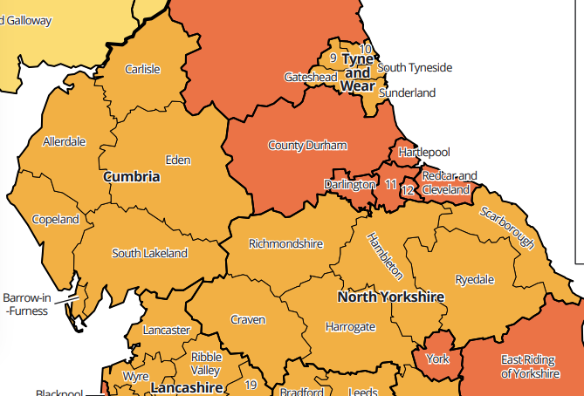

2. Assessment Criteria

2.1 When formulating a response to the consultation, it is important to consider the key criteria against which the Secretary of State will be considering and assessing the proposals. These are:

- whether they are likely to improve local government and service delivery across the area of the proposal (giving greater value for money, generating savings, providing stronger strategic and local leadership, and which are more sustainable structures);

- whether they command a good deal of local support as assessed in the round across the whole area of the proposal; and

- whether the area of any new unitary council is a credible geography consisting of one or more existing local government areas with an aggregate population which is either within the range 300,000 to 600,000, or such other figure that, having regard to the circumstances of the authority, including local identity and geography, could be considered substantial.

  - Furthermore, guidance from the Secretary of State indicates that proposals should:

- clearly describe structures and how they will achieve the outcomes above;
- include evidence and analysis to support the proposal;
- consider impact on other local boundaries for example an assessment of the impact on police forces and/or fire and rescue and should include the views of the relevant Police and Crime Commissioners and Fire and Rescue Authorities; and
- take into account the wider context on promoting economic recovery and growth, possible devolution deals and Mayoral Combined Authorities.

2.3 The respective proposals for North Yorkshire and Cumbria are described in Section 3 below and the key points for the County Council aligned to the key criteria as set out in section 2.1 above and Appendix A are summarised as ‘LCC Considerations’. Subject to the decision of Full Council, it is intended that the Chief Executive be authorised to respond to the formal consultation before the Government deadline using the online platform, based on the principles agreed.

3. Proposals

North Yorkshire: Descriptions of Options

3.1 There are two options for Local Government Reorganisation in North Yorkshire; a single unitary, retaining the existing City of York unitary, and two unitaries, East and West, absorbing the existing City of Your unitary.

(NY1) Single Unitary for North Yorkshire

3.2 North Yorkshire County Council submitted a proposal to establish a single unitary authority for the whole administrative county of North Yorkshire, with a population of 618,100 and no changes to the existing City of York unitary (with a population of 210,600).
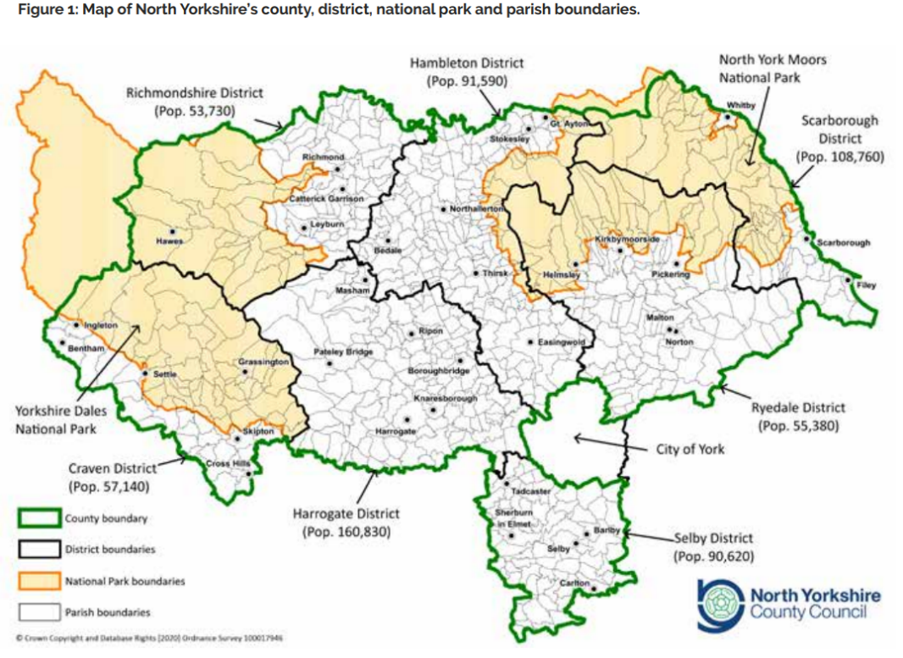
(NY2) Two Unitaries, West and East

3.3 Six authorities comprising Craven District Council, Harrogate Borough Council, Richmondshire District Council, Ryedale District Council, Scarborough Borough Council and Selby District Council submitted a joint proposal for two unitary councils covering the whole of the area of the administrative county of North Yorkshire and the administrative area of the City of York. The proposal comprises one unitary to the east with a population of 465,400, including Ryedale, Scarborough, Selby and the current unitary of York; and one to the west with a population of 363,200 including Craven, Hambleton, Harrogate and Richmondshire.

Figure 2 Proposal for two, east and west unitary authorities
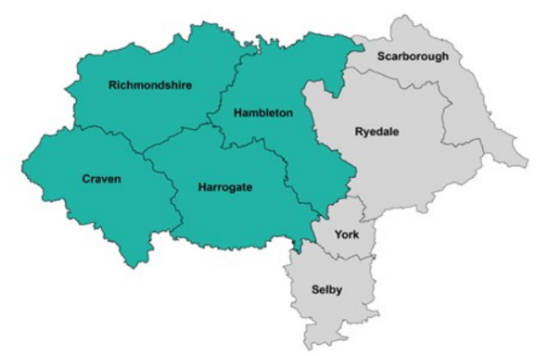
LCC Considerations - North Yorkshire

3.4 It is considered that as a principle, the creation of unitary authorities of appropriate size and scale can be a means to deliver better, more sustainable local government services, especially in large administrative areas where there is currently a complex mix of two tier and unitary authorities. This section considers the two options for North Yorkshire against the key criteria and consultation questions.

Improving local government and service delivery

    - Whilst on a smaller scale than Lancashire comprising just over half our population size, North Yorkshire is currently made up of a county council, seven districts and a unitary council. It is therefore considered that in principle both of the options, proposing unitary authorities, would represent an improvement on the current position.

Local Support

3.4.2 It is considered that the views of those people and stakeholders directly affected should be paramount. As a neighbouring authority either change would have minimal impact on the operations of Lancashire County Council. However, at a strategic level an amplified, stronger and unified voice for North Yorkshire is likely to compromise Lancashire's ability to present its case and advocate for its residents and businesses with the same level of authority and influence.

Credible Geography

    - The criteria for a credible geography set out at para 2.1 above indicates either a population range of 300,000-600,000 or other such figure having regard to the circumstances of the authority, including local identity and geography. Both options ensure that all tiers of government affected are within the scope of the review. The City of York has a population less than the government range but is an established unitary authority at that scale. From a Lancashire perspective and in relation to the shared border with Lancashire and associated interconnectivity, it is not considered that there are any reasons to object to the proposals on grounds of credible geography.

Summary of Proposed Response to Consultation

    - It is therefore considered that both proposals for North Yorkshire can be supported, however noting that the outcome for North Yorkshire may place Lancashire at a relative disadvantage in both the regional and national dimensions.

Cumbria: Description of Options

3.5 There are four options for Local Government Reorganisation in Cumbria; a two unitary model, East and West with a Combined Authority; a two unitary model, the Bay and North Cumbria, including Lancaster City Council; a further two unitary model North and South with a Combined Authority; and a single county wide unitary.

(C1) East and West Unitary Authorities & Mayoral CA
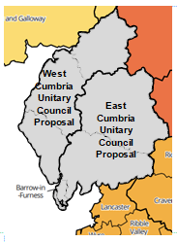
3.6 Allerdale Borough Council and Copeland Borough Council submitted a joint proposal for two unitary councils covering the whole of the area of the administrative county of Cumbria: one unitary council in the West with a population of 274,700 comprising the current districts of Allerdale, Carlisle and Copeland; and one in the East with a population of 225,400 comprising the current districts of Barrow, Eden and South Lakeland.
3.6.1 Allerdale and Copeland Councils believe that two unitary authorities should be overseen by a Mayoral Combined Authority.

3.6.2 Further information can be found online:

Allerdale Link to Proposal C1
Copeland Link to Proposal C1
Link to Full Business Case for Proposal C1

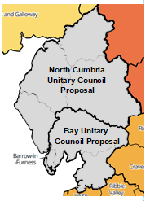
(C2) The Bay Authority & North Cumbria Authority

3.7 Barrow Borough Council and South Lakeland District Council submitted a joint proposal for two unitary councils covering the whole of the area of the administrative county of Cumbria and the administrative district area of Lancaster City Council within the county of Lancashire: one unitary council (“The Bay”) with a population of 318,100 comprising the current districts of Barrow, Lancaster City (in Lancashire) and South Lakeland; and one "North Cumbria" with a population of 328,000 comprising the current districts of Allerdale, Carlisle, Copeland and Eden districts.
3.7.1 Further Information can be found online:
Barrow Link to Proposal C2
South Lakeland Link to Proposal C2
Link to Full Business Case for Proposal C2
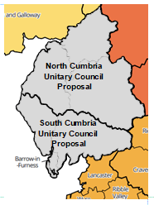
(C3) North & South Unitary Authorities & Mayoral CA

3.8 Carlisle City Council and Eden District Council submitted a joint proposal for two unitary councils covering the whole of the area of the administrative county of Cumbria: one unitary council in the north with a population of 259,800 comprising the current districts of Allerdale, Carlisle and Eden; and one in the south with a population of 240,300 comprising the current districts of Barrow, Copeland and South Lakeland.

3.8.1 Carlisle and Eden Councils believe that two unitary authorities should be overseen by a Mayoral Combined Authority.

3.8.2 Further Information can be found online:

Carlisle Link to Proposal C3
Eden Link to Proposal C3
Link to Full Business Case for Proposal C3
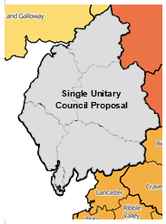
(C4) Single Unitary for Cumbria

3.9 Cumbria County Council submitted a proposal for a single unitary council for the whole area of the administrative county of Cumbria with a population of 500,000.

3.9.1 Further Information can be found online:

Cumbria Link to Proposal C4
Link to Full Business Case for Proposal C4

LCC Considerations – Cumbria

3.10 It is considered that as a principle, the creation of unitary authorities of appropriate size and scale can be a means to deliver better, more sustainable local government services. Cumbria's administrative mix of six districts and a county includes a small population relative to Lancashire, dispersed over a large geographical area. This smaller population provides a challenge for a multi unitary proposal within Cumbria to meet the population criteria set out by the Secretary of State in pure numeric terms.

3.11 However the proposal for the Bay Authority, reaches into Lancashire, to include Lancaster City Council differentiating it from the other proposals. This will have a direct impact on Lancashire's businesses, residents and services and is therefore inevitably the focus of the analysis below which considers the four options for Cumbria against the key criteria and consultation questions.

Improving local government and service delivery

3.11.1 Cumbria is of smaller scale and complexity than North Yorkshire, and indeed Somerset (as the other areas invited by the secretary of State to submit proposals), comprising a third of Lancashire's population. Cumbria, comprising a county council and six district councils with a population of 500,000 people, therefore presents different challenges to delivering service improvements to those in larger county areas. In particular, securing the right balance between economies of scale and consistency offered by unitarisation and engagement with communities will be a key consideration. Smaller authorities may have more options to ensure a greater connectivity to local communities. However, they may not lever the same level of economies of scale and may proliferate some overheads particularly in the statutory roles of Director of Public Health, Adults and Children's services and the governance necessary to support those activities. Dividing a relatively smaller area into smaller administrative parts also brings with it the challenge of securing strategic leadership at a scale and the ability to align service delivery in terms of other public services. Some of this latter point may be addressed though a Combined Authority, where proposed.
3.11.2 Proposal C2 includes the specific proposal to create a Bay Unitary Authority which adds the administrative area and population of Lancaster City Council to that currently covered by South Lakeland and Barrow. Whilst this increases the aggregate population range and unitary size of the proposals that will counter some of the concerns that the Cumbria constituents have faced it brings different complexities and considerations particularly in respect to the delivery of improved local government services. Those implications move beyond the geographical boundaries of the proposals and will impact on all residents, businesses and services across the Lancashire County Council area.

    - Within proposal C2, there is no detailed analysis of the service implications of transferring the current upper tier services, which as set out below will form the biggest element of the budget and workforce of the new unitary. Nor is there any evidence of the legacy impact to the remainder of the county council that will need to be borne by residents, businesses and service users. It is highly likely that additional costs will be carried in the legacy organisation as overheads will not be defrayed as efficiently and Lancashire will not have the corresponding reorganisation opportunities to address this.

    - All County Council services provided in Lancaster would transfer to the new Bay Authority were proposal C2 to proceed. These include:

- Adult Social Care, Disability, Public Health and Wellbeing Services;
- Education, Early Help and Children's Services including Safeguarding, Fostering and Looked After Children;
- Libraries, Museums, Culture and Registrars;
- Highways and Transport Authority;
- Waste Management;
- Trading Standards; and
- Economic Development, Environment and Planning Authority

    - On a simple pro rata of population basis, the value of net revenue budget for these services that would transfer to the Bay Unitary in respect of Lancaster City would amount to in excess of £105m. This is more than 3 times the total net budget of the three constituting District Councils at £34m. Around one third of Cumbria County Council's budget would also transfer.

    - In this respect it is difficult to envisage how, without considering the existing local government arrangements in Lancashire at the same time, or seeking the input of the upper tier authority to the proposal itself, that C2 can be considered by Government as 'locally-led'. The County Council is not involved in the proposal, has offered but has not been asked to provide detail or data about the services it provides in Lancaster, nor is able to put forward any counter proposals in the broader interests of the residents of Lancashire without an invitation from the Secretary of State to do so.

    - As set out at para 2.2 above, the Government has issued guidance requiring any proposal for a unitary authority which crosses existing police force and fire and rescue authority boundaries, such as the Bay Authority within proposal C2, to include an assessment of the impact on police forces and/or fire and rescue authorities and to include and take into account the views of the relevant Police and Crime Commissioners and Fire and Rescue Authorities. The respective responses are included in full at Appendix B.

    - Lancashire's Police and Crime Commissioner ('Lancashire PCC') states that the proposal is not supported as it would necessitate a change in the policing boundary and that impacts on the operating model and finances for the whole of Lancashire have not been considered. The Lancashire PCC does state support for the principle of local government reorganisation and advocates a mayoral combined authority for Lancashire to reflect the divisional policing footprint. Cumbria's Police and Crime Commissioner ('Cumbria PCC') comments collectively on the proposals for Cumbria in a single response and notes the opportunities for significant efficiencies through fewer levels of administration as well as the challenges of strategic leadership over a large geographical area. Cumbria PCC states that whilst options should not be discounted, policing is 'best delivered by maintaining the current county border and …footprint' and strongly advises that policing boundaries should not change if local government administrative boundaries do. Cumbria PCC also supports proposals for an elected Mayor

    - With regard to the Fire and Rescue Authority, a letter from the Chief Executive of Cumbria County Council states that the formal views of the Fire Authority on proposal C2 have not been sought. Proposal C2 does not appear to include a response from Lancashire Fire and Rescue service.

    - In order to draw conclusions as to whether the proposals in C2 improve local government and service delivery, it is important to consider the services themselves, the financial implications, value for money and the potential to generate savings. In the absence of service data and analysis it is not possible to evidence improved services for Lancashire residents. Furthermore, the legacy cost on the remaining constituencies in the Lancashire county council area is one that cannot be effectively mitigated in the absence of opportunities to reform. Taking a piecemeal approach to local government reorganisation in Lancashire will require a significant restructure across all county services, demanding additional one-off costs as well as higher ongoing costs. The potential for additional disruption to service users is significant without any opportunity to secure the benefits than would be expected if Lancashire was to be considered as a whole.
Local Support

    - It is considered that the views of those people and stakeholders directly affected should be paramount. As a neighbouring authority, proposals C1, C3 and C4 would have minimal impact on the operations of Lancashire County Council. However at a strategic level an amplified, stronger and more unified voice for Cumbria, especially with a mayoral combined authority, is likely to compromise Lancashire's ability to present its case and advocate for its residents and businesses with the same level of authority and influence.

    - With regard to proposal C2, there are close community links between Lancaster and other parts of Lancashire, notably Wyre (which shares a parliamentary constituency with the city of Lancaster) and the Ribble Valley, which enjoy close links over the Forest of Bowland. It is considered that the Lancaster voice should be heard as much in the context of it being part of Lancashire as it should in consideration of the proposed Bay Authority.

    - The heritage of Lancaster as Lancashire's county town is important to community identity and place-shaping. If the Bay Authority ultimately came under a Cumbria Mayoral Combined Authority, the administrative change could potentially undermine the Lancashire heritage and cause confusion in respect of Lancaster's local identity, heritage and place-shaping.

Credible Geography

    - The criteria for a credible geography set out at para 2.1 above indicates either a population range of 300,000-600,000 or other such figure having regard to the circumstances of the authority, including local identity and geography. The latest population estimates indicate Cumbria has a total population of 500,000 people comprising a range within the six district areas ranging between 53,300 (Eden) and 108,700 (Carlisle). Lancaster's population is 146,000. Hence the proposals C1 and C3 to divide the existing six district areas into two unitary authorities, inevitably result in aggregate unitary population sizes less than the indicated threshold of 300,000-600,000. The East Cumbria authority within proposal C1 being the smallest of those proposed at 225,400 people. Proposal C2 results in two unitary authorities of 328,000 and 318,100 respectively, due to the 'Bay Authority' including Lancaster's population. Proposal C4 would equate to a population of 500,000.

    - With regard to proposal C2 the business case describes the alignment with health services. However, there is less alignment with other critical public service functions, including police, fire and coronial jurisdictions.

    - Local identity is part of the key criteria identified by Government. The business case for C2 states that the proposal does not restrict future options for local government reorganisation of the remaining areas of Lancashire. The proposal describes the case for a North Cumbria unitary and a Bay Authority unitary and considers both the connectivity as well as the distinction between north and south Cumbria. Taken together this has potential to underplay the importance of Lancaster to Lancashire.

    - There are clear historic ties between Barrow and the Furness peninsula and Lancashire. Whilst much of the South Lakeland area, formed as a district in 1974, has not been historically part of Lancashire, there are neighbouring economic links.

    - Most recently, close working between all 12 districts of Lancashire and the County Council, as well as the Blackpool and Blackburn with Darwen unitary councils during the Covid-19 pandemic has demonstrated close interdependences across the Lancashire area, including Lancaster.

Summary of Proposed Response to Consultation

    - The principle of unitary authorities of appropriate size and scale can drive improved services to the public. It is therefore considered that proposals C1, C3 and C4 for Cumbria can be supported as they are unlikely to have a material impact on the day to day operations for Lancashire County Council.

    - However, it is noted that smaller unitaries are less likely to offer economies of scale and the outcome for Cumbria in respect of all 3 options may place Lancashire at a relative disadvantage in both the regional and national dimensions.

    - The position is more complex in respect of proposal C2 as this impacts directly on Lancashire itself. The current Bay Authority proposal contains no detail of the local government services provided by the County Council in Lancaster and how that would be absorbed into the new authority. The business case acknowledges the challenges and complexities stating, "in particular for the move of Lancaster from Lancashire County Council, and potential longer term changes that may be required for police and fire authorities to support the new footprint." However, the business case does not provide any detailed assessment of County Council services acknowledging "there will need to be more time and opportunity for discussion… about the implications of local government reorganisation on other authorities."

    - Also, no detailed assessment has been carried out with regard to the impact on Lancashire County Council, its residents, services and business users of the proposed changes, nor has the county council been asked to provide relevant data. It is therefore not evident that the proposals will lead to improved services either within the Bay or more broadly across Lancashire.

    - If proposal C2 were to proceed now without looking at the broader considerations in Lancashire, this would limit the options available in future reorganisation rounds and potentially drive a sub-optimal outcome for our residents and businesses.

    - Bearing in mind the above it is considered that any re-organisation that directly impacts on Lancashire, in isolation of the consideration of all tiers of local government at the same time, is premature and can only progress if Lancashire is considered in its entirety.

Consultations

N/A

Implications:

This item has the following implications, as indicated:

Risk management

There are no direct legal or financial implications in this report, on the basis that it is a response to a consultation and no impact arises directly from it. However, there are a number of potential impacts depending on the ultimate decision to be taken by the Secretary of State, and these are set out in the main body of the report.

Local Government (Access to Information) Act 1985

List of Background Papers

Paper | Date | Contact/Tel
N/A

Reason for inclusion in Part II, if appropriate

N/A

Latest ONS Population Estimates (www.nomisweb.so.uk) Allerdale 97,800; Barrow 67,000; Carlisle 108,700; Copeland 68,200; Cumbria 500,000; Eden 53,300; Lancaster 146,000; and South Lakeland 105,100

