Lancashire Health and Wellbeing Board
Meeting to be held on 7 March 2023

Corporate Priorities:
Delivering better services;

Development of the Lancashire and South Cumbria Integrated Care Strategy 2023-2028
(Appendices 'A', 'B' and 'C' refer)

Contact for further information:
Sarah James, Integrated Place Leader, Lancashire and South Cumbria Integrated Care Board (ICB), sarah.james79@nhs.net

Brief Summary

This paper provides the Health and Wellbeing Board with information on the development of the draft Lancashire and South Cumbria Integrated Care Strategy and the next steps for further engagement and finalisation of the document.

Recommendations

The Health and Wellbeing Board is asked to:

- Endorse the current version of the Lancashire and South Cumbria Integrated Care Strategy, noting that this will be further updated in the coming weeks to reflect feedback from partners and residents.
- Note that the final version of the Lancashire and South Cumbria Integrated Care Strategy will be presented to the Integrated Care Partnership (ICP) in April 2023 for formal agreement.

Detail

This paper provides the Health and Wellbeing Board with information on the development of the draft Lancashire and South Cumbria Integrated Care Strategy and the next steps for further engagement and finalisation of the document.

Requirements of the Integrated Care Partnership and the Integrated Care Strategy

The Integrated Care Partnership (ICP) is a statutory joint committee of the Integrated Care Board (ICB) and each responsible local authority (upper tier and unitary) within the Lancashire and South Cumbria area. Membership of the Integrated Care Partnership (ICP) includes elected members from each of upper tier and unitary local authorities, as well as two representatives of district councils – one for Lancashire and one for Cumbria.

The Health and Care Act 2022 requires Integrated Care Partnerships (ICPs) to develop an Integrated Care Strategy which details how the assessed needs of the population, as identified in joint strategic needs assessments (JSNAs), will be met by the exercise of functions by the Integrated Care Board, partner Local Authorities, and NHS England. This strategy is described in NHS England (NHSE) guidance as setting “the direction of the system … setting out how the NHS and local authorities, working with providers and other partners, can deliver more joined-up, preventative, and person-centred care for their whole population, across the course of their life”.

Locally, the Integrated Care Partnership (ICP) has agreed that this strategy provides an opportunity for us to set out our ambitions for what we can achieve as an Integrated Care System. It aims to outline, at a high level, the difference we can make by working in an integrated way. It does not seek to replace or duplicate existing strategies and activity that is already underway in the system. Instead, it seeks to link them together by providing an overarching narrative about what it is that we are all trying to change and improve together.

The national expectation was for each system to publish its initial strategy by December 2022, although this was not a statutory requirement. Locally, it has been agreed that the final version of the strategy will be agreed by the Integrated Care Partnership (ICP) in April 2024 following further engagement with residents and stakeholders.

Development of the draft strategy: work to date

Work to date on the draft Integrated Care Strategy has included:

September 2022

Identifying the needs and wants of the population: The joint strategic needs assessments (JSNAs), Joint Health and Wellbeing Strategies and Public Health Annual Reports for Lancashire, Blackpool, Blackburn with Darwen, Cumbria and North Yorkshire were reviewed, and key themes identified. Additional data from Voluntary, Community, Faith and Social Enterprise (VCFSE) partners and the Lancashire and Cumbria Health Equity Commission was also used to supplement this stage of work. These themes were triangulated with insights from resident engagement activities that have taken place over the past several years, mainly those led by the Clinical Commissioning Groups (CCGs).

Identifying draft priorities: Based on the above work and discussions at the inaugural Integrated Care Partnership (ICP) meeting in September 2022, a number of draft priorities were used as the basis for further engagement.

October 2022

Engaging with residents and staff on the draft priorities: The timeframe for creating an initial draft of the strategy limited our engagement activities. However, during October 2022 we engaged with over 1000 people via a range of engagement activities with our residents and staff (an online survey managed by the Integrated Care Board (ICB) Communications and Engagement Team, and a series of focus groups/pop-up events run by Healthwatch Together). The findings from this engagement are attached as Appendices 'A' and 'B'.

November 2022

Scoping the priorities: This commenced by using the Integrated Care Partnership (ICP) meeting in October 2022 as a workshop to consider feedback from the engagement activities and generate our sense of ambition for the above priorities, as well as considering key enablers to delivery. From this workshop, we identified a number of executive leads, and asked them to undertake further scoping work during November 2022, as well as testing their thinking with a range of stakeholders.

December 2022

Creating the draft strategy: An initial draft of the Integrated Care Strategy was presented to the Integrated Care Partnership (ICP) in January 2023.

Current version of the strategy: The current version of the Integrated Care Strategy is attached as Appendix 'C'. As outlined above, this has been developed through, and fully endorsed by, the Integrated Care Partnership (ICP). It must be noted that this remains a ‘work in progress’ with further minor amendments/additions to be made to the content of document in the coming weeks along with refinements to the design/layout of information.

This version is currently being circulated to members of the Integrated Care Partnership (ICP) and the executive leads for the life course priorities, with an ask that they provide any further feedback as soon as possible.

Finalising the strategy: next steps: The final version of the Integrated Care Strategy will be presented to the Integrated Care Partnership (ICP) in April 2023 for formal agreement.

To support achievement of this, a time-limited Strategy Development Group has been established to oversee finalisation of the strategy and the next stage of engagement with residents and stakeholders.

The diagram below shows the phases of engagement and future iterations of the strategy document. The final version of the strategy will include a document that is intended for Integrated Care Partnership (ICP) partners and a document that is an ‘easy read’ intended for residents.

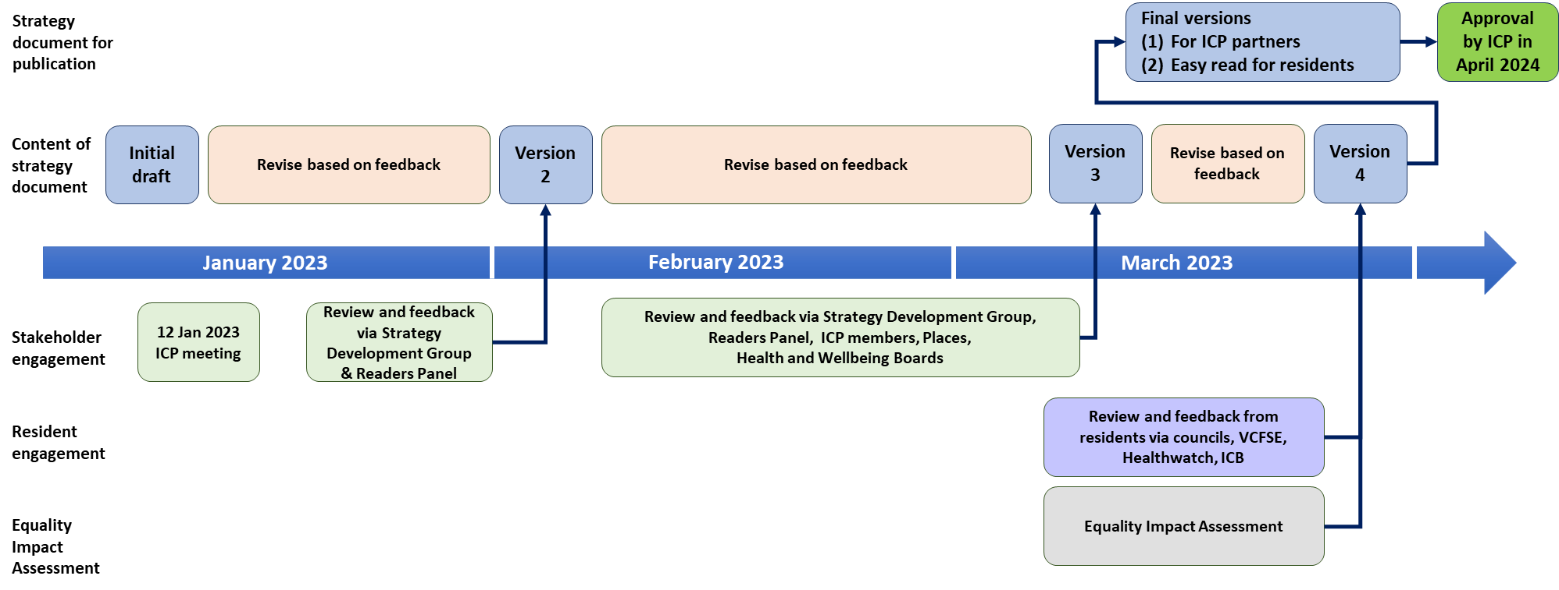

List of background papers

N/A

Reason for inclusion in Part II, if appropriate

N/A

