APPLICATION LCC/2015/0070 VARIATION OF CONDITION 3 OF PERMISSION
06/10/0169 TO VARY THE HOURS OF OPERATION OF THE SHREDDER TO
07.30 TO 17.30 MONDAY TO FRIDAY (EXCEPT BANK HOLIDAYS) 7.30 TO 13.00 ON SATURDAYS, NO METAL PROCESSING OPERATIONS SHALL BE
UNDERTAKEN BY THE SHREDDER RECYCLING PLANT AT ANY TIME ON
SUNDAYS AND PUBLIC HOLIDAYS. WORK CAN BE CARRIED OUT OUTSIDE THESE HOURS FOR ESSENTIAL REPAIRS TO PLANT AND MACHINERY USE ON THE SITE. RECYCLING LIVES, LONGRIDGE ROAD PRESTON.

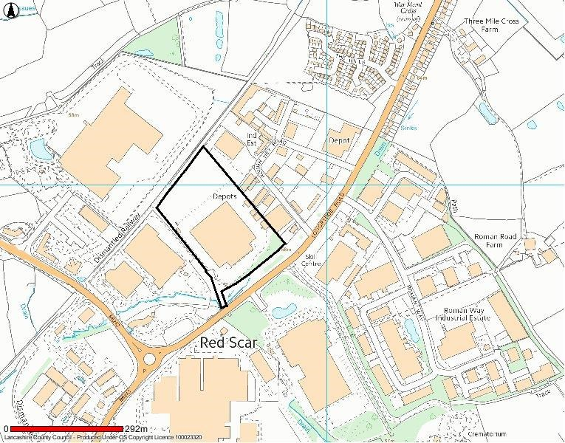
Location of Site

Indicative Only

This Map is reproduced from Ordnance Survey material with the permission of Ordnance Survey on behalf of the controller of Her Majesty's Stationery Office (C) Crown Copyright. Unauthorised reproduction infringes Crown Copyright and may lead to Prosecution or civil proceedings. Lancashire County Council Licence No. 100023320

