Regulatory Committee
Meeting to be held on 26 July 2017

Electoral Division affected:
Accrington South

Wildlife and Countryside Act 1981
Definitive Map Modification Order Investigation
Addition of Public Footpath from Manchester Road to Haworth Park, Baxenden, Accrington, Borough of Hyndburn
File No. 804-584
(Annex ‘A’ refers)

Contact for further information:
Paralegal, Legal and Democratic Services, legalservicesPROW@lancashire.gov.uk
Jayne Elliott, 01772 537663, Public Rights of Way Definitive Map Officer, Environment and Planning, jayne.elliott@lancashire.gov.uk

Executive Summary

Application for the addition of a public footpath from Manchester Road to Haworth Park, Baxenden, Accrington, in accordance with File No. 804-584.

Recommendation

1. That the application for a public footpath from Manchester Road to Haworth Park, Baxenden, Accrington, in accordance with File No. 804-584, be accepted.

2. That an Order(s) be made pursuant to Section 53 (2)(b) and Section 53 (3)(b) and/or Section 53 (3)(c)(i) of the Wildlife and Countryside Act 1981 to add a public footpath from Manchester Road to Haworth Park, Accrington on the Definitive Map and Statement of Public Rights of Way as shown on Committee Plan between points A-B.

3. That being satisfied that the higher test for confirmation can be met the Order be promoted to confirmation.

Background

An application under Schedule 14 of the Wildlife and Countryside Act 1981 has been received for the addition of a public footpath from Manchester Road to Haworth Park, Accrington on the Definitive Map and Statement of Public Rights of Way.

The County Council is required by law to investigate the evidence and make a decision based on that evidence as to whether a public right of way exists, and if so its status. Section 53(3)(b) and (c) of the Wildlife and Countryside Act 1981 set out the tests that need to be met when reaching a decision; also current Case Law needs to be applied.

An order will only be made to add a public right of way to the Definitive Map and Statement if the evidence shows that:
- A right of way “subsists” or is “reasonably alleged to subsist”

An order for adding a way to or upgrading a way shown on the Definitive Map and Statement will be made if the evidence shows that:
- “the expiration… of any period such that the enjoyment by the public…raises a presumption that the way has been dedicated as a public path or restricted byway”

When considering evidence, if it is shown that a highway existed then highway rights continue to exist (“once a highway, always a highway”) even if a route has since become disused or obstructed unless a legal order stopping up or diverting the rights has been made. Section 53 of the Wildlife and Countryside Act 1981 (as explained in Planning Inspectorate’s Advice Note No. 7) makes it clear that considerations such as suitability, the security of properties and the wishes of adjacent landowners cannot be considered. The Planning Inspectorate’s website also gives guidance about the interpretation of evidence.

The County Council’s decision will be based on the interpretation of the evidence discovered by officers and documents and other evidence supplied by the applicant, landowners, consultees and other interested parties produced to the County Council before the date of the decision. Each piece of evidence will be tested and the evidence overall weighed on the balance of probabilities. It is possible that the Council’s decision may be different from the status given in any original application. The decision may be that the routes have public rights as a footpath, bridleway, restricted byway or byway open to all traffic, or that no such right of way exists. The decision may also be that the routes to be added or deleted vary in length or location from those that were originally considered.

Consultations

Hyndburn Borough Council

The Borough Council have been consulted and do not support the application. The Borough Council own Haworth Art Gallery and Park and whilst the application route does not cross their land it provides access into the park at point B on the Committee Plan. The Council don’t support the application to cross their land for the following reasons:

- It was never intended to open this route up as a public right of way
- It is not a formal entrance to Haworth Park and adds no value as an entrance
- To access Haworth Park you have to cross a third party's land
- There is an existing public entrance approximately 50 meters away
- If it is designated as right of away Hyndburn Borough Council will be required to maintain the access and footpath

Applicant/Landowners/Supporters/Objectors

The evidence submitted by the applicant/landowners/supporters/objectors and observations on those comments are included in Advice – Head of Service – Legal and Democratic Services Observations.

Advice

Head of Service – Planning and Environment

Points annotated on the attached Committee plan.

Point | Grid Reference (SD) | Description
A | 7684 2714 | Open junction with Manchester Road (A680)
B | 7683 2714 | Boundary of Haworth Park and Art Galley

Description of Route

A site inspection was carried out on 8th June 2017.

The total length of the route is 5 metres. It commences at a point on the western boundary of Manchester Road (A680) directly opposite house number 239 Manchester Road (point A on the Committee plan).

At point A the route passes through a 3.5 metre wide gap between stone gateposts. Access is not possible through the gateway and along the application route currently because temporary security fencing has been erected across it.

From point A the application route can be seen to extend in a north westerly direction across the corner of land which is currently fenced off as part of a building site and ascends two stone steps to meet a metal fence adjacent to the western end of a short length of stone wall which forms part of the boundary between the building site (former residential home) and Haworth Park (point B). The metal fencing appeared to have only recently been erected and prevented access from the route at point B.

Beyond point B the route enters Haworth Park which is owned and maintained by Hyndburn District Council. A trodden path extends through woodland from point B to continue in a north westerly for approximately 25 metres to join the tarmac path which loops around the park. There is evidence that the path linking the application route to the tarmac path has, at some time been surfaced with stone and that a fallen tree had been cleared from the route. A litter bin and dog waste bin are located on this path in such a position that they must have been intended for use by people walking on the path as they gained access to, or left the public park via the application route.

Map and Documentary Evidence

Document Title | Date | Brief Description of Document & Nature of Evidence
Yates’ Map  of Lancashire | 1786 | Small scale commercial map. Such maps were on sale to the public and hence to be of use to their customers the routes shown had to be available for the public to use. However, they were privately produced without a known system of consultation or checking. Limitations of scale also limited the routes that could be shown.
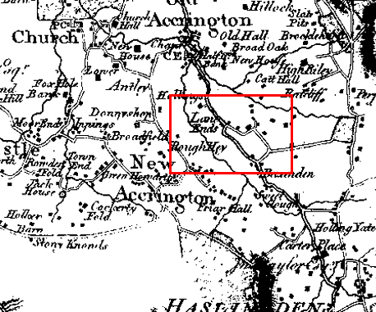
Observations |  | The application route is not shown. A property is named on the map as 'Hollings' which may be Howarth art gallery.
Investigating Officer's Comments |  | It is unlikely that a claimed public footpath across open land would have been shown on the map. The application route did not exist as a major route at the time although it may have existed as a minor route which would not have been shown due to the limitations of scale so no inference can be drawn in this respect.
Greenwood’s Map of Lancashire | 1818 | Small scale commercial map. In contrast to other map makers of the era Greenwood stated in the legend that this map showed private as well as public roads and the two were not differentiated between within the key panel.
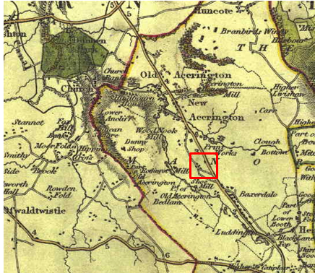
Observations |  | The application route is not shown.
Investigating Officer's Comments |  | It is unlikely that such a short claimed public footpath across open land would have been shown on the map. The application route did not exist as a major route at the time although it may have existed as a minor route which would not have been shown due to the limitations of scale so no inference can be drawn in this respect.
Hennet's Map of Lancashire | 1830 | Small scale commercial map. In 1830 Henry Teesdale of London published George Hennet's Map of Lancashire surveyed in 1828-1829 at a scale of 71/2 inches to 1 mile. Hennet's finer hachuring was no more successful than Greenwood's in portraying Lancashire's hills and valleys but his mapping of the county's communications network was generally considered to be the clearest and most helpful that had yet been achieved.
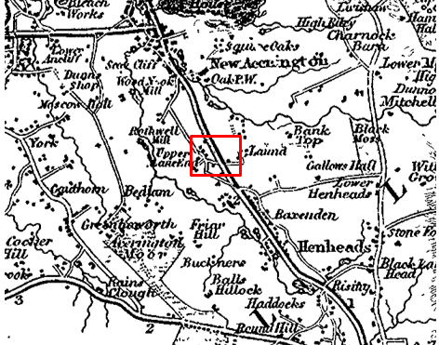
Observations |  | The application route is not shown.
Investigating Officer's Comments |  | It is unlikely that a claimed public footpath across open land would have been shown on the map. The application route did not exist as a major route at the time although it may have existed as a minor route which would not have been shown due to the limitations of scale so no inference can be drawn in this respect.
Canal and Railway Acts |  | Canals and railways were the vital infrastructure for a modernising economy and hence, like motorways and high speed rail links today, legislation enabled these to be built by compulsion where agreement couldn't be reached. It was important to get the details right by making provision for any public rights of way to avoid objections but not to provide expensive crossings unless they really were public rights of way. This information is also often available for proposed canals and railways which were never built.
Observations |  | There are no existing, disused or proposed railways or canals crossing the land affected by the application.
Investigating Officer's Comments |  | No inference can be drawn with regards to public rights.
Tithe Map and Tithe Award or Apportionment |  | Maps and other documents were produced under the Tithe Commutation Act of 1836 to record land capable of producing a crop and what each landowner should pay in lieu of tithes to the church. The maps are usually detailed large scale maps of a parish and while they were not produced specifically to show roads or public rights of way, the maps do show roads quite accurately and can provide useful supporting evidence (in conjunction with the written tithe award) and additional information from which the status of ways may be inferred.
Observations |  | There is no Tithe Map deposited in the County Records Office for Accrington.
Investigating Officer's Comments |  | No inference can be drawn with regards to public rights.
Inclosure Act Award and Maps |  | Inclosure Awards are legal documents made under private acts of Parliament or general acts (post 1801) for reforming medieval farming practices, and also enabled new rights of way layouts in a parish to be made. They can provide conclusive evidence of status.
Observations |  | There is no Inclosure Award available to view in the County Records Office for the land crossed by the application route.
Investigating Officer's Comments |  | No inference can be drawn with regards to public rights.
6 Inch Ordnance Survey (OS) Map | 1849 | The earliest Ordnance Survey 6 inch map for this area surveyed in 1844-45 and published in 1849.
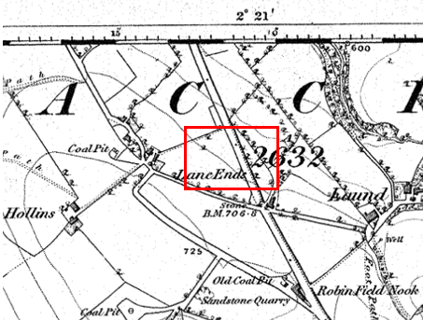
Observations |  | The application route is not shown. The land crossed by the application route is shown as undeveloped.
Investigating Officer's Comments |  | The application route did not exist in 1849.
25 Inch OS Map | 1893 | The earliest OS map at a scale of 25 inch to the mile. Surveyed in 1891 and published in 1983.
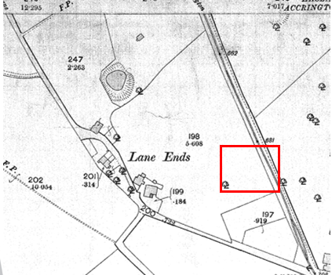
Observations |  | The application route is not shown. A property known as Lane Ends is shown to exist west of the application route close to the modern day location of Haworth Hall.
Investigating Officer's Comments |  | The application route did not exist in 1893.
25 inch OS Map | 1911 | Further edition of the 25 inch map surveyed in 1891, revised in 1909 and published in 1911.
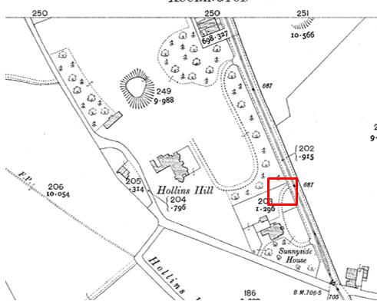
Observations |  | The application route is not shown. However, a property known as Sunnyside House is shown with a semi circular driveway extending from two points on Manchester Road. The north westerly exit of the driveway onto Manchester Road is consistent with the position of the start of the application route (point A). However the application route between point A and point B is not shown.  The buildings named as Lane Head on the 1893 OS map no longer exist and a property known as Hollins Hill with a long driveway/access from Manchester Road is shown.
Investigating Officer's Comments |  | Access onto the application route at point A may have existed but the application route itself (between point A and point B) probably did not exist in 1911.
Finance Act 1910 Map | 1910 | The comprehensive survey carried out for the Finance Act 1910, later repealed, was for the purposes of land valuation not recording public rights of way but can often provide very good evidence. Making a false claim for a deduction was an offence although a deduction did not have to be claimed so although there was a financial incentive a public right of way did not have to be admitted.  Maps, valuation books and field books produced under the requirements of the 1910 Finance Act have been examined. The Act required all land in private ownership to be recorded so that it could be valued and the owner taxed on any incremental value if the land was subsequently sold. The maps show land divided into parcels on which tax was levied, and accompanying valuation books provide details of the value of each parcel of land, along with the name of the owner and tenant (where applicable).  An owner of land could claim a reduction in tax if his land was crossed by a public right of way and this can be found in the relevant valuation book. However, the exact route of the right of way was not recorded in the book or on the accompanying map. Where only one path was shown by the Ordnance Survey through the landholding, it is likely that the path shown is the one referred to, but we cannot be certain. In the case where many paths are shown, it is not possible to know which path or paths the valuation book entry refers to. It should also be noted that if no reduction was claimed this does not necessarily mean that no right of way existed.
Observations |  | The Finance Act plan showing the area crossed by the application route is not available to view at the Lancashire County Records office.
Investigating Officer's Comments |  | No inference can be drawn regarding the existence of public rights.
25 Inch OS Map | 1930 | Further edition of 25 inch map (resurveyed 1891, revised in 1909 and published 1930.
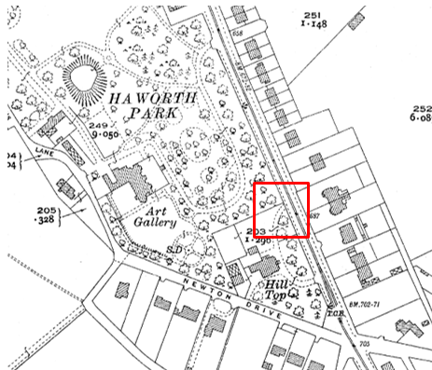
Observations |  | The application route is not shown. Sunnyside Hill has been renamed as Hill Top and the semi-circular driveway is shown with access at point A.  Hollins Hill is now shown as Haworth Park and the building labelled as an art gallery. The area surrounding the art gallery is shown as parkland with a number of formal-looking paths.  The path connecting the formal path to the application route at point B is not shown.
Investigating Officer's Comments |  | The application route probably did not exist in 1930.
Authentic Map Directory of South Lancashire by Geographia | Circa1934 | An independently produced A-Z atlas of Central and South Lancashire published to meet the demand for such a large-scale, detailed street map in the area. The Atlas consisted of a large scale coloured street plan of South Lancashire and included a complete index to streets which includes every 'thoroughfare' named on the map.  The introduction to the atlas states that the publishers gratefully acknowledge the assistance of the various municipal and district surveyors who helped incorporate all new street and trunk roads. The scale selected had enabled them to name 'all but the small, less-important thoroughfares'.
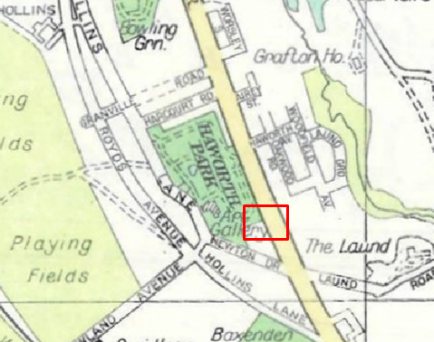
Observations |  | The application route is not shown.
Investigating Officer's Comments |  | It is not unusual for public footpaths not to be shown on this small scale map which was produced primarily as a street gazetteer so no inference can be drawn regarding whether the application route existed at that time.  Haworth Park is shown coloured green indicating that it was a public park.
Aerial Photograph | 1940s | The earliest set of aerial photographs available was taken just after the Second World War in the 1940s and can be viewed on GIS. The clarity is generally very variable.
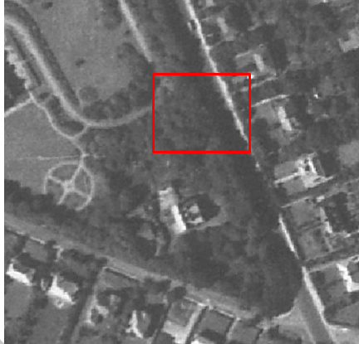
Observations |  | The application route is not shown. The access driveway from point A cannot be seen leading to Hill Top.  Dense tree cover means that it is not possible to see whether the application route (or driveway) existed.
Investigating Officer's Comments |  | No inference can be drawn with regards to the existence of public rights.
1:2500 OS Map | 1961 | Further edition of 25 inch map reconstituted from former county series, part surveyed 1955-56 and revised in 1960 and published 1961 as national grid series.
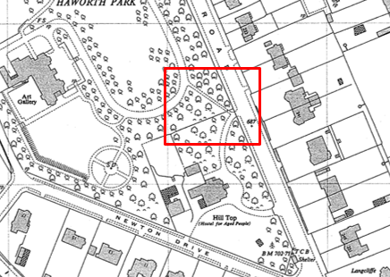
Observations |  | The application route is shown from point A as part of the access way to Hill Top extending north west from the driveway and passing through the boundary at point B to continue through the trees and extending in a north westerly direction to the main access way leading up to the art gallery. Hill Top is described on the map as being a 'Hostel for aged people'.
Investigating Officer's Comments |  | The application route existed in 1961 providing access into the public park. The position of the route – at the bottom of the hill immediately accessible from Manchester Road – suggests that it was not necessarily constructed for the residents of a hostel for old people who would have to walk down the drive from Hill Top and then walk back up the hill if using the application route to gain access to the art gallery and park. The route appears, however, to have provided an additional link into the park from Manchester Road.
OS 6 inch Map | 1965 | Surveyed 1956-60 and published 1965
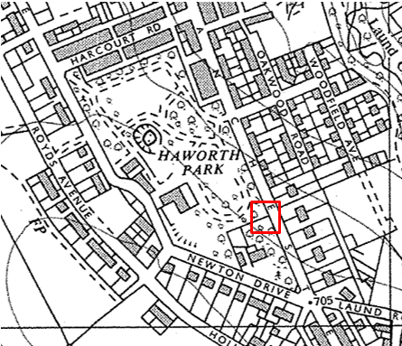
Observations |  | The application route is not shown.
Investigating Officer's Comments |  | The map was probably derived from the same survey as the 25 inch map published in 1961. Its stylised format and small scale are likely to account for the fact that the route is not shown rather than it no longer existing just a few years after it was clearly shown on the 25 inch map. No inference can be drawn.
Aerial photograph | 1960s | The black and white aerial photograph taken in the 1960s and available to view on GIS.
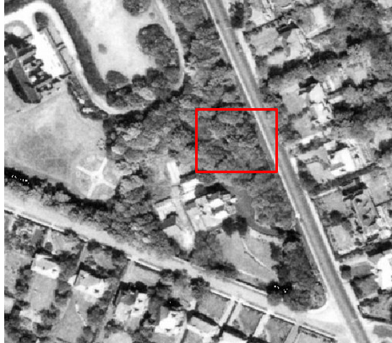
Observations |  | The land crossed by the application route is obscured by tree cover. The application route – if it did exist - cannot be seen.
Investigating Officer's Comments |  | No inference can be drawn with regards to public rights.
Aerial Photograph | 2000 | Aerial photograph available to view on GIS.
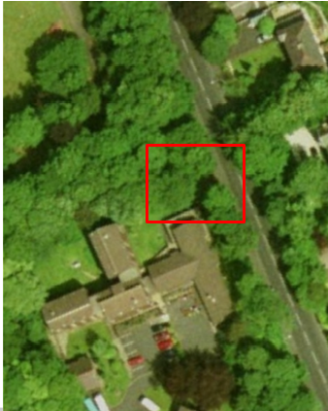
Observations |  | The application route cannot be seen but the area crossed by the route is obscured by tree cover.
Investigating Officer's Comments |  | No inference can be drawn with regards to public rights.
Aerial Photograph | 2014 | Aerial photograph available to view on GIS.
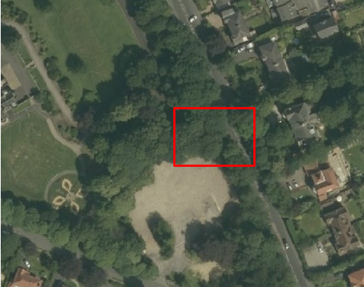
Observations |  | Hill Top is not shown and appears to have been demolished and the site cleared of debris. The application route cannot be seen as the land is obscured by tree cover.
Investigating Officer's Comments |  | No inference can be drawn with regards to the existence of public rights.
Google Street View |  | Google images captured from google street map.
2009
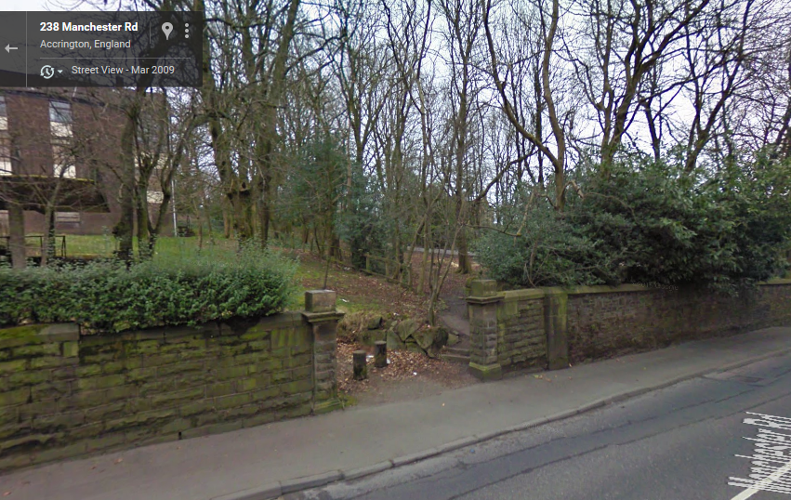
2016
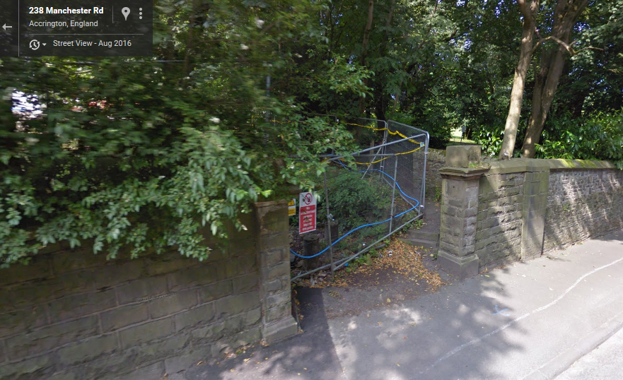
Observations |  | The photograph taken in 2009 shows the application route. Access appears to be available at point A between two substantial stone gateposts within a longer length of stone wall. Bollards can be seen across the driveway (beyond the application route) to prevent vehicular use of the former driveway from Manchester Road.  Immediately in front of the bollards stone steps can be seen leading from the driveway along the application route with a worn path leading to the boundary (fence) at point B. At point B there appears to be a gap in the fence providing access through to Haworth Park.  The photograph taken in 2016 shows the application route similar to in 2009 but with security fencing preventing access to the building site. The fencing is erected in such a way that access to the application route was still possible.
Investigating Officer's Comments |  | The application route existed and appeared capable of being used in 2009.  The application route existed in 2016 and fencing to secure the building site had been erected in such a way as to ensure that access was still available along it.
Definitive Map Records |  | The National Parks and Access to the Countryside Act 1949 required the County Council to prepare a Definitive Map and Statement of Public Rights of Way.  Records were searched in the Lancashire Records Office to find any correspondence concerning the preparation of the Definitive Map in the early 1950s.
Parish Survey Map | 1950-1952 | The initial survey of public rights of way was carried out by the parish council in those areas formerly comprising a rural district council area and by an urban district or municipal borough council in their respective areas. Following completion of the survey the maps and schedules were submitted to the County Council. In the case of municipal boroughs and urban districts the map and schedule produced, was used, without alteration, as the Draft Map and Statement. In the case of parish council survey maps, the information contained therein was reproduced by the County Council on maps covering the whole of a rural district council area. Survey cards, often containing considerable detail exist for most parishes but not for unparished areas.
Observations |  | Accrington was a Municipal Borough Council in the 1950s and no parish survey map was produced.
Draft Map |  | The Draft Maps were given a “relevant date” (1st January 1953) and notice was published that the draft map for Lancashire had been prepared. The draft map was placed on deposit for a minimum period of 4 months on 1st January 1955 for the public, including landowners, to inspect them and report any omissions or other mistakes. Hearings were held into these objections, and recommendations made to accept or reject them on the evidence presented.
Observations |  | The application route was not shown on the Draft Map and there were no representations made regarding the fact that it was not shown.
Provisional Map |  | Once all representations relating to the publication of the draft map were resolved, the amended Draft Map became the Provisional Map which was published in 1960, and was available for 28 days for inspection. At this stage, only landowners, lessees and tenants could apply for amendments to the map, but the public could not. Objections by this stage had to be made to the Crown Court.
Observations |  | The application route was not shown on the Provisional Map and there were no representations made regarding the fact that it was not shown.
The First Definitive Map and Statement |  | The Provisional Map, as amended, was published as the Definitive Map in 1962.
Observations |  | The application route was not shown on the First Definitive Map and Statement.
Revised Definitive Map of Public Rights of Way (First Review) |  | Legislation required that the Definitive Map be reviewed, and legal changes such as diversion orders, extinguishment orders and creation orders be incorporated into a Definitive Map First Review. On 25th April 1975 (except in small areas of the County) the Revised Definitive Map of Public Rights of Way (First Review) was published with a relevant date of 1st September 1966. No further reviews of the Definitive Map have been carried out. However, since the coming into operation of the Wildlife and Countryside Act 1981, the Definitive Map has been subject to a continuous review process.
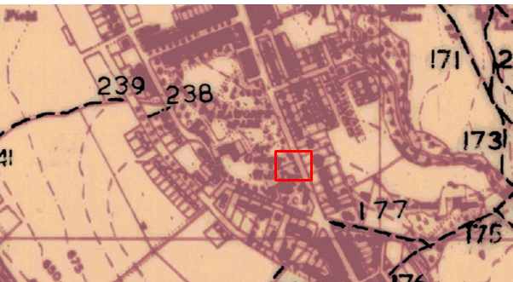
Observations |  | The application route is not shown on the Revised Definitive Map and Statement of Public Rights of Way (First Review).
Investigating Officer's Comments |  | The route under investigation was not considered to be public during the preparation of the 1st Definitive Map and Statement through to the 1960s.
Highway Adoption Records including maps derived from the '1929 Handover Maps' | 1929 to present day | In 1929 the responsibility for district highways passed from district and borough councils to the County Council. For the purposes of the transfer, public highway 'handover' maps were drawn up to identify all of the public highways within the county. These were based on existing Ordnance Survey maps and edited to mark those routes that were public. However, they suffered from several flaws – most particularly, if a right of way was not surfaced it was often not recorded.  A right of way marked on the map is good evidence but many public highways that existed both before and after the handover are not marked. In addition, the handover maps did not have the benefit of any sort of public consultation or scrutiny which may have picked up mistakes or omissions.  The County Council is now required to maintain, under section 31 of the Highways Act 1980, an up to date List of Streets showing which 'streets' are maintained at the public's expense. Whether a road is maintainable at public expense or not does not determine whether it is a highway or not.
Observations |  | The application route is not recorded as being publicly maintainable in the records originally derived from the 1929 Handover Maps and now held by the County Council.
Investigating Officer's Comments |  | The fact that the application route is not recorded as a publicly maintainable highway does not mean that it does not necessarily carry public rights of access.
Statutory deposit and declaration made under section 31(6) Highways Act 1980 |  | The owner of land may at any time deposit with the County Council a map and statement indicating what (if any) ways over the land he admits to having been dedicated as highways. A statutory declaration may then be made by that landowner or by his successors in title within ten years from the date of the deposit (or within ten years from the date on which any previous declaration was last lodged) affording protection to a landowner against a claim being made for a public right of way on the basis of future use (always provided that there is no other evidence of an intention to dedicate a public right of way).  Depositing a map, statement and declaration does not take away any rights which have already been established through past use. However, depositing the documents will immediately fix a point at which any unacknowledged rights are brought into question. The onus will then be on anyone claiming that a right of way exists to demonstrate that it has already been established. Under deemed statutory dedication the 20 year period would thus be counted back from the date of the declaration (or from any earlier act that effectively brought the status of the route into question).
Observations |  | There are no Highways Act 1980 Section 31(6) deposits lodged with the County Council for the area of land over which the route under investigation runs.
Investigating Officer's Comments |  | There is no indication by a landowner under this provision of non-intention to dedicate public rights of way over their land.
Haworth Park and Art Gallery |  | Online research carried out into the history of Haworth Park and Art Gallery.  Haworth Art Gallery was originally called Hollins Hill and belonged to Mr. William Haworth JP (Ex-Mayor of Accrington). The park area surrounding the house covers an area of 3.2 hectares including grass, woodland, shrubbery and formal gardens and was originally known as Hollins Hill Park, after the name of William's home.  When Miss Haworth died in 1920 her will bequeathed the house and grounds to the Borough with a view to the grounds being laid out as a park and the house being used as an Art Gallery.  The park and mansion subsequently became known as Haworth Park and Haworth Art Gallery in recognition of the family and their generous gift for the public to enjoy.  The art gallery and park are currently managed by Hyndburn Borough Council and are open to the public.
Plan submitted by the Applicant
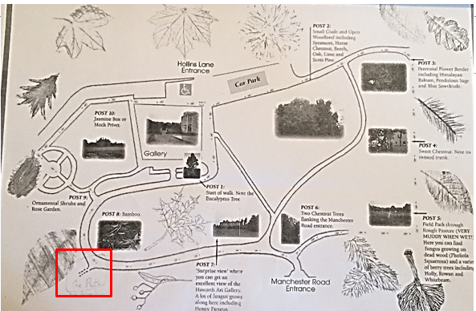
Observations |  | A plan submitted by the applicant and originally produced by Hyndburn Borough Council details a walk around the park and provides details of the types of plants and trees which are located at different spots. The plan shows a doubled pecked line indicating the existence of a path leaving the formal path around the garden in the south west corner. This path corresponds to the location of the path that links to the application route at point B.
Investigating Officer's Comments |  | The application route provides access from Manchester Road to a public park. The leaflet produced by Hyndburn Borough Council is undated but acknowledges the existence of a path linking from the park to the application route.

The affected land is not designated as access land under the Countryside and Rights of Way Act 2000 and is not registered common land.

Landownership

All of the land crossed by the application route has been in the ownership of Baxenden Developments Limited, 89 The Bowls, Vicarage Lane, Chigwell 1G7 6NP since February 2016.

Summary

The map and documentary evidence examined does not support the existence of the route as an accessible through route linking Manchester Road to Haworth Park until the 1960s.

The route is clearly shown on the 1961 Ordnance Survey map and its existence as a through route linking to the formal tarmac path through the park is further supported by the google street view image captured in 2009.

Both pieces of evidence detailed above, together with the undated leaflet published by the Borough Council and provided by the applicant, together with the site evidence of the existence of the route and of the continuation of the route into the park support the user evidence submitted.

Head of Service – Legal and Democratic Services Observations

Information from the Applicant

Seventeen user evidence forms detailing use of the route were submitted by the applicant.

The user evidence forms referred to use over a period of 47 years dating back to 1970 and continuing through until the route was closed off in 2017.

Eight of the users claimed to have used the route in excess of 20 years: 27 years (1980-2017), 25 years (1982-2017), 27 years (1980-2017), 42 years (1975-2017), 45 years (1942-2017), 28 years (1979-2017), 45 years (1972-2017) and 47 years (1970-2017).

The Applicant stated that she had known the route to be in use for at least 30 years but didn't specify details of her own use.

The remaining 9 user evidence forms detailed use of the route during the same period of time but for less than 20 years; two users specified 19 years (1998-2017), two users also specified 17 years (2000-2017), 10 years (2007-2017), 18 years (2009-2017), 14 years (2003-2017), 13 years (2004-2017).

All of the users completing the forms stated that they used the route on foot, saw other people using it on foot and that they believed it to be a footpath. One user also referred to use by bicycles another user stated that the steps deterred cyclists.

Two users stated that they used the route daily but most used it weekly with one referring to use being every few months and one referring to frequency of use 'varying' over a 25 year period.

All of the users stated that they had always used the same route and that it had not altered or changed over the time that they had used it.

Reasons for use were listed as for dog walking, access to the park and art gallery, as part of a route from Manchester Road to Hollins Lane, for pleasure, to visit friends, to access the bus stop, to get to work, to gain entry to the park, to visit the art gallery and café, for jogging, as part of a guided walk, and used to carry out community forum work in the park.

None of the users recalled any gates or other barriers on the route which prevented or restricted access.

None of the users had been given permission to use the route or stated that they had ever sought permission to use the route. None had been stopped or challenged when using the route until it was blocked off in 2017.

One user stated that he had worked for Hyndburn Borough Council Parks Department since 1975 and that he had used the route for both work and pleasure.

A number of users referred to the blockage of the route in 2017 as part of the re-development of the former old people home which had been demolished and where new houses are currently being built. Several users stated that when the route was originally blocked off for several weeks but then re-opened following a protest but that it was closed off again not long after.

Most of the users, when describing the route, referred to a 'formal' opening from Manchester Road and the existence of two stone steps. There was also repeated reference to the fact that the route continued into the park along a stone surfaced/gravel/earth path on which there were litter and dog waste bins situated before you reached the formal tarmac path in the park grounds.

One user referred to the path being shown in a 2000 guide to Haworth Park in which it was shown as one of the entry points into the park.

A number of users also referred to the continuation of the route beyond point B as being along a stone surfaced or gravel path along which a dog bin and signage had been placed.

All of the users stated that they had always used the same route and that it had never altered.

Information from the Landowner

The current landowners have only owned the land crossed by the application route since February 2016.
The landowners have not provided any evidence relating to use of the route prior to them purchasing the site. They have indicated that they would object to the public footpath on their land unless it was adopted by the County Council because once the development has been completed the communal parts of the site will be owned jointly by the residents and they are concerned about liability for accidents.

Assessment of the Evidence

The Law - See Annex 'A'

In Support of Making an Order(s)

- User evidence
- 1960s OS Map Evidence
- Google Street view images
- Absence of signs and notices along the route to suggest there is no public right to use the route
- Absence of actions taken by the landowner to discourage the use of the route
- Howarth Park "user guide" submitted by the Applicant produced by Hyndburn Borough Council
- Stone steps constructed on the route leading to a gravel path in the park.

Against Making an Order(s)

- Route not shown on any pre-1960s maps

Conclusion

The claim is that the route A-B is an existing public footpath and should be added to the Definitive Map and Statement of Public Rights of Way. It is therefore advised that as there is no express dedication that the Committee should consider, on balance, whether there is sufficient evidence from which to have its dedication inferred at common law from all the circumstances or for the criteria in section 31 Highways Act 1980 for a deemed dedication to be satisfied based on sufficient twenty years "as of right" use to have taken place ending with this use being called into question in 2017.

Considering initially the criteria for a deemed dedication under section 31 of the
Highways Act, that use needs to be "as of right" and also sufficient for the 20 year period. The first consideration is to determine whether the route has been called into question. In this matter the evidence suggests that access to the route was prevented by being closed off in 2017 by way of fencing erected at point A.
It would appear that some users complained initially in 2017 to the owners about the access to the route being blocked off resulting in the route being made available for a short period of time before being blocked off again later the same year (2017).

The period of use from which dedication can be deemed would therefore be 1997-2017, 17 user evidence forms have been submitted in addition to information provided by the applicant by the applicant. Of the 17 users, all the users have claimed to have used the route during the period under consideration and 8 have used the claimed route for 20 years or more suggesting good user evidence for the sufficient period. All users claim to have known and used the route on foot on a regular basis "as of right" with one user also recounting having used the route on bicycle. All users refer to having witnessed other users whilst using the route. None of the users have seen any signs or notices along the route other than signs concerning the request to use the dog fouling bin located on continuation of the route within Haworth Park, none of the users have asked permission to use the route. The majority of the users also describe the claimed route as a formal route in that the entrance was marked by stone pillars and the surface was made up of a few stones steps and surfaced with tarmac.

Considering also whether there are circumstances from which dedication could be inferred at common law. The analysis of the map and documentary evidence by the
Head of Service – Planning and Environment provides evaluation of the documentary evidence. The route is not shown to exist on any of the early commercial maps and there is no documentary evidence to support the existence of the route as a public highway. From 1961 there is map evidence of the application route having existed as a route from point A to B and continuing from B into the park.

It is suggested that the way this route is recorded on documentary evidence is not in itself sufficient circumstances from which dedication could be inferred. However, sufficient as of right use may also be circumstances from which dedication can be inferred. The use as corroborated by the documentary evidence outlined above would suggest that it may reasonably be alleged that there are sufficient circumstances to infer at common law.

Taking all of the evidence into account, the Committee on balance may consider that the provisions of section 31 Highways Act can be satisfied and that it can also be reasonably alleged that there is sufficient evidence from which to infer dedication at common law of a footpath in this matter and that the claim can be accepted.
Committee is therefore advised to accept the claim.

Consideration has been given to the risk management implications associated with this claim. The Committee is advised that the decision taken must be based solely on the evidence contained within the report, and on the guidance contained both in the report and within Annex A included in the Agenda Papers. Provided any decision is taken strictly in accordance with the above then there are no significant risks associated with the decision making process.

Alternative options to be considered - N/A

Local Government (Access to Information) Act 1985

List of Background Papers

Paper | Date | Contact/Directorate/Tel
All documents on File Ref: 804-584 |  | Paralegal , 01772 535604, County Secretary and Solicitors Group
Reason for inclusion in Part II, if appropriate

N/A

The Ordnance Survey (OS) has produced topographic maps at different scales (historically one inch to one mile, six inches to one mile and 1:2500 scale which is approximately 25 inches to one mile). Ordnance Survey mapping began in Lancashire in the late 1830s with the 6-inch maps being published in the 1840s. The large scale 25-inch maps which were first published in the 1890s provide good evidence of the position of routes at the time of survey and of the position of buildings and other structures. They generally do not provide evidence of the legal status of routes, and carry a disclaimer that the depiction of a path or track is no evidence of the existence of a public right of way.
Aerial photographs can show the existence of paths and tracks, especially across open areas, and changes to buildings and field boundaries for example. Sometimes it is not possible to enlarge the photos and retain their clarity, and there can also be problems with trees and shadows obscuring relevant features.

