Internal Scrutiny Committee
Meeting to be held on Friday, 16 November 2018

Electoral Division affected:
All

Customer Access Service - Update on Performance and Savings Initiatives

Contact for further information:
Sarah Jenkins, Tel: 01772 537401, Head of Service – Customer Access Service.
sarah.jenkins@lancashire.gov.uk

Executive Summary

The purpose of this report is to provide the Customer Access Service (CAS), operational performance and key statistics for the period April 2018 to August 2018.

The report also provides a comparison against the previous financial year. The final page of the report lists the savings plan for the service 2015-21.

Recommendation

The Internal Scrutiny Committee are requested to note and comment on the contents of this report.

Background and Advice

The Customer Access Service (CAS) currently deliver first point of contact for telephone, email and social media interactions for 28 Lancashire County Council services, handling over 1.1 million customer interactions a year. This equates to roughly two thirds of all customer contacts coming into the authority.

In addition to this, the Customer Access Service also processes 24,800 Blue Badge applications, over 5,000 Crisis Support Applications, and over 51,700 Customer Satisfaction feedback reports.

These services are very diverse and vary widely from booking a wedding to reporting a pothole, with the sensitive handling of safeguarding reports in between.
Each service has its own data handling tool(s) which we record contacts in, requiring Customer Access staff to be able to competently use over 25 separate specialist systems.

- Summary
  - Telephony
There has been an overall improvement in telephony performance both in terms of calls answered and wait times compared to the same period in the previous financial year. Calls answered have increased from 89% to 91% with calls answered within 40 seconds up from 45% to 55%. The total number of calls answered is up from 315,689 to 323,062, an increase of 7,373 telephone contacts. This increase in calls answered is mainly due to the handling improvements implemented by CAS to try and minimise the impact of vacancies and the reduction in headcount as a result of the savings programme. We are constantly reviewing our processes based on the statistical data we analyse and use this business intelligence to optimise performance where possible, including the cross skilling of advisors, directing callers to our website, changes made to the customer experience and updating service call priorities. However it should be noted that the reduction in headcount over the last three year period as a result of the savings programme has left the service with little capacity to handle influxes of calls relating to the weather and other unexpected service increases. This then results in customer wait times being longer than we aspire to deliver.
  - Email
There has been an increase in the volumes of emails being received and handled from 62,315 to 62,619, compared to the same period in the previous financial year, an increase of 304 contacts.
  - Customer Satisfaction
Customer Satisfaction has remained consistent with overall satisfaction at 81% compared with 80% in the previous financial year. Satisfaction with our first point of contact resolution has also increased slightly from 77% to 79%. There have been a total of 12,296 customer satisfaction surveys fully completed by customers in the year so far.
  - Social Media
The introduction of a Social Media channel within Customer Access in November 2017 has proved successful and will be a contributing factor in the Digital Strategy as we move forward. Since its introduction we have handled 1,945 interactions.
  - Blue Badges
Approval rates of Blue Badges have remained consistent at 80%. The number of applications received for the year so far is 13,110. A Blue Badge Improvement Programme is underway, to review all aspects of the service and comparing to best practice in other authorities. This will put the service in a strong position ahead of the impending Department for Transport policy amendments in 2019.
  - Crisis Support
The number of applications received for the year so far is 1,597, the approval rate of Crisis Support applications has decreased since the previous financial year and is currently 21% compared to 34%. This has been due to improved signposting allowing us to find alternative solutions for our citizens. The number of applications received has seen a downward trend, partially influenced by the change from monetary awards to the provision of food parcels, but can also be linked to the problems experienced with tax credits in the previous year which hasn't occurred this year.
  - Retention
Retention within Customer Access has remained challenging largely due to opportunities elsewhere within the authority. The recent restructure of the service has allowed an opportunity to address this area with the design focused on frontline staff development and stronger career pathways within Customer Access. The number of new starters so far this year has been 31, in the same period we have also seen 33 leavers.
  - Savings
The current financial year has seen a further reduction in both budget and headcount within Customer Access, continuing the trend over the last three years. Future savings have been agreed but are dependent on technological implementation. The savings delivered to date have totalled £1,005,000, and we have seen a reduction of 44.4 FTE. Details can be found under Paragraph 5.1 of this report. It should be noted that the budget for the Customer Access Service is based almost entirely on staffing and therefore in order for CAS to make the necessary saving reductions, staffing levels must be reduced. Reducing headcount without reducing the work coming through the centre will result in longer wait times for callers and callers having to abandon calls and make several further call attempts. This could lead to complaints and have a negative impact on the reputation of the authority.
Customer Access commenced their Service Challenge on 3 September 2018 with a large amount of initial research already undertaken in order to benchmark ourselves against other authorities.

- Operational Performance
  - April to August 2018 Performance Summary
    - Telephony
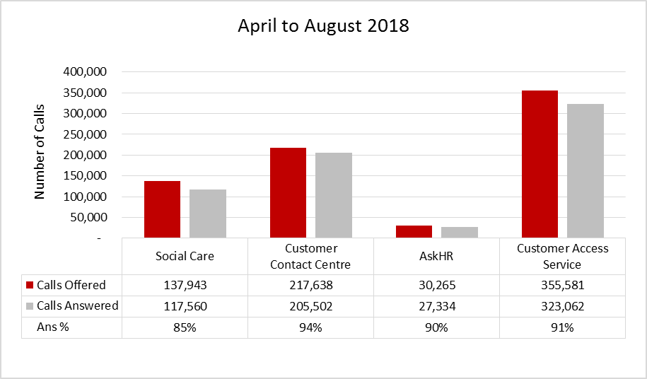

Table 2.1: Telephony performance April to August 2018

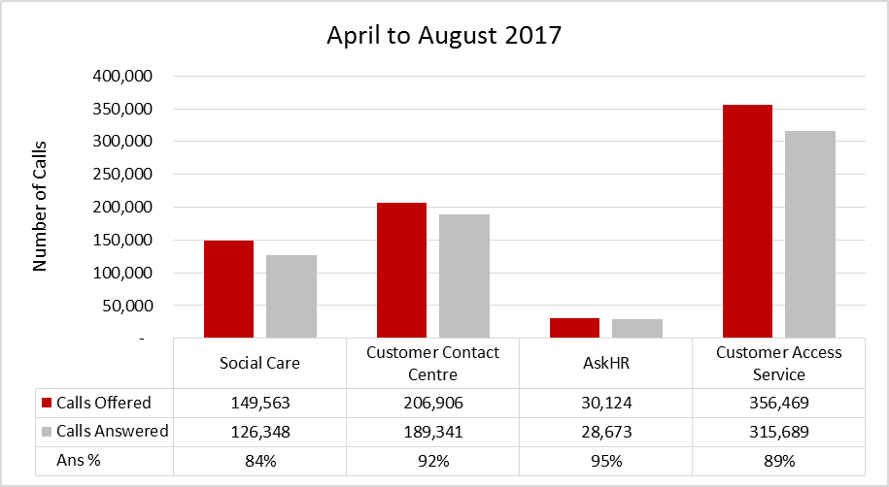

Table 2.2: Telephony performance April to August 2017

    - Email
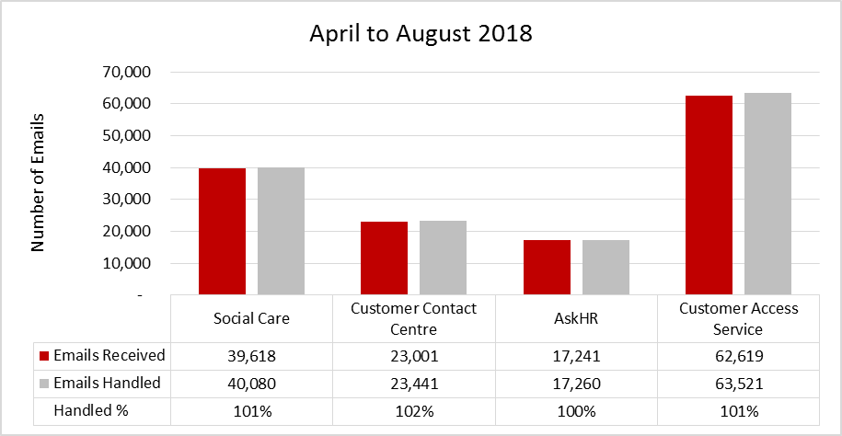

Table 2.3: Email performance April to August 2018
* Performance of over 100% is due to carry-over of emails from previous period.

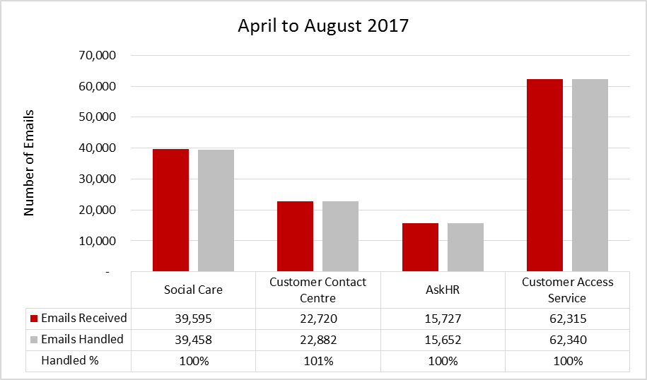

Table 2.4: Email performance April to August 2017
* Performance of over 100% is due to carry-over of emails from previous period.

    - Social Media
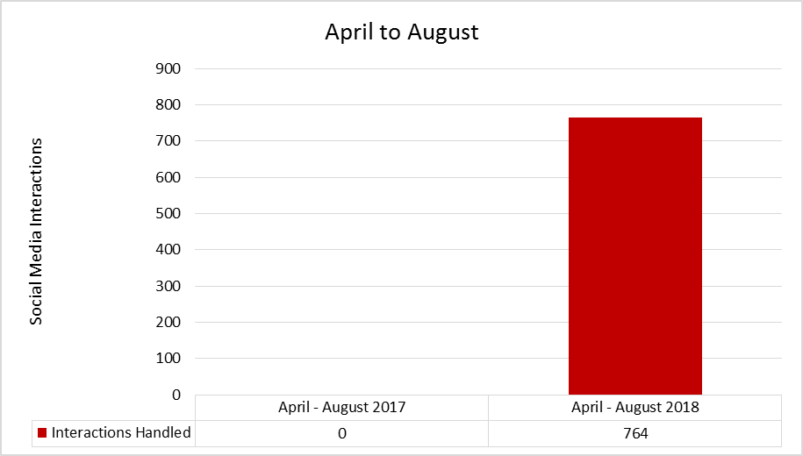

Table 2.5: Social Media performance (Highways) April to August
Social Media channel went live in November 2017.
  - April to August 2018 Performance breakdown
    - Telephony
Customer Access Service
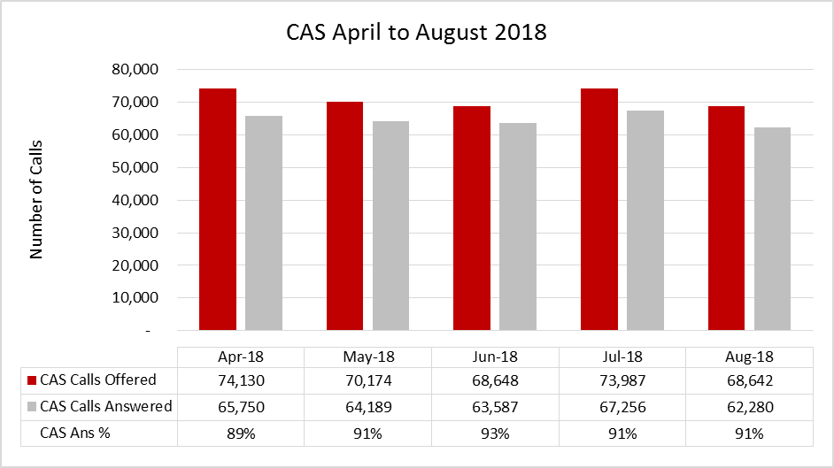

Table 2.6: Overall Telephony performance monthly breakdown April to August 2018

Social Care
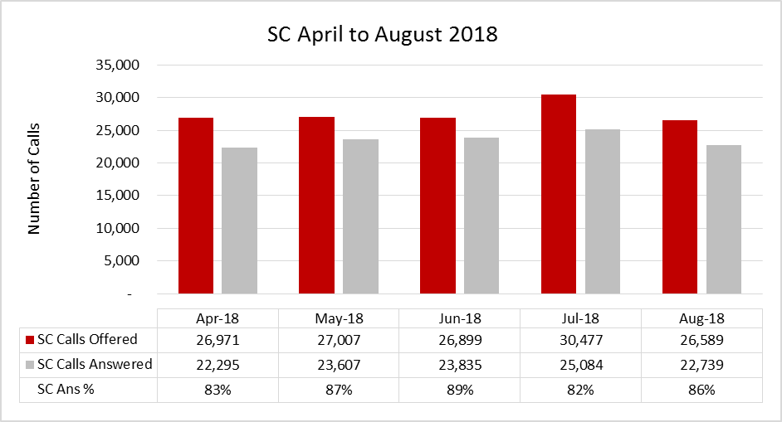
Table 2.7: Social Care Telephony performance monthly breakdown April to August 2018 *
* To note: Adults blended email training took place during April which has affected the SLA %. Team meetings, consultation briefings and interview support sessions took place during July which has impacted coverage and affected the SLA%.

Customer Contact Centre
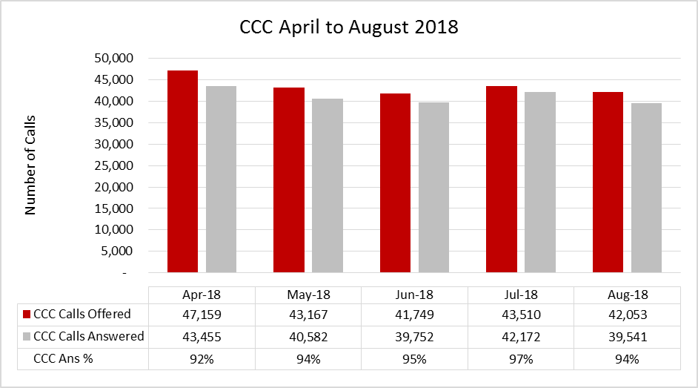

Table 2.8: Customer Contact Centre Telephony performance monthly breakdown April to August 2018

AskHR
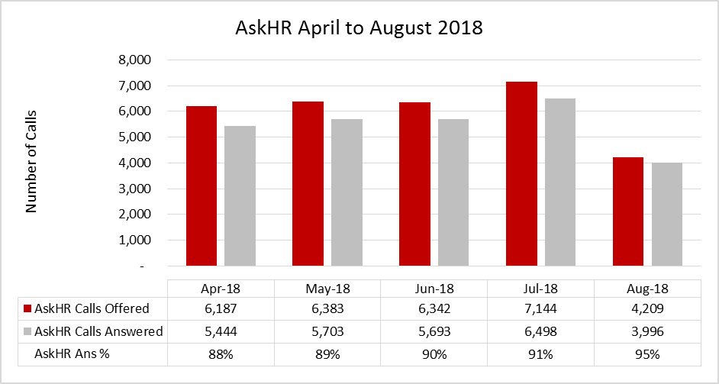

Table 2.9: AskHR Telephony performance monthly breakdown April to August 2018

    - Email
Customer Access Service
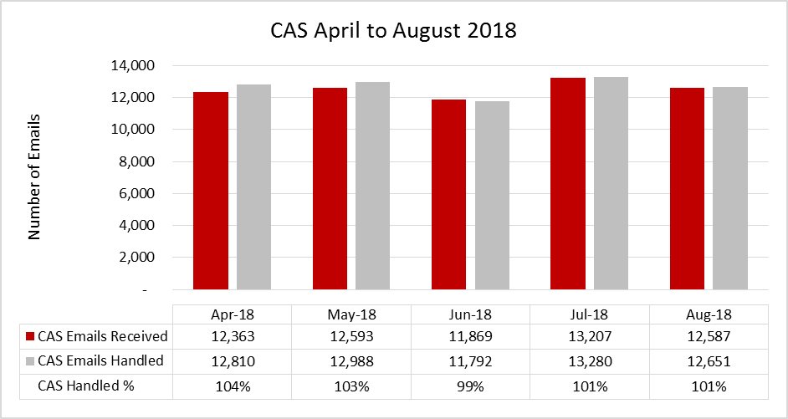

Table 2.10: Overall Email performance monthly breakdown April to August 2018
* Performance of over 100% is due to carry-over of emails from previous period.

Social Care
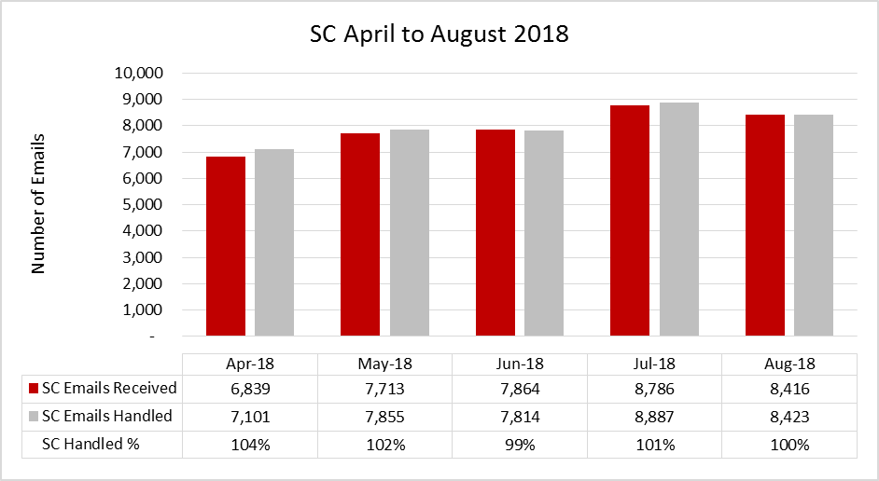

Table 2.11: Social Care Email performance monthly breakdown April to August 2018
* Performance of over 100% is due to carry-over of emails from previous period.

Customer Contact Centre
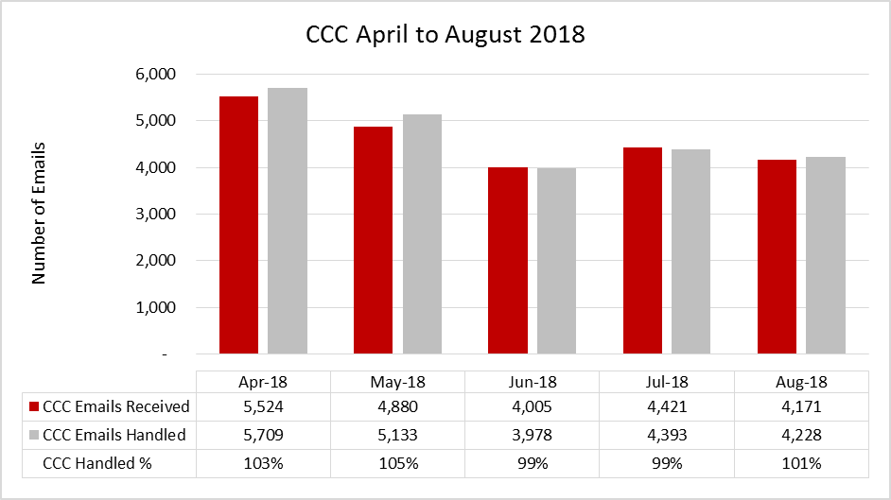

Table 2.12: Customer Contact Centre Email performance monthly breakdown April to August 2018
* Performance of over 100% is due to carry-over of emails from previous period.

AskHR
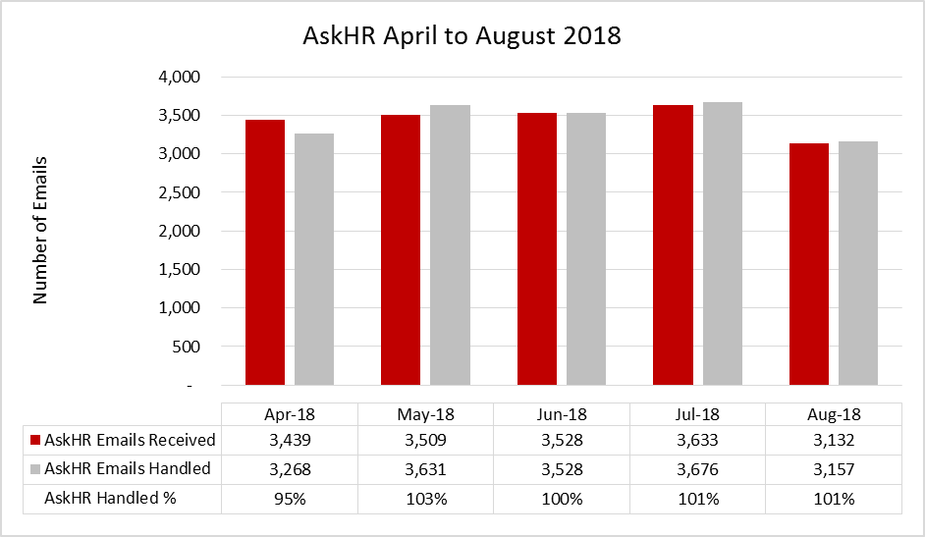

Table 2.13: AskHR Email performance monthly breakdown April to August 2018
* Performance of over 100% is due to carry-over of emails from previous period.

    - Social Media
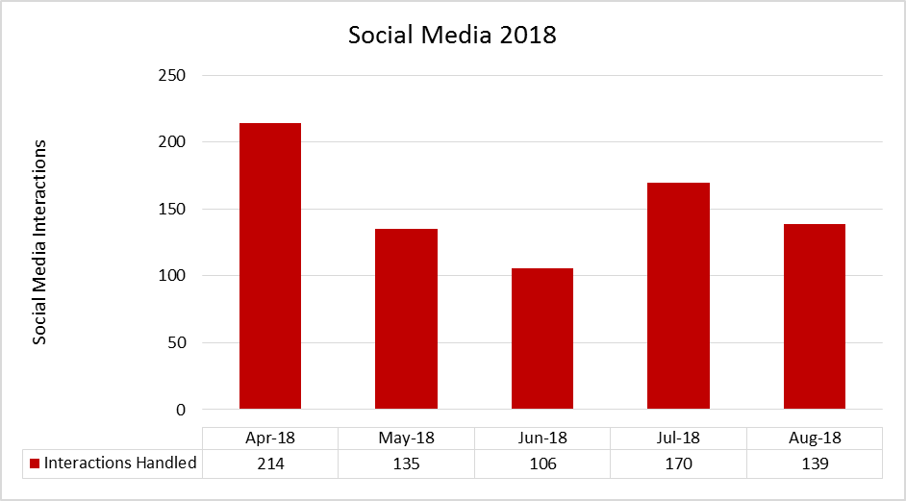

Table 2.14: Social Media (Highways) performance monthly breakdown April to August 2018

High volumes experienced in April due to ongoing issues with potholes and the associated customer queries.
Social Media channel went live in November 2017.
  - 2017/18 Financial Year Performance Breakdown
    - Telephony
Customer Access Service
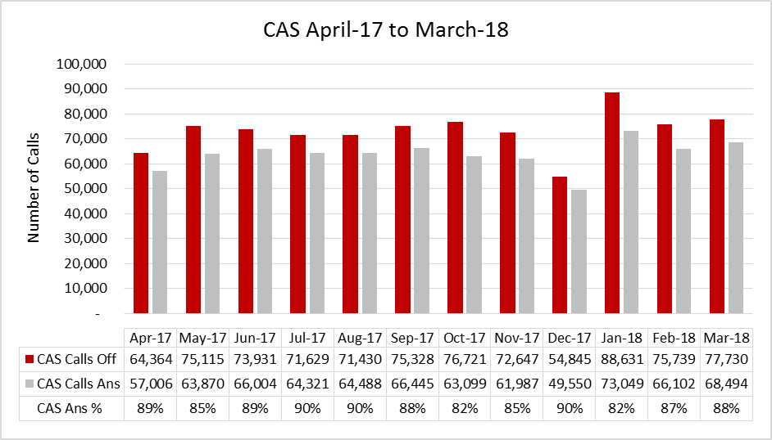

Table 2.15: Overall Telephony performance monthly breakdown April 2017 to March 2018

Social Care
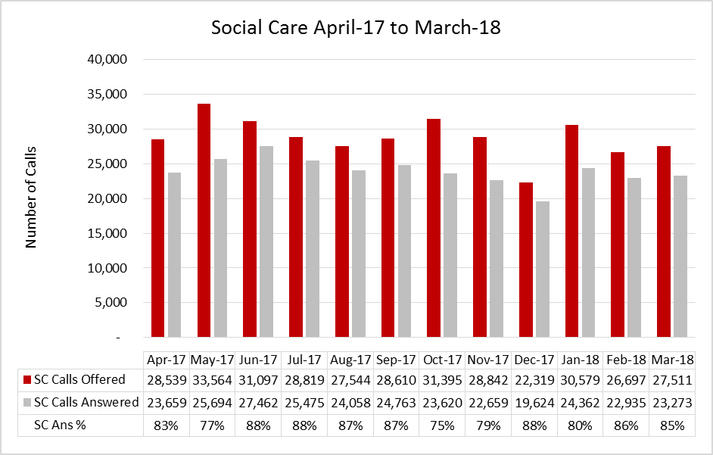
Table 2.16: Social Care Telephony performance monthly breakdown April 2017 to March 2018
Customer Contact Centre
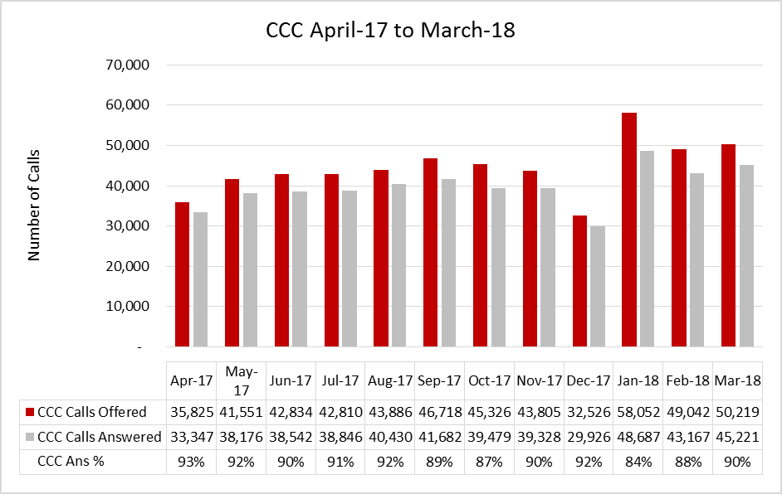

Table 2.17: Customer Contact Centre Telephony performance monthly breakdown April 2017 to March 2018

AskHR
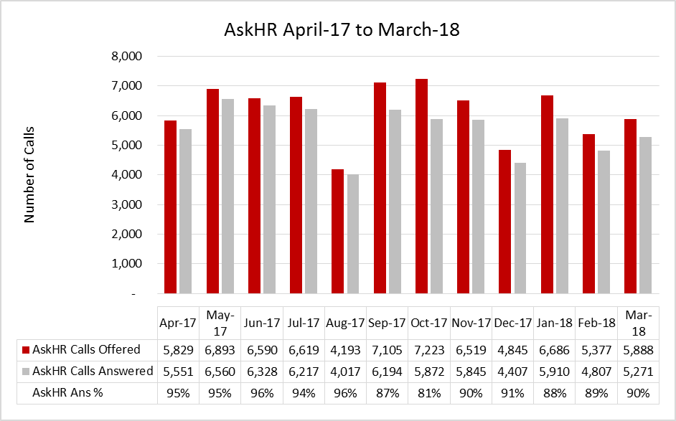

Table 2.18: AskHR Telephony performance monthly breakdown April 2017 to March 2018
    - Email
Customer Access Service
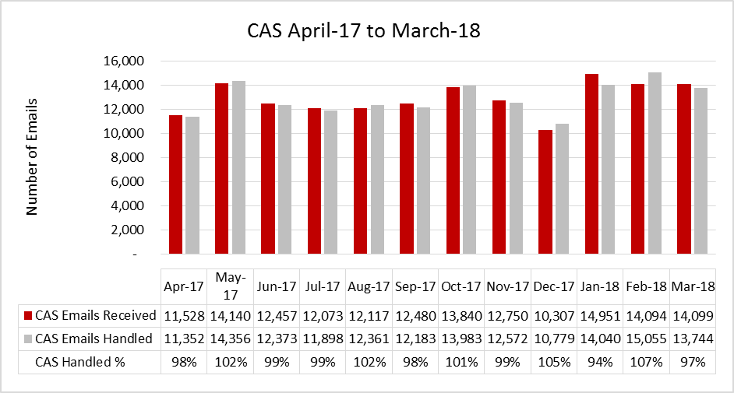

Table 2.19: Overall Email performance monthly breakdown April 2017 to March 2018
* Performance of over 100% is due to carry-over of emails from previous period.

Social Care
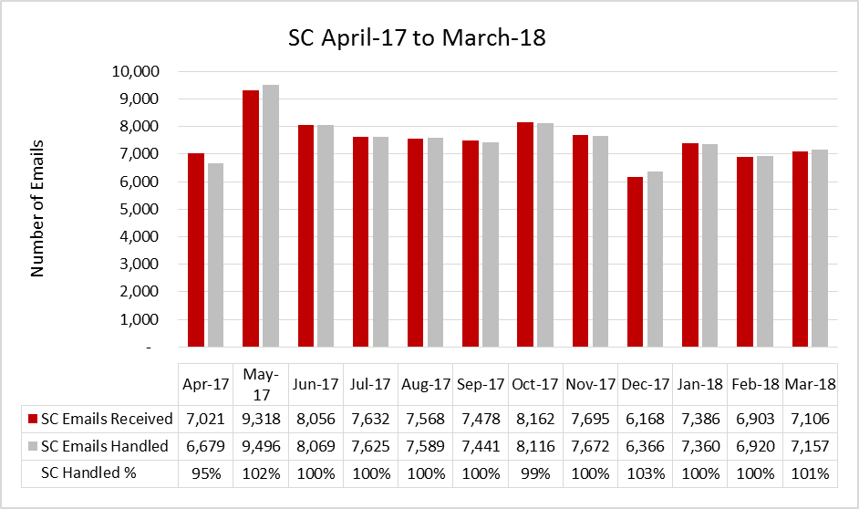

Table 2.20: Social Care Email performance monthly breakdown April 2017 to March 2018
* Performance of over 100% is due to carry-over of emails from previous period.
Customer Contact Centre
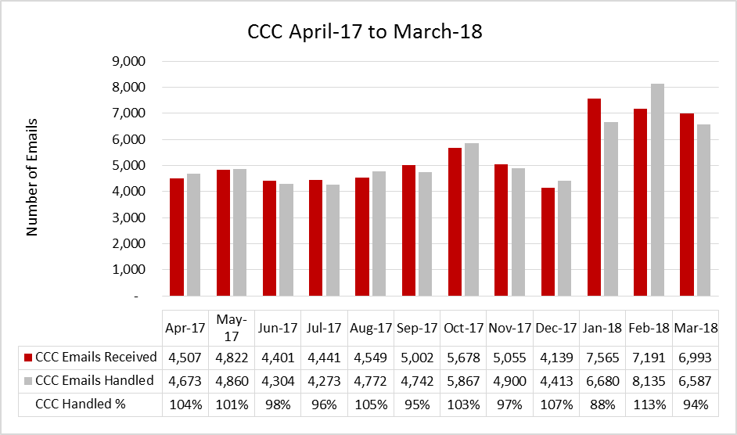

Table 2.21: Customer Contact Centre Email performance monthly breakdown April 2017 to March 2018
* Performance of over 100% is due to carry-over of emails from previous period.

AskHR
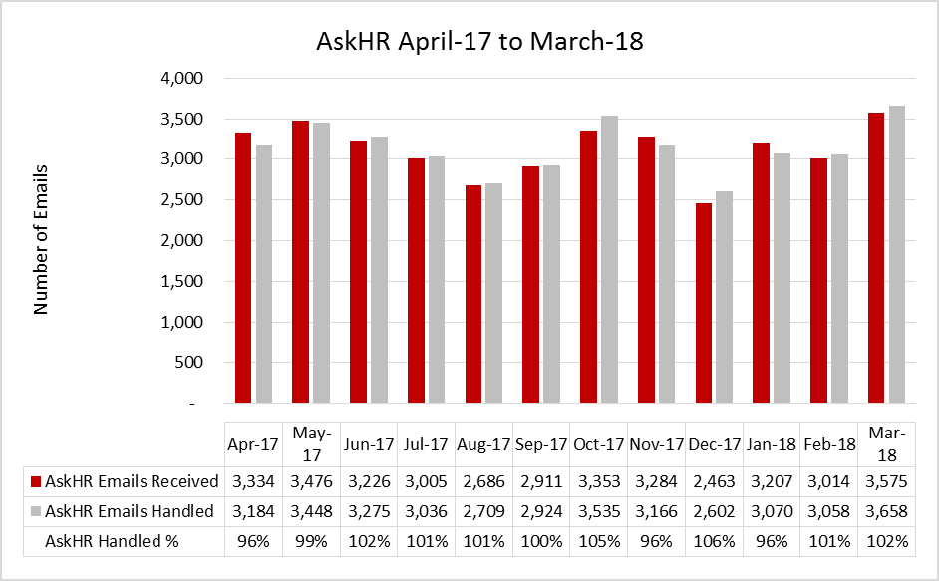

Table 2.22: AskHR Email performance monthly breakdown April 2017 to March 2018
* Performance of over 100% is due to carry-over of emails from previous period.

    - Social Media
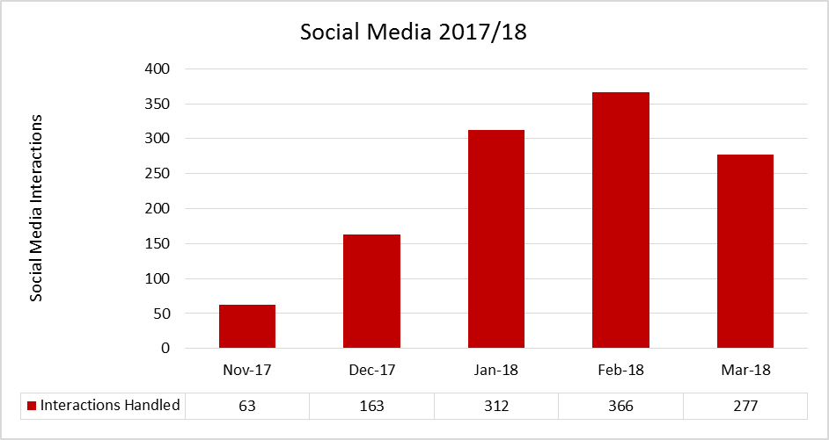

Table 2.23: Social Media performance monthly breakdown April 2017 to March 2018
High volumes experienced between January-March, due to ongoing issues with potholes and the associated customer queries.
Social Media channel went live in November 2017.
  - Telephony Performance (Answered within 40 seconds)
    - April to August 2018
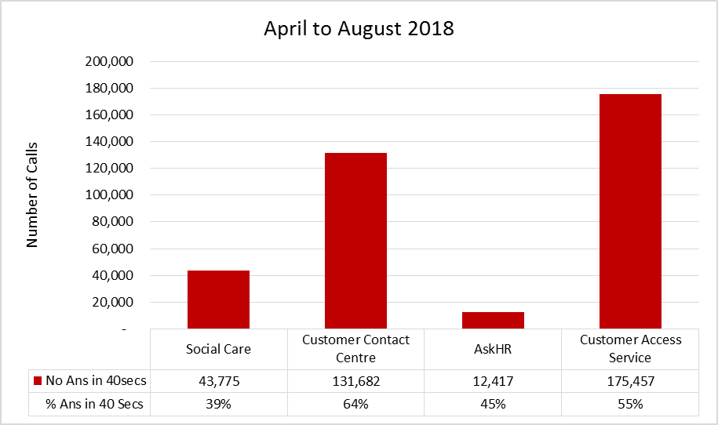

Table 2.24: Telephony performance Answered within 40 seconds April to August 2018

    - April to August 2017
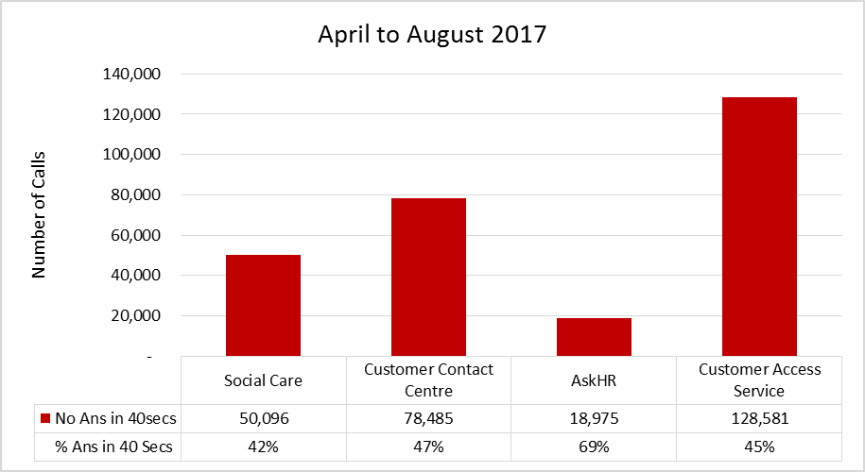

Table 2.25: Telephony performance Answered within 40 seconds April to August 2017

    - 2017/18 Financial Year
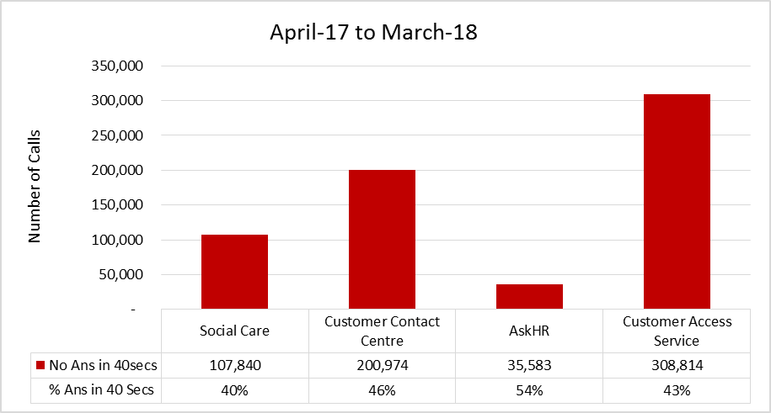

Table 2.26: Telephony performance Answered within 40 seconds April 2017 to March 2018

- Customer Feedback
  - Customer Feedback: Overall Customer Satisfaction
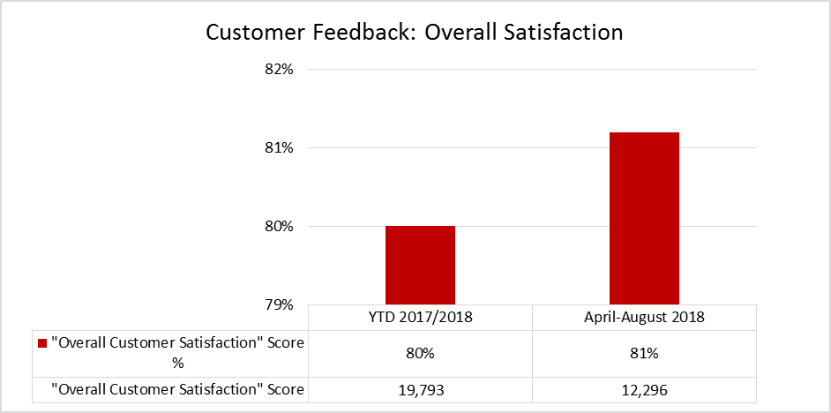

Table 3.1: Customer Access Service overall, customer satisfaction
A new suite of Customer Surveys went live on 14th May 2018, reducing from 6 questions to 4.
  - Customer Feedback: Resolved at First Point of Contact
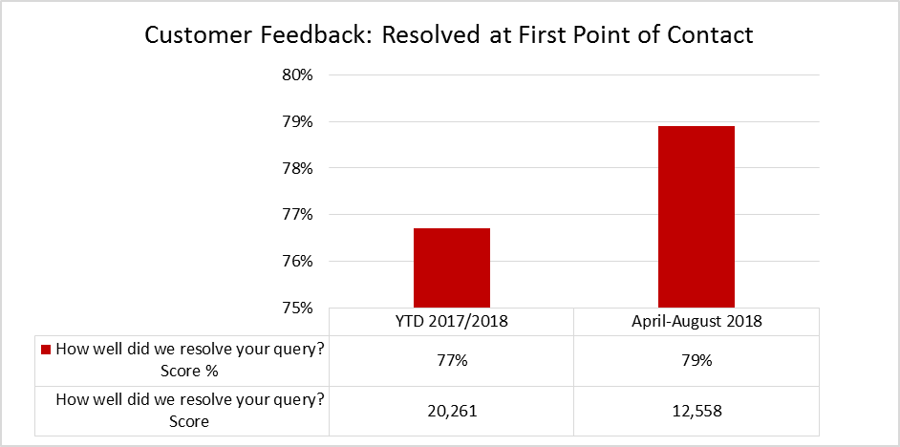

Table 3.2: Customer Access Service overall, customer queries resolved at first point of contact
A new suite of Customer Surveys went live on 14th May 2018, reducing from 6 questions to 4.

- Offline Performance
  - Blue Badge Applications
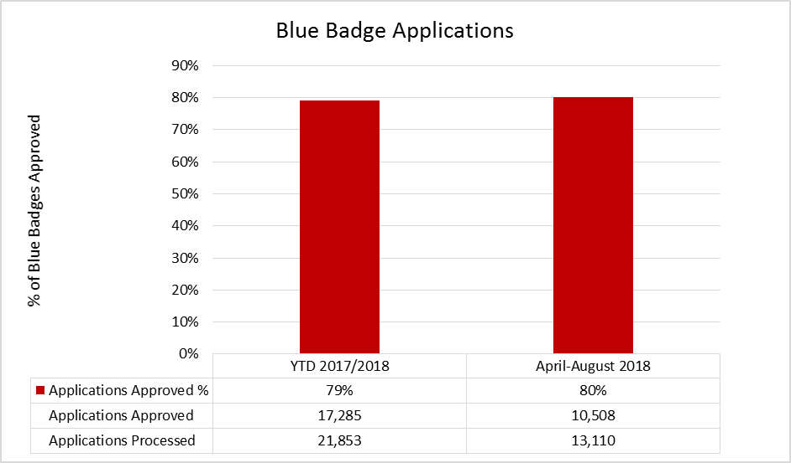
Table 4.1: Blue Badge Applications Processed & Approved.
  - Crisis Support Scheme
    - Crisis Support Scheme: Food & Fuel
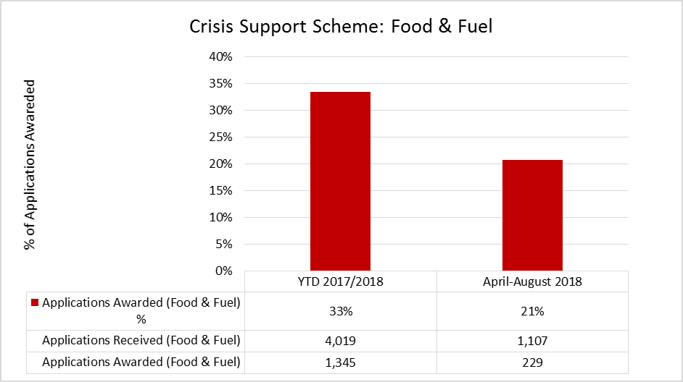
Table 4.2: Crisis Support Scheme applications received and awarded for Food & Fuel
The number of applications received has seen a substantial decrease and can be linked to the problems experienced with tax credits in the previous year which hasn't occurred this year.

    - Crisis Support Scheme: Furniture
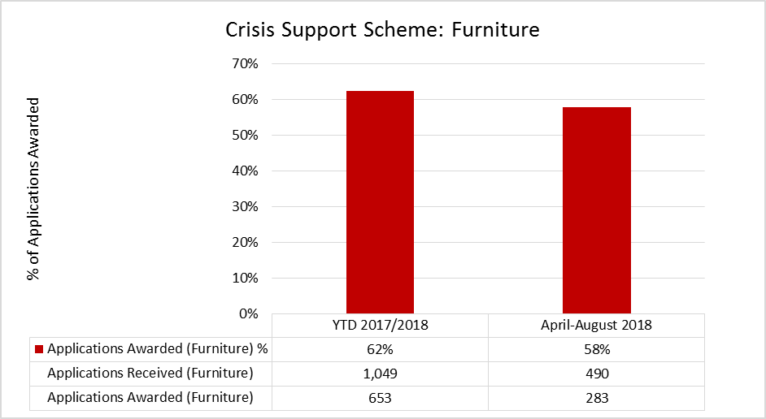
Table 4.3: Crisis Support Scheme applications received and awarded for Furniture

  - Leavers & New Starters
    - Leavers (April – August 2018)
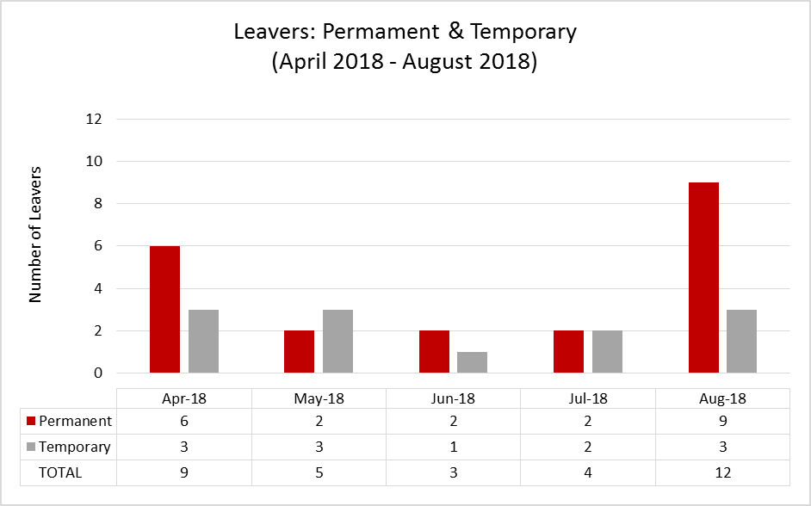
Table 4.4: Customer Access Service Permanent & Temporary Leavers April to August 2018

    - Leavers (April 2017 – March 2018)
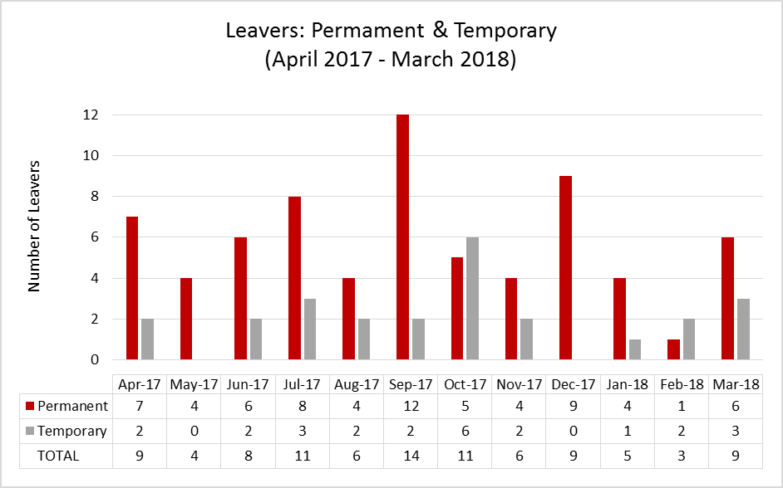
Table 4.5: Customer Access Service Permanent & Temporary Leavers April 2017 to March 2018

    - New Starters (April 2018 – August 2018)
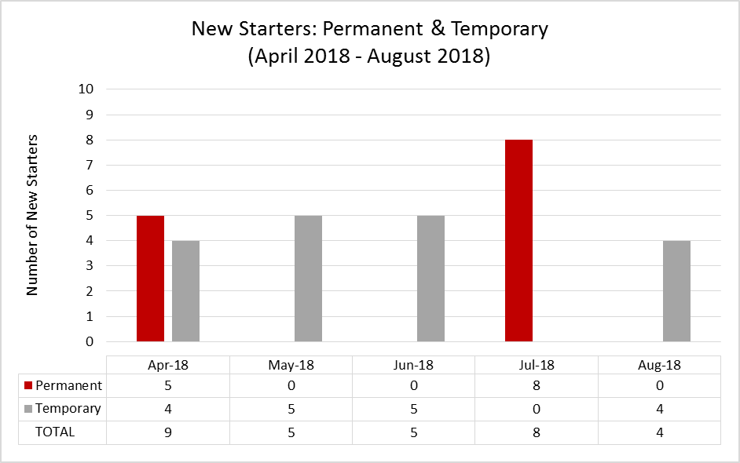
Table 4.6: Customer Service Access Permanent & Temporary New Starters April to August 2018

    - New Starters (April 2017 – March 2018)
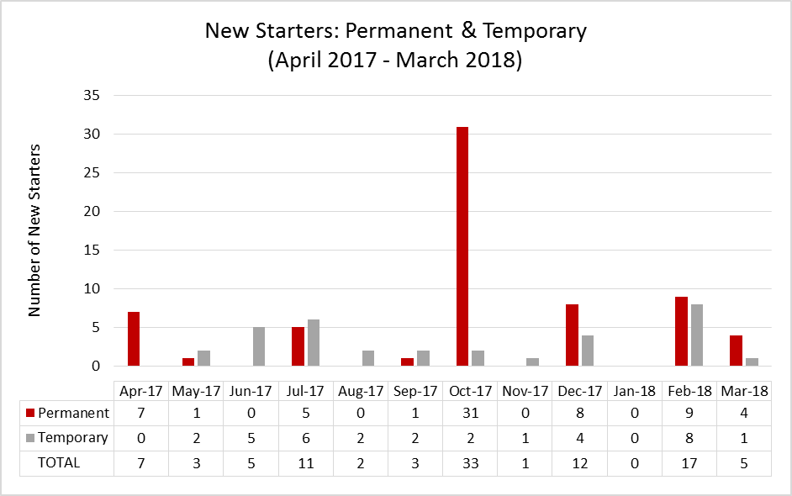
Table 4.7: Customer Service Access Permanent & Temporary New Starters April 2017 to March 2018
- Savings
  - FTE & Savings Delivered 2015 - 18
Year | Savings resulting from | FTE reductions |  | Establishment at time of reduction |  | Budget Reduction
Year | Savings resulting from | # per year | Cumulative | % | Cumulative | Amount | Cumulative
2015/16 | Staffing Reduction | 11 | 11 | 4.73% | 4.73% | £241,000 | £241,000
2016/17 | Staffing Reduction | 9.5 | 20.5 | 4.29% | 9.02% | £234,000 | £475,000
2017/18 | Staffing Reduction | 13.4 | 33.9 | 6.32% | 15.34% | £269,000 | £744,000
2018/19 | Reduction in operating hours | 9 | 42.9 | 4.72% | 20.06% | £228,000 | £972,000
2018/19 | Restructure support functions | 0.5 | 43.4 | 0.26% | 20.32% | £13,000 | £985,000
2018/19 | Reception cover removal | 1 | 44.4 | 0.53% | 20.85% | £20,000 | £1,005,000

Table 5.1: Customer Service Access FTE & Savings delivered between the period April 2015 – August 2018
* The saving quoted includes a transfer of 2.50 FTE £58k to the Emergency Duty Team (EDT), the saving to the authority is 6.50 FTE £170k.

  - FTE & Savings Outstanding
Year | Savings resulting from | FTE reductions |  | Establishment as at 17/09/2018 |  | Budget Reduction
Year | Savings resulting from | # per year | Cumulative | % | Cumulative | Amount | Cumulative
2018/19 | AskHR Self-Service | 7 | 51.4 | 3.83% | 24.68% | £174,000 | £1,179,000
2019/20 | Restructure support functions | 2 | 53.4 | 1.05% | 25.73% | £40,000 | £1,219,000
2019/20 | Telephony Automation | 6 | 59.4 | 3.40% | 29.13% | £118,000 | £1,337,000
2019/20 | Blended email implementation | 3 | 62.4 | 1.73% | 30.86% | £60,000 | £1,397,000
2020/21 | Telephony Automation Phase 2 | 2.75 | 65.15 | 1.61% | 32.47% | £56,000 | £1,453,000
2020/21 | Self-Service Portal | 7 | 72.15 | 4.27% | 36.74% | £140,000 | £1,593,000

Table 5.2: Customer Service Access FTE & Savings Outstanding

Consultations

NA

Implications

Over 90% of the Customer Access budget is made up of staffing costs, a reduction in this resource without reducing the work coming in will certainly have a negative impact on the customer experience. Customers will likely wait longer to connect calls and those who cannot wait will need to make multiple attempts to get through, increasing volumes and exacerbating this problem. This could increase complaints and damage the reputation of the authority.
Risk management

Performance and customer experience will continue to be closely monitored with regards to the delivery of the saving challenges and the associated reduction of staff in the service.

Local Government (Access to Information) Act 1985

List of Background Papers

Paper | Date | Contact/Tel
NA
Reason for inclusion in Part II, if appropriate
NA

