Lancashire Health and Wellbeing Board
Meeting to be held on 28 January 2020

Integrated Care System Strategy and Population Health Plan Priorities

Contact for further information:
Andrew Bennett, Executive Director for Commissioning, Integrated Care System, Lancashire and South Cumbria, andrew.bennett5@nhs.net
Dr Sakthi Karunanithi, Director Public Health and Wellbeing, Lancashire County Council,
Tel: 01772 537065, sakthi.karunanithi@lancashire.gov.uk;

Executive Summary

The draft Integrated Care System (ICS) Strategy (Appendix A) has recently been discussed by the Integrated Care System Board. The draft strategy identifies the Population Health Plan priorities:

• Best start in life
• Healthy Behaviours
• Zero Suicides
• Neighbourhood Development
• Work and Health

These are aimed at improving the health and wellbeing outcomes of our communities. A system wide approach to develop the Implementation Plan is under way, managed through the Population Health Steering Group of the Integrated Care System.

Recommendations

The Health and Wellbeing Board is requested to:

- Receive, discuss and endorse the draft Integrated Care System Strategy.
- Confirm commitment to the Population Health Plan priorities identified in the draft Strategy.
- Engage with and support the development of the Integrated Care System Population Health Implementation Plan.
- Endorse the alignment of the existing population health and prevention activity across the Integrated Care System work streams and Integrated Care Partnership/Multispeciality Community Provider plans.

Background

- Draft Strategy and Population Health Priorities

1.1 The draft Integrated Care System (ICS) Strategy (Appendix A) has recently been discussed by the Integrated Care System Board. The vision identifies the following ambitions:

- Healthy communities
- High quality and efficient services
- Health and care service that works for everyone, including our staff

The strategy also identifies the Population Health Plan priorities, which are aimed at improving the health and wellbeing outcomes of our communities. Our overarching Population Health ambition is to achieve best health for all, with a focus on reducing health inequalities. The ambitions and objectives are informed by the latest national and local data and evidence based practice of what good looks like. The strength is our focus in places and neighbourhoods. We are building on a range of successful collaborations we already have across our system.

  - The Lancashire and South Cumbria Integrated Care System Board signed off our population health framework that incudes our organising principles, strategic objectives and theory of change for improving health and care at scale in February 2018. These are aligned to the priorities identified by the four Health and Wellbeing Boards.
  - Our organising principle is to embed prevention in everything we do and provide place based, person centred care, by working with our residents.
  - Our theory of change for improving health and care outcomes at scale is illustrated below.

1.5 Our framework for population health is based on The Kings Fund Population Health Framework as well as Public Health England’s (PHE) toolkit for place-based approaches to reduce health inequalities. This includes action to improve the wider determinants of health, healthy behaviours and lifestyles, the places and neighbourhoods we live in, and delivering person centred care.
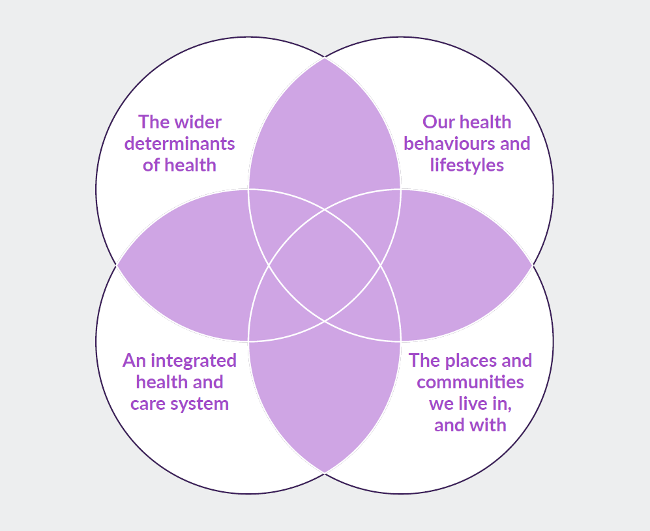

The King’s Fund. A vision for population health: Towards a healthier future. 2018. Available from: https://www.kingsfund.org.uk/publications/vision-population-health.

The Population Health approach will be embedded across every level of our system level as follows:

- Integrated Care System – whole system setting of quality, standards and population level health and wellbeing campaigns.
- Integrated Care Partnerships/Multispeciality Community Provider – develop integrated population level prevention programmes tackling key health and care inequalities.
- Primary Care Networks – extend the Population Health Management accelerator to improve health outcomes and maximise the neighbourhood and community assets for local communities.

- Five Key Population Health Priorities

Based on our analysis and building on our strengths, we have identified five key Population Health priorities for implementation in the next five years. We are in the process of developing robust delivery plans during 2019/20 in the following areas:

• Best start in life
• Healthy Behaviours
• Zero Suicides
• Neighbourhood Development
• Work and Health

Further details on each of these priorities can be found in the Integrated Care System Strategy (Appendix A).

3. What are we doing next?

3.1 Engaging with each Integrated Care Partnership (ICP)/Multispecialty Community Provider (MCP) and local authority teams, together with the Integrated Care System work streams, in developing the Population Health Implementation Plan, with the support from NHS England, Public Health England, Local Government Association and partners e.g. Innovation Agency and Universities.

3.2 As part of this a planning workshop on 'place based approaches to reducing inequalities' is being organised with support from Public Health England in February 2020.

3.3 Reviewing the governance, programme management capacity and coordination arrangements so that the Population Health programme is reset and aligned to the NHS Long Term Plan implementation.

3.4 Developing the first draft of the implementation plan by April 2020.

List of background papers

N/A

