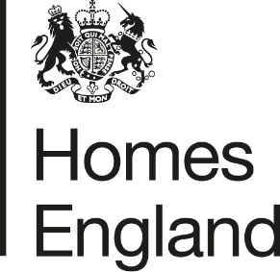
Making homes happen

CITY DEAL EXECUTIVE & STEWARDSHIP BOARD 3rd February 2021
Homes England Quarterly Monitoring Progress Update Report
Quarter 3 2020 / 21
- Report Overview
  - This report provides an update on the progress that has been made in relation to Homes England sites that form part of the Preston, South Ribble and Lancashire City Deal. The update relates to activity that has taken place during the third quarter of the 2020 / 21 financial year, between 1st October and 31st December 2020.
  - The report focuses on key delivery milestones, finances invested, and outputs generated, and provides a breakdown of the key risks and any emerging issues across the portfolio of sites.
- Recommendation
  - Homes England recommends that the Executive and Stewardship Board:
Note the content of this report and the progress made by Homes England during the third quarter of 2020 / 21.
- Homes England Site Highlights
  - As reported in the previous quarterly update; the global pandemic ‘Covid-19’ has impacted the delivery of development across all of Homes England’s City Deal sites, with all developers ceasing operations for a period of time during the first national lockdown within the first quarter of the 2020 / 21 financial year.
  - Whilst the effects of Covid-19 continue to be realised, the delivery of development across Homes England’s City Deal sites continues. A second national lockdown was in effect for this third quarter from 31st October – 2nd December, but construction throughout this period continued.
  - Key highlights from the third quarter of 2020 / 21 are set out in the table below:
Phase / Plot | Status | Completions/  Total Units | Completions  (Oct – Dec) | Finance  (Oct – Dec) | Summary
1. Cottam Hall
Phase 1 | Phase completed by Barratt Homes | 104 / 104 (100%) | n/a | n/a | n/a - Build out complete
Phase 2 | Story Homes on-site | 123 / 283 (43%) | 0 | n/a | Story Homes on-site and building out. No update available this quarter due to Covid 19.
Phase 3 | Morris Homes on-site | 18 / 119  (15%) | 6 | n/a | A further 6 completions have been achieved Q3 2020 / 21.  Site build-out continues.
Phase 4 | Conditional deal agreed with Rowland Homes. Reserved matters approved July 2019 | 0 / 141  (0%) | n/a | n/a | It is anticipated that the unconditional stage of the deal will complete and housebuilding to commence Q4 2020 / 21 as Rowland Homes and LCC need to agree detail on Section 38 and Section 106 needs to be signed.
Phase 5 | Tenders for disposal received Q3 20 / 21. | 0 / 233  (0%) | n/a | n/a | Tenders to appoint preferred developer partner received Q3 2020/21, selection of preferred bidder and contract to be entered in Q4 2020/21.
Phase 6  (Plots 14 and 15) | Both plots (14 and 15) of Phase 6 have now been disposed of on an unconditional and conditional basis to Countryside and Barratt Homes respectively. | 0 / 189  (0%) | n/a | n/a | Plot 14: Countryside has resumed  build out post-lockdown. First housing completions for this phase anticipated Q4 2020/21.  Plot 15: Disposed of on a conditional basis to Barratt Homes in March Q4 2019/20. No reserved matters application has been submitted yet. Planning pack received and approved by HE in Q3 20/21. Barratt liaising with PCC on scheme detail.
Local Centre | Site successfully disposed of to Thistlewood Properties in Q3 2020 / 21 | n/a | n/a | n/a | Deal with Thistlewood Properties completed October 2020 with associated City Deal loan payment made to LCC.
2. Cottam Brickworks
Access agreement | Ongoing discussion regarding access into adjacent land via Homes England site | 0 / 260  (0%) | n/a | n/a | Discussion ongoing to find a resolution to the site’s access rights. Homes England continues to monitor the ongoing dialogue between landowner and LCC.
3. Land at Eastway
Residential Plot | Story Homes on-site completing build out | 110 / 329  (33%) | 0 | n/a | Story Homes on-site build out. No update available this quarter due to Covid-19.
Commercial Plot | Site under conditional contract with HSB Healthcare | n/a | n/a | n/a | Delivery of a new access into the site ongoing.
4. Whittingham Hospital
Phase 1 | Taylor Wimpey has completed Phase 1 | 150 / 150 (100%) | n/a | n/a | Taylor Wimpey has completed build out of Phase 1.
Phase 2 | Preferred bidder Barratt David Wilson selected Q4 2019/20. | 0 / 232  (0%) | n/a | n/a | Preferred bidder Barratt David Wilson selected at the end of March 2020 and conditional contract agreed. Awaiting reserved matters approval.
Phases 3 and 4 | Final phases of the site to be disposed of 2020/21 and 2021/22 | 0 / 512  (0%) | n/a | n/a | Bids opened October Q3 2020/21. Due to enter contract on phase 3A by end of March 2021 (Q4), with phases 3B and 4 remaining. .
5. Preston East
Expansion Area | Marketing of site concluded Q2 2020/21. | n/a | n/a | n/a | Homes England currently assessing and clarifying on submitted bids, with view to agree conditional contract (subject to planning) with preferred developer by Q4 2020/21.
Sector D | Build-out of site complete. | n/a | n/a | n/a | Build-out of site complete.
6. Pickerings Farm
n/a | Masterplan and outline application submitted | 0 / 275  (0%) | n/a | n/a | Updated version of Masterplan submitted August 2020. Masterplan refused at SRBC planning committee held 17th September 2020. Homes England continuing to progress/resolve planning position at site with Taylor Wimpey.
7. Altcar Lane
n/a | Continued build-out of site by Lovell | 59 / 200  (30%) | 21 | n/a | 21 completions have been recorded during Q3 2020/21 as Lovell has resumed build out of the site after lockdown
8. Croston Road North
n/a | Keepmoat selected as preferred developer in October 2019 | 0 / 400  (0%) | n/a | n/a | Hybrid application including reserved matters for the 400 units on Homes England land was approved Q3 2020/21.
9. Croston Road South
Phase 1 | Miller Homes has completed Phase 1 | 96 / 96 (100%) | n/a | n/a | Miller Homes has completed build out of Phase 1
Phase 2 | Miller Homes on-site | 78 / 79  (99%) | 8 | n/a | 8 completions have been recorded on Phase 2 of this site during this period
10. Brindle Road
n/a | Complete | 46 / 46  (100%) | n/a | n/a | All units completed and all finances paid.
11. Walton Park Link
n/a | Morris Homes on site | 45 / 280  (6%) | 28 | n/a | 28 completions have been recorded on this site in Q3 2020/21
- Finance
  - Homes England is currently still on track to pay the majority of £37.5 million grant by 2023 / 24 however this position has been reviewed as part of the Homes England Business Disposal Plans (BDP) Refresh (2020/21-2023/24) and some grant will now be paid up to 2030 in relation to the contract with Keepmoat at Croston Road North.
  - A loan amount of £123,497.00 was paid out in October 2020 in relation to the successful disposal of the Local Centre at Cottam Hall.
  - A grant amount of £1,288,509 was paid out in December 2020 in relation to a contractual receipt from Story Homes received at the Eastway residential site.
  - The following payments remain forecast to be made this 2020/21 financial year within quarter 4:
    - A loan amount of £1,556,005 in relation to Phase 4 (Plots 1-3) of Cottam Hall; and
    - A loan amount of £1,217,707, subject to reserved matters consent being achieved and agreement with Keepmoat going unconditional on Croston Road North.

- Affordable Housing Provision
  - The table below provides a break-down of the on-site affordable homes provision made across Homes England’s City Deal sites.
  - Where affordable housing is not policy compliant this is either due to the planning authority requesting less affordable homes to be delivered on site (in these cases the difference was paid in funds via s106), or where viability discussions have taken place and a lower percentage has been agreed.
City Deal Site |  | Total Units Across Site with Planning Consent |  | Total Units anticipated to be delivered across Homes England Land Only | Of which: Open Market Sales | Of which: Affordable / Social Rent / Shared Ownership | Of which: Percentage Affordable | Completions to date across Homes England Land Only | Of which: Affordable / Social Rent / Shared Ownership
 |  | Granted | Awaited
1 | Cottam Hall | Up to 1,100 | - | 1,069 | 713 | 340 | 30% | 246 | 59
2 | Cottam Brickworks* | n/a | n/a | n/a | n/a | n/a | n/a | n/a | n/a
3 | Land at Eastway | 329 | - | 329 | 280 | 49 | 15% | 110 | 15
4 | Whittingham Hospital**** | 900 | - | 894 | 781 | 113 | 13% | 150 | 17
5 | Preston East EA | n/a | n/a | n/a | n/a | n/a | n/a | n/a | n/a
6 | Pickering’s Farm ** | - | 275 | 275 | TBC |  |  | 0 | 0
7 | Altcar Lane | 200 | - | 200 | 140 | 60 | 30% | 59 | 31
8 | Croston Road North | 400 | - | 400 | 340 | 60 | 15% | 0 | 0
9 | Croston Road South*** | 254 | - | 175 | 149 | 26 | 15% | 174 | 26
10 | Brindle Road | 46 | - | 46 | 46 | 0 | 0% | 46 | 0
11 | Walton Park Link* | n/a | n/a | n/a | n/a | n/a | n/a | n/a | n/a
Total |  | 3,229 | 275 | 3,388 | 2,449 | 664 | n/a | 785 | 148
* The landowner / developers at Cottam Brickworks and Walton Park Link are responsible for obtaining planning consent for the development proposed, not Homes England.
** The 275 units at Pickering’s Farm relate to the original Homes England land forming part of the original City Deal agreement. Following submission of the outline planning application, it is anticipated that 1,020 homes will be delivered overall: 745 by Taylor Wimpey and 275 by Homes England.
*** The 254 units shown comprises Phase 1 (175 units) completed by Miller Homes, and Phase 2 (79 units) currently under construction.
**** Due to viability a lower affordable housing percentage was agreed
- Summary of Delivery
  - Following a period of lockdown last quarter, housebuilders and developers have returned to sites, albeit not at full capacity and with ongoing issues associated with Covid-19, including supply chain problems and legal issues (e.g. re-appraisal of Plot 15 at Cottam) ongoing.
  - A second national lockdown was in effect from 31st October – 2nd December in quarter 3, but several milestones and completions have still been achieved including:
    - Approval of reserved matters application for development at Croston Road North October 2020;
    - Build out of Phase 3 at Cottam Hall continues with a further 6 completions this quarter;
    - A further 21 completions have also been recorded this quarter at Altcar Lane; and
    - A further 8 completions have also been recorded at Croston Road South.
  - Marketing of phase 3A at Whittingham Hospital has also commenced this quarter with bids due back Q4 2020 / 21.

Summary of BDP Payments |  |  |  | BDP Forecast 2020 / 21
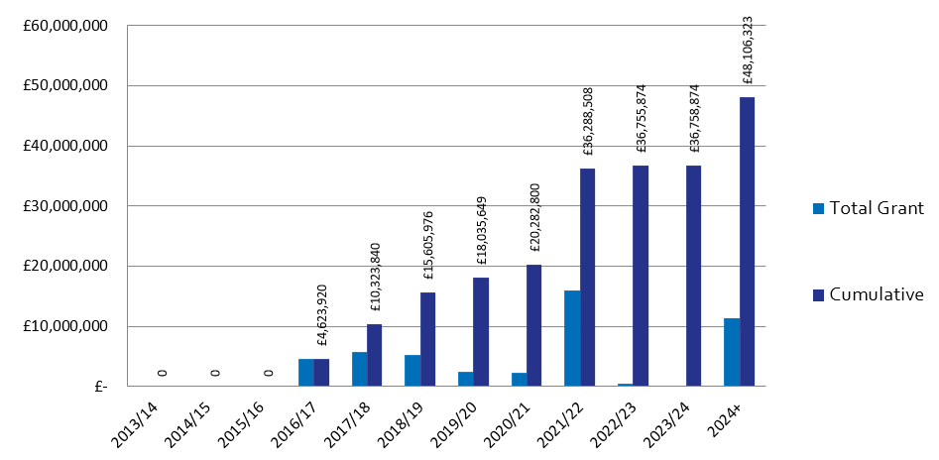
 |  |  |  |  | Q1 | Q2 | Q3 | Q4 |  | In Year Actual
 |  |  |  | Grant | £0 | £0 | £1,288,509 | £0 |  | £1,288,509
 |  |  |  | Loan | £0 | £0 | £123,497 | £0 |  | £123,497
 |  |  |  | Housing Completions | 3 | 24 | 35 | 0 |  | 62
Planning Consents |  | Starts on Site |  | Housing Completions |  |  |  |  | Grant Payments
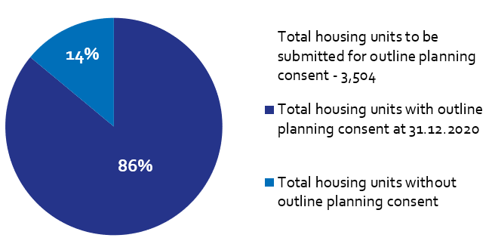 |  | 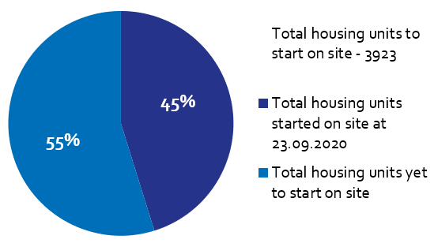 |  | 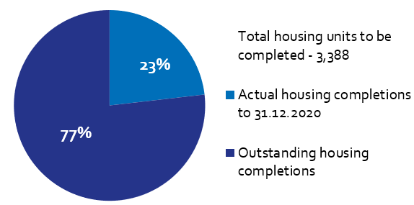 |  |  |  |  | 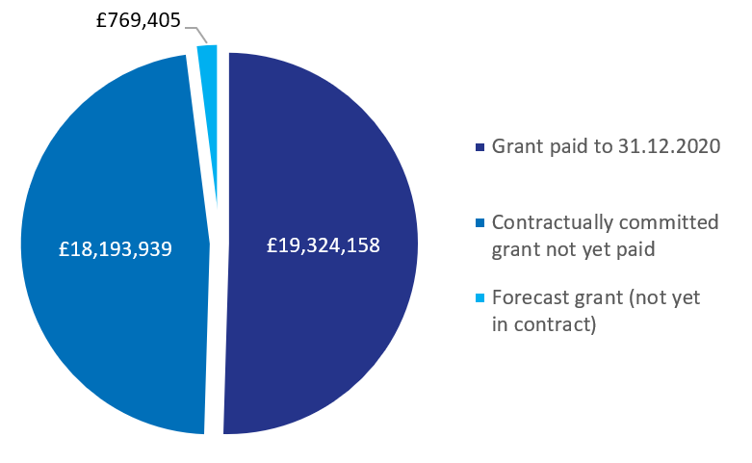
Of the Homes England residential City Deal sites, only Pickering’s Farm is yet to achieve planning consent. |  | Housing starts have been claimed for 1,773 units on Homes England City Deal sites to date, out of a total 3,923 units (including Walton Park Link and Cottam Brickworks). |  | There have been 785 housing completions to date on Homes England City Deal sites.  There were 35 housing completions during this reporting period on Homes England sites. |  |  |  |  | To date, £19,324,158 has been paid to LCC as grant, with a further circa £18m contractually committed across Homes England City Deal sites.

