**AONB Team Report to JAC**

**October 2020 – April 2021**

**An outstanding landscape of natural and cultural heritage**

**Peatland Restoration**

**Celebrating 10 years of partnership work which has resulted in** **peat restoration equivalent to the size of 1000 football pitches**

£2.5 million has been spent on peat restoration in Bowland since 2010 and thanks to partnership work between local landowners, regional partners, national agencies, volunteers and funders this investment has resulted in 755 hectares of blanket bog restoration during the past decade.

Over the decades, peatlands have been damaged through a number of factors including atmospheric pollution, drainage, wild fires, grazing, trampling and the effects of climate. Work carried out in Bowland aims initially to stabilise the peat to prevent further loss and then to restore it to the point where it can begin to capture carbon once again.

No two peat sites are the same, which means that restoration techniques vary from place to place across the AONB, but three main principals apply – control peat erosion, manage hydrology and re-instate vegetation cover.  This specialist work involves expert contractors who access the fells between September and March in order to avoid disturbance to nesting birds and other wildlife.

To date work has been carried out on 18 fells covering land within each of the AONB's three main river catchments of the Lune, Ribble and Wyre.

**Moorland restoration continues with funding from the Environment Agency and Defra**

In 2018, the Northern England Peatland Project received around £8mill of funding from Defra's climate change fund via a large collaborative bid with the other protected landscapes within the Northern Upland Chain Local Natural Partnership and Cumbria. Within the AONB we received £560K to work on five sites within the Bowland Fells SSSI. This season saw peatland restoration work undertaken on the final one of these sites, in the last year of the project.

Lee Fell lies between Grit Fell and Ward Stone and was selected for this project as it has areas of eroding gullies and pans of bare peat, as well as areas where some of the characteristic plant and moss species we would like to see are missing, most probably due to the peat drying out. The restoration programme for the site included the repair of eroding gully edges, rewetting of the peat using timber dams, peat dams and coir logs and then revegetation of the bare peat with moorland seed and moss rich brash cut from close by.

The weather worked in our favour for once, after the snow had retreated the hard frosts allowed the tracked machinery to travel across the site without leaving a trace, allowing the cut brash to be moved onto site without the need for costly helicopter lifts. All the planned work was completed within the time allowed, as well as some additional works which we were able to commission – for example some additional timber and stone dams across the site.

In early 2020, the Environment Agency approached us to ask if we had any 'spade-ready' peat restoration projects, as they were expecting some funding to come through with a short turn around. We were able to put together a list of seven, from which we selected two which went forward and were successfully funded, in partnership with the Lancashire Wildlife Trust. Both these sites are up on Tarnbrook in Abbeystead and are sites where peat restoration is already underway. This additional funding has enabled us to continue that restoration work, adding in another dressing of moorland seed, covering bare peat with geo-textile matting to prevent peat loss and installing timber dams and coir logs to reduce water flow off the fell in high rainfall events.

Working with two different contractors on three sites at the same time was a challenge, but regular visits on site helped a lot, and also enabled us to post footage of the works and their progress on social media on a weekly basis. We made16 short films in all, between January and March. The Facebook posts had a reach of 21,019 and engagement of 2,309 people (which includes reactions, comments, shares).

**For further information email** [**sarah.robinson@lancashire.gov.uk**](mailto:sarah.robinson@lancashire.gov.uk)

**Bowland Hay Time**

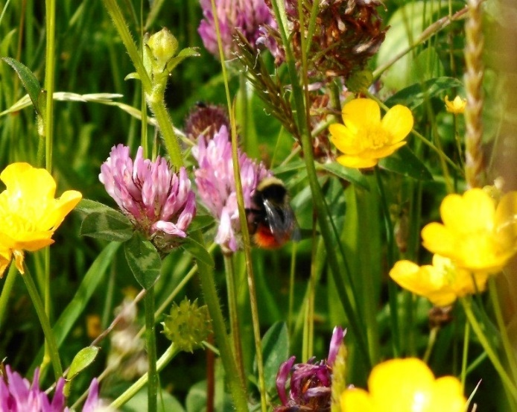Following the successful Plantlife bid to the Green Recovery Challenge Fund, and our partnership with Yorkshire Dales Millennium Trust, Bowland Hay Time will be delivered through the 2021 – 2022 *Meadow Makers Project*. The countrywide project aims to restore over 500 hectares of species-rich grassland on 100+ sites and will include a nationwide engagement programme connecting 7000 people in local and wider communities to grassland heritage, improving their experiences and wellbeing.

Our part in this project is to carry out 25 hectares of meadow restoration work at 11 sites in the Forest of Bowland area. Using a combination of "green hay" and brush harvested seed from our donor meadows, the meadow restoration work in the Forest of Bowland continues into its tenth year.

The Project also provides funding for a trainee "Meadow Maker", a 6-month traineeship with Plantlife working with our project officer, aimed at encouraging young people into conservation work.

We will also be running meadow related events, both on site and online, over the course of the project, raising awareness of the work we do in the meadows and why it is so important.

**For further information email** [**carol.edmondson@lancashire.gov.uk**](mailto:carol.edmondson@lancashire.gov.uk)

**Farming and Wildlife Advice**

**Pendle Hill Farmer Network completes third year of work - online**

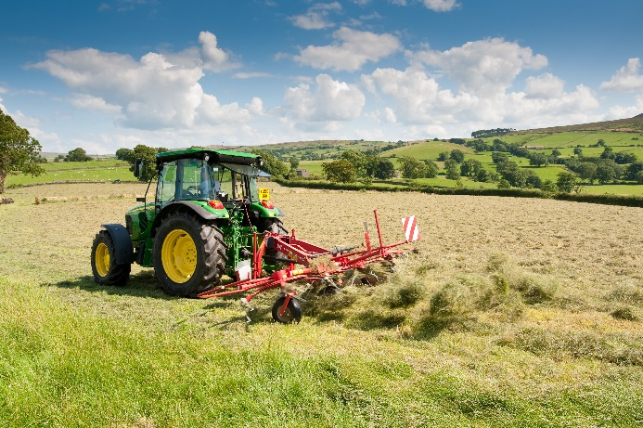This has been the final year of the Pendle Hill Farmer network, and since the start of the pandemic, all our activity has been via Zoom. As in previous years we have held a series of monthly talks and workshops, but this year we have not been able to meet us as we normally would.

We have covered a variety of topics:

* Help and advice in putting applications together to join the Countryside Stewardship scheme
* Integrated Parasite Management – how to reduce costs and environmental impacts by reducing use of wormer vedmeds
* Carbon – how to produce carbon audits for the farm as a whole and how to reduce carbon outputs and costs
* Soils – what to look for in a healthy soil and how to maintain soil health
* Post Brexit farming support – market reports, tariff predictions and what the new post CAP support will look like, how to manage the loss of BPS from the business
* Public goods – results of the 'What's a Hill Worth' research project

We have missed our brews, farm walks and chats, but hope those will be back soon.

The group was due to disband this March, but we have been offered the opportunity to apply for an underspend extension, and we await the outcome of that, and in the meantime we have started planning events for April and May.

**For further information email** [**sarah.robinson@lancashire.gov.uk**](mailto:sarah.robinson@lancashire.gov.uk)

**Green Recovery Challenge Fund**

The Government launched the £ 40M Green Recovery Challenge Fund in September. 600 plus applications were received of which 68 were successful including three that will deliver in the Forest of Bowland AONB. These are: Magnificent Meadows (submitted by a partnership co-ordinated by Plantlife) and Holme House Fell Peatland Restoration (submitted by the AONB on behalf of the Yorkshire Peat Partnership and the Forest of Bowland AONB). The AONB team submitted an application towards restoration of 17.3 hectares of blanket bog.

**For further information email** [**robin.gray@lancashire.gov.uk**](mailto:robin.gray@lancashire.gov.uk)

**'High Nature Value Farming in the Northern Upland AONBs' – A Defra Environmental Land Management Test**

Work on this Environment Land Management Test continues with the six participating farms in the AONB. Draft land management plans have been developed in close consultation with each farmer with support from consultants Margaret Dickinson and Nethergill Associates. The land management plans consider how each farm business may be able to benefit from future support payment that are likely to be offer via the components of the Environmental Land Management system, whilst also looking at ways to maximise profitability. This project will complete and report back to Defra in late April/early May 2021.

**For further information contact** [**elliott.lorimer@lancashire.gov.uk**](mailto:elliott.lorimer@lancashire.gov.uk)

**Resilient and Sustainable Rural Communities**

**Discover Bowland Guide**

The Discover Bowland guide was produced ready for the start of 2021; for now we have held off promoting it, but as restrictions ease, we hope the guide will be provide a positive welcome back to the area. The guide is partially funded by continuing support from the members of the Sustainable Tourism Network who advertise within it.

As well as offering practical advice and information on making the most of their holidays and short breaks in Bowland, the Discover Guide also tells the stories of how several local businesses reinvented themselves during last year’s lockdown.

These positive ‘lockdown diaries’ include:

* Courtyard Dairy, which pivoted to online tastings and nationwide delivery to replace some of the business lost during the closure of the hospitality industry
* Slaidburn Central Stores, which became a community groceries hub and essential lifeline for outlying communities
* Bowland e-bikes, which accelerated its growth plans as demand for eco-friendly electric bikes rocketed as lockdown lifted

The 112-page guide also includes a series of five detailed short break itineraries and useful information on accommodation, hospitality, events and outdoor activity providers.

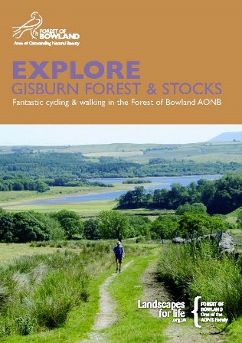

**If you would like to receive a copy please email Hetty Byrne with your postal address or you can view it online here:** <https://www.forestofbowland.com/discover-bowland-guide-2021>

We have also updated and re-printed the popular Gisburn Forest Bikes Trails leaflet and Tearooms and Villages leaflet.

**For further information email** [**hetty.byrne@lancashire.gov.uk**](mailto:hetty.byrne@lancashire.gov.uk)

**Sustainable Tourism Network**

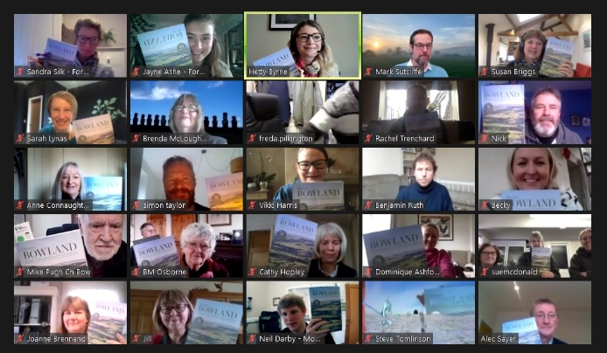We carried out our annual forum and informal launch of the Discover Bowland guide via an online event attended by 38 businesses on 15th February. It was a great opportunity to re-connect and the businesses appreciated the opportunity of being in the virtual company of other businesses. The forum included lockdown reflections from 3 of our business network members and we were pleased to welcome two external speakers: Susan Briggs from the Tourism Network presenting about 'Marketing to Bounce Back' and Sarah Lynas a mind and business self-belief coach.

**For further information email** [**hetty.byrne@lancashire.gov.uk**](mailto:hetty.byrne@lancashire.gov.uk)

**A Strong Connection between People & the Landscape**

**Champion Bowland**

Champion Bowland were awarded a grant of £ 10,000 in April 2020 to produce a business plan and secure advice on fundraising and increase the profile of Champion Bowland through communications. The business plan was carried out by Jenny Wain Associates with Mark Sutcliffe of Salar Media appointed to produce and implement a communications plan for Champion Bowland. Discussions have taken place with the AONB about funding access, hay meadows and landmark trees.

.

**For further information email** [**robin.gray@lancashire.gov.uk**](mailto:robin.gray@lancashire.gov.uk)

**Festival Bowland** 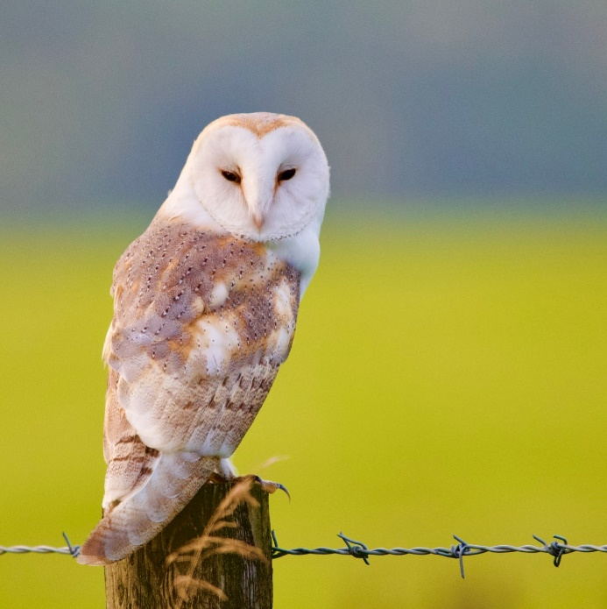

Our Festival Bowland events programme had been exclusively online so far this year and continues to attract encouraging numbers of participants. Our Bowland Dark Skies week during February half-term saw 320 plus attendances over the eight events, which ranged from astronomy to wildlife and family sessions to photography.

Events featuring local heritage are proving popular and support from local and regional history groups is helping us to promote these more widely.

Going forward, the programme includes both virtual events – which we hope to make a permanent feature – and face to face sessions, but the latter will be dependent on any coronavirus restrictions in place at the time. Decisions on whether to go ahead with each event will be taken as they approach.

**For further information email** [**sandra.silk@lancashire.gov.uk**](mailto:sandra.silk@lancashire.gov.uk)

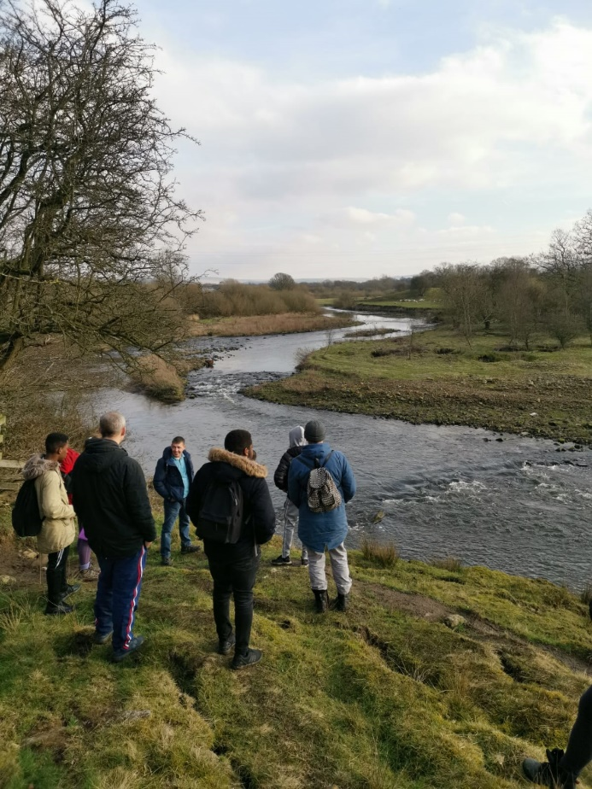**Social Prescribing**

Two members of the team have been accepted onto the *Learning Together* programme organised by the National Academy for Social Prescribing and delivered in this region by the North West Thriving Communities Partnership.

Social prescribing recognises that, to a large degree, people's health and wellbeing is affected by social, economic and environmental factors. It offers a holistic, personalised approach to health, focusing on what matters to an individual and helping them to find practical and emotional support.

The Voluntary, Community, Faith and Social Enterprise sector (VCFSE) plays a key role in supporting individuals to access wider health and wellbeing services through linking them to local, non-clinical opportunities within the community.

VCSFE groups also directly provide many of these services, which range from exercise groups and art sessions to gardening and money advise, with lots in between. The Pendle Hill LP's PEN project is a great example of social prescribing.

The *Learning Together* programme will help the AONB team to connect with local social prescribing link workers, develop additional social prescribing projects within Bowland, potentially collaborate with other local and regional agencies and ultimately be in a stronger position to access funding for social prescribing activities.

**For further information email** [**sandra.silk@lancashire.gov.uk**](mailto:sandra.silk@lancashire.gov.uk)

**Promoted Route Volunteers**

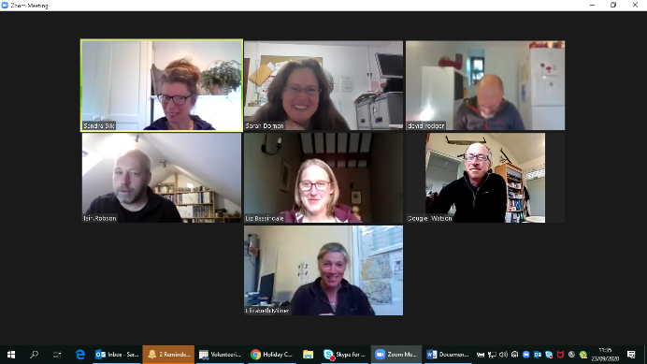

Digital volunteering meetings have been held with other AONB's which have proved to be not only a great sounding board for ideas on how to negotiate the differing coronavirus guidelines but also a great way to keep in touch with other staff they we would usually see through the year.

Promoted route volunteers have remained on hold but with the easing of coronavirus restrictions we hope to restart this in the next quarter.

**For further information email** [**sarah.dornan@lancashire.gov.uk**](mailto:sarah.dornan@lancashire.gov.uk)

**New Countryside Code**

A new, refreshed Countryside Code was launched on 1st April by Natural England and Natural Resources Wales, coinciding with the 70th anniversary of the creation of the founding booklet.

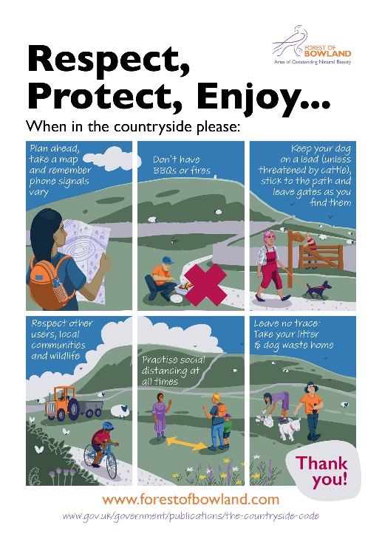With more people enjoying the outdoors than ever before, the code has been revised to help people enjoy countryside in a safe and respectful way.

The updated Countryside Code can be viewed here: <https://www.gov.uk/government/publications/the-countryside-code>

#### We have also continued to produce and print our version of the code printed on outdoor materials which we've actively disseminated via parish councils, farmers and landowners across the AONB. This has been welcomed along with social media posts around **continuing to respect communities, farmers and landowners and following the code while enjoying visits to the area.**

.

**Promoted Route & Countryside Access**

Coronavirus sadly does not affect the weather and as such the Access Project was involved in repairs to the bridleway through the Dunsop Valley as part of the easy access trail.

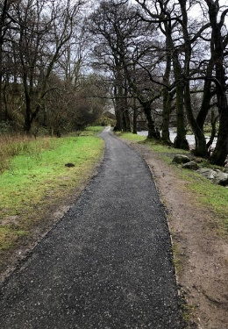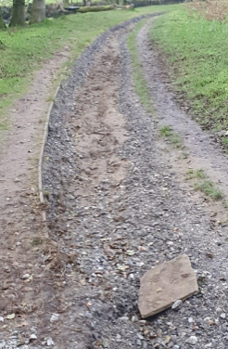

The increase in visitor numbers has not declined and several future projects on some high-pressure sites throughout Bowland have been investigated with one feasibility study commissioned and planning future works.

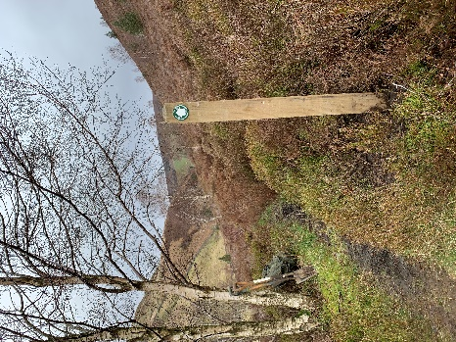Working with United Utilities and RSPB, we have installed new way markers to guide walkers away from Hen Harrier nesting sites, leading to further discussions about managing access and visitor pressures in Bowland. Working together in conjunction with the new Lancashire Police Rural Task Force we hope to able to manage expectations of visitors and land managers alike.

**For further information email** [**sarah.dornan@lancashire.gov.uk**](mailto:sarah.dornan@lancashire.gov.uk)

**Parish Lengthsman**

The Parish lengthsman scheme has seen several virtual meetings to revisit the principles of the lengthsman scheme, these have proved really useful as there have been changes in staffing over the years, we hope this will ensure the scheme goes from strength the strength.

**For further information email** [**sarah.dornan@lancashire.gov.uk**](mailto:sarah.dornan@lancashire.gov.uk)

**Pendle Hill Landscape Partnership Scheme**

A separate report will be presented about the work of the partnership or if you wish to keep up to date with the project work of the Pendle Hill Landscape Partnership you can read their summer quarterly   
e-bulletin and sign-up to their distribution list here: <https://pendlehillproject.com/e-bulletin>

**For further information email** [**cathy.hopley@lancashire.gov.uk**](mailto:cathy.hopley@lancashire.gov.uk)

**National Association for AONBs**

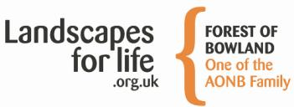The National Association for AONBs have continued to lead a number of collaborative activities between AONBs in England and Wales, primarily facilitated via online meetings and workshops:

* Colchester Declaration on nature recovery
* Diversity and inclusion in AONBs
* Art in the Landscape strategy
* The Agri-environment Advocacy and Information Project

In addition, NAAONB staff have continued to represent AONBs in discussions with Defra regarding the Government's response to the Glover Review and the development of proposals for National Landscapes Service.

**COVID-19**

In keeping with the latest Government guidance, the Forest of Bowland AONB team continue to work from home. We are planning to start our volunteering activities and nature and wellbeing group activities once again in the next few weeks with all the necessary parameters in place. We will continue to follow the latest advice on the situation from[Public Health England](https://www.gov.uk/government/collections/coronavirus-covid-19-list-of-guidance).

This means we won’t be reachable on our main office phone number – however, we are carrying on with business as usual as far as possible and we are all still working remotely. If you have a query, please email or ring individual mobile numbers, and they’ll reply or give you a call as soon as they are able.  Or use the general Bowland email [bowland@lancashire.gov.uk](mailto:bowland@lancashire.gov.uk)and we’ll get back to you as soon as we can.