Guide for Three Tier Forums on the County Council's
Transport Asset Management Plan (TAMP)

What is the TAMP?

- It is the county council's approved Transport Asset Management Plan and investment strategy that identifies the key strategic priorities of Lancashire County Council as highway authority during the period 2015-2030.
- It is a fundamental change from tackling, 'worst first' to one aligned to the Department for Transport's philosophy that, 'prevention is better than cure'. It recommends that resources are used to reduce key maintenance backlogs through preventative methods.
- It sets out the principles and approach that the county council will use to determine the priorities for allocating capital resources to highways and transport assets.

What does the TAMP say?

- The analysis indicates that the county council requires approximately £35m per.annum to maintain all its transport assets at their 2013 levels. The direct allocation likely to be received from central government, via the Department for Transport is £25m per annum. This funding shortfall provides a real challenge to do more, or even the same, with less.
- In the last few years we have experienced a number of severe weather events (long, very cold winters and flood events) which have had an impact on the network and accelerated the deterioration of our assets.
- Preventative intervention works are proposed to reduce our maintenance backlogs. Such works involve treatments that are generally carried out at an earlier critical stage in an asset's life-cycle and are usually less expensive and less intrusive.
- Key maintenance backlogs will be reduced over a ten to fifteen year period, the effect of which will be that the level of available funding broadly matches the amount we need to maintain all our assets.
- It is not possible within the amount of resources that are likely to be available in future years to improve the condition of all transport asset types at the same time. A phased approach, based on the county council's priorities and affordability is therefore required.
- The A, B and C roads and the footway network will be prioritised. The intention during this period is to maintain other transport assets as close to their 2013 condition as resources will allow.
- In respect of those assets scheduled for later phases the primary focus will be to slow down their rate of deterioration as far as possible.

So what will change?

Assets will be managed on a holistic, county wide basis and funding will be prioritised between different parts of the transport asset network, based on need, as measured by engineering analysis.

- Service standards for each asset grouping will be used to set priorities and guide investment levels to reduce maintenance backlogs, make the best use of available resources, and ensure transparency and accountability.
- Investment in each district will be targeted to priority needs in each district annually. Surface dressing will be the main treatment used for preventative maintenance.
- Preventative intervention at the right point will reduce the cost of treatment overall by a factor of 3.
- The public's expectation is that the highway network should be maintained to the highest standard. However, given the current financial constraints the county council will have to prioritise its resources to maximise their effectiveness. We will have to explain this new approach and help the public understand the rationale behind it.
- The TAMP provides a better defence against claims.

Timescales and Priorities

- The TAMP covers the period 2015-2030.
- The efficiency of highway maintenance programmes will only be increased if planned resources are invested for at least a 5 year period. Therefore, it contains three implementation periods of 5 years, with a phased approach to funding priorities:
  - 2015-2020 A, B and C roads and footways
  - 2021-2025 rural unclassified and residential roads
  - 2026-2030 priority structures and street lighting

Phase 1:
- £8m p.a. for A, B and C roads. This comprises;
    - £4m of structural patching to bring red and amber roads up to a condition that they can be surface dressed (approx 47km roads)
    - £4m of surface dressing (approx 200km roads)
- £3m p.a. for footways to tackle defects and reduce claims
- There is some funding for rural unclassified and residential roads in phase 1. Adopting the same structural patching and surface dressing approach will address 100km a year
- Other assets will be supported at 2013/14 levels where possible

Phase 2:
- Priority to residential and rural unclassified £5m pa
- Structural patching (starts the year before in anticipation of surface dressing)
- ABC roads and footways still funded to a level to manage annual deterioration

Phase 3:
- Our bridge structures are in excellent condition and deteriorate at a very slow rate. For that reason investment in the bridge stock is identified as happening in phase 3 (£6m). This does not mean that we won't be dealing with "at risk" structures and will continue to manage the stock.
- We will also continue a programme of replacing the street lighting that is at the highest risk of failure on a programmed basis (£4m).

Resurfacing v structural patching - how much does £8m buy?

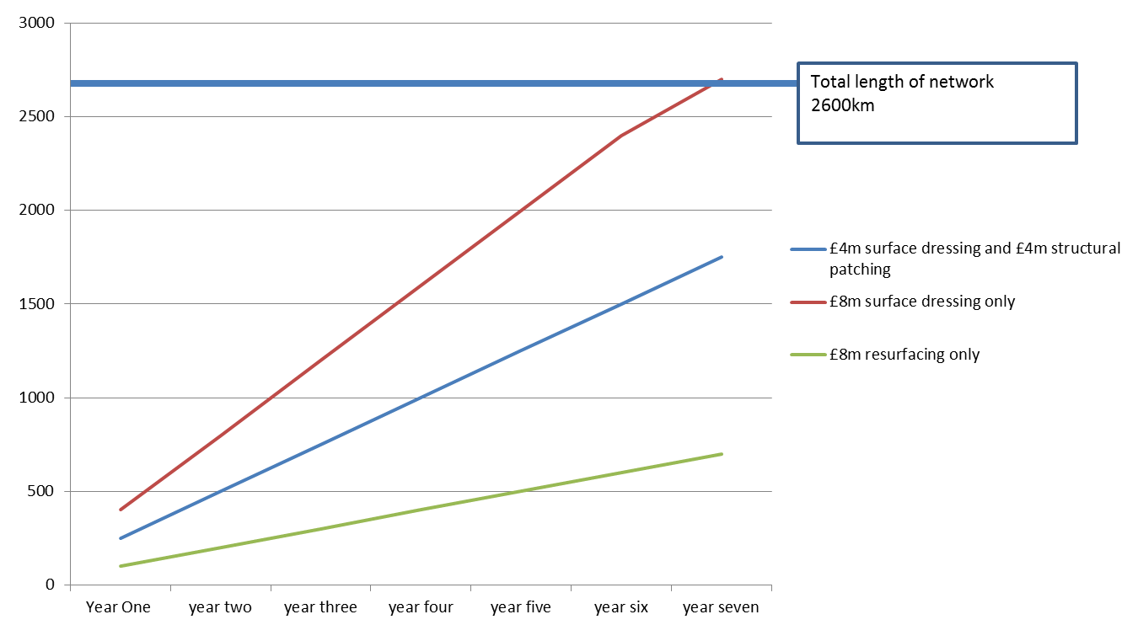

Highway condition by district

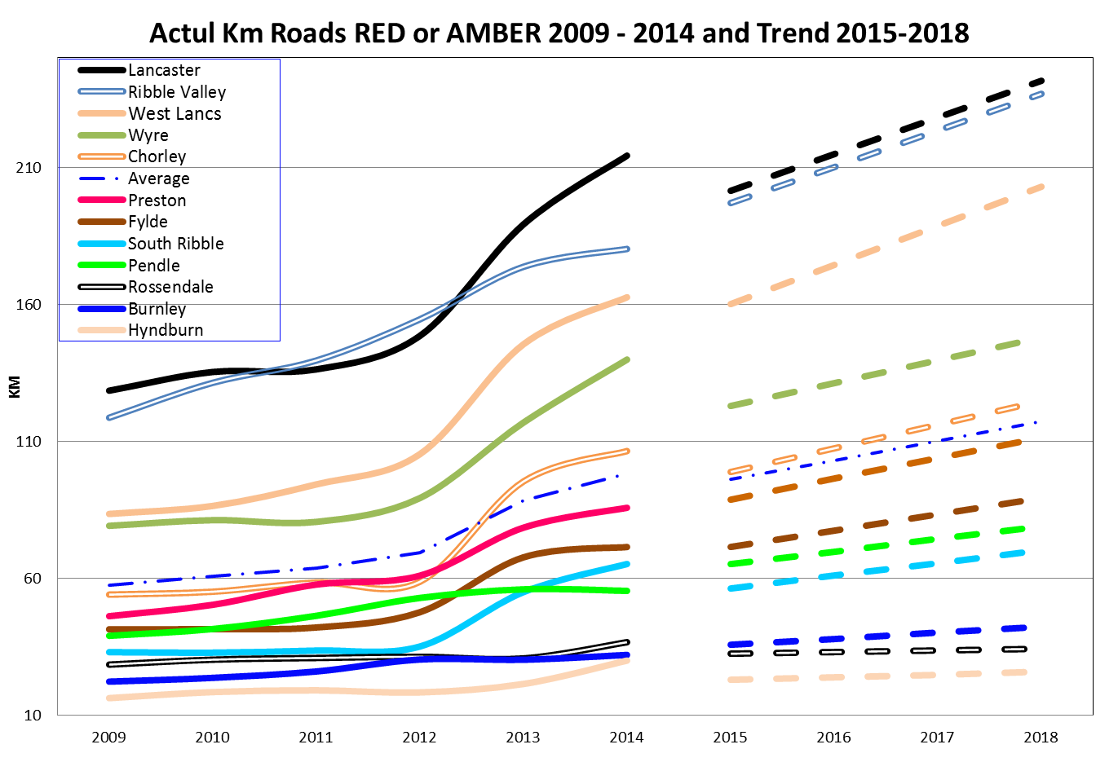

Where we are and where we want to be

The table below shows the current condition of each asset type covered by the plan and the overall target that has been set to the end of 2029/30, together with interim 5-year targets.

Anticipated Asset Condition to 2029/30
Asset Category | Condition Now | 5 Year  Target | 10 Year Target | 15 Year Target
 | 2013-14 | 2015/16 to 2019/20 | 2020/21 to 2024/25 | 2025/26 to 2029/30
A Roads  B Roads  C Roads | FAIR
 | ACCEPTABLE | GOOD | GOOD | GOOD
 | POOR
Residential Unclassified Roads | ACCEPTABLE | ACCEPTABLE | GOOD | GOOD
Rural Unclassified Roads | ACCEPTABLE | ACCEPTABLE | GOOD | GOOD
Footways | ACCEPTABLE | EXCELLENT | EXCELLENT | EXCELLENT
Bridges and Similar Structures | GOOD | GOOD | GOOD | GOOD
Street Lighting | FAIR | ACCEPTABLE | ACCEPTABLE | ACCEPTABLE
Traffic Signals | ACCEPTABLE | ACCEPTABLE | FAIR | GOOD

In practical terms what does it mean for councillors/your area?

- You will have greater clarity regarding the county council's priorities as the highway authority.
- You will see a significant improvement in the condition of the A, B and C road network generally over the life of the plan. However that improvement will take place across the county at varying rates based on priority. The maintenance backlogs on the A, B and C road network should be significantly reduced by 2020/21.
- Increased investment in the footway network should improve its condition and reduce the number of successful claims made against the county council by 2020/21.
- The maintenance backlogs on the urban and rural unclassified networks will be prioritised in phase 2 (2020/21 – 2024/25).
- The move to countywide allocations may result in the amount spent in individual districts varying compared with previous years. As funding will be based on condition data, investment in districts may vary year on year.
- The public may not appreciate that 'prevention is better than cure' and may query why what they perceive as 'the worst roads' are not prioritised.
- Surface dressing, although not always the public's preferred treatment, will be the main treatment used for preventative maintenance as this will reduce the cost of treatment overall by a factor of 3.
- LCC's Scrutiny Committee will be involved in the ongoing monitoring and implementation of the plan.
- You will receive ongoing briefings to allow you to explain the plan to your constituents.

